**DATABASE MANAGEMENT SYSTEM**

**ASSIGNMENT-3**

UE19CS301

**Team - 24**

Divyanshu Sharma: PES1UG20CS806

Navya C: PES1UG20CS818

**REASON FOR CHOOSE DBMS:**

* It plays a crucial role in both the creation and management of data.
* It is versatile and can be accessed on computers, tablets and on mobile phones.
* It can manage data with different levels of transparency and increased availability etc.

**PROJECT SPECIFICATION:**

In this assignment we are going to display some queries using PostgreSQL / MySQL as implementation on command prompt in windows.

**SQL QUERIES:**

1. 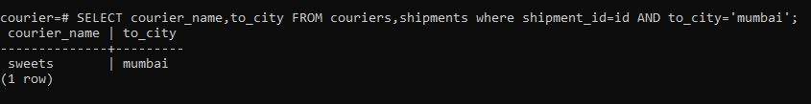**List all the couriers which is delivered to Mumbai.**
2. 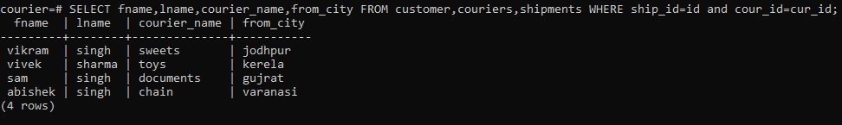**List all the courier name and the person name who has sent the courier person city.**
3. 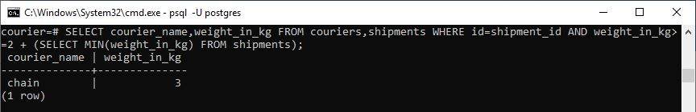**Retrieve the courier name and weight of the courier which has weight is more than 2kg more than the courier whose weight is least in the shipments**
4. 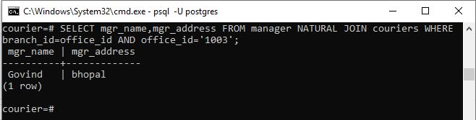**Using natural join retrieve the name and address of every manager who works for ‘1003’ office-id.**
5. 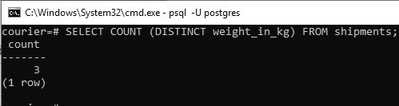**Count the number of distinct weight values in the database.**
6. 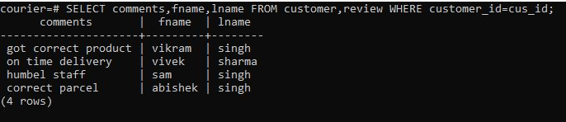**Retrieve all the reviews made by every customer.**
7. 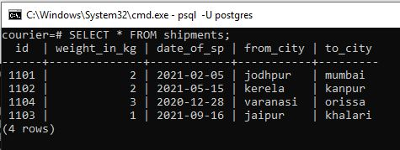**Update the from_city and to_city of shipment id 1103 to ‘jaipur’ and ‘khalari’, respectively.**
8. 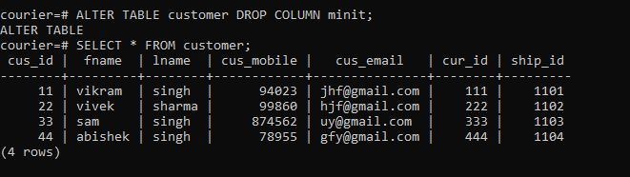**Drop the column named minit from customer table.**
9. 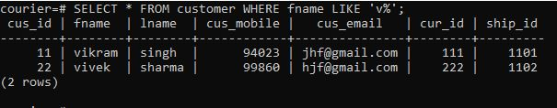**Retrieve all the customer name starting with letter ‘v’**
10. 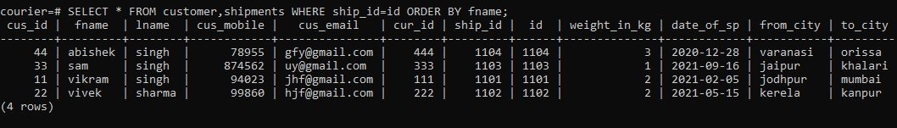**Retrieve all the information from customer and shipment table which is alphabetically order.**

* 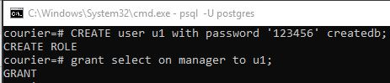**Creating user access privilege**
* Created access for user as u1 and password=123456 and granting u1 user to access only manager table.

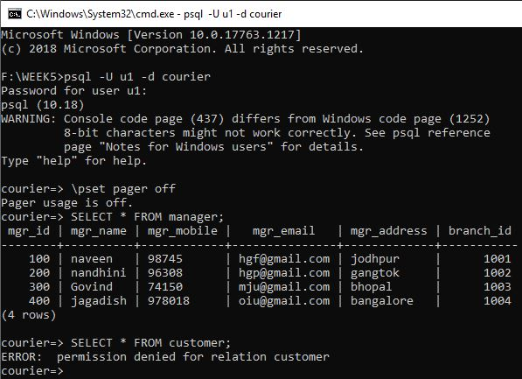

* 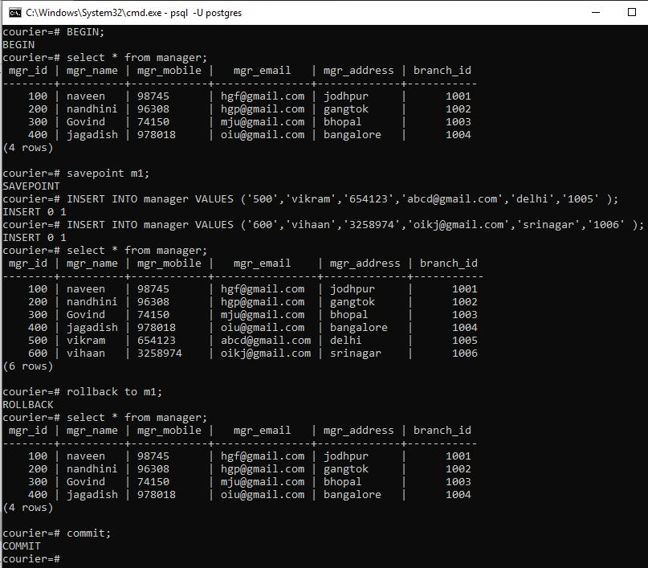**Transaction function:**

**CONTRIBUTIONS:**

Divyanshu Sharma:

Navya C: