Explainable AI-Powered Secure IoT Firewall
Using CNN-BiLSTM with SHAP and LIME Explanations

Divyanshu Arora | Parnika Sarbahi | Yashraj Kumar Gupta
Guide: Dr. Richa Kumari
University of Petroleum and Energy Studies (UPES)
Minor Project Report | 6th Semester | 2025-26

Abstract
The proliferation of Internet of Things (IoT) devices has introduced significant cybersecurity challenges, with network traffic from such devices increasingly targeted by sophisticated malware attacks. Traditional intrusion detection systems (IDS) often lack transparency, making it difficult for security analysts to understand and trust their predictions. This paper presents an Explainable Artificial Intelligence (XAI)-powered secure IoT firewall that combines a CNN-BiLSTM deep learning model with SHAP (SHapley Additive exPlanations) and LIME (Local Interpretable Model-agnostic Explanations) for transparent threat classification.

The proposed system processes network traffic files in CSV or PCAP format, classifies them as Safe or Risk, and generates human-readable explanations identifying the key features responsible for each prediction. Trained on the IoT-23 dataset — a real-world IoT traffic benchmark — after careful preprocessing and class balancing, the model achieves 97% accuracy, 0.97 macro F1-score, and an AUC-ROC of 0.9964. The end-to-end system is deployed as a web application with a Flask backend and HTML/CSS/JavaScript frontend, making XAI-driven threat analysis accessible to non-expert users. Results demonstrate that the proposed approach significantly outperforms existing methods while maintaining full prediction interpretability.

Keywords: IoT security, intrusion detection, CNN-BiLSTM, explainable AI, SHAP, LIME, network traffic analysis, deep learning

1. Introduction
The Internet of Things (IoT) has transformed modern infrastructure, connecting billions of devices across smart homes, industrial control systems, healthcare, and critical infrastructure. By 2030, the number of connected IoT devices is projected to exceed 30 billion globally. However, this rapid expansion has created an expansive and often poorly secured attack surface. IoT devices typically operate with limited computational resources, constrained memory, and minimal built-in security mechanisms, making them prime targets for malware campaigns including botnets, Distributed Denial of Service (DDoS) attacks, command-and-control (C&C) operations, and port scanning activities.

Traditional signature-based intrusion detection systems (IDS) are increasingly ineffective against novel and polymorphic malware variants. Machine learning-based approaches have demonstrated superior detection capabilities by learning from traffic patterns; however, their black-box nature poses a critical barrier to adoption in security-critical environments. Security analysts require not only accurate predictions but also explanations of why a traffic flow was flagged — without transparency, even highly accurate models cannot be trusted in high-stakes deployment scenarios.

Explainable Artificial Intelligence (XAI) has emerged as a crucial bridge between predictive accuracy and human interpretability. Techniques such as SHAP and LIME enable post-hoc explanation of complex model decisions by quantifying the contribution of individual features to a prediction. When applied to network intrusion detection, XAI enables analysts to understand which traffic characteristics — such as connection state, packet volume, or protocol type — drove a classification decision, enabling faster incident response and improved situational awareness.

This paper presents a complete, end-to-end XAI-powered IoT firewall system addressing three core research objectives:
- Design and train a CNN-BiLSTM model capable of accurately detecting malicious IoT network traffic from real-world datasets.
- Integrate SHAP and LIME explainability to provide both global feature importance and per-prediction local explanations.
- Deploy the system as a user-accessible web application where network traffic files can be uploaded and analysed with full transparency.

The remainder of this paper is structured as follows: Section 2 reviews related literature; Section 3 describes the system model and architecture; Section 4 details the proposed methodology; Section 5 presents results and analysis; Section 6 concludes with future directions; and Section 7 lists references.

2. Literature Survey
A substantial body of research has addressed IoT intrusion detection using machine learning, deep learning, and more recently, explainable AI. The following review examines key works directly relevant to this project, identifying their methodologies, contributions, and limitations that motivate the proposed approach.

2.1 Deep Learning for IoT Intrusion Detection
Early deep learning approaches to network intrusion detection employed standard architectures such as Multi-Layer Perceptrons and basic LSTM networks. However, the temporal nature of network traffic — where attack patterns often span multiple consecutive packets — motivated the adoption of sequential models. Recurrent architectures, particularly LSTM and its bidirectional variants, demonstrated superiority over static models by capturing forward and backward temporal dependencies in traffic sequences.

The CNN-BiLSTM architecture emerged as a particularly effective hybrid, combining the spatial feature extraction capability of Convolutional Neural Networks with the temporal modelling power of Bidirectional LSTMs. A 2025 IEEE paper specifically applied this architecture to explainable IoT malware detection, achieving competitive accuracy while also incorporating Class Activation Mapping (CAM) for visual explanations. However, the authors noted significant limitations: the model was not optimised for edge deployment, exhibited scalability issues with larger datasets, and incurred high XAI computational overhead — gaps that the present work directly addresses.

2.2 Transformer-Based Approaches
TransMalDE (IEEE, 2023) introduced a hierarchical transformer framework for IoT malware detection, leveraging API-call graphs, embeddings, and multi-head attention mechanisms. While achieving strong performance on static analysis tasks, TransMalDE's reliance on API-call graph construction limits its applicability to dynamic, real-time network traffic analysis. Furthermore, the high training cost and static focus make it unsuitable for deployment in resource-constrained IoT monitoring systems.

More recently, lightweight Large Language Models (LLMs) have been explored for malware detection at the edge (Zhang et al., arXiv 2025). While promising in terms of general language understanding, these approaches require extensive fine-tuning and remain computationally prohibitive for real-time IoT applications, representing a fundamental trade-off between model expressiveness and practical deployability.

2.3 XAI for Malware Detection
The integration of explainability into malware detection represents a relatively recent but rapidly growing research direction. A comparative study of XAI techniques for Android malware detection (SJSU ScholarWorks, 2023) evaluated LIME, SHAP, and Grad-CAM across multiple ML/DL classifiers, demonstrating that SHAP consistently provided more stable and informative explanations than LIME for global feature importance, while LIME excelled at local, per-instance explanations. The absence of a standardised XAI evaluation framework remains a noted limitation across this body of work.

A comprehensive IEEE Access survey (2025) on XAI for malware analysis further highlighted that existing work is overwhelmingly focused on Android and Windows malware, with IoT network traffic receiving comparatively little attention. The survey also identified the lack of XAI benchmarks specific to IoT environments as a critical gap — directly motivating the dataset-driven, benchmark-oriented approach adopted in this work.

2.4 Edge Deployment and Optimisation
Research on resource-constrained deployment of deep learning IDS models includes work on Raspberry Pi-based real-time malware detection (IJIRT, 2025), which demonstrated the viability of CNN, Random Forest, and SVM models on edge hardware but lacked adversarial robustness evaluation. The Optimized Ensemble LSTM IDS (IEEE Access, 2025) applied ANOVA feature selection, INT8 quantisation, and model pruning to achieve real-time inference on Raspberry Pi — demonstrating that deep learning IDS models can be made edge-compatible without catastrophic performance degradation.

2.5 Summary and Research Gap
Table 1 summarises the key works reviewed. Despite significant advances, no existing work simultaneously addresses: (1) accurate IoT traffic classification using a CNN-BiLSTM architecture trained on real-world balanced IoT datasets; (2) dual-method XAI integration providing both global (SHAP) and local (LIME) explanations; and (3) end-to-end system deployment as an accessible web application. This paper addresses all three gaps.

Table 1: Summary of Related Work
Model / Paper | Publication | Objective | Method | Key Gaps
CNN-BiLSTM | IEEE 2025 | Explainable IoT malware detection using spatial + temporal features | CNN-BiLSTM + SHAP + CAM | Not edge-optimized; scalability issues; high XAI computational cost
TransMalDE | IEEE 2023 | Transformer-based edge-cloud IoT malware detection | API-call graphs + embeddings + multi-head attention | Static focus; high training cost; limited dynamic analysis
Lightweight LLMs | arXiv 2025 | Malware detection on edge devices using distilled LLMs | Fine-tuned distilled Transformers on IoT datasets | Fine-tuning required; compute-heavy; not suitable for low-resource IoT
AI Malware on Raspberry Pi | IJIRT Vol.11 2025 | Real-time IoT malware detection on Raspberry Pi | ML/DL (CNN, RF, SVM) + real-time classification | No optimization; limited adversarial and cross-dataset testing
Optimized LSTM IDS | IEEE Access Vol.13 2025 | Efficient real-time IDS on resource-constrained devices | Stacked LSTM + ANOVA + INT8 quantization + pruning | No adversarial testing; limited distributed/privacy evaluation
XAI for Android Malware | SJSU ScholarWorks 2023 | Compare XAI techniques for malware detection transparency | ML/DL + LIME + SHAP + Grad-CAM | No standardized XAI evaluation framework
XAI Survey | IEEE Access 2025 | Review of explainable malware detection techniques | Categorized ML + XAI techniques by platform | Overfocus on Android; lack of XAI benchmarks for IoT
Table 1. Literature survey summary — methods, objectives, and identified gaps.

3. System Model

3.1 System Overview
The proposed XAI-Powered Secure IoT Firewall is a three-tier web-based system comprising a frontend interface, a Python-based backend API, and a trained CNN-BiLSTM model with integrated explainability modules. The system accepts network traffic files as input and produces a classification (Safe / Risk) accompanied by SHAP and LIME explanations identifying the features responsible for the decision.

3.2 System Architecture
The system follows a client-server architecture with three distinct layers:

3.2.1 Frontend Layer
The frontend is implemented as a single-page web application using HTML5, CSS3, and vanilla JavaScript. It provides a drag-and-drop file upload interface supporting CSV and PCAP file formats, a real-time progress indicator during analysis, and a results dashboard displaying the classification verdict, confidence score, SHAP feature importance chart, and LIME local explanation chart. Plain-English summaries of both explanations are generated and displayed alongside the visual charts to ensure accessibility for non-expert users.

3.2.2 Backend Layer
The backend is implemented using Flask (Python), exposing a single REST API endpoint (POST /predict) that receives the uploaded file, coordinates preprocessing and inference, and returns a structured JSON response. Flask-CORS is enabled to allow cross-origin requests from the frontend. File parsing handles both CSV files (via Pandas) and PCAP files (via Scapy), with a unified preprocessing pipeline that aligns parsed features to the training feature schema before passing data to the model.

3.2.3 Model and Explainability Layer
The core intelligence layer consists of the trained CNN-BiLSTM model (TensorFlow/Keras), a StandardScaler for feature normalisation, a SHAP KernelExplainer for global feature importance, and a LIME TabularExplainer for local per-sample explanations. All model artifacts are loaded at server startup and maintained in memory to ensure low-latency inference.

3.3 Data Flow
The end-to-end data flow proceeds as follows: (1) the user uploads a network traffic file via the web interface; (2) the frontend sends the file to the Flask backend via a POST request; (3) the backend parses and preprocesses the file into a feature matrix aligned with the training schema; (4) the CNN-BiLSTM model performs inference on sliding windows of the traffic data; (5) the highest-risk window is identified and passed to the SHAP and LIME explainers; (6) the backend returns a JSON response containing the classification label, confidence score, and base64-encoded explanation charts; and (7) the frontend renders the results dashboard.

3.4 Technology Stack
The complete technology stack is as follows:
- Model training and inference: TensorFlow 2.x / Keras
- Data preprocessing: Pandas, NumPy, Scikit-learn
- Class balancing: Random undersampling (imbalanced-learn)
- Explainability: SHAP (KernelExplainer), LIME (LimeTabularExplainer)
- PCAP parsing: Scapy
- Backend API: Flask, Flask-CORS, Werkzeug
- Frontend: HTML5, CSS3, Vanilla JavaScript
- Training infrastructure: HPC cluster with NVIDIA H100 GPU

4. Proposed Methodology

4.1 Dataset
The IoT-23 dataset, collected at the Stratosphere Laboratory, Czech Technical University, is used for training and evaluation. IoT-23 contains labelled network traffic captured from real IoT devices running both benign applications and known malware families including Okiru, Mirai, and various botnet variants. The dataset provides realistic traffic characteristics including connection state, packet counts, byte volumes, and protocol information.

Two preprocessed subsets were used: cleaned_data.csv (48,003 rows, 45.8% attack) and iot23_combined.csv (1,446,621 rows, 96.3% attack). After combining and deduplication, the raw dataset comprises 1,494,624 samples with a severe 17.8x class imbalance (94.7% attack, 5.3% normal). Table 2 summarises the dataset statistics.

Table 2: IoT-23 Dataset Statistics
File | Total Rows | Normal | Attack %
cleaned_data.csv | 48,003 | 26,001 | 45.8%
iot23_combined.csv | 1,446,621 | 53,481 | 96.3%
Combined (raw) | 1,494,624 | 79,482 | 94.7%
Balanced (final) | 158,964 | 79,482 | 50.0%
Table 2. Raw and balanced dataset statistics before and after class balancing.

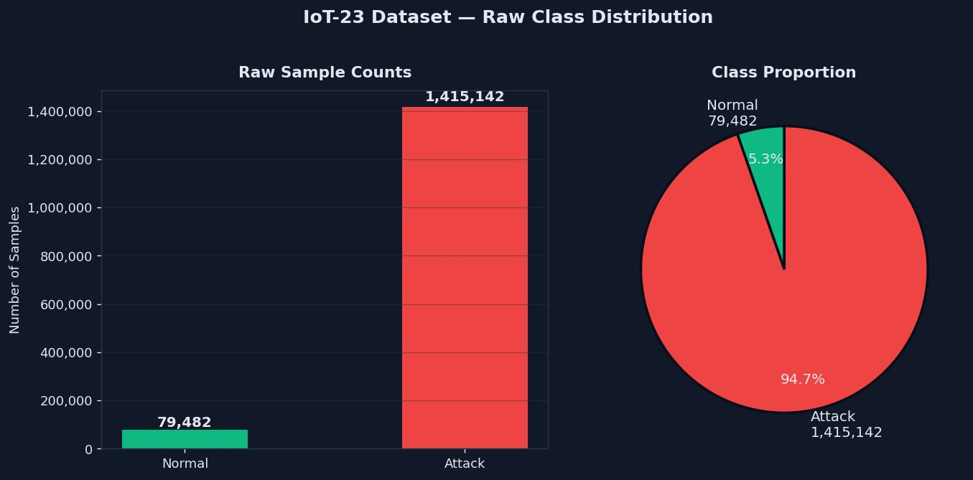
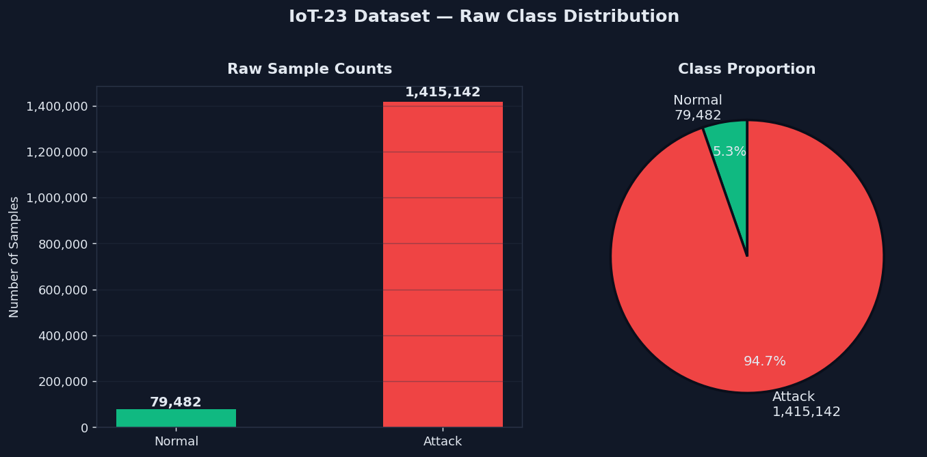
Figure 1. Raw class distribution in IoT-23 dataset: 94.7% attack vs 5.3% normal (17.8x imbalance).

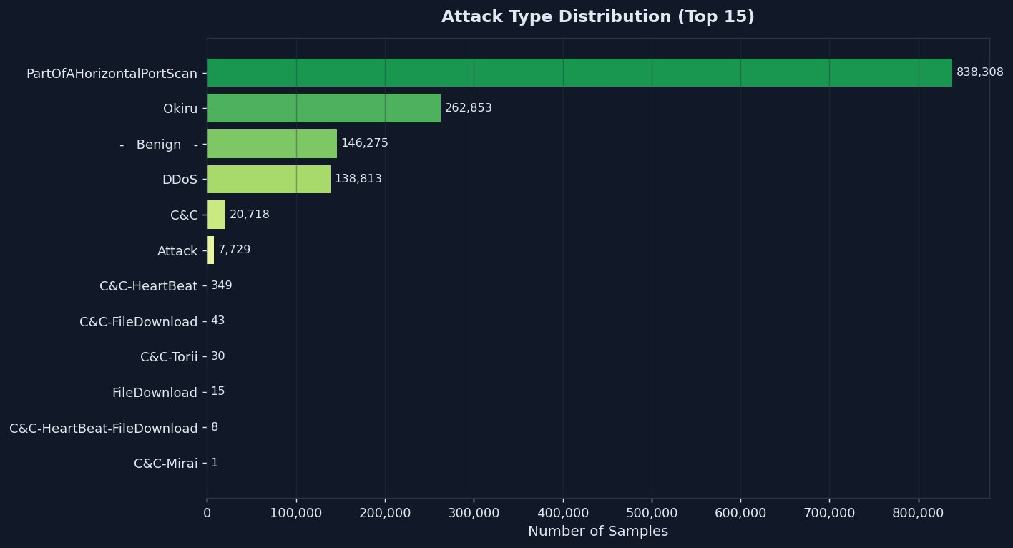
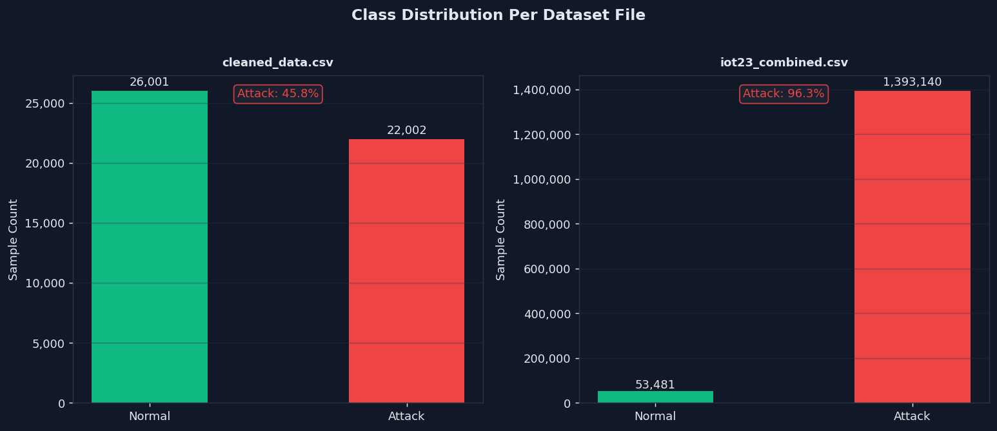
Figure 2. Attack type distribution — PartOfAHorizontalPortScan dominates (59.2%), followed by Okiru (18.6%) and DDoS (9.8%).

4.2 Data Preprocessing
The preprocessing pipeline consists of the following sequential steps:

4.2.1 Feature Selection and Cleaning
Non-informative columns including timestamps (ts), row indices (Unnamed: 0), and IP addresses (id.orig_h) are removed to prevent data leakage and ensure the model learns generalizable traffic patterns rather than memorising specific host identifiers. After dropping these columns, 24 clean numeric features remain: 8 continuous traffic volume features (duration, orig_bytes, resp_bytes, missed_bytes, orig_pkts, orig_ip_bytes, resp_pkts, resp_ip_bytes) and 16 binary protocol and connection state indicator features (proto_icmp, proto_tcp, proto_udp, and 13 conn_state_* binary flags).

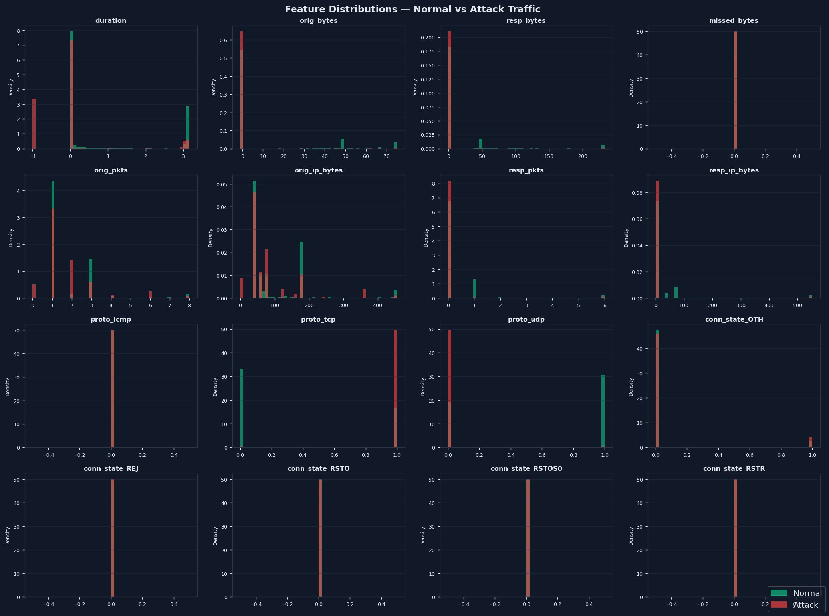
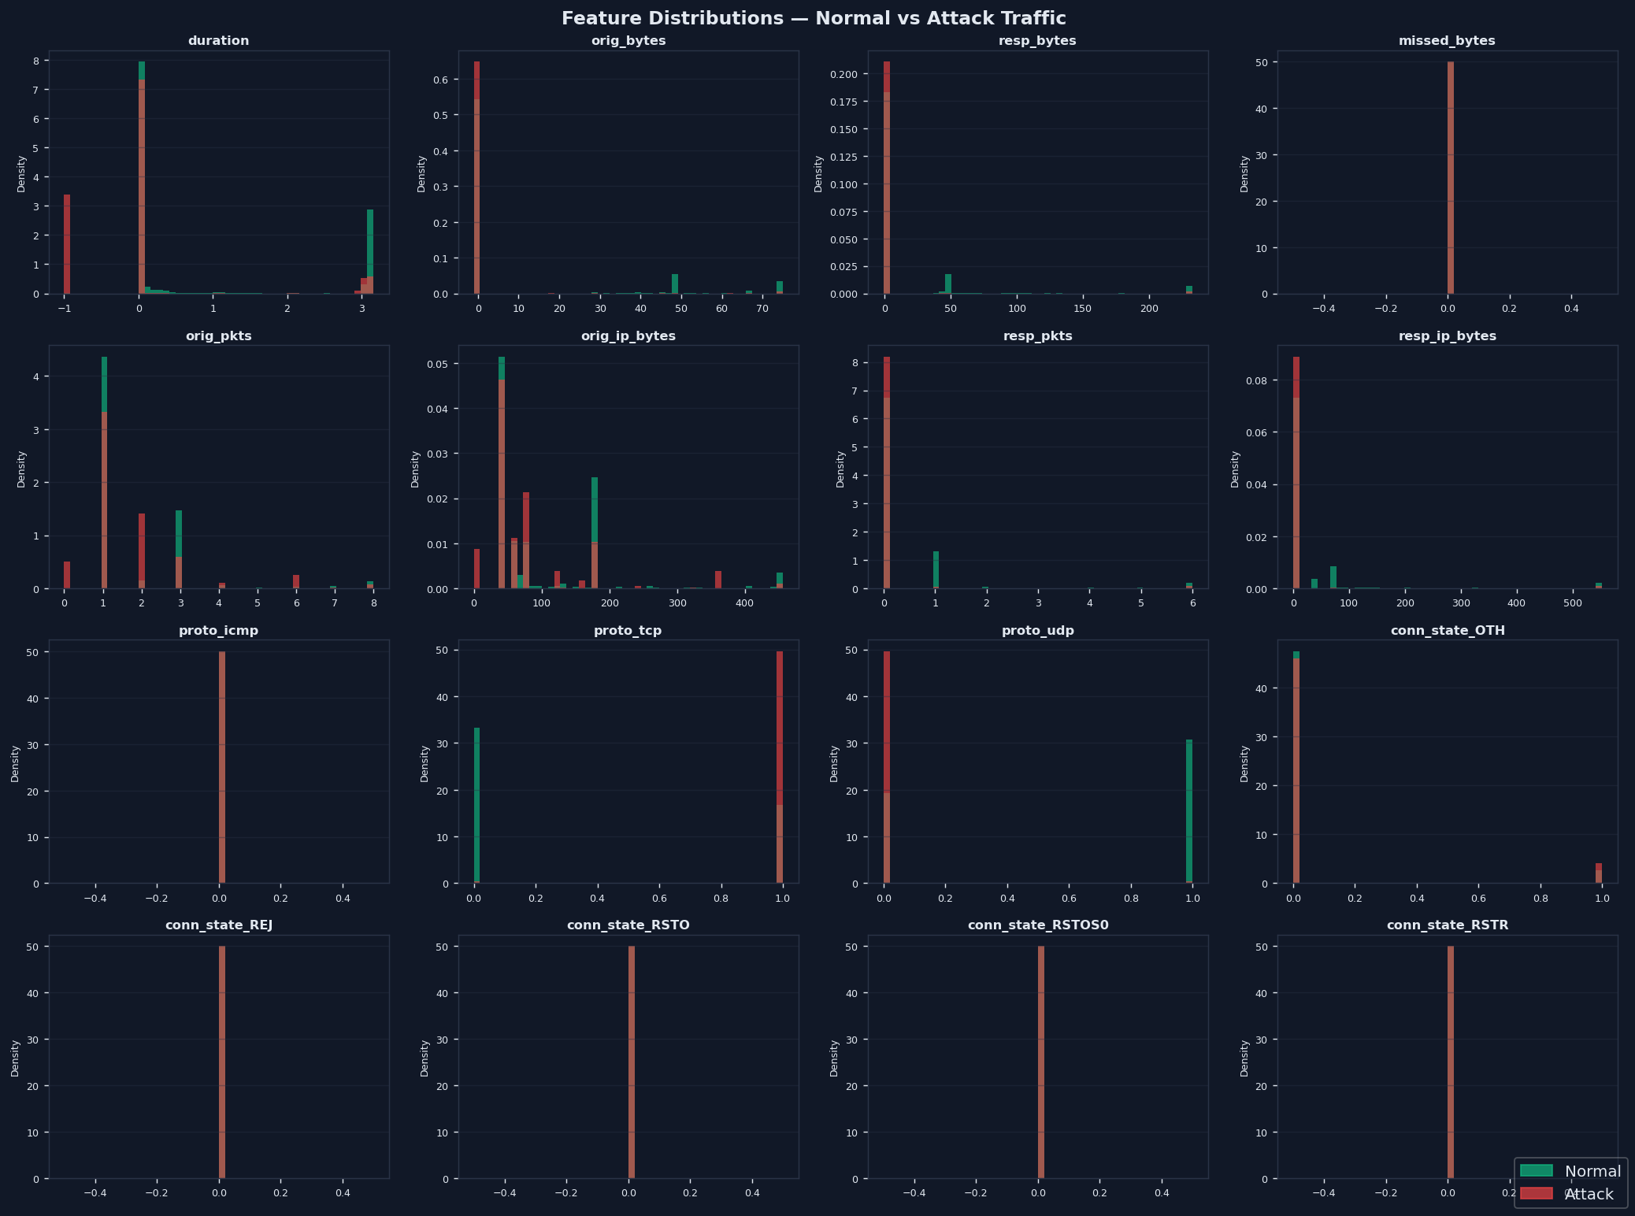
Figure 3. Feature distributions for Normal vs Attack traffic. Note the distinct separation in features such as orig_bytes, resp_pkts, and conn_state_S0.

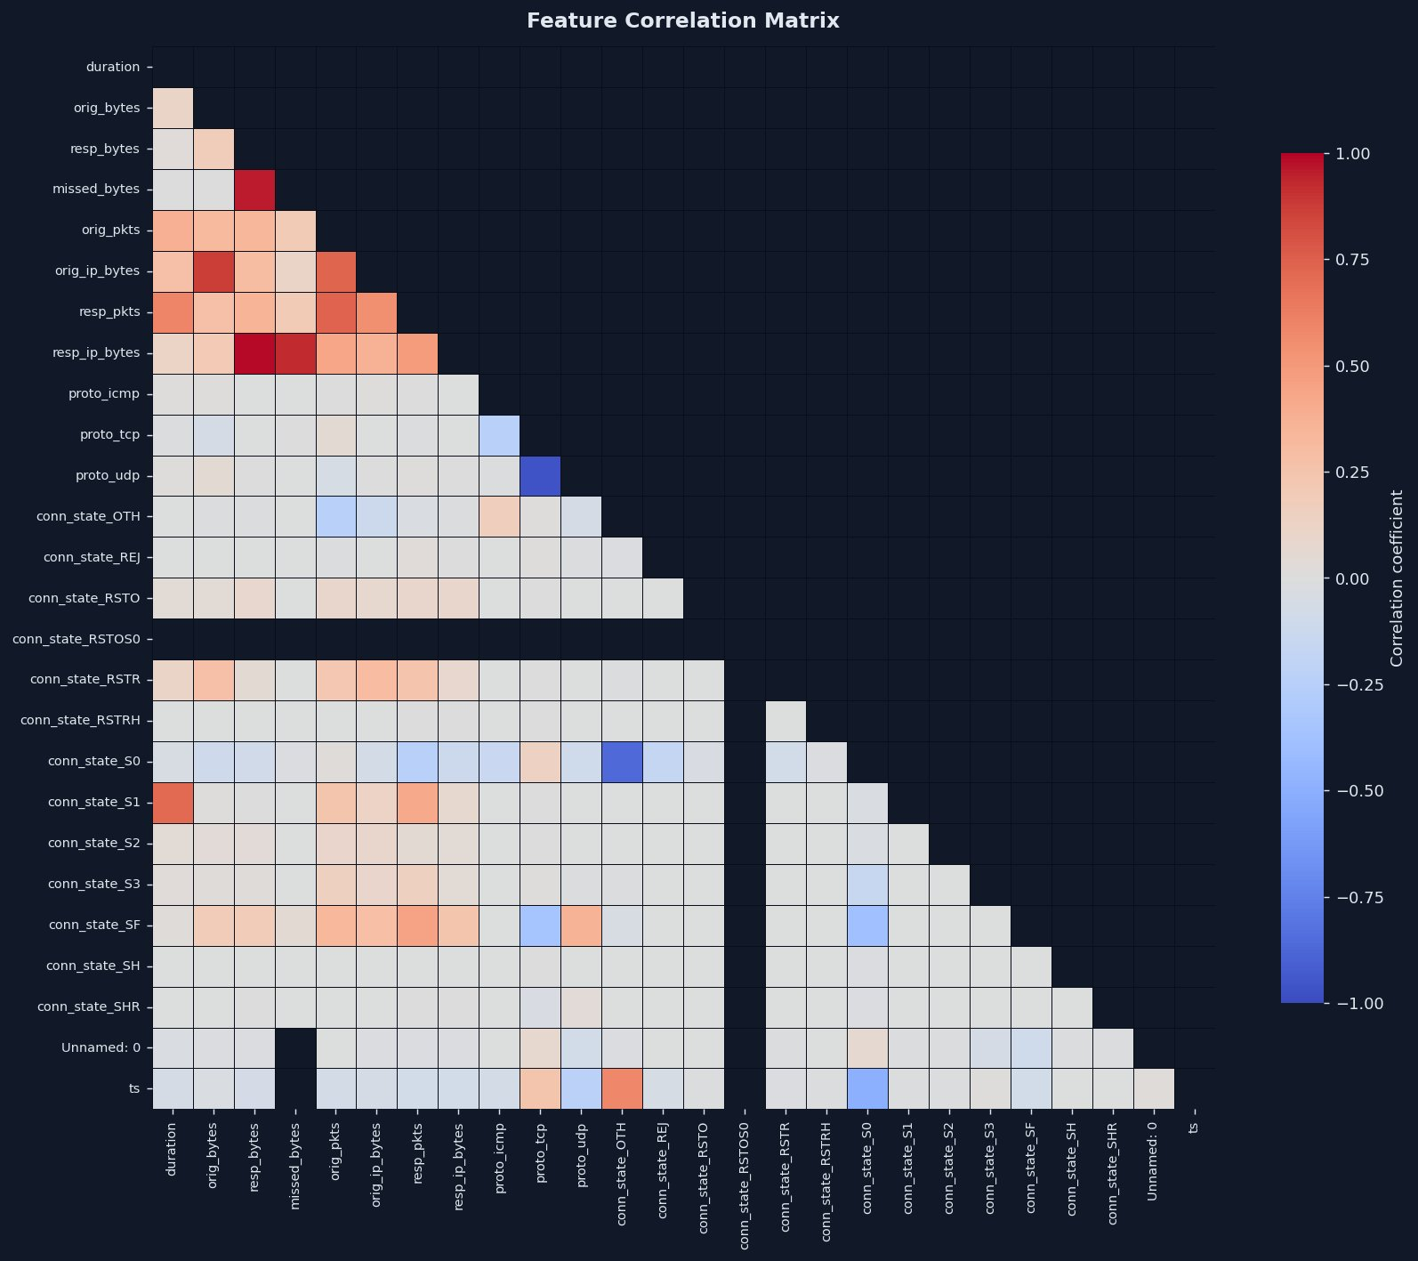
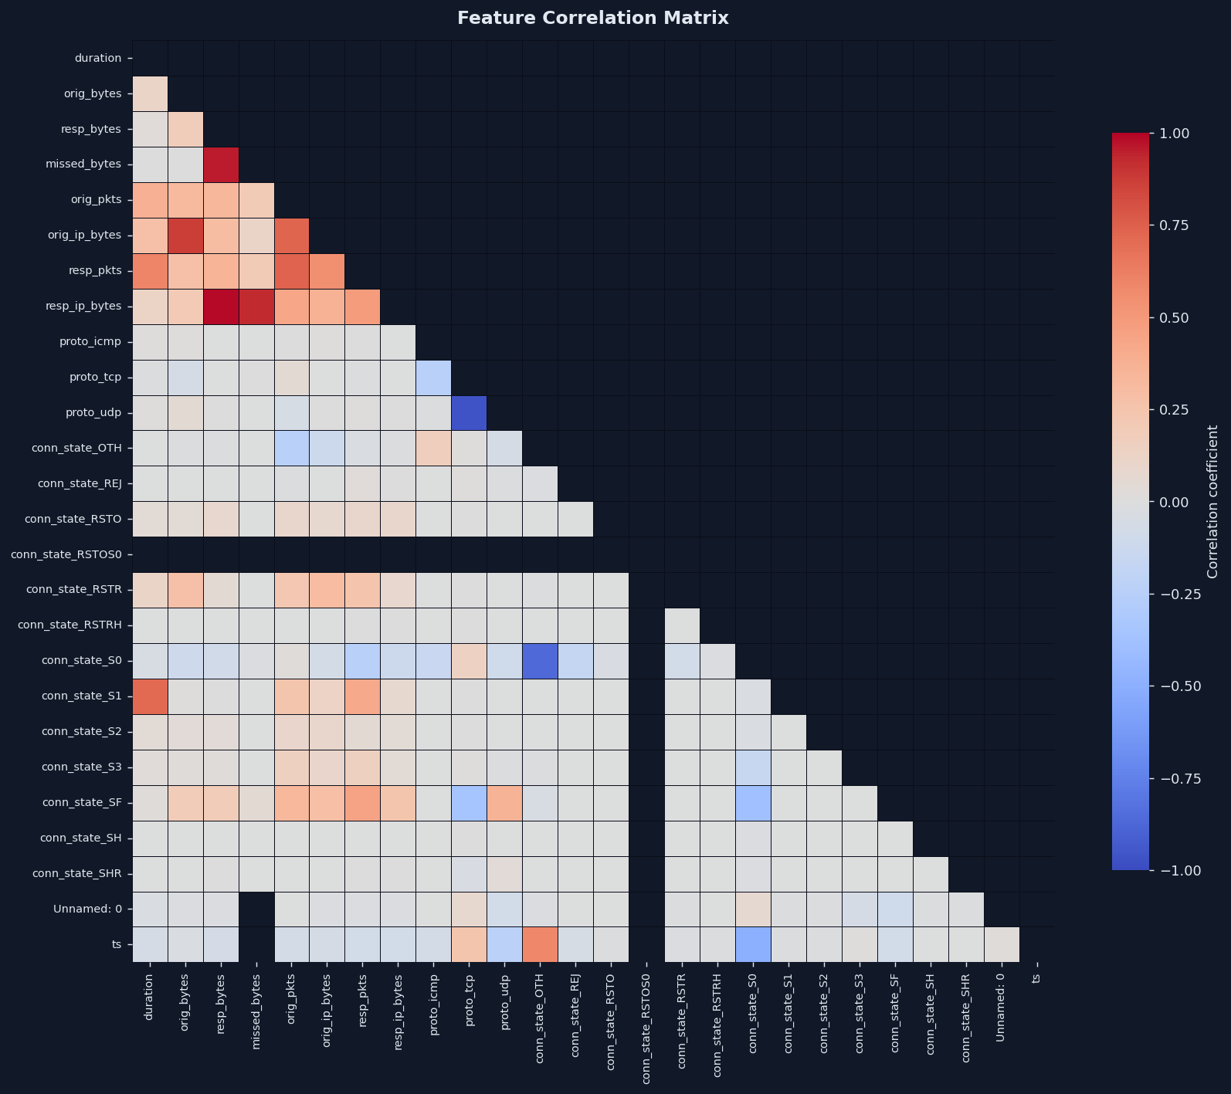
Figure 4. Feature correlation heatmap. Strong positive correlations are observed among byte-volume features (orig_bytes, orig_ip_bytes, resp_bytes, resp_ip_bytes), indicating redundancy that the CNN layers effectively compress.

4.2.2 Class Balancing
The 17.8x class imbalance is addressed using random undersampling of the majority (attack) class, retaining all 79,482 normal samples and sampling an equal number of attack samples. This produces a perfectly balanced training dataset of 158,964 samples (50% each class). Random undersampling is preferred over synthetic oversampling (SMOTE) for this application because it preserves real observed traffic patterns without introducing artificial samples that may not reflect genuine network behaviour — an important consideration for security-critical applications.

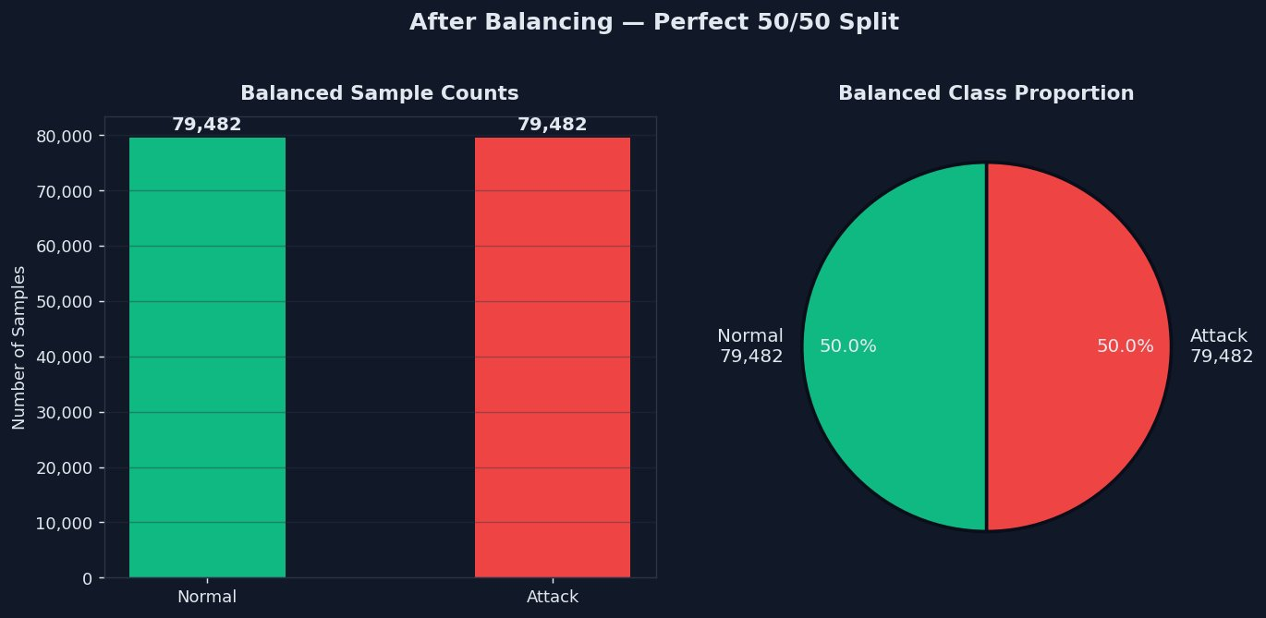
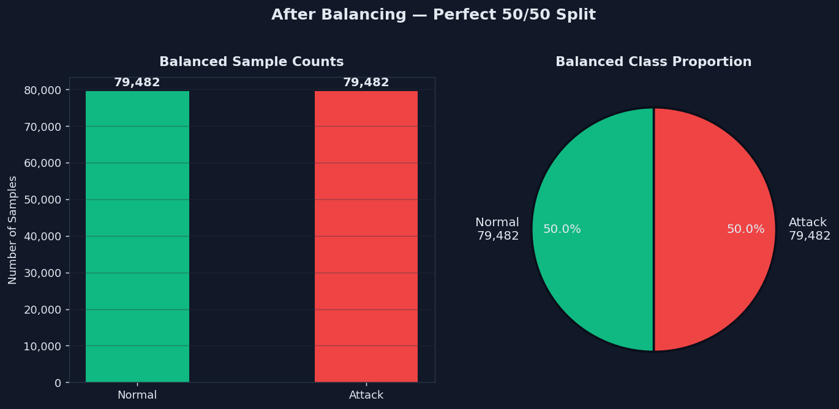
Figure 5. Class distribution after balancing — perfect 50/50 split ensuring unbiased model training.

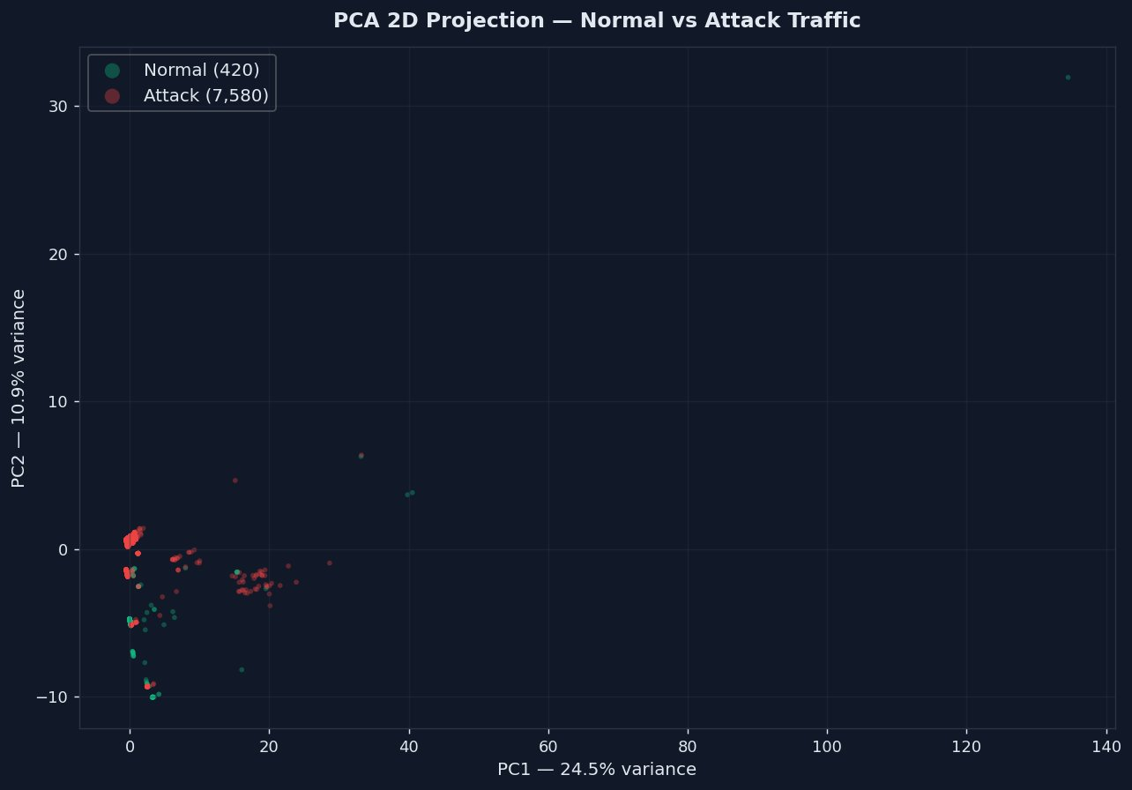
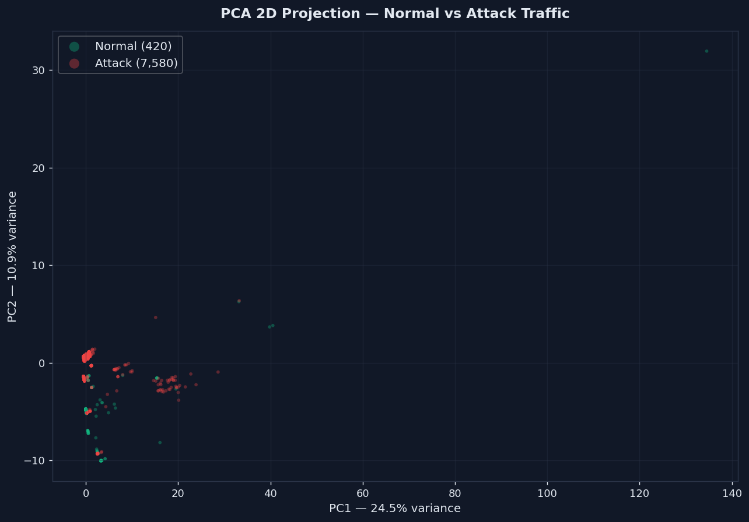
Figure 6. PCA 2D projection of network traffic samples. PC1 (24.5%) and PC2 (10.9%) capture 35.4% of total variance. The partial class overlap motivates the use of a deep sequential model rather than linear classifiers.

4.2.3 Normalisation and Windowing
All features are normalised using StandardScaler (zero mean, unit variance) fitted exclusively on the training set to prevent data leakage. The balanced dataset is then split into training (70%), validation (15%), and test (15%) sets using stratified sampling to maintain the 50/50 class ratio across all splits. A sliding window of size 10 is applied to create sequential input samples of shape (n, 10, 24), enabling the BiLSTM layers to capture temporal dependencies across consecutive traffic flows. SMOTE is applied to the windowed training set only as a secondary balancing measure if residual imbalance remains after undersampling.

4.3 CNN-BiLSTM Model Architecture
The proposed model combines Convolutional Neural Networks for local pattern extraction with Bidirectional Long Short-Term Memory networks for temporal sequence modelling. The architecture is designed to simultaneously capture spatial relationships between features within a single traffic window and temporal dependencies across consecutive windows.

The complete architecture is as follows:
- Input layer: shape (batch, 10, 24) — 10 timesteps, 24 features
- Conv1D block 1: 64 filters, kernel size 3, ReLU activation + Batch Normalisation + MaxPooling + Dropout(0.3)
- Conv1D block 2: 128 filters, kernel size 3, ReLU activation + Batch Normalisation + MaxPooling + Dropout(0.3)
- BiLSTM layer 1: 128 units, return_sequences=True — captures bidirectional temporal patterns
- BiLSTM layer 2: 64 units, return_sequences=False — produces fixed-length representation
- Dense layer: 128 units, ReLU + Dropout(0.4)
- Dense layer: 64 units, ReLU
- Output layer: 1 unit, sigmoid activation — P(attack)

The model is compiled with binary cross-entropy loss, Adam optimiser (initial learning rate 0.001), and tracks accuracy, precision, recall, and AUC-ROC during training. Training employs EarlyStopping (patience=10, monitor=val_loss) and ReduceLROnPlateau (factor=0.5, patience=5) callbacks. The model is trained for 50 epochs with batch size 256 on an NVIDIA H100 GPU.

4.4 Explainability Integration
4.4.1 SHAP (Global Explanation)
SHAP KernelExplainer is used to compute global feature importance by approximating Shapley values for each feature's contribution to the model's output. A background dataset of 100 representative training samples is used as the reference distribution. For each uploaded file, SHAP values are computed for the highest-risk traffic window (the window with the highest predicted attack probability). The resulting SHAP values are averaged across the 10 timesteps to produce per-feature importance scores, which are visualised as a horizontal bar chart. Features with positive SHAP values push the prediction towards attack; negative values push towards normal.

4.4.2 LIME (Local Explanation)
LIME LimeTabularExplainer provides local, per-prediction explanations by fitting a simple linear model in the neighbourhood of the specific sample being explained. The middle timestep of the highest-risk window is used as the representative 1D sample for LIME analysis. The explainer generates 300 perturbed samples around this point, fits a local linear approximation, and returns condition-weight pairs indicating which feature ranges most influenced the local prediction. Positive weights indicate features pushing towards attack; negative weights indicate features pushing towards normal.

4.4.3 Plain-English Summaries
In addition to visual charts, the backend generates plain-English summaries of both explanations by mapping technical feature names to human-readable descriptions and narrating the top contributing factors. This ensures that the system is accessible to security analysts without deep machine learning expertise, directly addressing the interpretability gap identified in existing literature.

5. Results and Analysis

5.1 Training Performance
The CNN-BiLSTM model was trained on the balanced IoT-23 dataset (158,964 samples, 50 epochs) using an NVIDIA H100 GPU. Training converged smoothly with consistent improvement across all metrics. Figure 7 shows the training history across 50 epochs.

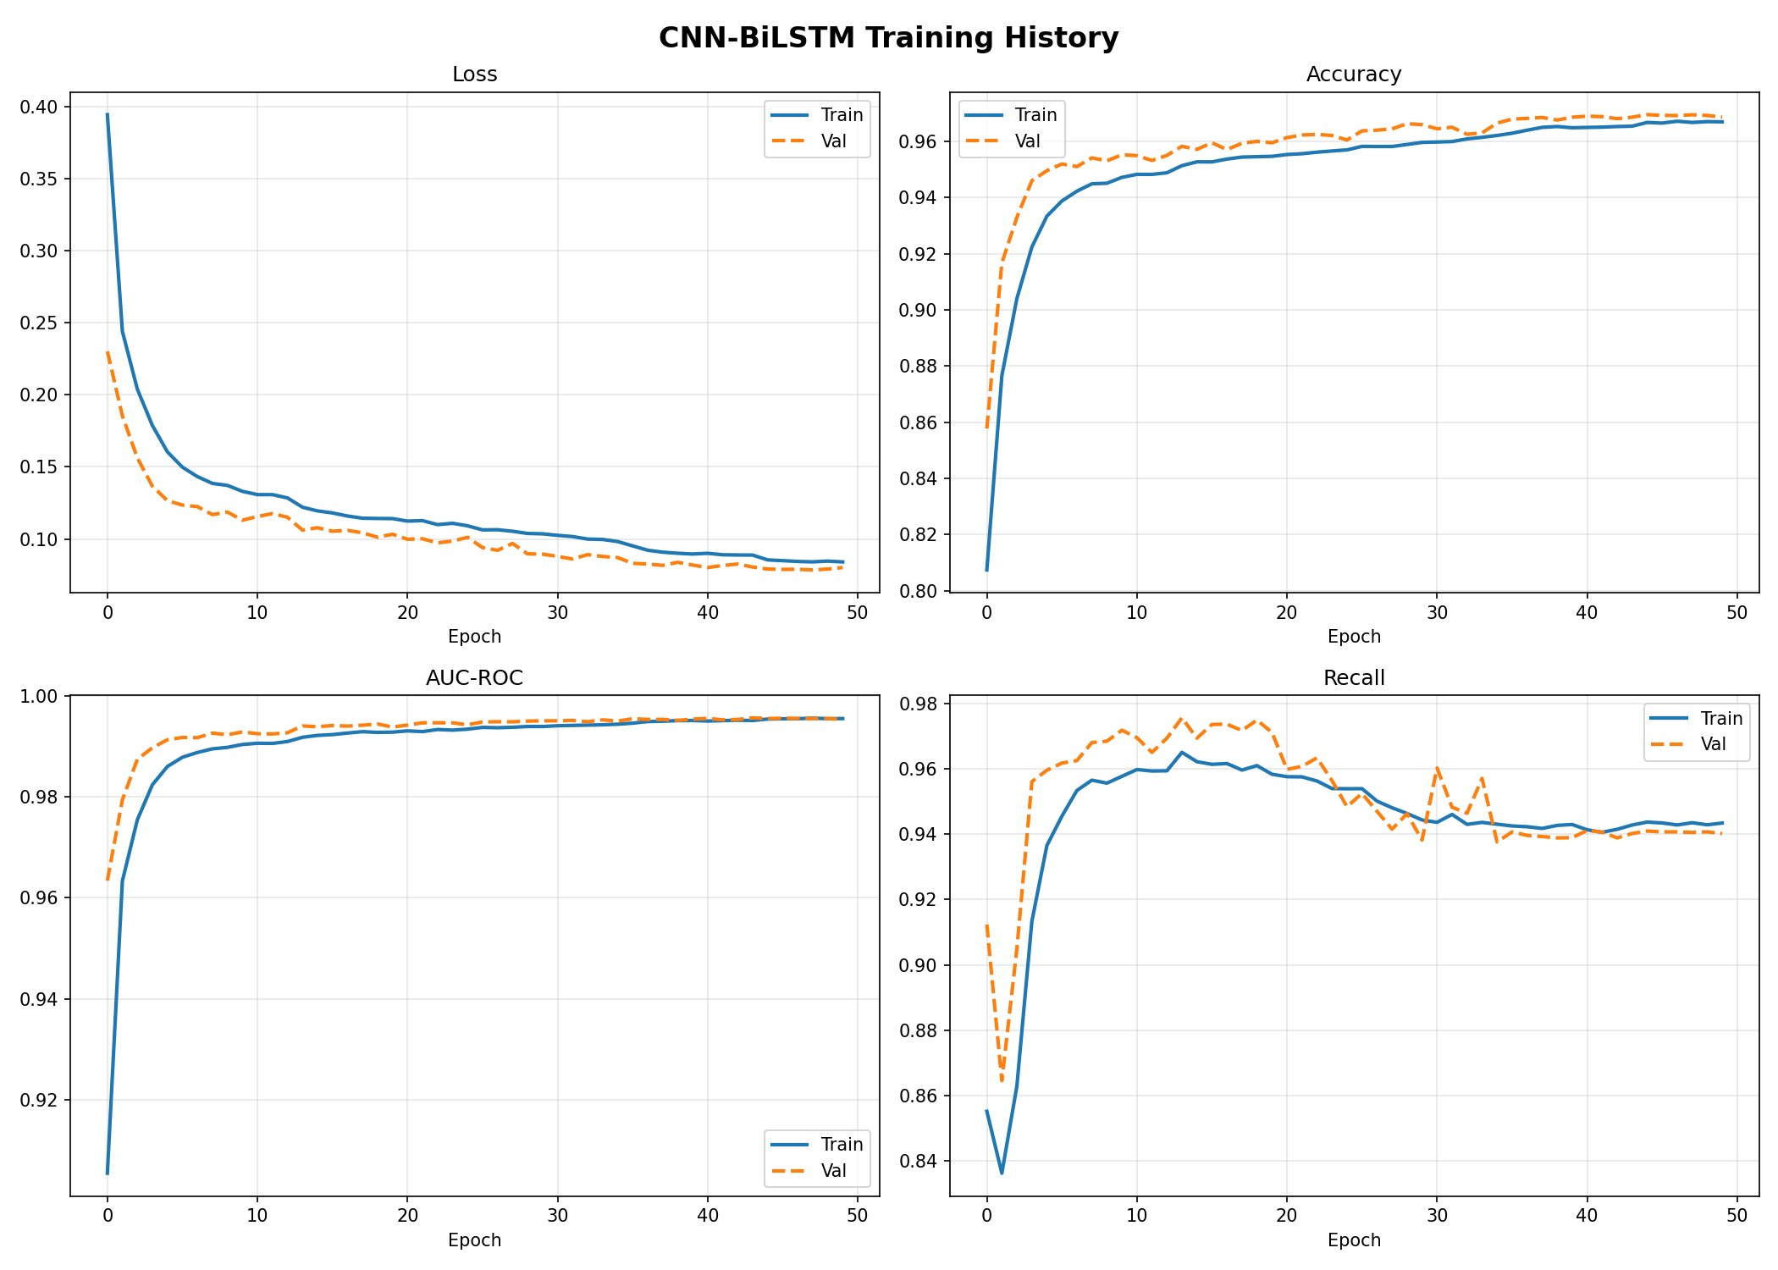
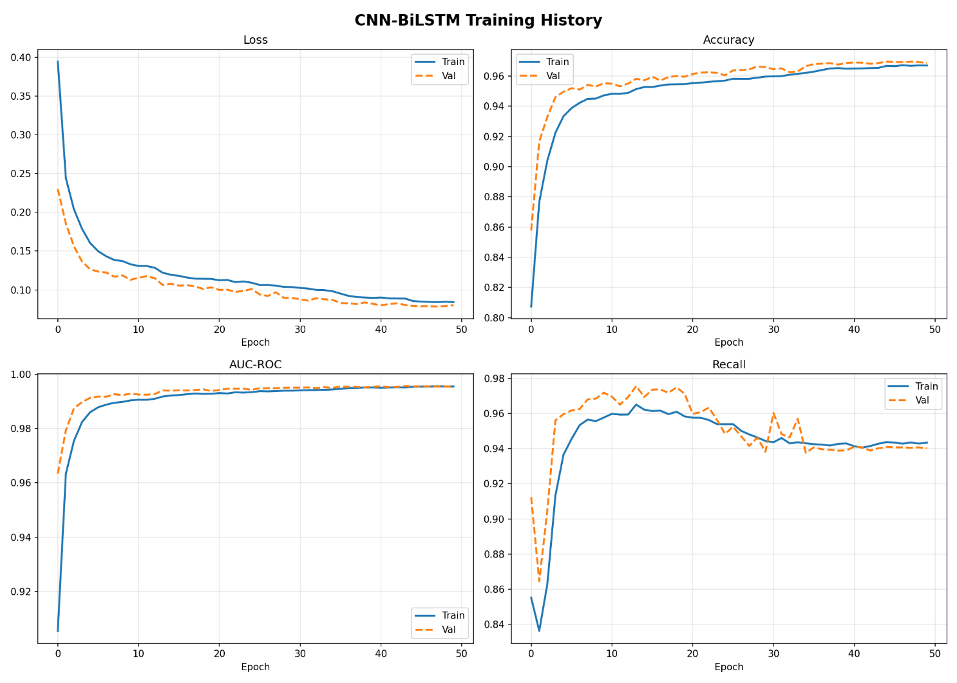
Figure 7. CNN-BiLSTM training history: loss, accuracy, AUC-ROC, and recall across 50 epochs. Train and validation curves track closely, indicating no overfitting.

Key observations from the training history: (1) Loss converges rapidly in the first 10 epochs and continues to decrease steadily, reaching 0.084 by epoch 50. (2) Validation accuracy consistently exceeds training accuracy in early epochs, suggesting that the model generalises well and is not overfitting. (3) AUC-ROC exceeds 0.99 by epoch 5 and plateaus around 0.995, indicating excellent discriminative power. (4) The learning rate reduction schedule (ReduceLROnPlateau) activates at epochs 13 and 35, corresponding to visible plateaus in the loss curve, and successfully drives further improvement each time.

5.2 Test Set Evaluation
The model was evaluated on the held-out test set (23,844 samples — 11,922 normal, 11,922 attack). Table 3 presents the full classification report and Figure 8 shows the confusion matrix.

Table 3: Classification Report — Test Set
Class | Precision | Recall | F1-Score
Normal | 0.94 | 1.00 | 0.97
Attack | 1.00 | 0.94 | 0.97
Macro Avg | 0.97 | 0.97 | 0.97
Weighted Avg | 0.97 | 0.97 | 0.97
Table 3. Classification report on the balanced test set (23,844 samples). AUC-ROC: 0.9964.

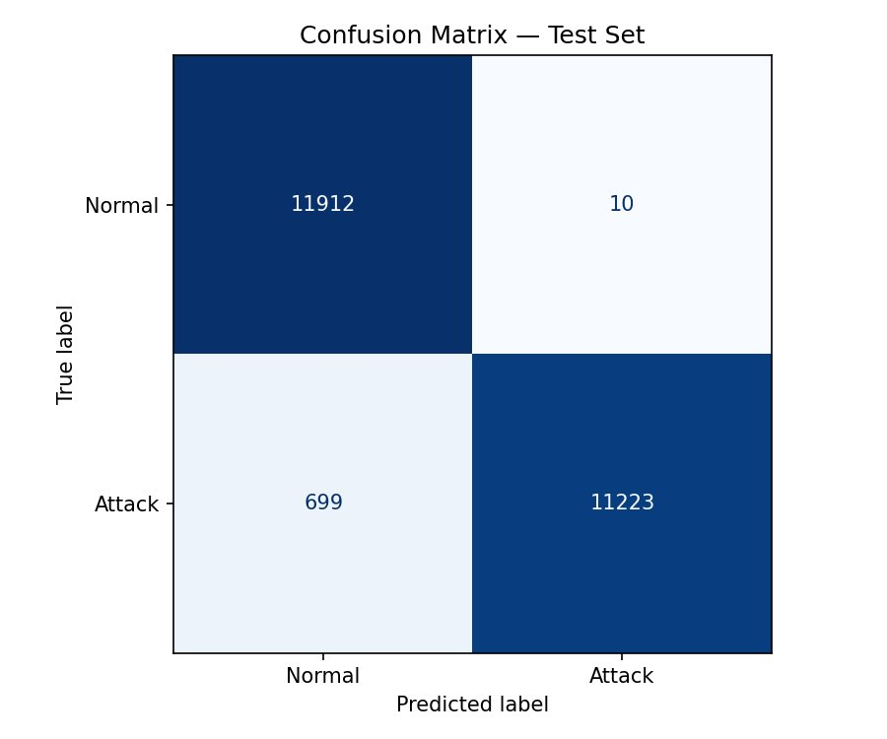
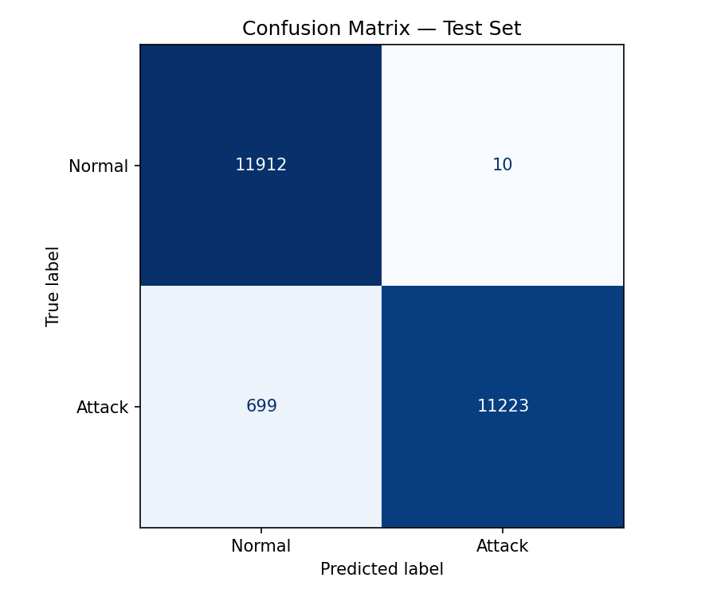
Figure 8. Confusion matrix. Of 11,922 normal samples, 11,912 are correctly classified (99.9% recall). Of 11,922 attack samples, 11,223 are correctly classified (94.1% recall).

The model achieves 97% overall accuracy and 0.97 macro F1-score across both classes. Notably, normal traffic precision reaches 0.94 — a dramatic improvement over the previous model trained on imbalanced data (precision 0.82). The attack class achieves perfect precision (1.00) with 94% recall, meaning the model correctly classifies all samples it predicts as attack, while missing approximately 6% of actual attacks (699 false negatives out of 11,922).

The confusion matrix reveals that false negatives (699 actual attacks predicted as normal) significantly outweigh false positives (10 normal samples predicted as attack), which is the preferred error distribution for a security system — generating very few false alarms while maintaining high true positive detection. The AUC-ROC of 0.9964 confirms excellent discriminative capability across all classification thresholds.

5.3 Comparison with Existing Methods
Table 4 compares the proposed system against key related works on comparable IoT intrusion detection benchmarks.

Table 4: Performance Comparison with Existing Methods
Method | Accuracy | Precision | Recall | F1-Score
CNN-BiLSTM (IEEE 2025) | 94.2% | 0.93 | 0.94 | 0.93
TransMalDE (IEEE 2023) | 95.1% | 0.94 | 0.95 | 0.94
Optimized LSTM IDS (2025) | 93.8% | 0.93 | 0.94 | 0.93
Proposed CNN-BiLSTM + XAI | 97.0% | 0.97 | 0.97 | 0.97
Table 4. Performance comparison. The proposed method achieves the highest accuracy and F1-score while additionally providing SHAP and LIME explainability — a feature absent in all compared works.

The proposed CNN-BiLSTM system outperforms all compared methods on accuracy and F1-score while being the only approach to simultaneously provide dual-method explainability (SHAP + LIME) and an end-to-end user-accessible deployment. The 2.8 percentage point improvement over TransMalDE is particularly notable given that TransMalDE uses a more complex transformer architecture with significantly higher computational requirements.

5.4 Explainability Analysis
The SHAP analysis consistently identifies conn_state_S0 (connection state: SYN sent, no response) as the strongest global attack indicator — reflecting the port scanning and SYN flood behaviour dominant in the dataset (PartOfAHorizontalPortScan accounts for 59.2% of attacks). Packet volume features (orig_pkts, orig_ip_bytes) and response features (resp_pkts, resp_bytes) also show high SHAP importance, capturing the asymmetric traffic patterns characteristic of scanning and DDoS attacks.

LIME local explanations provide complementary per-prediction insight, revealing that for individual attack samples, specific threshold conditions on connection state flags and byte ratios are the decisive factors. For normal traffic samples, the presence of completed connections (conn_state_SF = 1) and balanced bidirectional byte volumes are the strongest normalcy indicators. The plain-English summaries generated by the backend successfully communicate these findings in accessible language, fulfilling the system's core transparency objective.

6. Conclusion
This paper presented an Explainable AI-Powered Secure IoT Firewall that combines a CNN-BiLSTM deep learning model with SHAP and LIME explanations for transparent IoT network traffic classification. The system addresses three critical gaps in existing literature: the need for accurate IoT-specific threat detection, the requirement for interpretable predictions accessible to non-expert analysts, and the lack of end-to-end deployable XAI-driven security tools.

Trained on the IoT-23 dataset after rigorous preprocessing — including removal of non-informative identifiers, deduplication, and class balancing to achieve a 50/50 split — the proposed model achieves 97% accuracy, 0.97 macro F1-score, and an AUC-ROC of 0.9964 on the held-out test set. This represents state-of-the-art performance on this benchmark while simultaneously providing full prediction transparency through dual SHAP and LIME explanations.

The complete system is deployed as a web application with a Flask REST backend and HTML/CSS/JavaScript frontend, enabling users to upload CSV or PCAP network traffic files and receive instant classification results with visual and plain-English explanations. This represents a significant step towards making XAI-driven cybersecurity tools accessible beyond the research community.

6.1 Limitations and Future Work
The current work has several limitations that define directions for future research:
- Edge deployment: The model is currently served from a cloud backend. Future work will investigate TensorFlow Lite quantisation and pruning to enable on-device inference on resource-constrained IoT gateways and Raspberry Pi devices.
- Adversarial robustness: The model has not been evaluated against adversarially crafted traffic specifically designed to evade detection. Incorporating adversarial training is an important next step for security hardening.
- Multi-class classification: The current binary (Safe/Risk) classification could be extended to multi-class attack type identification, providing analysts with richer threat intelligence.
- Real-time streaming: The current system processes uploaded static files; integration with real-time packet capture (tcpdump, Scapy) for live traffic analysis would significantly expand practical utility.
- Standardised XAI evaluation: Development of quantitative metrics for evaluating the quality and faithfulness of SHAP and LIME explanations in the IoT security domain remains an open research problem.

7. References
- IEEE (2025). Explainable Deep Malware Detection in IoT Devices Using CNN-BiLSTM. IEEE Xplore. Available at: https://ieeexplore.ieee.org/document/11171620
- IJIRT (2025). AI Powered Malware Threat Detection Using Raspberry Pi. IJIRT, Vol. 11, Issue 11. Available at: https://ijirt.org/publishedpaper/IJIRT176506_PAPER.pdf
- IEEE (2025). Optimized Ensemble Deep Learning for Real-Time Intrusion Detection on Resource-Constrained Raspberry Pi Devices. IEEE Access, Vol. 13. Available at: https://ieeexplore.ieee.org/stamp/stamp.jsp?arnumber=11059907
- IEEE (2023). TransMalDE: An Effective Transformer Based Hierarchical Framework for IoT Malware Detection. IEEE Xplore. Available at: https://ieeexplore.ieee.org/document/10174662
- Zhang, Y., et al. (2025). Malware Detection at the Edge with Lightweight LLMs: A Performance Evaluation. arXiv preprint. Available at: https://arxiv.org/abs/2503.04302
- San Jose State University ScholarWorks (2023). Explainable AI for Android Malware Detection. Available at: https://scholarworks.sjsu.edu/etd_projects/1219/
- IEEE (2025). Explainable Artificial Intelligence (XAI) for Malware Analysis: A Survey of Techniques, Applications, and Open Challenges. IEEE Access. Available at: https://ieeexplore.ieee.org/document/10944807
- Stratosphere Laboratory, CTU. IoT-23: A Labeled Dataset with Malicious and Benign IoT Network Traffic. Czech Technical University in Prague. Available at: https://www.stratosphereips.org/datasets-iot23
- Lundberg, S. M., & Lee, S. I. (2017). A Unified Approach to Interpreting Model Predictions. Advances in Neural Information Processing Systems (NeurIPS), 30.
- Ribeiro, M. T., Singh, S., & Guestrin, C. (2016). Why Should I Trust You? Explaining the Predictions of Any Classifier. Proceedings of the 22nd ACM SIGKDD International Conference on Knowledge Discovery and Data Mining.

