Software Requirements Specification

Time Table Management System

**Prepared by:**

Divyanshu Deoli (16)

Kartik Garg (03)

Pratimesh Bajpai (07)

University Of Petroleum And Energy Studies, Dehradun

Batch: CSE(IOT)

Introduction

**1.1 Purpose**

Our project which is entitled as “Timetable Management System” is implied to generating Timetable planning handle in colleges or in any other teach which could minimize the human work and maximize the proficiency and the timetable was stored in a centralized server which might be simple to get to all over.

**1.2 Problem Definition**

Preparation of time table manually is cumbersome and human errors may be possible which includes wrong allotment or multiple allotment to same faculty or same class at same time. Also a lot of human resource and time is consumed and an error free schedule is also not guaranteed . This software guarantees feasible solution which is guaranteed to be error free. Time Table Scheduling is an NP-hard problem and hence polynomial time verifiable using genetic algorithm. This window based application generates a time table that satisfies the all the conditions to be met. This software generates an error free time schedule which makes unique time table to each faculty and class room. It also let faculties and students view their respective time table by logging in to the system. This software allows users to generate time table for newly occurring changes in less time, with less effort and with more efficiency.

**1.3 Intended Audience and Reading Suggestions**

The intended reader groups for this software Requirement Specification are students of the college and the other faculty members.

**1.Students**: Students who are enrolled in the different courses for a semester under the various faculties .

**2. Faculty :** To get to know their own time table on demand .

**1.4 Product Scope**

The purpose of this application system is to create a convenient and easy to use system where each student and faculty member can access to their time table schedule and provides complete information about it. The scope of the system includes Generation of Timetable, Access the available Timetable(s), Modify/Delete an existing Timetable. Add/ Modify Faculty details of a department. Add / Modify Semester wise subjects details. Add/Modify time scheduling and period allocation process and room / location of classroom where lectures / labs/ tutorials need to take place.

**1.5 Document Conventions**

DB Database

JAVA

ER Entity Relationship

UML Unified Modelling Language

CRC Class Responsibility Diagram

Overall Description

2.1 **Product Perspective**

The project was envisioned taking in mind the importance of a fully functional website to make viewing and modifying time tables for the faculty and students easier subject to satisfy all the constraints . It also decreases loads of human efforts involved in developing time table of each faculty members and each semesters that satisfies all the hard and soft constraints which would otherwise take many days to come up with . The project can be considered as a replacement of human efforts involved and ease their work and also come up with a solution in a very short period of time in comparison .

**2.2 Product Functions**

The project serves the following major functions:

1. Project provides an interface for the logging in by different roles i.e. as Admin , as faculty member and as student with respective credentials.

2. If logged in as Admin , it can modify the constraints , alter and edit the time table and generate a new time table .

3. If logged in as Faculty member , it shows the time table of the concerned faculty member only.

4. If logged in as student , it shows the time table of the concerned student only given his semester in which he is studying.

**2.3 User Classes and Characteristics**

• Student :

– Student is studying at UPES .

– Student can enter his/her credentials and can view the time table accordingly .

• Faculty :

– Faculty is teaching at UPES.

– Faculty can enter his/her credentials and can view the time table accordingly .

• Admin :

– Admin should have knowledge of database .

– Admin should enter the course details , faculty details and semester details classroom details and add to the database.

– Admin creates , edits , modify and generates the time table.

**2.4 Operating Environment**

This product is a app designed to be compatible with different types platform . It is compatible on different type of operating systems on pc like windows , linux etc

**2.5 Design and Implementation Constraints**

Constraints are limitations that are outside the control of the project team and need to be managed around. They are not necessarily problems. However, the project manager should be aware of constraints because they represent limitations that the project must execute within.

• **Hard Constraints**

1. A classroom is not assigned to more than one lecture at the same time.

2. An instructor cannot teach more than one class at the same time.

3. Courses for the same year-session students of a department cannot take place at the

same time.

4. The classroom for a course should have enough capacity to take students registered

in the course.

5. The classroom should be well equipped with required facilities for the classes

• **Soft Constraints**

1. The lectures are not assigned to time slots, which are in the instructor’s forbidden

time zones.

2. Instructors daily lecture hours should be restricted to be within the allowed maximum

hours.

External Interface Requirements

**3.1 User Interfaces**

The entire section can be viewed in 3 different views, which are : teacher, student, and admin. Each of which will be having unique property in our software. These are shown below for each of the respective fields:

**3.1.1 Starting Interface**

3 icons (or buttons) will be displayed with the heading time table management system. Then each button followed by a click event listener where these brings us down to our desired perspective.

**3.1.2 Teacher**

A teacher can have the following characteristics in our time table:

Has to login into the application, or if is a new one will have to register into the portal for successful display.

After successful authentication, a teacher can view/ edit the time table based on his/her

convenience.

A teacher can publish an announcement, he/she can also change or edit the current announcement.

**3.1.3 Student**

Once the student is authorised he/she will automatically be redirected to the time table page (or menu).

A student has no right to modify the time table. A student can only view the contents of the time table and can also view the announcement made by the respective teacher in the time table forum. A student can select the semester out of the option available in the option pane and select one of those to get his/her time table.

**3.1.4 Admin**

An admin is the main head of the authority, so his view first needs to be authenticated and be checked from the list of predefined members in the database , if successful then redirect to the time table page, else ask him to login again displaying proper message of invalid login.

An admin can add or remove or edit the credentials of any faculty or a teacher in the database, once a teacher registers into the application , admins task is to verify it and allow the successful append of information of that teacher into the database, if allowed then the teacher can login else cannot.

3.2 **Software Interfaces**

Software Interfaces includes more towards working with javaand also for the purpose of database we will be using MySQL ,since the algorithms that is being used in the above is a NP Hard problem for automatic generating the time table, so it needs to implemented , implementation will be done in java using the genetic algorithm for automatic scheduling of time table, and also for the purpose of connecting the java code with the web based application we will be using the Java servlet provided which comes as a tool for appending the web based services with java.

UML Diagrams

4.1 Use Case Diagram

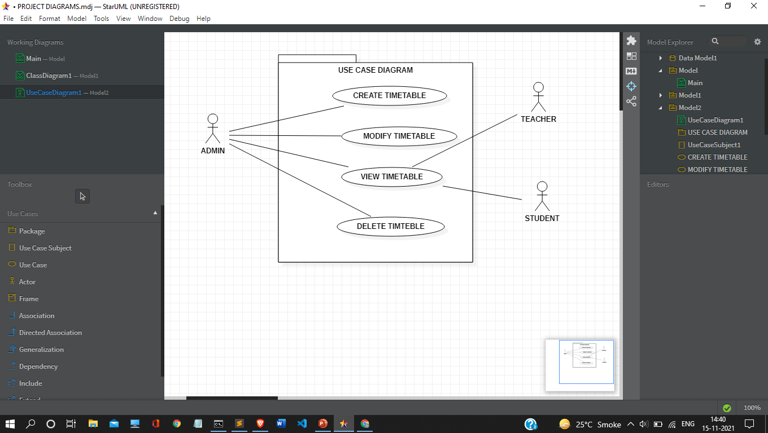

4.2 CRC Diagram

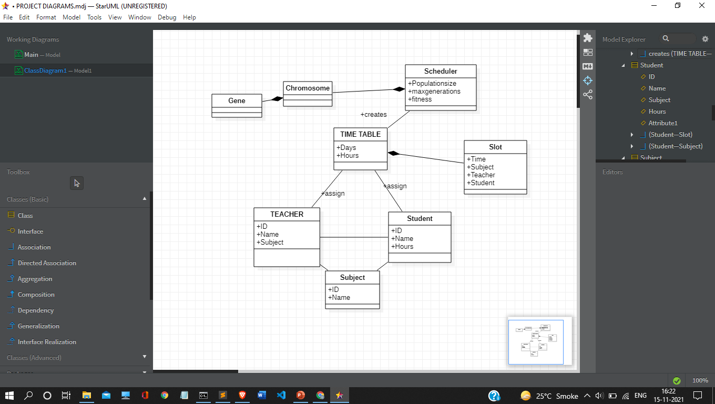

Other Non-functional Requirements

**5.1 Performance Requirements**

The response time must be quick to extend convenience. Too, the associations between MySQL database server, java must be smooth without any idleness to avoid them is fortune of information and keep the stream of utilization going.

**5.2 Safety Requirements**

There is no option to create a user or delete a user. If we need to create a new user with certain permissions it can only be done by manually adding a user with his/her role into the database.

**5.3 Security Requirements**

We have given three types of user so that only the authorised user can see the data. Also the admin can only delete the data from the database. No other user can view the data for any other student.

**5.4 Software Quality Attributes**

**Adaptability**

Since there will be three distinctive roles for this extend, the framework will adjust itself for the utilize of those distinctive roles by inquiring for endorsements.

**Correctness**

It will create and modify the data on the database correctly.

It ensures that only authorised person should get the access.

**Reusability**

Codes are written in such a way that is can be used again for similar projects or projects which have the similar functions.

It ensures that any modifications to the website or database can be easily implemented.

**Testability**

Testability of the software includes the correctness, validity and completeness check. It requires that all the functions of the software should be tested using the proper testcases for any errors, and if any it should be corrected.

It also requires that all the requirements should be satisfied, i.e. all the functions which the end users of the software may require should be implemented properly.