

**WEB PROGRAMMING LAB**

**BCSE203E**

**SLOT: L11 + L12 + L19 + L20**

LAB MANUAL

Exercise 1

Date: 11-01-2025

LETTER

TABLE LAYOUT

CHESS

[using HTML]

**SUBMITTED TO:**

**PROF. DR. ASHOKA RAJAN R**

**SUBMITTED BY:**

**DIVYANSHU PATEL  
23BAI1214**

**School of Computer Science and Engineering**

Vellore Institute of Technology, Chennai

Chennai 600127, Tamil Nadu

**GITHUB REPO LINK:**

<https://github.com/divyanshupatel17/23BAI1214_WEB_LAB>

**WEB PROG LAB PORTFOLIO:**

[**https://23bai1214-divyanshu-web-lab-portfolio.netlify.app/**](https://23bai1214-divyanshu-web-lab-portfolio.netlify.app/)

**1. LEAVE LETTER USING HTML**

[**https://23bai1214-divyanshu-exercise-1-t-1.netlify.app/**](https://23bai1214-divyanshu-exercise-1-t-1.netlify.app/)

<!-- 1. Leave letter  -->

<!**DOCTYPE** html>

<**html** lang="en">

<**head**>

    <**meta** charset="UTF-8">

    <**meta** name="viewport" content="width=device-width, initial-scale=1.0">

    <**title**>23BAI1214 Leave Letter</**title**>

    <**style**>

**body** {

*font-family*: Arial, sans-serif;

*background-color*: #f4f4f4;

*margin*: 0;

*padding*: 0;

        }

        .letter-container {

*background-color*: #fff;

*width*: 60**%**;

*margin*: 50**px** auto;

*padding*: 40**px**;

*border-radius*: 10**px**;

*box-shadow*: 0 0 10**px** rgba(0, 0, 0, 0.1);

        }

**h2** {

*text-align*: center;

*text-decoration*: underline;

*margin-bottom*: 20**px**;

        }

**p** {

*line-height*: 1.6;

*margin-bottom*: 15**px**;

        }

        #date {

*font-weight*: bold;

        }

    </**style**>

</**head**>

<**body**>

    <**div** class="letter-container">

        <**h2**>Leave Letter</**h2**>

        <**p**>Date: <**span** id="date">10 January 2025</**span**></**p**>

        <**p**>To,<**br**>

           Mr. Jaganathan B,<**br**>

           The Proctor,<**br**>

           VIT Chennai,<**br**>

           Tamil Nadu.

        </**p**>

        <**p**>Subject: Request for Leave</**p**>

        <**p**>Respected Sir,</**p**>

        <**p**>

            I, Divyanshu Patel, bearing the registration number 23BAI1214, studying at VIT Chennai, am writing to request leave for personal reasons. I need to visit my hometown, Raipur, Chhattisgarh, and kindly request leave from 11 January 2025 to 15 January 2025.

        </**p**>

        <**p**>

            I assure you that I will compensate for the missed academic work and adhere to the institution's guidelines.

        </**p**>

        <**p**>

            Kindly grant me leave for the mentioned period.

        </**p**>

        <**p**>Thank you for your consideration.</**p**>

        <**p**>Sincerely,<**br**>

           Divyanshu Patel<**br**>

           Reg No: 23BAI1214

        </**p**>

    </**div**>

</**body**>

</**html**>

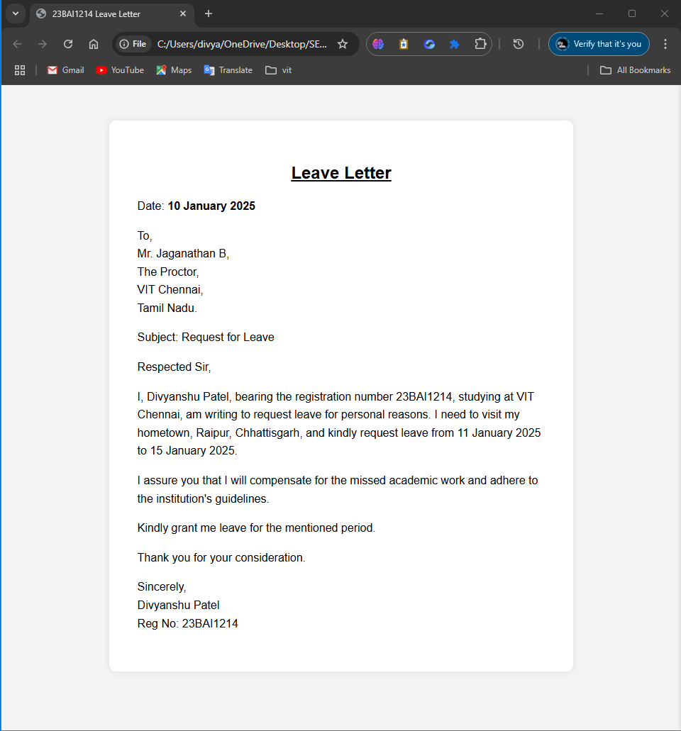

**QUE 2. TABLE LAYOUT USING HTML**

[**https://23bai1214-divyanshu-exercise-1-t-2.netlify.app/**](https://23bai1214-divyanshu-exercise-1-t-2.netlify.app/)

<!-- 2. Table Layout  -->

<!**DOCTYPE** html>

<**html** lang="en">

    <**head**>

        <**meta** charset="UTF-8">

        <**meta** name="viewport" content="width=device-width, initial-scale=1.0">

        <**title**>23BAI1214 Table</**title**>

        <**style**>

**table** {

*width*: 50**%**;

*text-align*: center;

*font-size*: 18**px**;

*border-collapse*: separate;

*border-spacing*: 2**px**;

*margin*: 10**px** auto;

            }

**table**, **th**, **td** {

*border*: .5**px** solid black;

*padding*: 5**px**;

            }

            .info {

*text-align*: center;

*margin-top*: 20**px**;

*font-size*: 18**px**;

*font-weight*: bold;

            }

        </**style**>

    </**head**>

    <**body**>

        <**table**>

            <**tr**>

                <**td** rowspan="2">A</**td**>

                <**td**>B</**td**>

                <**td** rowspan="3">D</**td**>

                <**td** colspan="2">E</**td**>

                <**td**>F</**td**>

            </**tr**>

            <**tr**>

                <**td**>C</**td**>

                <**td** rowspan="2">G</**td**>

                <**td** rowspan="2">H</**td**>

                <**td** rowspan="2">I</**td**>

            </**tr**>

            <**tr**>

                <**td** colspan="2">J</**td**>

            </**tr**>

            <**tr**>

                <**td** colspan="3">K</**td**>

                <**td**>L</**td**>

                <**td** colspan="2">M</**td**>

            </**tr**>

        </**table**>

        <**div** class="info">

            Name: Divyanshu Patel<**br**>

            Reg No: 23BAI1214

        </**div**>

    </**body**>

</**html**>

**QUE 3. CHESS LAYOUT USING HTML**

[**https://23bai1214-divyanshu-exercise-1-t-3.netlify.app/**](https://23bai1214-divyanshu-exercise-1-t-3.netlify.app/)

<!-- 3. Chessboard -->

<!**DOCTYPE** html>

<**html** lang="en">

<**head**>

    <**meta** charset="UTF-8">

    <**meta** name="viewport" content="width=device-width, initial-scale=1.0">

    <**title**>23BAI1214 Chessboard</**title**>

    <**style**>

**body** {

*display*: flex;

*flex-direction*: column;

*justify-content*: center;

*align-items*: center;

*height*: 100**vh**;

*background-color*: #575555;

        }

**table** {

*border-collapse*: collapse;

        }

**td** {

*width*: 60**px**;

*height*: 60**px**;

*text-align*: center;

*vertical-align*: middle;

*font-size*: 40**px**;

        }

        .green {

*background-color*: #4CAF50;

        }

        .white {

*background-color*: #FFFFFF;

        }

        .info {

*margin-bottom*: 20**px**;

*font-size*: 20**px**;

*font-weight*: bold;

        }

    </**style**>

</**head**>

<**body**>

    <**div** class="info">

        Name: Divyanshu Patel | Reg No: 23BAI1214

    </**div**>

    <**table**>

        <!-- Chessboard Rows -->

        <**tr**>

            <**td** class="white">♖</**td**>

            <**td** class="green">♘</**td**>

            <**td** class="white">♗</**td**>

            <**td** class="green">♕</**td**>

            <**td** class="white">♔</**td**>

            <**td** class="green">♗</**td**>

            <**td** class="white">♘</**td**>

            <**td** class="green">♖</**td**>

        </**tr**>

        <**tr**>

            <**td** class="green">♙</**td**>

            <**td** class="white">♙</**td**>

            <**td** class="green">♙</**td**>

            <**td** class="white">♙</**td**>

            <**td** class="green">♙</**td**>

            <**td** class="white">♙</**td**>

            <**td** class="green">♙</**td**>

            <**td** class="white">♙</**td**>

        </**tr**>

        <**tr**>

            <**td** class="white"></**td**>

            <**td** class="green"></**td**>

            <**td** class="white"></**td**>

            <**td** class="green"></**td**>

            <**td** class="white"></**td**>

            <**td** class="green"></**td**>

            <**td** class="white"></**td**>

            <**td** class="green"></**td**>

        </**tr**>

        <**tr**>

            <**td** class="green"></**td**>

            <**td** class="white"></**td**>

            <**td** class="green"></**td**>

            <**td** class="white"></**td**>

            <**td** class="green"></**td**>

            <**td** class="white"></**td**>

            <**td** class="green"></**td**>

            <**td** class="white"></**td**>

        </**tr**>

        <**tr**>

            <**td** class="white"></**td**>

            <**td** class="green"></**td**>

            <**td** class="white"></**td**>

            <**td** class="green"></**td**>

            <**td** class="white"></**td**>

            <**td** class="green"></**td**>

            <**td** class="white"></**td**>

            <**td** class="green"></**td**>

        </**tr**>

        <**tr**>

            <**td** class="green"></**td**>

            <**td** class="white"></**td**>

            <**td** class="green"></**td**>

            <**td** class="white"></**td**>

            <**td** class="green"></**td**>

            <**td** class="white"></**td**>

            <**td** class="green"></**td**>

            <**td** class="white"></**td**>

        </**tr**>

        <**tr**>

            <**td** class="white">♟</**td**>

            <**td** class="green">♟</**td**>

            <**td** class="white">♟</**td**>

            <**td** class="green">♟</**td**>

            <**td** class="white">♟</**td**>

            <**td** class="green">♟</**td**>

            <**td** class="white">♟</**td**>

            <**td** class="green">♟</**td**>

        </**tr**>

        <**tr**>

            <**td** class="green">♜</**td**>

            <**td** class="white">♞</**td**>

            <**td** class="green">♝</**td**>

            <**td** class="white">♛</**td**>

            <**td** class="green">♚</**td**>

            <**td** class="white">♝</**td**>

            <**td** class="green">♞</**td**>

            <**td** class="white">♜</**td**>

        </**tr**>

    </**table**>

</**body**>

</**html**>

