

**WEB PROGRAMMING LAB**

**BCSE203E**

**SLOT: L11 + L12 + L19 + L20**

LAB MANUAL

Exercise 2

Date: 11-01-2025

Coffee Shop

Animation

Form

[using HTML and CSS]

**SUBMITTED TO:**

**PROF. DR. ASHOKA RAJAN R**

**SUBMITTED BY:**

**DIVYANSHU PATEL  
23BAI1214**

**School of Computer Science and Engineering**

Vellore Institute of Technology, Chennai

Chennai 600127, Tamil Nadu

**GITHUB REPO LINK:**

<https://github.com/divyanshupatel17/23BAI1214_WEB_LAB>

**WEB PROG LAB PORTFOLIO:**

[**https://23bai1214-divyanshu-web-lab-portfolio.netlify.app/**](https://23bai1214-divyanshu-web-lab-portfolio.netlify.app/)

**1. COFFEE SHOP USING HTML AND CSS**

[**https://23bai1214-divyanshu-exercise-2-t-1.netlify.app/**](https://23bai1214-divyanshu-exercise-2-t-1.netlify.app/)

<!--

1. Coffee Shop -->

<!**DOCTYPE** html>

<**html** lang="en">

<**head**>

    <**meta** charset="UTF-8">

    <**meta** name="viewport" content="width=device-width, initial-scale=1.0">

    <**title**>23BAI1214 Coffee Shop</**title**>

    <**style**>

**body** {

*font-family*: 'Arial', sans-serif;

*background-color*: #f0f0f0;

*margin*: 0;

*padding*: 0;

*color*: #333;

        }

**header** {

*background-color*: #6f4f37;

*color*: white;

*padding*: 15**px** 0;

*text-align*: center;

*font-size*: 28**px**;

*box-shadow*: 0 4**px** 10**px** rgba(0, 0, 0, 0.1);

        }

        .container {

*display*: flex;

*flex-wrap*: wrap;

*justify-content*: center;

*gap*: 20**px**;

*padding*: 20**px**;

        }

        .card {

*background-color*: white;

*border-radius*: 10**px**;

*margin*: 15**px**;

*width*: 220**px**;

*padding*: 20**px**;

*box-shadow*: 0 6**px** 15**px** rgba(0, 0, 0, 0.1);

*transform*: scale(1);

*transition*: transform 0.3**s** ease, box-shadow 0.3**s** ease;

        }

        .card:hover {

*transform*: scale(1.05);

*box-shadow*: 0 8**px** 20**px** rgba(0, 0, 0, 0.2);

        }

        .card **img** {

*width*: 100**%**;

*border-radius*: 10**px**;

*transition*: opacity 0.3**s** ease;

        }

        .card **img**:hover {

*opacity*: 0.9;

        }

        .card **h3** {

*text-align*: center;

*color*: #6f4f37;

*font-size*: 22**px**;

*margin-top*: 10**px**;

        }

        .card **p** {

*text-align*: center;

*color*: #777;

*font-size*: 18**px**;

        }

        .card .description {

*text-align*: center;

*color*: #555;

*font-size*: 14**px**;

*margin-top*: 10**px**;

*font-style*: italic;

        }

        .card **button** {

*background-color*: #6f4f37;

*color*: white;

*padding*: 10**px**;

*border*: none;

*width*: 100**%**;

*cursor*: pointer;

*border-radius*: 5**px**;

*font-size*: 16**px**;

*margin-top*: 10**px**;

*transition*: background-color 0.3**s** ease;

        }

        .card **button**:hover {

*background-color*: #5e4028;

        }

        .footer {

*background-color*: #6f4f37;

*color*: white;

*text-align*: center;

*padding*: 15**px** 0;

*margin-top*: 40**px**;

        }

        .footer **p** {

*font-size*: 16**px**;

        }

        .footer .name {

*font-weight*: bold;

*font-size*: 18**px**;

        }

        .footer .reg {

*font-size*: 14**px**;

        }

        .footer .name, .footer .reg {

*margin-top*: 5**px**;

        }

    </**style**>

</**head**>

<**body**>

<**header**>

    Welcome to the Latte Love Coffee Shop

</**header**>

<**div** class="container">

    <**div** class="card">

        <**img** src="coffee1.jpg" alt="Espresso">

        <**h3**>Espresso</**h3**>

        <**p**>$3.00</**p**>

        <**p** class="description">Strong, bold, and rich in flavor. A true coffee lover's choice!</**p**>

        <**button**>Add to Cart</**button**>

    </**div**>

    <**div** class="card">

        <**img** src="coffee2.jpg" alt="Cappuccino">

        <**h3**>Cappuccino</**h3**>

        <**p**>$4.00</**p**>

        <**p** class="description">Smooth and creamy with a perfect balance of coffee and milk froth.</**p**>

        <**button**>Add to Cart</**button**>

    </**div**>

    <**div** class="card">

        <**img** src="coffee3.jpg" alt="Latte">

        <**h3**>Latte</**h3**>

        <**p**>$4.50</**p**>

        <**p** class="description">A creamy and milky coffee experience, perfect for those who enjoy a gentle brew.</**p**>

        <**button**>Add to Cart</**button**>

    </**div**>

    <**div** class="card">

        <**img** src="coffee4.jpg" alt="Americano">

        <**h3**>Americano</**h3**>

        <**p**>$3.50</**p**>

        <**p** class="description">A rich and full-bodied coffee made with espresso and hot water.</**p**>

        <**button**>Add to Cart</**button**>

    </**div**>

    <**div** class="card">

        <**img** src="coffee5.jpg" alt="Mocha">

        <**h3**>Mocha</**h3**>

        <**p**>$4.75</**p**>

        <**p** class="description">A sweet and indulgent treat made with espresso, chocolate, and steamed milk.</**p**>

        <**button**>Add to Cart</**button**>

    </**div**>

    <**div** class="card">

        <**img** src="coffee6.jpg" alt="Macchiato">

        <**h3**>Macchiato</**h3**>

        <**p**>$3.25</**p**>

        <**p** class="description">Espresso with a small amount of steamed milk, creating a delightful contrast of strong and smooth.</**p**>

        <**button**>Add to Cart</**button**>

    </**div**>

</**div**>

<**div** class="footer">

    <**p** class="name">Divyanshu Patel</**p**>

    <**p** class="reg">23BAI1214</**p**>

</**div**>

</**body**>

</**html**>

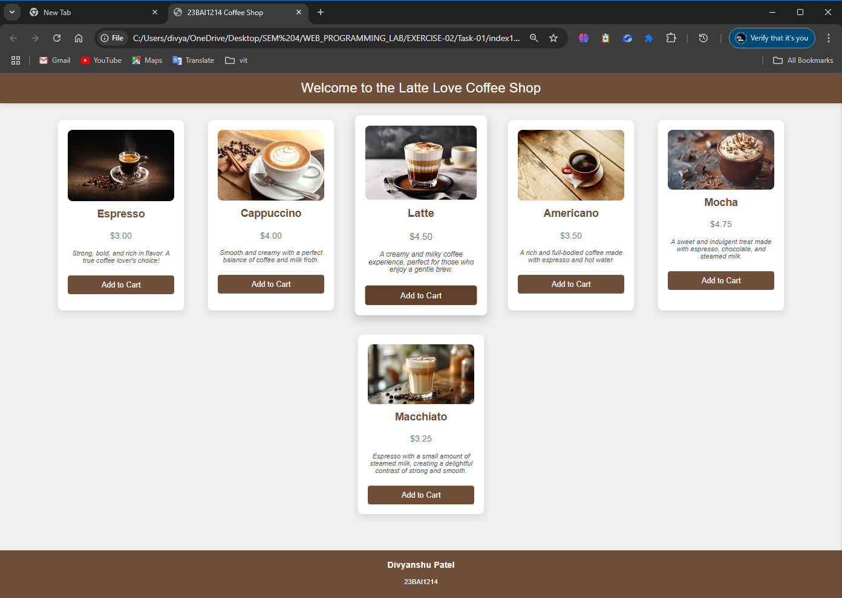

**QUE 2. Animation**

[**https://23bai1214-divyanshu-exercise-2-t-2.netlify.app/**](https://23bai1214-divyanshu-exercise-2-t-2.netlify.app/)

<!-- 2. Animation  -->

<!**DOCTYPE** html>

<**html** lang="en">

<**head**>

<**meta** charset="UTF-8">

<**meta** name="viewport" content="width=device-width, initial-scale=1.0">

<**title**>23BAI1214 Web Programming Lab - Exercise 2</**title**>

<**style**>

**body**{*font-family*:'Arial',sans-serif;*background*:linear-gradient(45**deg**,#fdd0d0,#f1d6d6);*margin*:0;*padding*:20**px**;*min-height*:100**vh**;*overflow-x*:hidden}

.container{*max-width*:1200**px**;*margin*:auto}

**@keyframes** *float*{0%,100%{*transform*:translateY(0)}50%{*transform*:translateY(-15**px**)}}

**@keyframes** *wave*{0%,100%{*transform*:translateY(0)}25%{*transform*:translateY(-15**px**)}50%{*transform*:translateY(0)}75%{*transform*:translateY(15**px**)}}

.wave-text{*display*:inline-block}

.wave-text **span**{*display*:inline-block;*animation*:wave 2**s** infinite}

**@keyframes** *spotlight*{0%,100%{*background-position*:-200**%** center}50%{*background-position*:200**%** center}}

.spotlight-text{*background*:linear-gradient(90**deg**,#000,#fff,#000);*background-size*:200**%** auto;*color*:#000;*background-clip*:text;*-webkit-background-clip*:text;*animation*:spotlight 3**s** linear infinite;*font-size*:24**px**;*font-weight*:bold;*margin*:20**px** 0}

.image-gallery{*display*:flex;*justify-content*:space-around;*flex-wrap*:wrap;*gap*:30**px**;*margin*:40**px** 0}

.image-container{*position*:relative;*width*:200**px**;*height*:200**px**;*overflow*:hidden;*border-radius*:10**px**;*box-shadow*:0 5**px** 15**px** rgba(0,0,0,0.3)}

.img-1{*animation*:moveLeft 3**s** infinite}

.img-2{*animation*:moveUpDown 2**s** infinite}

.img-3{*animation*:rotate 4**s** infinite}

.img-4{*animation*:pulse 3**s** infinite}

.animated-image{*width*:100**%**;*height*:100**%**;*object-fit*:cover}

.header{*text-align*:center;*padding*:20**px**;*margin-bottom*:30**px**}

.rainbow-text{*background-image*:linear-gradient(90**deg**,#ff0000,#ff7f00,#ffff00,#00ff00,#0000ff,#4b0082,#8f00ff);*background-size*:200**%** auto;*color*:#000;*background-clip*:text;*-webkit-background-clip*:text;*-webkit-text-fill-color*:transparent;*animation*:rainbow 5**s** linear infinite;*font-size*:36**px**;*font-weight*:bold}

**@keyframes** *rainbow*{to{*background-position*:200**%** center}}

.student-info{*font-size*:24**px**;*margin*:20**px** 0}

.blink{*animation*:blink 1**s** infinite}

**@keyframes** *blink*{0%{*opacity*:1}50%{*opacity*:0}100%{*opacity*:1}}

</**style**>

</**head**>

<**body**>

<**div** class="container">

    <**div** class="header">

        <**marquee** behavior="alternate" scrollamount="10" direction="right">

            <**h1** class="rainbow-text">WEB PROGRAMMING LAB</**h1**>

        </**marquee**>

        <**marquee** behavior="slide" direction="down" scrollamount="5">

            <**div** class="wave-text">EXERCISE 2</**div**>

        </**marquee**>

    </**div**>

    <**marquee** behavior="alternate" scrollamount="3" direction="up" height="100">

        <**div** class="student-info">

            <**span** class="blink">Divyanshu Patel</**span**>

        </**div**>

    </**marquee**>

    <**marquee** behavior="scroll" scrollamount="4" direction="left">

        <**span** class="spotlight-text">23BAI1214</**span**>

    </**marquee**>

    <**div** class="image-gallery">

        <**div** class="image-container">

            <**marquee** behavior="alternate" direction="right">

                <**img** src="coffee1.jpg" alt="Moving Left-Right" class="animated-image img-1">

            </**marquee**>

        </**div**>

        <**div** class="image-container">

            <**marquee** behavior="scroll" direction="up" height="200">

                <**img** src="coffee2.jpg" alt="Moving Up-Down" class="animated-image img-2">

            </**marquee**>

        </**div**>

        <**div** class="image-container">

            <**marquee** behavior="alternate" direction="down" height="200">

                <**img** src="coffee3.jpg" alt="Rotating" class="animated-image img-3">

            </**marquee**>

        </**div**>

        <**div** class="image-container">

            <**marquee** behavior="slide" direction="left">

                <**img** src="coffee4.jpg" alt="Pulsing" class="animated-image img-4">

            </**marquee**>

        </**div**>

    </**div**>

    <**marquee** behavior="alternate" direction="right" scrollamount="5">

        <**span** style="color:red;font-size:24px">★ HTML ★</**span**>

    </**marquee**>

    <**marquee** behavior="scroll" direction="left" scrollamount="8">

        <**span** style="color:blue;font-size:24px">⚡ CSS ⚡</**span**>

    </**marquee**>

    <**marquee** behavior="alternate" direction="up" height="50" scrollamount="3">

        <**span** style="color:green;font-size:24px">☆ Animation ☆</**span**>

    </**marquee**>

    <**table** width="100%" **border**="1">

        <**tr**>

            <**td** **align**="center">

                <**marquee** behavior="alternate" direction="right">

                    <**span** style="color:purple">Web Programming</**span**>

                </**marquee**>

            </**td**>

            <**td** **align**="center">

                <**marquee** behavior="alternate" direction="left">

                    <**span** style="color:orange">Laboratory</**span**>

                </**marquee**>

            </**td**>

        </**tr**>

    </**table**>

    <**div** style="margin:20px 0">

        <**marquee** behavior="scroll" direction="left" scrollamount="2">

            <**span** style="letter-spacing:5px">DIVYANSHU PATEL - 23BAI1214</**span**>

        </**marquee**>

        <**marquee** behavior="scroll" direction="right" scrollamount="2">

            <**span** style="letter-spacing:5px">WEB PROGRAMMING LAB - EXERCISE 2</**span**>

        </**marquee**>

    </**div**>

    <**div** style="text-align:center">

        <**marquee** behavior="alternate" width="200" direction="right">

            <**span** style="font-size:20px">→</**span**>

        </**marquee**>

        <**marquee** behavior="alternate" width="200" direction="left">

            <**span** style="font-size:20px">←</**span**>

        </**marquee**>

    </**div**>

</**div**>

</**body**>

</**html**>

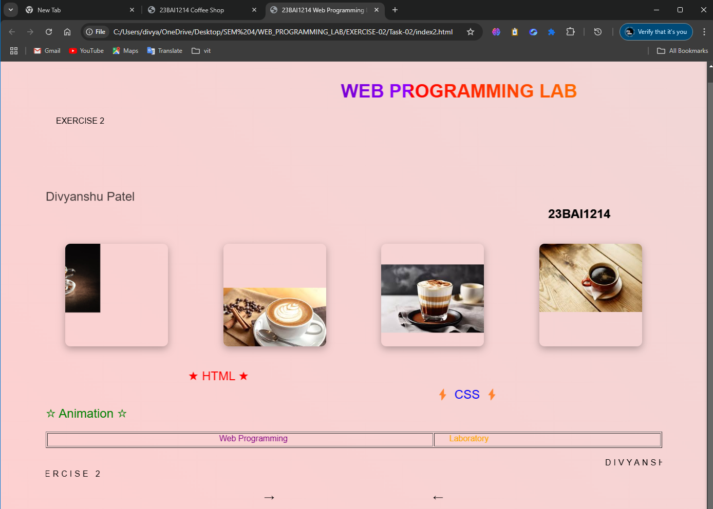

**QUE 3. Job Registration Form**

[**https://23bai1214-divyanshu-exercise-2-t-3.netlify.app/**](https://23bai1214-divyanshu-exercise-2-t-3.netlify.app/)

<!-- 3. Job Registration Form  -->

<!**DOCTYPE** html>

<**html** lang="en">

<**head**>

    <**meta** charset="UTF-8">

    <**meta** name="viewport" content="width=device-width, initial-scale=1.0">

    <**title**>23BAI1214 Registration Form</**title**>

    <**style**>

        :root {

            --primary-color: #2c3e50;

            --secondary-color: #3498db;

            --accent-color: #e74c3c;

            --background-color: #ecf0f1;

            --section-bg: #ffffff;

            --text-color: #2c3e50;

            --border-color: #bdc3c7;

        }

**body** {

*font-family*: 'Segoe UI', Tahoma, Geneva, Verdana, sans-serif;

*background-color*: var(--background-color);

*margin*: 0;

*padding*: 20**px**;

*color*: var(--text-color);

        }

        .container {

*max-width*: 1200**px**; /* Increased from 900px */

*margin*: 0 auto;

*background*: var(--section-bg);

*border-radius*: 15**px**;

*box-shadow*: 0 0 20**px** rgba(0, 0, 0, 0.1);

*padding*: 30**px**;

        }

        .creator-info {

*text-align*: center;

*margin*: 20**px** 0;

*font-style*: italic;

*color*: var(--primary-color);

        }

        .creator-info **p** {

*margin*: 5**px** 0;

*font-size*: 1.1**em**;

        }

**h1** {

*color*: var(--primary-color);

*text-align*: center;

*font-size*: 2.5**em**;

*margin-bottom*: 30**px**;

*border-bottom*: 3**px** solid var(--secondary-color);

*padding-bottom*: 10**px**;

        }

        .section {

*background*: var(--section-bg);

*margin-bottom*: 30**px**;

*padding*: 25**px**;

*border-radius*: 10**px**;

*border*: 1**px** solid var(--border-color);

        }

**h2** {

*color*: var(--secondary-color);

*margin-bottom*: 20**px**;

*font-size*: 1.5**em**;

        }

        .form-row {

*display*: flex;

*gap*: 20**px**;

*margin-bottom*: 20**px**;

*flex-wrap*: wrap;

        }

        .form-group {

*flex*: 1;

*min-width*: 250**px**; /* Prevents too narrow columns */

        }

**label** {

*display*: block;

*margin-bottom*: 8**px**;

*font-weight*: 600;

*color*: var(--primary-color);

        }

**input**[type**=**"text"],

**input**[type**=**"email"],

**input**[type**=**"tel"],

**input**[type**=**"password"],

**input**[type**=**"number"],

**input**[type**=**"url"],

**input**[type**=**"date"],

**input**[type**=**"time"],

**select**,

**textarea** {

*width*: 100**%**;

*padding*: 12**px**;

*border*: 2**px** solid var(--border-color);

*border-radius*: 8**px**;

*font-size*: 16**px**;

*box-sizing*: border-box;

        }

**input**:focus,

**select**:focus,

**textarea**:focus {

*border-color*: var(--secondary-color);

*outline*: none;

*box-shadow*: 0 0 5**px** rgba(52, 152, 219, 0.3);

        }

        .radio-group,

        .checkbox-group {

*display*: flex;

*gap*: 20**px**;

*flex-wrap*: wrap;

*padding*: 10**px** 0;

        }

        .radio-group **label**,

        .checkbox-group **label** {

*display*: inline-flex;

*align-items*: center;

*gap*: 5**px**;

*font-weight*: normal;

        }

        .range-group {

*display*: flex;

*align-items*: center;

*gap*: 15**px**;

        }

        .range-value {

*min-width*: 60**px**;

*text-align*: center;

*font-weight*: bold;

        }

        .submit-btn {

*background-color*: var(--secondary-color);

*color*: white;

*padding*: 15**px** 30**px**;

*border*: none;

*border-radius*: 8**px**;

*cursor*: pointer;

*font-size*: 18**px**;

*font-weight*: bold;

*width*: 100**%**;

*transition*: background-color 0.3**s** ease;

        }

        .submit-btn:hover {

*background-color*: #2980b9;

        }

        .file-input-container {

*position*: relative;

*overflow*: hidden;

*display*: inline-block;

        }

        .file-input-label {

*background-color*: var(--secondary-color);

*color*: white;

*padding*: 10**px** 20**px**;

*border-radius*: 5**px**;

*cursor*: pointer;

*display*: inline-block;

        }

**input**[type**=**"file"] {

*position*: absolute;

*left*: 0;

*top*: 0;

*opacity*: 0;

*cursor*: pointer;

        }

**progress** {

*width*: 100**%**;

*height*: 20**px**;

*border-radius*: 10**px**;

        }

        .footer {

*text-align*: center;

*margin-top*: 30**px**;

*padding-top*: 20**px**;

*border-top*: 2**px** solid var(--border-color);

*color*: var(--primary-color);

        }

    </**style**>

</**head**>

<**body**>

    <**div** class="container">

        <**h1**>Job Registration Form</**h1**>

        <**div** class="creator-info">

            <**p**>Created by: DIVYANSHU PATEL</**p**>

            <**p**>Registration Number: 23BAI1214</**p**>

        </**div**>

        <**form** action="#" method="post">

            <!-- Personal Information Section -->

            <**div** class="section">

                <**h2**>Personal Information</**h2**>

                <**div** class="form-row">

                    <**div** class="form-group">

                        <**label** for="name">Full Name:</**label**>

                        <**input** type="text" id="name" name="name" required placeholder="Enter your full name">

                    </**div**>

                    <**div** class="form-group">

                        <**label** for="email">Email Address:</**label**>

                        <**input** type="email" id="email" name="email" required placeholder="your.email@example.com">

                    </**div**>

                </**div**>

                <**div** class="form-row">

                    <**div** class="form-group">

                        <**label** for="phone">Phone Number:</**label**>

                        <**input** type="tel" id="phone" name="phone" pattern="[0-9]{10}" placeholder="1234567890">

                    </**div**>

                    <**div** class="form-group">

                        <**label** for="password">Password:</**label**>

                        <**input** type="password" id="password" name="password" required>

                    </**div**>

                </**div**>

                <**div** class="form-group">

                    <**label**>Gender:</**label**>

                    <**div** class="radio-group">

                        <**label**><**input** type="radio" name="gender" value="male"> Male</**label**>

                        <**label**><**input** type="radio" name="gender" value="female"> Female</**label**>

                        <**label**><**input** type="radio" name="gender" value="other"> Other</**label**>

                    </**div**>

                </**div**>

                <**div** class="form-row">

                    <**div** class="form-group">

                        <**label** for="dob">Date of Birth:</**label**>

                        <**input** type="date" id="dob" name="dob" required>

                    </**div**>

                    <**div** class="form-group">

                        <**label** for="preferred-time">Preferred Contact Time:</**label**>

                        <**input** type="time" id="preferred-time" name="preferred-time">

                    </**div**>

                </**div**>

            </**div**>

            <!-- Professional Information Section -->

            <**div** class="section">

                <**h2**>Professional Information</**h2**>

                <**div** class="form-row">

                    <**div** class="form-group">

                        <**label** for="education">Highest Education:</**label**>

                        <**select** id="education" name="education">

                            <**option** value="">Select Education Level</**option**>

                            <**option** value="high-school">High School</**option**>

                            <**option** value="bachelors">Bachelor's Degree</**option**>

                            <**option** value="masters">Master's Degree</**option**>

                            <**option** value="phd">Ph.D.</**option**>

                        </**select**>

                    </**div**>

                    <**div** class="form-group">

                        <**label** for="experience">Years of Experience:</**label**>

                        <**input** type="number" id="experience" name="experience" min="0" max="50">

                    </**div**>

                </**div**>

                <**div** class="form-group">

                    <**label** for="salary">Expected Salary Range:</**label**>

                    <**div** class="range-group">

                        <**input** type="range" id="salary" name="salary" min="20000" max="200000" step="5000" value="50000">

                        <**span** class="range-value">50000</**span**>

                    </**div**>

                </**div**>

                <**div** class="form-group">

                    <**label**>Skills:</**label**>

                    <**div** class="checkbox-group">

                        <**label**><**input** type="checkbox" name="skills[]" value="html"> HTML</**label**>

                        <**label**><**input** type="checkbox" name="skills[]" value="css"> CSS</**label**>

                        <**label**><**input** type="checkbox" name="skills[]" value="javascript"> JavaScript</**label**>

                        <**label**><**input** type="checkbox" name="skills[]" value="python"> Python</**label**>

                        <**label**><**input** type="checkbox" name="skills[]" value="java"> Java</**label**>

                    </**div**>

                </**div**>

            </**div**>

            <!-- Additional Details Section -->

            <**div** class="section">

                <**h2**>Additional Details</**h2**>

                <**div** class="form-row">

                    <**div** class="form-group">

                        <**label** for="website">Portfolio Website:</**label**>

                        <**input** type="url" id="website" name="website" placeholder="https://your-website.com">

                    </**div**>

                    <**div** class="form-group">

                        <**label** for="linkedin">LinkedIn Profile:</**label**>

                        <**input** type="url" id="linkedin" name="linkedin" placeholder="https://linkedin.com/in/your-profile">

                    </**div**>

                </**div**>

                <**div** class="form-group">

                    <**label** for="bio">Brief Bio:</**label**>

                    <**textarea** id="bio" name="bio" rows="4" placeholder="Tell us about yourself..."></**textarea**>

                </**div**>

                <**div** class="form-group">

                    <**label** for="resume">Upload Resume:</**label**>

                    <**div** class="file-input-container">

                        <**label** class="file-input-label">Choose File

                            <**input** type="file" id="resume" name="resume" accept=".pdf,.doc,.docx">

                        </**label**>

                    </**div**>

                </**div**>

                <**div** class="form-group">

                    <**label** for="profile-completion">Profile Completion:</**label**>

                    <**progress** id="profile-completion" value="70" max="100"></**progress**>

                </**div**>

                <**div** class="form-group">

                    <**label**>Preferences:</**label**>

                    <**div** class="checkbox-group">

                        <**label**><**input** type="checkbox" name="preferences[]" value="remote"> Remote Work</**label**>

                        <**label**><**input** type="checkbox" name="preferences[]" value="travel"> Willing to Travel</**label**>

                        <**label**><**input** type="checkbox" name="preferences[]" value="relocation"> Open to Relocation</**label**>

                    </**div**>

                </**div**>

            </**div**>

            <**button** type="submit" class="submit-btn">Submit Application</**button**>

        </**form**>

        <**div** class="footer">

            <**p**>© 2025 WEB PROGRAMMING LAB EXERCISE 2</**p**>

            <**p**>Contact us at: <**a** href="mailto:itzdivyanshupatel@gmailcom">itzdivyanshupatel@gmailcom</**a**></**p**>

        </**div**>

    </**div**>

    <**script**>

        document.getElementById('salary').addEventListener('input', *function*(*e*) {

            document.querySelector('.range-value').textContent **=** e.target.value;

        });

    </**script**>

</**body**>

</**html**>

