

**WEB PROGRAMMING LAB**

**BCSE203E**

**SLOT: L11 + L12 + L19 + L20**

LAB MANUAL

Exercise 3

Date: 18-01-2025

**Stacked Panel: A CSS Layout Exploration**

**Side-by-Side Panels: A CSS Layout Exploration**

**Login Page**

**Navigation Bar – Horizontal**

**Navigation Bar – Vertical**

**Display ACER and Projector Info.**

[using HTML and CSS]

**SUBMITTED TO:**

**PROF. DR. ASHOKA RAJAN R**

**SUBMITTED BY:**

**DIVYANSHU PATEL  
23BAI1214**

**School of Computer Science and Engineering**

Vellore Institute of Technology, Chennai

Chennai 600127, Tamil Nadu

 **GITHUB REPO LINK:**

<https://github.com/divyanshupatel17/23BAI1214_WEB_LAB>

**WEB PROG LAB PORTFOLIO:**

<https://23bai1214-divyanshu-web-lab-portfolio.netlify.app/>

**QUE 1. Stacked Panel: A CSS Layout Exploration**

<https://23bai1214-divyanshu-exercise-3-t-1.netlify.app/>

<!-- 1. Stacked Panel: A CSS Layout Exploration -->

<!-- index.html  -->

<!DOCTYPE html>

<html lang="en">

<head>

    <meta charset="UTF-8">

    <meta name="viewport" content="width=device-width, initial-scale=1.0">

    <title>Stacked Panel: A CSS Layout Exploration</title>

    <link rel="stylesheet" href="styles.css">

</head>

<body>

    <div class="stacked-panel">

        <div class="panel"></div>

        <div class="panel"></div>

    </div>

</body>

</html>

/* styles.css */

body {

    margin: 0;

    padding: 0;

    display: flex;

    justify-content: center;

    align-items: center;

    height: 100vh;

    background-color: #f0f0f0;

}

.stacked-panel {

    display: flex;

    flex-direction: column;

    gap: 10px;

}

.panel {

    width: 100px;

    height: 150px;

    background-color: red;

}

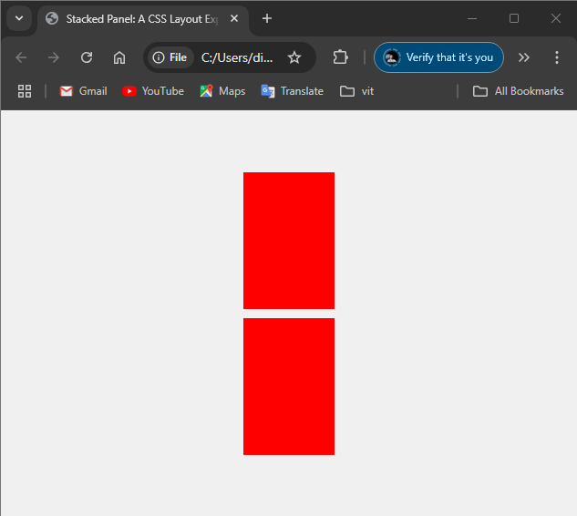

**QUE 2. Side-by-Side Panels: A CSS Layout Exploration**

<https://23bai1214-divyanshu-exercise-3-t-2.netlify.app/>

<!-- 2. Side-by-Side Panels: A CSS Layout Exploration -->

<!-- index.html  -->

<!DOCTYPE html>

<html lang="en">

<head>

    <meta charset="UTF-8">

    <meta name="viewport" content="width=device-width, initial-scale=1.0">

    <title>Side-by-Side Panel: A CSS Layout Exploration</title>

    <link rel="stylesheet" href="styles.css">

</head>

<body>

    <div class="side-panel">

        <div class="panel"></div>

        <div class="panel"></div>

    </div>

</body>

</html>

/* styles.css  */

body {

    margin: 0;

    padding: 0;

    display: flex;

    justify-content: center;

    align-items: center;

    height: 100vh;

    background-color: #f0f0f0;

}

.side-panel {

    display: flex;

    flex-direction: row;

    gap: 10px;

}

.panel {

    width: 100px;

    height: 100px;

    background-color: red;

}

**QUE 3. Login Page**

<https://23bai1214-divyanshu-exercise-3-t-3.netlify.app/>

<!-- 3. Login Page  -->

<!-- index.html  -->

<!DOCTYPE html>

<html lang="en">

<head>

    <meta charset="UTF-8">

    <meta name="viewport" content="width=device-width, initial-scale=1.0">

    <title>Login Page</title>

    <link rel="stylesheet" href="styles.css">

</head>

<body>

    <div class="login-container">

        <h2>Login</h2>

        <form>

            <label for="username">Username</label>

            <input type="text" id="username" placeholder="Enter your username" required>

            <label for="password">Password</label>

            <input type="password" id="password" placeholder="Enter your password" required>

            <button type="submit">Login</button>

            <a href="#" class="forgot-password">Forgot Password?</a>

        </form>

    </div>

</body>

</html>

/* styles.css  */

/* Background styling */

body {

    margin: 0;

    padding: 0;

    font-family: Arial, sans-serif;

    background-color: #ffc0cb; /* Light pink background */

    display: flex;

    justify-content: center;

    align-items: center;

    height: 100vh;

}

/* Login container styling */

.login-container {

    background-color: #ffffff;

    padding: 40px 30px;

    border-radius: 10px;

    box-shadow: 0 2px 10px rgba(0, 0, 0, 0.1);

    width: 350px;

    text-align: center;

}

/* Heading */

.login-container h2 {

    margin-bottom: 20px;

    color: #333333;

}

/* Label styling */

.login-container label {

    display: block;

    text-align: left;

    margin-bottom: 5px;

    font-weight: bold;

    color: #333333;

}

/* Input field styling */

.login-container input[type="text"],

.login-container input[type="password"] {

    width: 100%;

    padding: 10px;

    margin-bottom: 15px;

    border: 1px solid #ccc;

    border-radius: 5px;

    box-sizing: border-box;

}

/* Button styling */

.login-container button {

    width: 100%;

    padding: 10px;

    background-color: #007bff;

    color: #ffffff;

    border: none;

    border-radius: 5px;

    cursor: pointer;

    font-size: 16px;

}

.login-container button:hover {

    background-color: #0056b3;

}

/* Forgot password link */

.login-container .forgot-password {

    display: block;

    margin-top: 15px;

    font-size: 14px;

    color: #007bff;

    text-decoration: none;

}

.login-container .forgot-password:hover {

    text-decoration: underline;

}

**QUE 4. Navigation Bar – Horizontal**

<https://23bai1214-divyanshu-exercise-3-t-4.netlify.app/>

<!-- 4. Navigation Bar - Horizontal -->

<!-- index.html  -->

<!DOCTYPE html>

<html lang="en">

<head>

    <meta charset="UTF-8">

    <meta name="viewport" content="width=device-width, initial-scale=1.0">

    <title>Navigation Menu</title>

    <link rel="stylesheet" href="styles.css">

</head>

<body>

    <nav class="navbar">

        <ul class="nav-list">

            <li><a href="#home">Home</a></li>

            <li class="dropdown">

                <a href="#services" class="active">Services</a>

                <ul class="dropdown-content">

                    <li><a href="#web-design">Web Design</a></li>

                    <li><a href="#seo">SEO</a></li>

                    <li><a href="#marketing">Marketing</a></li>

                </ul>

            </li>

            <li><a href="#about">About</a></li>

            <li><a href="#contact">Contact</a></li>

        </ul>

    </nav>

</body>

</html>

/* styles.css  */

.navbar {

    background-color: #333;

    padding: 15px 0;

    font-family: Arial, sans-serif;

}

.nav-list {

    list-style: none;

    margin: 0;

    padding: 0;

    display: flex;

    justify-content: flex-start;

    gap: 20px;

    padding-left: 20px;

}

.nav-list li a {

    color: white;

    text-decoration: none;

    font-size: 20px;

    padding: 10px 15px;

}

.active {

    color: #00ffff !important;

}

/* Dropdown styles */

.dropdown {

    position: relative;

}

.dropdown-content {

    display: none;

    position: absolute;

    top: 100%;

    left: 0;

    background-color: #444;

    min-width: 180px;

    padding: 10px 0;

    border-radius: 4px;

    box-shadow: 0 2px 5px rgba(0,0,0,0.2);

}

.dropdown-content li {

    padding: 5px 0;

}

.dropdown-content li a {

    color: white;

    padding: 8px 20px;

    display: block;

    font-size: 18px;

}

.dropdown:hover .dropdown-content {

    display: block;

}

.dropdown-content li a:hover {

    background-color: #555;

}

/* Hover effects */

.nav-list li a:hover {

    color: #00ffff;

}

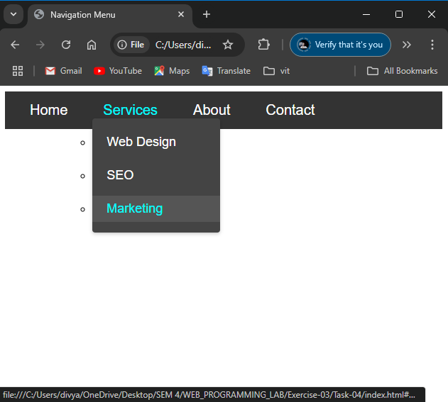

**QUE 5. Navigation Bar – Vertical**

<https://23bai1214-divyanshu-exercise-3-t-5.netlify.app/>

<!-- 5. Navigation Bar - Vertical -->

<!-- index.html  -->

<!DOCTYPE html>

<html lang="en">

<head>

    <meta charset="UTF-8">

    <meta name="viewport" content="width=device-width, initial-scale=1.0">

    <title>Vertical Navigation Menu</title>

    <link rel="stylesheet" href="styles.css">

</head>

<body>

    <nav class="nav-menu">

        <div class="nav-header">

            <a href="#home">Home</a>

        </div>

        <ul class="nav-list">

            <li><a href="#services">Services</a></li>

            <li><a href="#about">About</a></li>

            <li><a href="#portfolio">Portfolio</a></li>

            <li><a href="#contact">Contact</a></li>

        </ul>

    </nav>

</body>

</html>

/* styles.css  */

.nav-menu {

    width: 250px;

    background-color: #333;

    border-radius: 10px;

    overflow: hidden;

    box-shadow: 0 4px 8px rgba(0,0,0,0.1);

}

.nav-header {

    background-color: #00c1d4;

    padding: 15px 20px;

}

.nav-header a {

    color: white;

    text-decoration: none;

    font-size: 24px;

    font-weight: bold;

}

.nav-list {

    list-style: none;

    margin: 0;

    padding: 0;

}

.nav-list li {

    border-bottom: 1px solid #444;

}

.nav-list li:last-child {

    border-bottom: none;

}

.nav-list li a {

    color: white;

    text-decoration: none;

    padding: 15px 20px;

    display: block;

    font-size: 20px;

    transition: background-color 0.3s ease;

}

.nav-list li a:hover {

    background-color: #444;

}

body {

    display: flex;

    justify-content: center;

    align-items: center;

    min-height: 100vh;

    margin: 0;

    background-color: #f5f5f5;

    font-family: Arial, sans-serif;

}

**QUE 6. Display ACER and Projector Info**

<https://23bai1214-divyanshu-exercise-3-t-6.netlify.app/>

<!-- 6. Display ACER and Projector Info  -->

<!-- index.html  -->

<!DOCTYPE html>

<html lang="en">

<head>

    <meta charset="UTF-8">

    <meta name="viewport" content="width=device-width, initial-scale=1.0">

    <title>Acer Projector Display</title>

    <link rel="stylesheet" href="styles.css">

    <link href="https://fonts.googleapis.com/css2?family=Roboto:wght@300;400&display=swap" rel="stylesheet">

</head>

<body>

    <div class="projector-screen">

        <div class="logo"><b>acer</b></div>

        <div class="bottom-info">

            <div class="qr-section">

                <img src="qr-scanner.jpg" alt="QR Code" class="qr-code">

                <span class="qr-text">X1223H<br>Projector Information</span>

            </div>

            <div class="signal-info">

                <img src="hdmi.png" alt="HDMI" class="hdmi-icon">

                <span class="signal-text">No Signal<br>HDMI IN</span>

            </div>

        </div>

    </div>

</body>

</html>

/* styles.css  */

* {

    margin: 0;

    padding: 0;

    box-sizing: border-box;

}

body {

    margin: 0;

    padding: 0;

    min-height: 100vh;

    background-color: #000;

    font-family: 'Roboto', sans-serif;

    overflow: hidden;

}

.projector-screen {

    width: 100vw;

    height: 100vh;

    background-color: #000;

    position: relative;

    display: flex;

    flex-direction: column;

    justify-content: space-between;

    padding: 40px;

}

.logo {

    color: white;

    font-size: 72px;

    position: absolute;

    top: 50%;

    left: 50%;

    transform: translate(-50%, -50%);

    font-style: italic;

    letter-spacing: 2px;

    font-weight: 300;

}

.bottom-info {

    display: flex;

    justify-content: space-between;

    align-items: flex-end;

    color: white;

    position: absolute;

    bottom: 40px;

    left: 40px;

    right: 40px;

}

.qr-section {

    display: flex;

    align-items: center;

    gap: 20px;

}

.qr-code {

    width: 80px;

    height: 80px;

    background-color: white;

    padding: 5px;

}

.qr-text {

    line-height: 1.6;

    font-weight: 300;

    font-size: 24px;

}

.signal-info {

    display: flex;

    align-items: center;

    gap: 20px;

}

.hdmi-icon {

    width: 40px;

    height: auto;

    filter: brightness(0) invert(1);

}

.signal-text {

    line-height: 1.6;

    text-align: right;

    font-weight: 300;

    font-size: 24px;

}

