



**BCSE203E**

**SLOT: L11 + L12 + L1G + L20**

LAB MANUAL

# Exercise 4

Date: 09-02-2025

Animated Box: w3schools

Infinite circular rotation following a square path Spinning Star

Structured C Responsive Web Design [using HTML and CSS]

**SUBMITTED TO:**

**PROF. DR. ASHOKA RAJAN R**

**SUBMITTED BY: DIVYANSHU PATEL**

**23BAI1214**

**School of Computer Science and Engineering**

Vellore Institute of Technology, Chennai Chennai 600127, Tamil Nadu

<https://github.com/divyanshupatel17/23BAI1214_WEB_LAB>

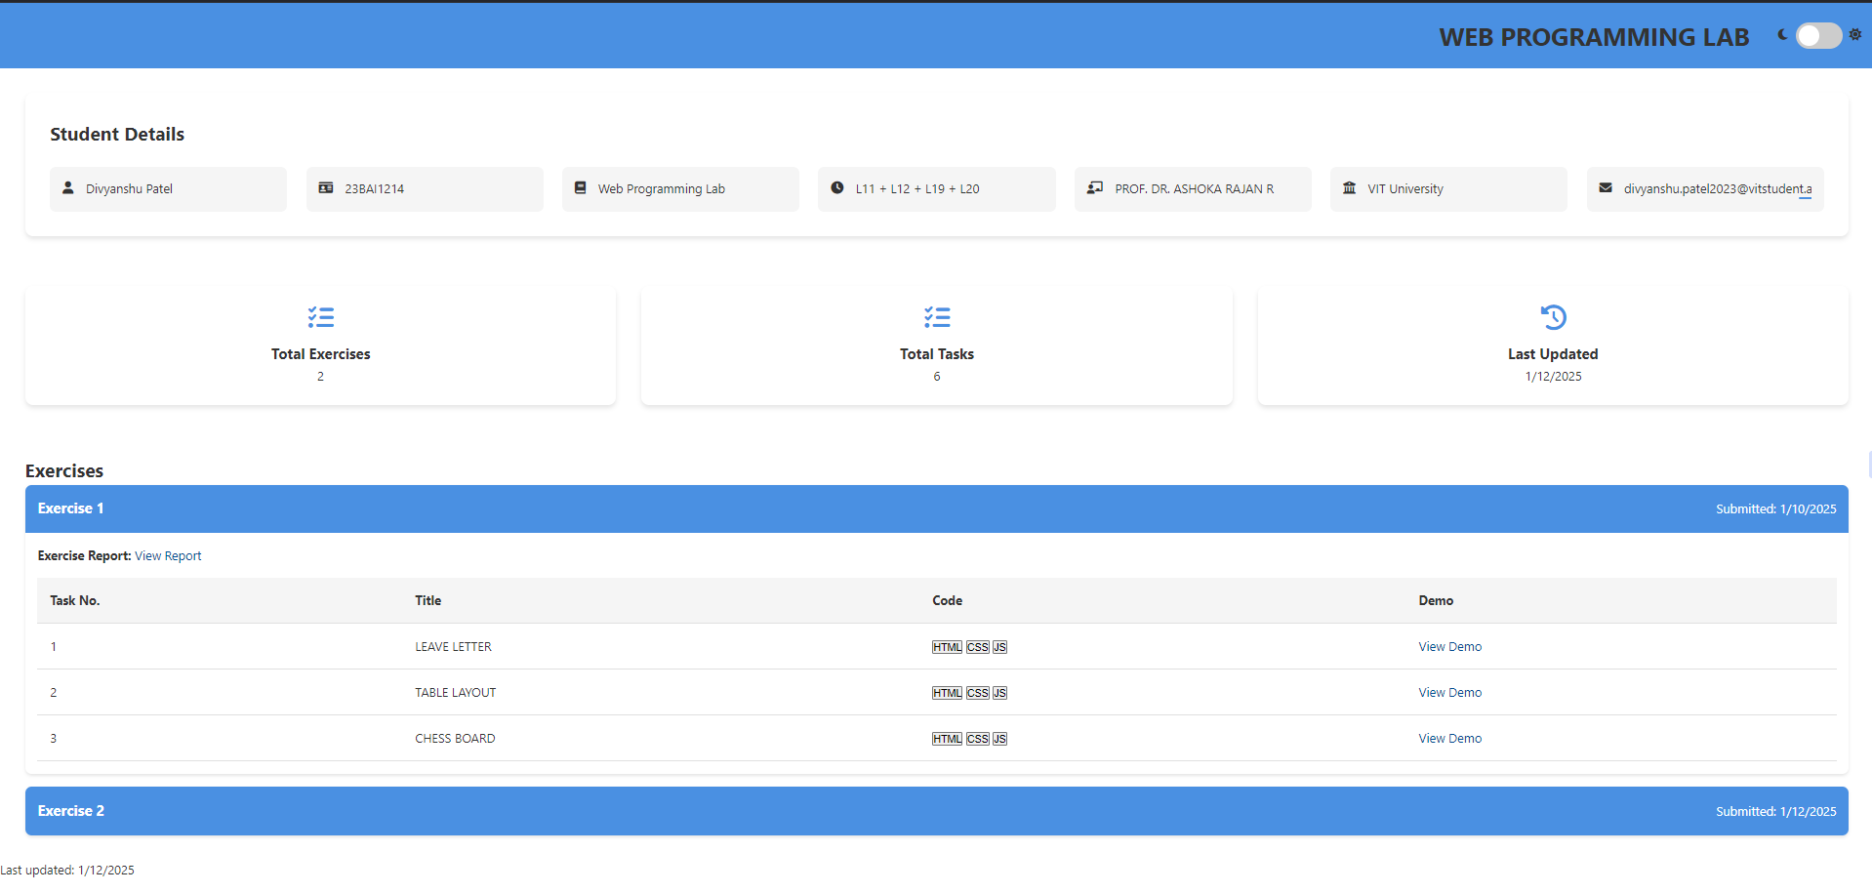

<https://23bai1214-divyanshu-web-lab-portfolio.netlify.app/>

|  |
| --- |
| <https://23bai1214-divyanshu-exercise-4-t-1.netlify.app/> |
| <!-- 1. Animated Box: w3schools -->  <!DOCTYPE html>  <html lang="en">  <head>  <meta charset="UTF-8" />  <meta name="viewport" content="width=device-width, initial-scale=1.0" />  <title>Question 1</title>  <style>  #text {  font-size: 20px;  font-family: "Lucida Sans", "Lucida Sans Regular", "Lucida Grande", "Lu- cida Sans Unicode", Geneva, Verdana, sans-serif;  }  #block {  margin: 20px; display: flex; align-items: center;  justify-content: center; height: 40px;  width: 65px; color: aliceblue;  background-color: #92b901; border-radius: 3px;  animation-name: block-animation; animation-duration: 5s;  animation-iteration-count: infinite;  }  @keyframes block-animation { 0% {  background-color: #92b901;  } 20% {  transform: rotate(20deg); background-color: #059862;  } 50% {  transform: translateX(500px); background-color: #24c6db;  }  100% {  transform: translateX(0px) rotate(-360deg); background-color: #92b901;  }  }  </style>  </head>  <body> |
|  |

|  |
| --- |
| <div id="block">  <div id="text"> CSS  </div>  </div>  <div class="me" style="margin-top: 90px;">Divyanshu Patel (23BAI1214)</div>  </body>  </html> |
| <https://23bai1214-divyanshu-exercise-4-t-2.netlify.app/> |
| <!-- 2. Infinite circular rotation following a square path -->  <!DOCTYPE html>  <html lang="en">  <head>  <meta charset="UTF-8">  <meta name="viewport" content="width=device-width, initial-scale=1.0">  <title>Square Path Rotation</title>  <style>  body {  display: flex;  justify-content: center; align-items: center; height: 100vh;  background-color: #111; |
|  |

|  |
| --- |
| }  .container {  position: relative; width: 400px; height: 400px;  }  .box {  width: 50px; height: 35px;  background-color: red; position: absolute; top: 0;  left: 0;  border-radius: 0px;  animation: moveSquare 6s linear infinite, rotateBox 1s linear infinite;  }  @keyframes moveSquare {  0% { top: 0; left: 0; }  25% { top: 0; left: 100%; }  50% { top: 100%; left: 100%; }  75% { top: 100%; left: 0; }  100% { top: 0; left: 0; }  }  @keyframes rotateBox {  0% { transform: rotate(0deg); } 100% { transform: rotate(360deg); }  }  </style>  </head>  <body>  <div class="container">  <div class="box"></div>  </div>  </body>  </html> |
|  |

|  |
| --- |
| A screenshot of a computer  AI-generated content may be incorrect.    <https://23bai1214-divyanshu-exercise-4-t-3.netlify.app/> |
| <!-- 3. Spinning Star -->  <!DOCTYPE html>  <html lang="en">  <head>  <meta charset="UTF-8" />  <meta name="viewport" content="width=device-width, initial-scale=1.0" />  <title>Question 3</title>  <style>  body {  min-height: 100vh; display: flex;  justify-content: center; align-items: center;  background: rgb(255, 255, 255);  }  .block1,  .block2,  .block3 {  position: absolute; width: 400px; height: 400px;  background-color: blue; |
|  |

|  |
| --- |
| z-index: calc(10 - var(--i)); animation-name: block-animation; animation-timing-function: linear; animation-iteration-count: infinite; animation-duration: 3s;  }  .block1 {  animation-delay: calc(var(--i) * 0.03s);  }  .block2 {  animation-delay: calc(var(--i) * 0.03s + 0.5s);  }  .block3 {  animation-delay: calc(var(--i) * 0.03s + 1s);  }  @keyframes block-animation { 0% {  transform: rotate(0deg);  }  100% {  transform: rotate(360deg);  }  }  </style>  </head>  <body>  <div class="block1" style="--i: 1;"></div>  <div class="block1" style="--i: 2;"></div>  <div class="block1" style="--i: 3;"></div>  <div class="block2" style="--i: 4;"></div>  <div class="block2" style="--i: 5;"></div>  <div class="block2" style="--i: 6;"></div>  <div class="block3" style="--i: 7;"></div>  <div class="block3" style="--i: 8;"></div>  <div class="block3" style="--i: 9;"></div>  </body>  </html> |
|  |

|  |
| --- |
| <https://23bai1214-divyanshu-exercise-4-t-4.netlify.app/> |
| <!-- 4. Structured & Responsive Web Design -->  <!DOCTYPE html>  <html lang="en">  <head>  <meta charset="UTF-8">  <meta name="viewport" content="width=device-width, initial-scale=1.0">  <title>Question 4</title>  <style> body {  margin: 0; height: 100vh;  color: aliceblue; |
|  |

|  |
| --- |
| font-family: 'Lucida Sans', Geneva, Verdana, sans-serif; display: grid;  grid-template-columns: repeat(5, 1fr);  grid-template-rows: 20vh 10vh 30vh 30vh 10vh; grid-template-areas:  "h h h h h" "n n n n n" "m m m m sb" "a a a a sb" "f f f f f";  }  .header, .footer { display: flex;  justify-content: center; align-items: center; text-align: center; font-weight: bold;  font-size: 30px;  border: 5px solid white;  }  .header {  background-color: #ff6347; grid-area: h;  }  .footer {  background-color: #34495e; grid-area: f;  }  .navbar {  background-color: #3498db; grid-area: n;  display: flex;  justify-content: flex-start; align-items: center;  }  .nav-items {  gap: 20px;  font-weight: bold; margin-left: 20px;  }  .sidebar {  display: flex;  flex-direction: column; background-color: #f39c12; grid-area: sb;  border: 5px solid white;  } |

|  |
| --- |
| .main, .article { display: flex;  flex-direction: column; justify-content: flex-start; align-items: flex-start; border: 5px solid white; padding: 15px;  }  .main {  background-color: #2ecc71; grid-area: m;  }  .article {  background-color: #9b59b6; grid-area: a;  }  .heading {  font-size: 20px; font-weight: bold; margin-bottom: 10px;  }  .text {  text-align: left;  }  </style>  </head>  <body>  <div class="header">Web Programming</div>  <div class="navbar">  <div class="nav-items">Home</div>  <div class="nav-items">About</div>  <div class="nav-items">Contact</div>  </div>  <div class="sidebar">  <div class="heading">Sidebar</div>  <div class="text">This is the sidebar, containing related links or ads.</div>  </div>  <div class="main">  <div class="heading">Main Section</div>  <div class="text">This is the main content of the page.</div>  </div>  <div class="article">  <div class="heading">Article</div>  <div class="text">This is a standalone article related to the main content.</div>  </div>  <div class="footer">&copy; 2025 Your Company. All rights reserved.</div>  </body>  </html> |
|  |

