
WEB PROGRAMMING LAB
BCSE203E
SLOT: L11 + L12 + L19 + L20

LAB MANUAL
Exercise 1
Date: 11-01-2025
LETTER
TABLE LAYOUT
CHESS
[using HTML]

SUBMITTED TO:
PROF. DR. ASHOKA RAJAN R
SUBMITTED BY:
DIVYANSHU PATEL
23BAI1214

School of Computer Science and Engineering
Vellore Institute of Technology, Chennai
Chennai 600127, Tamil Nadu
GITHUB REPO LINK:
https://github.com/divyanshupatel17/23BAI1214_WEB_LAB

WEB PROG LAB PORTFOLIO:
https://23bai1214-divyanshu-web-lab-portfolio.netlify.app/
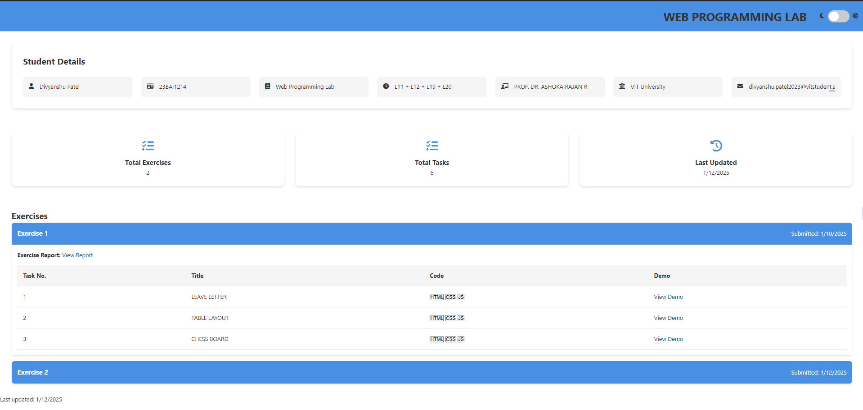

QUE 1. LEAVE LETTER USING HTML
https://23bai1214-divyanshu-exercise-1-t-1.netlify.app/

<!-- 1. Leave letter -->

<!DOCTYPE html>
<html lang="en">
<head>
<meta charset="UTF-8">
<meta name="viewport" content="width=device-width, initial-scale=1.0">
<title>23BAI1214 Leave Letter</title>
<style>
body {
font-family: Arial, sans-serif;
background-color: #f4f4f4;
margin: 0;
padding: 0;
}
.letter-container {
background-color: #fff;
width: 60%;
margin: 50px auto;
padding: 40px;
border-radius: 10px;
box-shadow: 0 0 10px rgba(0, 0, 0, 0.1);
}
h2 {
text-align: center;
text-decoration: underline;
margin-bottom: 20px;
}
p {
line-height: 1.6;
margin-bottom: 15px;
}
#date {
font-weight: bold;
}
</style>
</head>
<body>
<div class="letter-container">
<h2>Leave Letter</h2>
<p>Date: <span id="date">10 January 2025</span></p>
<p>To,<br>
Mr. Jaganathan B,<br>
The Proctor,<br>
VIT Chennai,<br>
Tamil Nadu.
</p>
<p>Subject: Request for Leave</p>
<p>Respected Sir,</p>
<p>
I, Divyanshu Patel, bearing the registration number 23BAI1214, studying at VIT Chennai, am writing to request leave for personal reasons. I need to visit my hometown, Raipur, Chhattisgarh, and kindly request leave from 11 January 2025 to 15 January 2025.
</p>
<p>
I assure you that I will compensate for the missed academic work and adhere to the institution's guidelines.
</p>
<p>
Kindly grant me leave for the mentioned period.
</p>
<p>Thank you for your consideration.</p>
<p>Sincerely,<br>
Divyanshu Patel<br>
Reg No: 23BAI1214
</p>
</div>
</body>
</html>

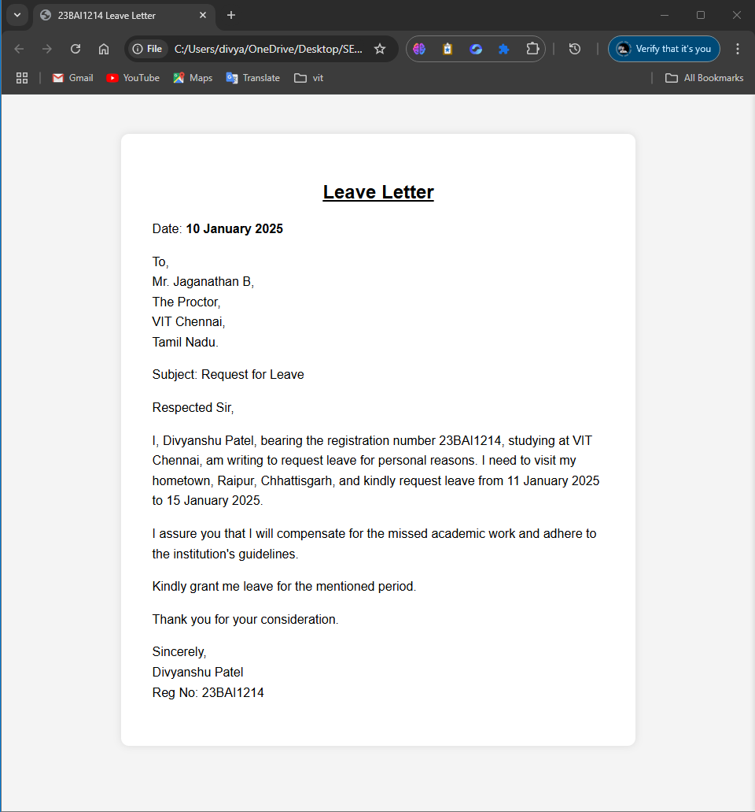
QUE 2. TABLE LAYOUT USING HTML
https://23bai1214-divyanshu-exercise-1-t-2.netlify.app/

<!-- 2. Table Layout -->

<!DOCTYPE html>
<html lang="en">
<head>
<meta charset="UTF-8">
<meta name="viewport" content="width=device-width, initial-scale=1.0">
<title>23BAI1214 Table</title>
<style>
table {
width: 50%;
text-align: center;
font-size: 18px;
border-collapse: separate;
border-spacing: 2px;
margin: 10px auto;
}
table, th, td {
border: .5px solid black;
padding: 5px;
}
.info {
text-align: center;
margin-top: 20px;
font-size: 18px;
font-weight: bold;
}
</style>
</head>

<body>
<table>
<tr>
<td rowspan="2">A</td>
<td>B</td>
<td rowspan="3">D</td>
<td colspan="2">E</td>
<td>F</td>
</tr>
<tr>
<td>C</td>
<td rowspan="2">G</td>
<td rowspan="2">H</td>
<td rowspan="2">I</td>
</tr>
<tr>
<td colspan="2">J</td>
</tr>
<tr>
<td colspan="3">K</td>
<td>L</td>
<td colspan="2">M</td>
</tr>
</table>

<div class="info">
Name: Divyanshu Patel<br>
Reg No: 23BAI1214
</div>
</body>
</html>
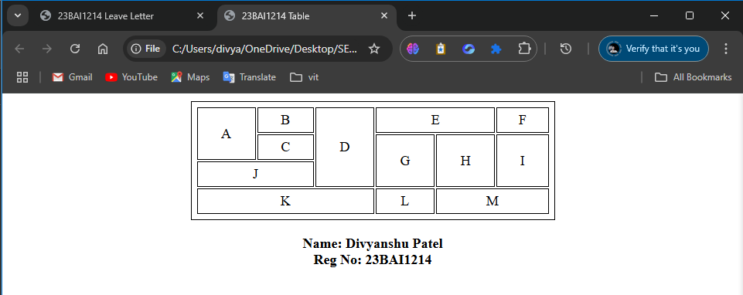
QUE 3. CHESS LAYOUT USING HTML
https://23bai1214-divyanshu-exercise-1-t-3.netlify.app/

<!-- 3. Chessboard -->

<!DOCTYPE html>
<html lang="en">
<head>
<meta charset="UTF-8">
<meta name="viewport" content="width=device-width, initial-scale=1.0">
<title>23BAI1214 Chessboard</title>
<style>
body {
display: flex;
flex-direction: column;
justify-content: center;
align-items: center;
height: 100vh;
background-color: #575555;
}
table {
border-collapse: collapse;
}
td {
width: 60px;
height: 60px;
text-align: center;
vertical-align: middle;
font-size: 40px;
}
.green {
background-color: #4CAF50;
}
.white {
background-color: #FFFFFF;
}
.info {
margin-bottom: 20px;
font-size: 20px;
font-weight: bold;
}
</style>
</head>
<body>
<div class="info">
Name: Divyanshu Patel | Reg No: 23BAI1214
</div>
<table>
<!-- Chessboard Rows -->
<tr>
<td class="white">♖</td>
<td class="green">♘</td>
<td class="white">♗</td>
<td class="green">♕</td>
<td class="white">♔</td>
<td class="green">♗</td>
<td class="white">♘</td>
<td class="green">♖</td>
</tr>
<tr>
<td class="green">♙</td>
<td class="white">♙</td>
<td class="green">♙</td>
<td class="white">♙</td>
<td class="green">♙</td>
<td class="white">♙</td>
<td class="green">♙</td>
<td class="white">♙</td>
</tr>
<tr>
<td class="white"></td>
<td class="green"></td>
<td class="white"></td>
<td class="green"></td>
<td class="white"></td>
<td class="green"></td>
<td class="white"></td>
<td class="green"></td>
</tr>
<tr>
<td class="green"></td>
<td class="white"></td>
<td class="green"></td>
<td class="white"></td>
<td class="green"></td>
<td class="white"></td>
<td class="green"></td>
<td class="white"></td>
</tr>
<tr>
<td class="white"></td>
<td class="green"></td>
<td class="white"></td>
<td class="green"></td>
<td class="white"></td>
<td class="green"></td>
<td class="white"></td>
<td class="green"></td>
</tr>
<tr>
<td class="green"></td>
<td class="white"></td>
<td class="green"></td>
<td class="white"></td>
<td class="green"></td>
<td class="white"></td>
<td class="green"></td>
<td class="white"></td>
</tr>
<tr>
<td class="white">♟</td>
<td class="green">♟</td>
<td class="white">♟</td>
<td class="green">♟</td>
<td class="white">♟</td>
<td class="green">♟</td>
<td class="white">♟</td>
<td class="green">♟</td>
</tr>
<tr>
<td class="green">♜</td>
<td class="white">♞</td>
<td class="green">♝</td>
<td class="white">♛</td>
<td class="green">♚</td>
<td class="white">♝</td>
<td class="green">♞</td>
<td class="white">♜</td>
</tr>
</table>
</body>
</html>

