
WEB PROGRAMMING LAB
BCSE203E
SLOT: L11 + L12 + L19 + L20

LAB MANUAL
Exercise 2
Date: 11-01-2025
Coffee Shop
Animation
Form
[using HTML and CSS]

SUBMITTED TO:
PROF. DR. ASHOKA RAJAN R
SUBMITTED BY:
DIVYANSHU PATEL
23BAI1214

School of Computer Science and Engineering
Vellore Institute of Technology, Chennai
Chennai 600127, Tamil Nadu
GITHUB REPO LINK:
https://github.com/divyanshupatel17/23BAI1214_WEB_LAB

WEB PROG LAB PORTFOLIO:
https://23bai1214-divyanshu-web-lab-portfolio.netlify.app/
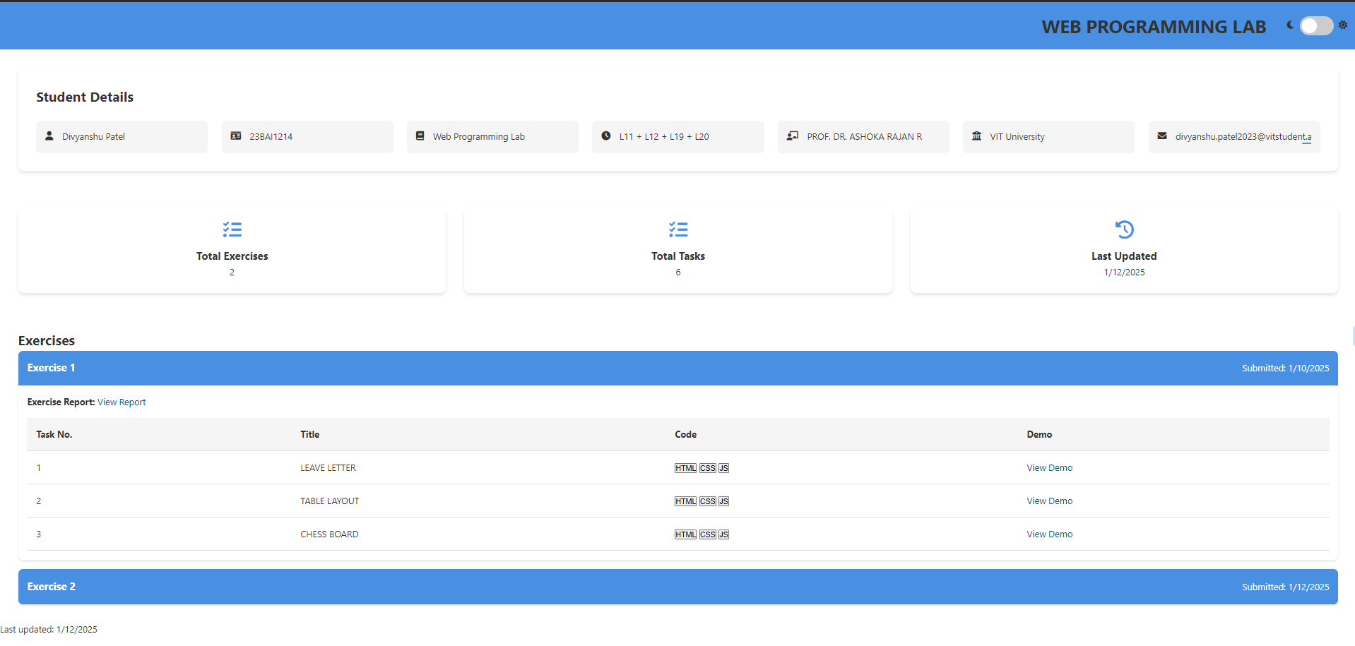

QUE 1. COFFEE SHOP USING HTML AND CSS
https://23bai1214-divyanshu-exercise-2-t-1.netlify.app/
<!-- 1. Coffee Shop -->

<!DOCTYPE html>
<html lang="en">
<head>
<meta charset="UTF-8">
<meta name="viewport" content="width=device-width, initial-scale=1.0">
<title>23BAI1214 Coffee Shop</title>
<style>
body {
font-family: 'Arial', sans-serif;
background-color: #f0f0f0;
margin: 0;
padding: 0;
color: #333;
}

header {
background-color: #6f4f37;
color: white;
padding: 15px 0;
text-align: center;
font-size: 28px;
box-shadow: 0 4px 10px rgba(0, 0, 0, 0.1);
}

.container {
display: flex;
flex-wrap: wrap;
justify-content: center;
gap: 20px;
padding: 20px;
}

.card {
background-color: white;
border-radius: 10px;
margin: 15px;
width: 220px;
padding: 20px;
box-shadow: 0 6px 15px rgba(0, 0, 0, 0.1);
transform: scale(1);
transition: transform 0.3s ease, box-shadow 0.3s ease;
}

.card:hover {
transform: scale(1.05);
box-shadow: 0 8px 20px rgba(0, 0, 0, 0.2);
}

.card img {
width: 100%;
border-radius: 10px;
transition: opacity 0.3s ease;
}

.card img:hover {
opacity: 0.9;
}

.card h3 {
text-align: center;
color: #6f4f37;
font-size: 22px;
margin-top: 10px;
}

.card p {
text-align: center;
color: #777;
font-size: 18px;
}

.card .description {
text-align: center;
color: #555;
font-size: 14px;
margin-top: 10px;
font-style: italic;
}

.card button {
background-color: #6f4f37;
color: white;
padding: 10px;
border: none;
width: 100%;
cursor: pointer;
border-radius: 5px;
font-size: 16px;
margin-top: 10px;
transition: background-color 0.3s ease;
}

.card button:hover {
background-color: #5e4028;
}

.footer {
background-color: #6f4f37;
color: white;
text-align: center;
padding: 15px 0;
margin-top: 40px;
}

.footer p {
font-size: 16px;
}

.footer .name {
font-weight: bold;
font-size: 18px;
}

.footer .reg {
font-size: 14px;
}

.footer .name, .footer .reg {
margin-top: 5px;
}

</style>
</head>
<body>

<header>
Welcome to the Latte Love Coffee Shop
</header>

<div class="container">
<div class="card">
<img src="coffee1.jpg" alt="Espresso">
<h3>Espresso</h3>
<p>$3.00</p>
<p class="description">Strong, bold, and rich in flavor. A true coffee lover's choice!</p>
<button>Add to Cart</button>
</div>

<div class="card">
<img src="coffee2.jpg" alt="Cappuccino">
<h3>Cappuccino</h3>
<p>$4.00</p>
<p class="description">Smooth and creamy with a perfect balance of coffee and milk froth.</p>
<button>Add to Cart</button>
</div>

<div class="card">
<img src="coffee3.jpg" alt="Latte">
<h3>Latte</h3>
<p>$4.50</p>
<p class="description">A creamy and milky coffee experience, perfect for those who enjoy a gentle brew.</p>
<button>Add to Cart</button>
</div>

<div class="card">
<img src="coffee4.jpg" alt="Americano">
<h3>Americano</h3>
<p>$3.50</p>
<p class="description">A rich and full-bodied coffee made with espresso and hot water.</p>
<button>Add to Cart</button>
</div>

<div class="card">
<img src="coffee5.jpg" alt="Mocha">
<h3>Mocha</h3>
<p>$4.75</p>
<p class="description">A sweet and indulgent treat made with espresso, chocolate, and steamed milk.</p>
<button>Add to Cart</button>
</div>

<div class="card">
<img src="coffee6.jpg" alt="Macchiato">
<h3>Macchiato</h3>
<p>$3.25</p>
<p class="description">Espresso with a small amount of steamed milk, creating a delightful contrast of strong and smooth.</p>
<button>Add to Cart</button>
</div>
</div>

<div class="footer">
<p class="name">Divyanshu Patel</p>
<p class="reg">23BAI1214</p>
</div>

</body>
</html>

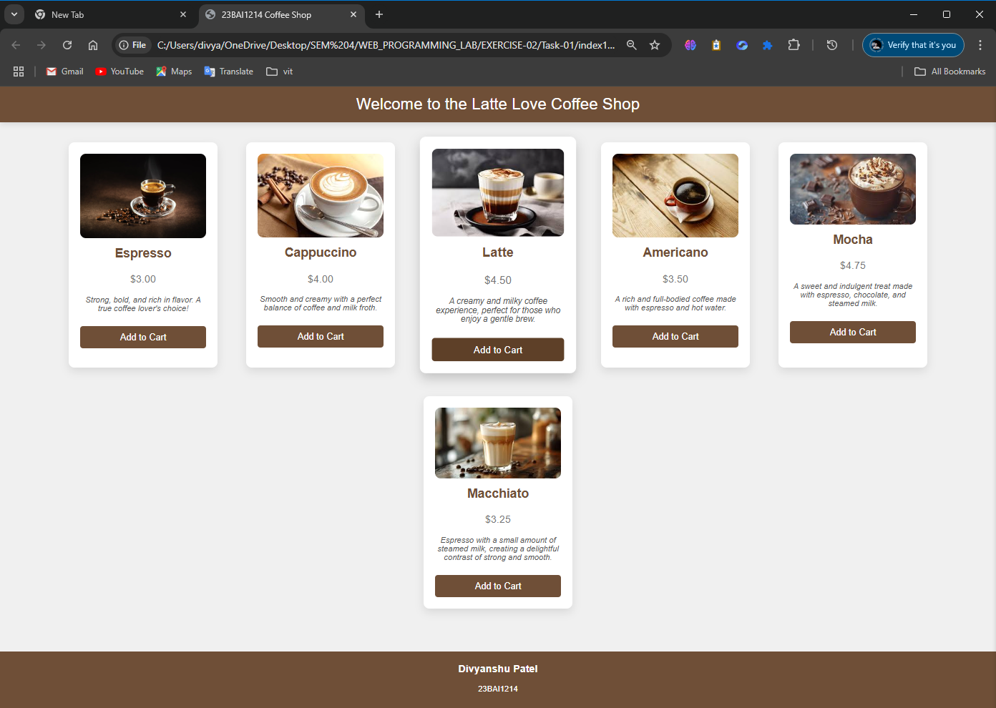

QUE 2. Animation
https://23bai1214-divyanshu-exercise-2-t-2.netlify.app/
<!-- 2. Animation -->

<!DOCTYPE html>
<html lang="en">
<head>
<meta charset="UTF-8">
<meta name="viewport" content="width=device-width, initial-scale=1.0">
<title>23BAI1214 Web Programming Lab - Exercise 2</title>
<style>
body{font-family:'Arial',sans-serif;background:linear-gradient(45deg,#fdd0d0,#f1d6d6);margin:0;padding:20px;min-height:100vh;overflow-x:hidden}
.container{max-width:1200px;margin:auto}
@keyframes float{0%,100%{transform:translateY(0)}50%{transform:translateY(-15px)}}
@keyframes wave{0%,100%{transform:translateY(0)}25%{transform:translateY(-15px)}50%{transform:translateY(0)}75%{transform:translateY(15px)}}
.wave-text{display:inline-block}
.wave-text span{display:inline-block;animation:wave 2s infinite}
@keyframes spotlight{0%,100%{background-position:-200% center}50%{background-position:200% center}}
.spotlight-text{background:linear-gradient(90deg,#000,#fff,#000);background-size:200% auto;color:#000;background-clip:text;-webkit-background-clip:text;animation:spotlight 3s linear infinite;font-size:24px;font-weight:bold;margin:20px 0}
.image-gallery{display:flex;justify-content:space-around;flex-wrap:wrap;gap:30px;margin:40px 0}
.image-container{position:relative;width:200px;height:200px;overflow:hidden;border-radius:10px;box-shadow:0 5px 15px rgba(0,0,0,0.3)}
.img-1{animation:moveLeft 3s infinite}
.img-2{animation:moveUpDown 2s infinite}
.img-3{animation:rotate 4s infinite}
.img-4{animation:pulse 3s infinite}
.animated-image{width:100%;height:100%;object-fit:cover}
.header{text-align:center;padding:20px;margin-bottom:30px}
.rainbow-text{background-image:linear-gradient(90deg,#ff0000,#ff7f00,#ffff00,#00ff00,#0000ff,#4b0082,#8f00ff);background-size:200% auto;color:#000;background-clip:text;-webkit-background-clip:text;-webkit-text-fill-color:transparent;animation:rainbow 5s linear infinite;font-size:36px;font-weight:bold}
@keyframes rainbow{to{background-position:200% center}}
.student-info{font-size:24px;margin:20px 0}
.blink{animation:blink 1s infinite}
@keyframes blink{0%{opacity:1}50%{opacity:0}100%{opacity:1}}
</style>
</head>
<body>
<div class="container">
<div class="header">
<marquee behavior="alternate" scrollamount="10" direction="right">
<h1 class="rainbow-text">WEB PROGRAMMING LAB</h1>
</marquee>

<marquee behavior="slide" direction="down" scrollamount="5">
<div class="wave-text">EXERCISE 2</div>
</marquee>
</div>

<marquee behavior="alternate" scrollamount="3" direction="up" height="100">
<div class="student-info">
<span class="blink">Divyanshu Patel</span>
</div>
</marquee>

<marquee behavior="scroll" scrollamount="4" direction="left">
<span class="spotlight-text">23BAI1214</span>
</marquee>

<div class="image-gallery">
<div class="image-container">
<marquee behavior="alternate" direction="right">
<img src="coffee1.jpg" alt="Moving Left-Right" class="animated-image img-1">
</marquee>
</div>
<div class="image-container">
<marquee behavior="scroll" direction="up" height="200">
<img src="coffee2.jpg" alt="Moving Up-Down" class="animated-image img-2">
</marquee>
</div>
<div class="image-container">
<marquee behavior="alternate" direction="down" height="200">
<img src="coffee3.jpg" alt="Rotating" class="animated-image img-3">
</marquee>
</div>
<div class="image-container">
<marquee behavior="slide" direction="left">
<img src="coffee4.jpg" alt="Pulsing" class="animated-image img-4">
</marquee>
</div>
</div>

<marquee behavior="alternate" direction="right" scrollamount="5">
<span style="color:red;font-size:24px">★ HTML ★</span>
</marquee>

<marquee behavior="scroll" direction="left" scrollamount="8">
<span style="color:blue;font-size:24px">⚡ CSS ⚡</span>
</marquee>

<marquee behavior="alternate" direction="up" height="50" scrollamount="3">
<span style="color:green;font-size:24px">☆ Animation ☆</span>
</marquee>

<table width="100%" border="1">
<tr>
<td align="center">
<marquee behavior="alternate" direction="right">
<span style="color:purple">Web Programming</span>
</marquee>
</td>
<td align="center">
<marquee behavior="alternate" direction="left">
<span style="color:orange">Laboratory</span>
</marquee>
</td>
</tr>
</table>

<div style="margin:20px 0">
<marquee behavior="scroll" direction="left" scrollamount="2">
<span style="letter-spacing:5px">DIVYANSHU PATEL - 23BAI1214</span>
</marquee>
<marquee behavior="scroll" direction="right" scrollamount="2">
<span style="letter-spacing:5px">WEB PROGRAMMING LAB - EXERCISE 2</span>
</marquee>
</div>

<div style="text-align:center">
<marquee behavior="alternate" width="200" direction="right">
<span style="font-size:20px">→</span>
</marquee>
<marquee behavior="alternate" width="200" direction="left">
<span style="font-size:20px">←</span>
</marquee>
</div>
</div>
</body>
</html>

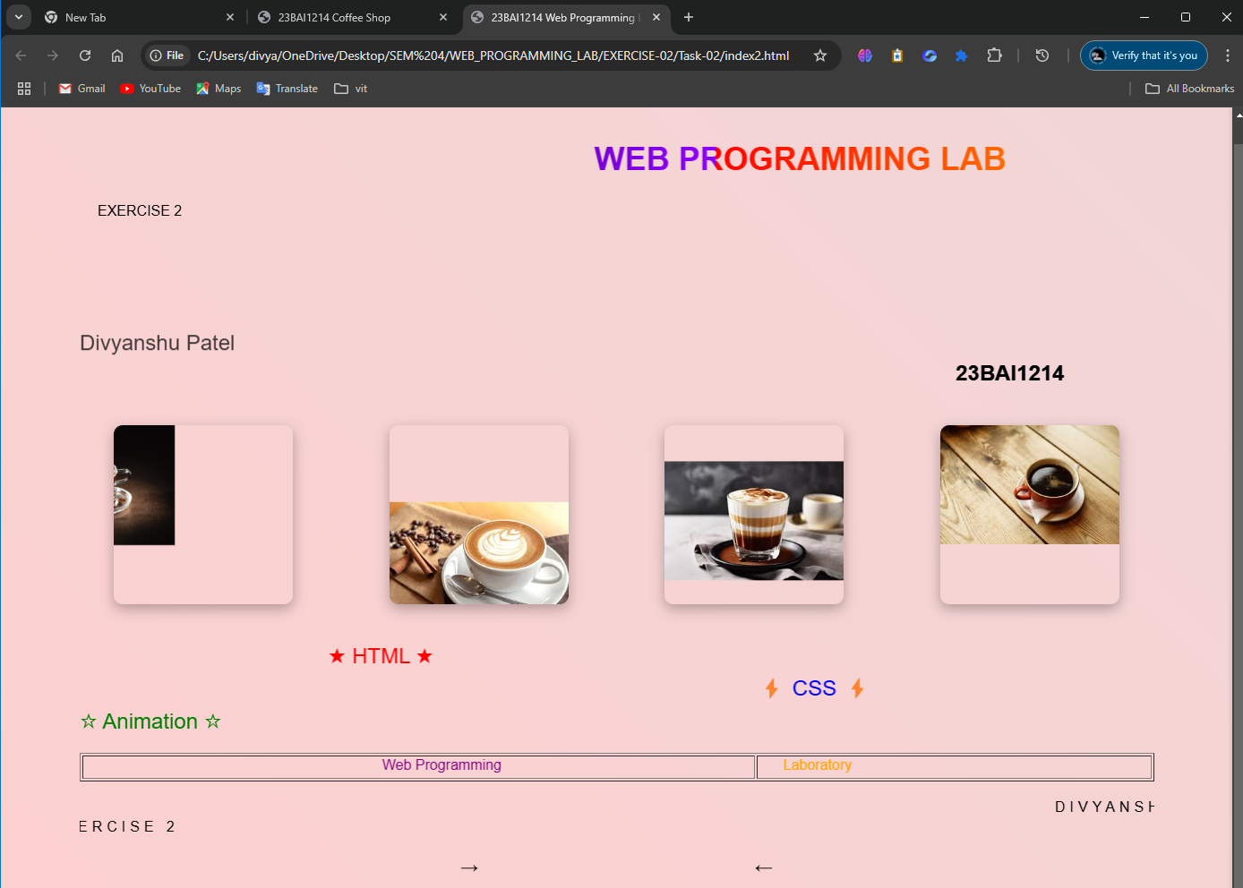
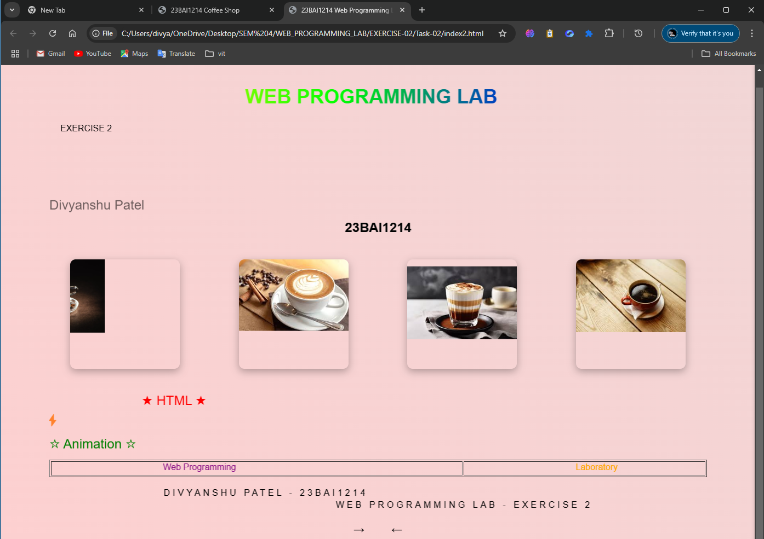

QUE 3. Job Registration Form
https://23bai1214-divyanshu-exercise-2-t-3.netlify.app/

<!-- 3. Job Registration Form -->

<!DOCTYPE html>
<html lang="en">
<head>
<meta charset="UTF-8">
<meta name="viewport" content="width=device-width, initial-scale=1.0">
<title>23BAI1214 Registration Form</title>
<style>
:root {
--primary-color: #2c3e50;
--secondary-color: #3498db;
--accent-color: #e74c3c;
--background-color: #ecf0f1;
--section-bg: #ffffff;
--text-color: #2c3e50;
--border-color: #bdc3c7;
}

body {
font-family: 'Segoe UI', Tahoma, Geneva, Verdana, sans-serif;
background-color: var(--background-color);
margin: 0;
padding: 20px;
color: var(--text-color);
}

.container {
max-width: 1200px; /* Increased from 900px */
margin: 0 auto;
background: var(--section-bg);
border-radius: 15px;
box-shadow: 0 0 20px rgba(0, 0, 0, 0.1);
padding: 30px;
}

.creator-info {
text-align: center;
margin: 20px 0;
font-style: italic;
color: var(--primary-color);
}

.creator-info p {
margin: 5px 0;
font-size: 1.1em;
}

h1 {
color: var(--primary-color);
text-align: center;
font-size: 2.5em;
margin-bottom: 30px;
border-bottom: 3px solid var(--secondary-color);
padding-bottom: 10px;
}

.section {
background: var(--section-bg);
margin-bottom: 30px;
padding: 25px;
border-radius: 10px;
border: 1px solid var(--border-color);
}

h2 {
color: var(--secondary-color);
margin-bottom: 20px;
font-size: 1.5em;
}

.form-row {
display: flex;
gap: 20px;
margin-bottom: 20px;
flex-wrap: wrap;
}

.form-group {
flex: 1;
min-width: 250px; /* Prevents too narrow columns */
}

label {
display: block;
margin-bottom: 8px;
font-weight: 600;
color: var(--primary-color);
}

input[type="text"],
input[type="email"],
input[type="tel"],
input[type="password"],
input[type="number"],
input[type="url"],
input[type="date"],
input[type="time"],
select,
textarea {
width: 100%;
padding: 12px;
border: 2px solid var(--border-color);
border-radius: 8px;
font-size: 16px;
box-sizing: border-box;
}

input:focus,
select:focus,
textarea:focus {
border-color: var(--secondary-color);
outline: none;
box-shadow: 0 0 5px rgba(52, 152, 219, 0.3);
}

.radio-group,
.checkbox-group {
display: flex;
gap: 20px;
flex-wrap: wrap;
padding: 10px 0;
}

.radio-group label,
.checkbox-group label {
display: inline-flex;
align-items: center;
gap: 5px;
font-weight: normal;
}

.range-group {
display: flex;
align-items: center;
gap: 15px;
}

.range-value {
min-width: 60px;
text-align: center;
font-weight: bold;
}

.submit-btn {
background-color: var(--secondary-color);
color: white;
padding: 15px 30px;
border: none;
border-radius: 8px;
cursor: pointer;
font-size: 18px;
font-weight: bold;
width: 100%;
transition: background-color 0.3s ease;
}

.submit-btn:hover {
background-color: #2980b9;
}

.file-input-container {
position: relative;
overflow: hidden;
display: inline-block;
}

.file-input-label {
background-color: var(--secondary-color);
color: white;
padding: 10px 20px;
border-radius: 5px;
cursor: pointer;
display: inline-block;
}

input[type="file"] {
position: absolute;
left: 0;
top: 0;
opacity: 0;
cursor: pointer;
}

progress {
width: 100%;
height: 20px;
border-radius: 10px;
}

.footer {
text-align: center;
margin-top: 30px;
padding-top: 20px;
border-top: 2px solid var(--border-color);
color: var(--primary-color);
}
</style>
</head>
<body>
<div class="container">
<h1>Job Registration Form</h1>
<div class="creator-info">
<p>Created by: DIVYANSHU PATEL</p>
<p>Registration Number: 23BAI1214</p>
</div>

<form action="#" method="post">
<!-- Personal Information Section -->
<div class="section">
<h2>Personal Information</h2>
<div class="form-row">
<div class="form-group">
<label for="name">Full Name:</label>
<input type="text" id="name" name="name" required placeholder="Enter your full name">
</div>
<div class="form-group">
<label for="email">Email Address:</label>
<input type="email" id="email" name="email" required placeholder="your.email@example.com">
</div>
</div>

<div class="form-row">
<div class="form-group">
<label for="phone">Phone Number:</label>
<input type="tel" id="phone" name="phone" pattern="[0-9]{10}" placeholder="1234567890">
</div>
<div class="form-group">
<label for="password">Password:</label>
<input type="password" id="password" name="password" required>
</div>
</div>

<div class="form-group">
<label>Gender:</label>
<div class="radio-group">
<label><input type="radio" name="gender" value="male"> Male</label>
<label><input type="radio" name="gender" value="female"> Female</label>
<label><input type="radio" name="gender" value="other"> Other</label>
</div>
</div>

<div class="form-row">
<div class="form-group">
<label for="dob">Date of Birth:</label>
<input type="date" id="dob" name="dob" required>
</div>
<div class="form-group">
<label for="preferred-time">Preferred Contact Time:</label>
<input type="time" id="preferred-time" name="preferred-time">
</div>
</div>
</div>

<!-- Professional Information Section -->
<div class="section">
<h2>Professional Information</h2>
<div class="form-row">
<div class="form-group">
<label for="education">Highest Education:</label>
<select id="education" name="education">
<option value="">Select Education Level</option>
<option value="high-school">High School</option>
<option value="bachelors">Bachelor's Degree</option>
<option value="masters">Master's Degree</option>
<option value="phd">Ph.D.</option>
</select>
</div>
<div class="form-group">
<label for="experience">Years of Experience:</label>
<input type="number" id="experience" name="experience" min="0" max="50">
</div>
</div>

<div class="form-group">
<label for="salary">Expected Salary Range:</label>
<div class="range-group">
<input type="range" id="salary" name="salary" min="20000" max="200000" step="5000" value="50000">
<span class="range-value">50000</span>
</div>
</div>

<div class="form-group">
<label>Skills:</label>
<div class="checkbox-group">
<label><input type="checkbox" name="skills[]" value="html"> HTML</label>
<label><input type="checkbox" name="skills[]" value="css"> CSS</label>
<label><input type="checkbox" name="skills[]" value="javascript"> JavaScript</label>
<label><input type="checkbox" name="skills[]" value="python"> Python</label>
<label><input type="checkbox" name="skills[]" value="java"> Java</label>
</div>
</div>
</div>

<!-- Additional Details Section -->
<div class="section">
<h2>Additional Details</h2>
<div class="form-row">
<div class="form-group">
<label for="website">Portfolio Website:</label>
<input type="url" id="website" name="website" placeholder="https://your-website.com">
</div>
<div class="form-group">
<label for="linkedin">LinkedIn Profile:</label>
<input type="url" id="linkedin" name="linkedin" placeholder="https://linkedin.com/in/your-profile">
</div>
</div>

<div class="form-group">
<label for="bio">Brief Bio:</label>
<textarea id="bio" name="bio" rows="4" placeholder="Tell us about yourself..."></textarea>
</div>

<div class="form-group">
<label for="resume">Upload Resume:</label>
<div class="file-input-container">
<label class="file-input-label">Choose File
<input type="file" id="resume" name="resume" accept=".pdf,.doc,.docx">
</label>
</div>
</div>

<div class="form-group">
<label for="profile-completion">Profile Completion:</label>
<progress id="profile-completion" value="70" max="100"></progress>
</div>

<div class="form-group">
<label>Preferences:</label>
<div class="checkbox-group">
<label><input type="checkbox" name="preferences[]" value="remote"> Remote Work</label>
<label><input type="checkbox" name="preferences[]" value="travel"> Willing to Travel</label>
<label><input type="checkbox" name="preferences[]" value="relocation"> Open to Relocation</label>
</div>
</div>
</div>

<button type="submit" class="submit-btn">Submit Application</button>
</form>

<div class="footer">
<p>© 2025 WEB PROGRAMMING LAB EXERCISE 2</p>
<p>Contact us at: <a href="mailto:itzdivyanshupatel@gmailcom">itzdivyanshupatel@gmailcom</a></p>
</div>
</div>

<script>
document.getElementById('salary').addEventListener('input', function(e) {
document.querySelector('.range-value').textContent = e.target.value;
});
</script>
</body>
</html>

