
WEB PROGRAMMING LAB
BCSE203E
SLOT: L11 + L12 + L19 + L20

LAB MANUAL
Exercise 5
Date: 23-02-2025

GITHUB REPO LINK:
https://github.com/divyanshupatel17/23BAI1214_WEB_LAB

WEB PROG LAB PORTFOLIO:
https://23bai1214-divyanshu-web-lab-portfolio.netlify.app/

SUBMITTED TO:
PROF. DR. ASHOKA RAJAN R
SUBMITTED BY:
DIVYANSHU PATEL
23BAI1214

School of Computer Science and Engineering
Vellore Institute of Technology, Chennai
Chennai 600127, Tamil Nadu

- Traffic Light
https://23bai1214-divyanshu-exercise-5-t-1.netlify.app/
<!-- 1. Traffic Light -->

<!DOCTYPE html>
<html lang="en">
<head>
<meta charset="UTF-8">
<meta name="viewport" content="width=device-width, initial-scale=1.0">
<title>Modern Traffic Light</title>
<style>
:root {
--red: rgb(207, 26, 26);
--yellow: rgb(240, 225, 13);
--green: rgb(8, 113, 8);
--button-bg: #2a2a2a;
--button-text: #ffffff;
}

* {
margin: 0;
padding: 0;
box-sizing: border-box;
}

body {
min-height: 100vh;
display: grid;
place-items: center;
gap: 2rem;
background: linear-gradient(135deg, #1a1a1a 0%, #303030 100%);
font-family: system-ui, -apple-system, sans-serif;
padding: 2rem;
}

.traffic-light {
background: linear-gradient(145deg, #333 0%, #222 100%);
padding: 1.5rem;
border-radius: 4rem;
display: flex;
flex-direction: column;
gap: 1.5rem;
box-shadow:
0 10px 20px rgba(0, 0, 0, 0.2),
inset 0 2px 4px rgba(255, 255, 255, 0.1);
}

.signal {
width: 5rem;
height: 5rem;
border-radius: 50%;
position: relative;
transition: all 0.3s ease;
}

.signal::before {
content: '';
position: absolute;
top: 0;
left: 0;
right: 0;
bottom: 0;
border-radius: 50%;
box-shadow: inset 0 2px 4px rgba(0, 0, 0, 0.3);
}

#red {
background-color: var(--red);
opacity: 0.3;
}

#yellow {
background-color: var(--yellow);
opacity: 0.3;
}

#green {
background-color: var(--green);
opacity: 0.3;
}

.controls {
display: flex;
flex-direction: column;
gap: 1rem;
align-items: center;
}

.button-group {
display: flex;
gap: 0.75rem;
}

.button {
background-color: var(--button-bg);
color: var(--button-text);
border: none;
padding: 0.75rem 1.5rem;
border-radius: 0.75rem;
cursor: pointer;
font-weight: 500;
transition: transform 0.2s ease, box-shadow 0.2s ease;
text-transform: uppercase;
letter-spacing: 0.5px;
}

.button:hover {
transform: translateY(-2px);
box-shadow: 0 4px 12px rgba(0, 0, 0, 0.2);
}

.button:active {
transform: translateY(0);
}

.active {
opacity: 1 !important;
box-shadow: 0 0 50px currentColor !important;
}
</style>
</head>
<body>
<div class="traffic-light">
<div class="signal" id="red"></div>
<div class="signal" id="yellow"></div>
<div class="signal" id="green"></div>
</div>

<div class="controls">
<button class="button" id="random">Random Signal</button>
<div class="button-group">
<button class="button" data-color="red">Red</button>
<button class="button" data-color="yellow">Yellow</button>
<button class="button" data-color="green">Green</button>
</div>
</div>

<script>
const signals = {
red: document.getElementById('red'),
yellow: document.getElementById('yellow'),
green: document.getElementById('green')
};

function resetSignals() {
Object.values(signals).forEach(signal => {
signal.style.opacity = '0.3';
signal.classList.remove('active');
});
}

function activateSignal(color) {
resetSignals();
signals[color].classList.add('active');
}

// Event delegation for color buttons
document.querySelector('.button-group').addEventListener('click', (e) => {
if (e.target.matches('[data-color]')) {
activateSignal(e.target.dataset.color);
}
});

// Random signal button
document.getElementById('random').addEventListener('click', () => {
const colors = Object.keys(signals);
const randomColor = colors[Math.floor(Math.random() * colors.length)];
activateSignal(randomColor);
});
</script>
</body>
</html>

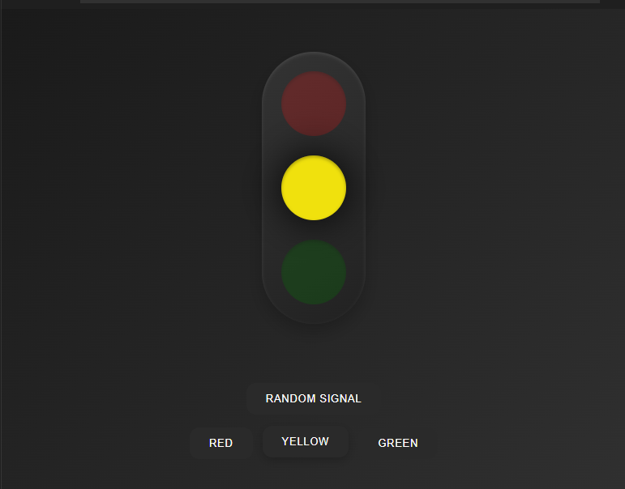
- Random Quote
https://23bai1214-divyanshu-exercise-5-t-2.netlify.app/
<!-- 2. Random Quote -->

<!DOCTYPE html>
<html lang="en">
<head>
<meta charset="UTF-8">
<meta name="viewport" content="width=device-width, initial-scale=1.0">
<title>Quote Generator</title>
<style>
:root {
--primary: #2a2d4c;
--text: #333;
--accent: #6366f1;
--background-start: #667eea;
--background-end: #764ba2;
--card: #ffffff;
}

* {
margin: 0;
padding: 0;
box-sizing: border-box;
}

body {
min-height: 100vh;
display: grid;
place-items: center;
font-family: system-ui, -apple-system, sans-serif;
background: linear-gradient(135deg, var(--background-start), var(--background-end));
padding: 1rem;
}

.container {
max-width: 600px;
width: 100%;
padding: 2rem;
background: var(--card);
border-radius: 1rem;
box-shadow: 0 10px 25px rgba(0, 0, 0, 0.1);
display: flex;
flex-direction: column;
gap: 1.5rem;
}

.quote-box {
position: relative;
padding: 1rem;
}

.quote-text {
font-size: 1.5rem;
color: var(--primary);
line-height: 1.5;
margin-bottom: 1rem;
position: relative;
padding: 0 1rem;
transition: opacity 0.3s ease;
}

.quote-text::before,
.quote-text::after {
content: '"';
font-size: 4rem;
position: absolute;
opacity: 0.1;
font-family: Georgia, serif;
}

.quote-text::before {
top: -1rem;
left: -1rem;
}

.quote-text::after {
bottom: -2rem;
right: -1rem;
}

.quote-author {
font-size: 1.1rem;
color: var(--accent);
text-align: right;
font-style: italic;
transition: opacity 0.3s ease;
}

.button {
background-color: var(--accent);
color: white;
border: none;
padding: 1rem 2rem;
border-radius: 0.5rem;
font-size: 1rem;
cursor: pointer;
transition: transform 0.2s ease, box-shadow 0.2s ease;
font-weight: 500;
align-self: center;
}

.button:hover {
transform: translateY(-2px);
box-shadow: 0 4px 12px rgba(99, 102, 241, 0.3);
}

.button:active {
transform: translateY(0);
}

@media (max-width: 480px) {
.container {
padding: 1.5rem;
}

.quote-text {
font-size: 1.25rem;
}
}
</style>
</head>
<body>
<div class="container">
<div class="quote-box">
<p class="quote-text" id="quote"></p>
<p class="quote-author" id="author"></p>
</div>
<button class="button" id="new-quote">New Quote</button>
</div>

<script>
const quotes = [
{ text: "The only way to do great work is to love what you do.", author: "Steve Jobs" },
{ text: "In three words I can sum up everything I've learned about life: it goes on.", author: "Robert Frost" },
{ text: "Success is not final, failure is not fatal: it is the courage to continue that counts.", author: "Winston Churchill" },
{ text: "The future belongs to those who believe in the beauty of their dreams.", author: "Eleanor Roosevelt" },
{ text: "Be yourself; everyone else is already taken.", author: "Oscar Wilde" },
{ text: "Two things are infinite: the universe and human stupidity; and I'm not sure about the universe.", author: "Albert Einstein" },
{ text: "Be the change that you wish to see in the world.", author: "Mahatma Gandhi" },
{ text: "The only impossible journey is the one you never begin.", author: "Tony Robbins" },
{ text: "To be yourself in a world that is constantly trying to make you something else is the greatest accomplishment.", author: "Ralph Waldo Emerson" },
{ text: "Everything you can imagine is real.", author: "Pablo Picasso" }
];

const quoteText = document.getElementById('quote');
const quoteAuthor = document.getElementById('author');
const newQuoteButton = document.getElementById('new-quote');

function getRandomQuote() {
return quotes[Math.floor(Math.random() * quotes.length)];
}

function displayQuote() {
const { text, author } = getRandomQuote();
quoteText.style.opacity = 0;
quoteAuthor.style.opacity = 0;
setTimeout(() => {
quoteText.textContent = text;
quoteAuthor.textContent = `— ${author}`;
quoteText.style.opacity = 1;
quoteAuthor.style.opacity = 1;
}, 300);
}

displayQuote();
newQuoteButton.addEventListener('click', displayQuote);
</script>
</body>
</html>

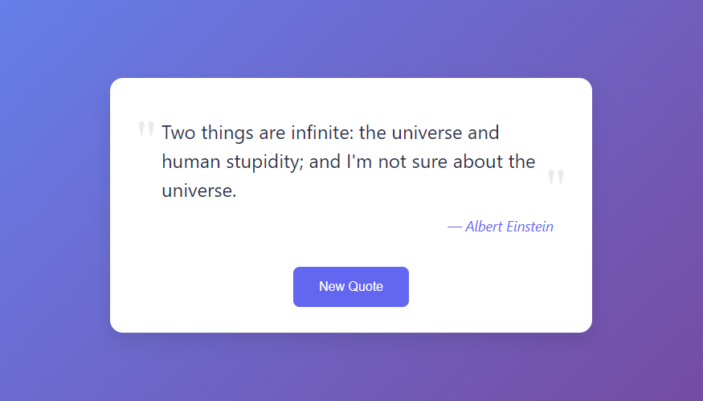
- To-Do-List
https://23bai1214-divyanshu-exercise-5-t-3.netlify.app/
<!-- 3. To-Do-List -->

<!DOCTYPE html>
<html lang="en">
<head>
<meta charset="UTF-8">
<meta name="viewport" content="width=device-width, initial-scale=1.0">
<title>To-Do List</title>
<style>
:root {
--primary-bg: #4A90E2;
--container-bg: #ffffff;
--text-color: #333;
--button-bg: #ff4081;
--button-text: #fff;
--task-bg: #f1f1f1;
--task-done: #bbb;
}

* {
margin: 0;
padding: 0;
box-sizing: border-box;
font-family: Arial, sans-serif;
}

body {
display: flex;
justify-content: center;
align-items: center;
height: 100vh;
background: linear-gradient(135deg, var(--primary-bg), #D4418E);
padding: 1rem;
}

.container {
background: var(--container-bg);
padding: 2rem;
border-radius: 1rem;
box-shadow: 0 10px 25px rgba(0, 0, 0, 0.1);
width: 350px;
text-align: center;
}

h2 {
margin-bottom: 1rem;
color: var(--text-color);
}

input {
width: 80%;
padding: 10px;
margin-bottom: 1rem;
border: 1px solid #ccc;
border-radius: 5px;
outline: none;
}

button {
padding: 10px 15px;
background: var(--button-bg);
color: var(--button-text);
border: none;
cursor: pointer;
border-radius: 5px;
transition: background 0.3s;
}

button:hover {
background: #e60073;
}

ul {
list-style: none;
padding: 0;
}

li {
display: flex;
justify-content: space-between;
padding: 10px;
background: var(--task-bg);
margin-top: 5px;
border-radius: 5px;
cursor: pointer;
transition: background 0.3s;
}

li:hover {
background: #e0e0e0;
}

.done {
text-decoration: line-through;
color: var(--task-done);
}

.delete-btn {
background: transparent;
border: none;
color: red;
font-size: 1rem;
cursor: pointer;
}
</style>
</head>
<body>
<div class="container">
<h2>To-Do List</h2>
<input type="text" id="task" placeholder="Add a new task...">
<button onclick="addTask()">Add</button>
<ul id="taskList"></ul>
</div>
<script>
function addTask() {
let taskInput = document.getElementById("task");
let taskText = taskInput.value.trim();
if (taskText === "") return;

let li = document.createElement("li");
li.innerHTML = `${taskText} <button class='delete-btn' onclick='removeTask(this)'>&times;</button>`;
li.addEventListener("click", function() {
this.classList.toggle("done");
});

document.getElementById("taskList").appendChild(li);
taskInput.value = "";
}

function removeTask(button) {
button.parentElement.remove();
}
</script>
</body>
</html>

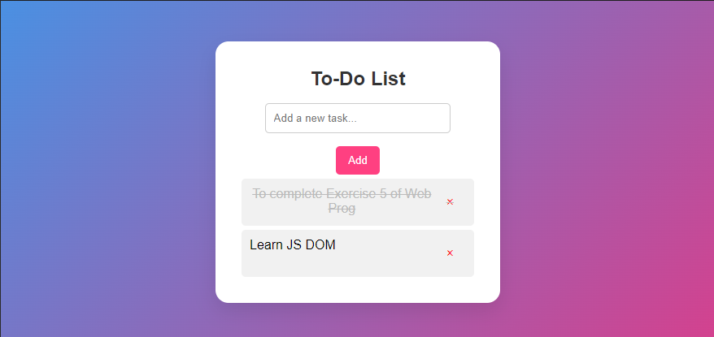
- Drawing Shape

https://23bai1214-divyanshu-exercise-5-t-4.netlify.app/

<!-- 4. Drawing Shapes -->

<!DOCTYPE html>
<html lang="en">
<head>
<meta charset="UTF-8">
<meta name="viewport" content="width=device-width, initial-scale=1.0">
<title>Canvas Shape Drawer</title>
<style>
* {
margin: 0;
padding: 0;
box-sizing: border-box;
}

body {
font-family: Arial, sans-serif;
background: linear-gradient(to right, #FF9A8B, #FF6A88, #FF99AC);
height: 100vh;
display: flex;
flex-direction: column;
justify-content: center;
align-items: center;
text-align: center;
}

h1 {
color: white;
margin-bottom: 15px;
}

.options {
margin-bottom: 15px;
}

button {
margin: 5px;
padding: 12px 20px;
font-size: 16px;
border: none;
outline: none;
background: #4A90E2;
color: white;
border-radius: 8px;
cursor: pointer;
transition: 0.3s ease-in-out;
}

button:hover {
background: #357ABD;
}

canvas {
background-color: white;
border: 3px solid black;
border-radius: 10px;
box-shadow: 0px 4px 10px rgba(0, 0, 0, 0.2);
}
</style>
</head>
<body>

<h1>Draw Random Shapes on Canvas</h1>
<div class="options">
<button onclick="drawRectangle()">Rectangle</button>
<button onclick="drawCircle()">Circle</button>
<button onclick="drawTriangle()">Triangle</button>
<button onclick="clearCanvas()">Clear</button>
</div>
<canvas id="myCanvas" width="500" height="500"></canvas>

<script>
const canvas = document.getElementById('myCanvas');
const ctx = canvas.getContext('2d');

function getRandomInt(min, max) {
return Math.floor(Math.random() * (max - min + 1)) + min;
}

function getRandomColor() {
return `hsl(${Math.random() * 360}, 70%, 60%)`;
}

function drawRectangle() {
const x = getRandomInt(0, canvas.width - 150);
const y = getRandomInt(0, canvas.height - 100);
ctx.fillStyle = getRandomColor();
ctx.fillRect(x, y, 150, 100);
}

function drawCircle() {
const radius = 50;
const x = getRandomInt(radius, canvas.width - radius);
const y = getRandomInt(radius, canvas.height - radius);
ctx.fillStyle = getRandomColor();
ctx.beginPath();
ctx.arc(x, y, radius, 0, Math.PI * 2);
ctx.fill();
}

function drawTriangle() {
const x1 = getRandomInt(50, canvas.width - 50);
const y1 = getRandomInt(50, canvas.height - 50);
const x2 = x1 - 50;
const y2 = y1 + 100;
const x3 = x1 + 50;
const y3 = y1 + 100;
ctx.fillStyle = getRandomColor();
ctx.beginPath();
ctx.moveTo(x1, y1);
ctx.lineTo(x2, y2);
ctx.lineTo(x3, y3);
ctx.closePath();
ctx.fill();
}

function clearCanvas() {
ctx.clearRect(0, 0, canvas.width, canvas.height);
}
</script>

</body>
</html>

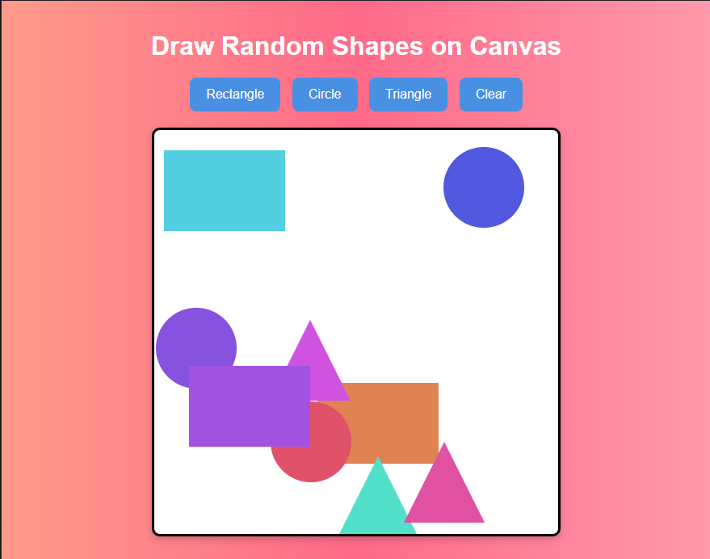
- Guess The Number
https://23bai1214-divyanshu-exercise-5-t-5.netlify.app/

<!-- 5. Guess The Number -->

<!DOCTYPE html>
<html lang="en">
<head>
<meta charset="UTF-8">
<meta name="viewport" content="width=device-width, initial-scale=1.0">
<title>Guess the Number</title>
<style>
:root {
--primary-bg: #4A90E2;
--container-bg: #ffffff;
--text-color: #333;
--button-bg: #ff4081;
--button-text: #fff;
}

* {
margin: 0;
padding: 0;
box-sizing: border-box;
font-family: Arial, sans-serif;
}

body {
display: flex;
justify-content: center;
align-items: center;
height: 100vh;
background: linear-gradient(135deg, var(--primary-bg), #D4418E);
padding: 1rem;
}

.container {
background: var(--container-bg);
padding: 2rem;
border-radius: 1rem;
box-shadow: 0 10px 25px rgba(0, 0, 0, 0.1);
width: 350px;
text-align: center;
}

h2 {
margin-bottom: 1rem;
color: var(--text-color);
}

input {
width: 80%;
padding: 10px;
margin-bottom: 1rem;
border: 1px solid #ccc;
border-radius: 5px;
outline: none;
}

button {
padding: 10px 15px;
background: var(--button-bg);
color: var(--button-text);
border: none;
cursor: pointer;
border-radius: 5px;
transition: background 0.3s;
}

button:hover {
background: #e60073;
}

.message {
margin-top: 1rem;
font-size: 1.1rem;
color: var(--text-color);
}
</style>
</head>
<body>
<div class="container">
<h2>Guess the Number</h2>
<p>Guess a number between 1 and 100</p>
<input type="number" id="guess" placeholder="Enter your guess...">
<button onclick="checkGuess()">Submit</button>
<p class="message" id="message"></p>
<p>Attempts: <span id="attempts">0</span></p>
<button onclick="resetGame()">Restart</button>
</div>

<script>
let randomNumber = Math.floor(Math.random() * 100) + 1;
let attempts = 0;

function checkGuess() {
let userGuess = parseInt(document.getElementById("guess").value);
let message = document.getElementById("message");
let attemptCounter = document.getElementById("attempts");

if (isNaN(userGuess) || userGuess < 1 || userGuess > 100) {
message.textContent = "Please enter a valid number between 1 and 100.";
return;
}

attempts++;
attemptCounter.textContent = attempts;

if (userGuess === randomNumber) {
message.textContent = `Congratulations! You guessed the number in ${attempts} attempts.`;
} else if (userGuess < randomNumber) {
message.textContent = "Too low! Try again.";
} else {
message.textContent = "Too high! Try again.";
}
}

function resetGame() {
randomNumber = Math.floor(Math.random() * 100) + 1;
attempts = 0;
document.getElementById("attempts").textContent = attempts;
document.getElementById("message").textContent = "";
document.getElementById("guess").value = "";
}
</script>
</body>
</html>

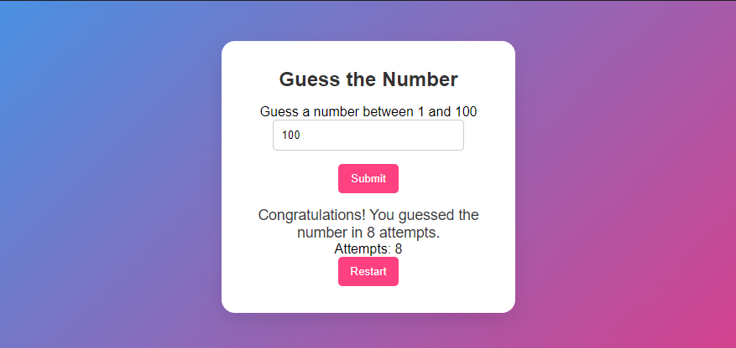
- Random Emoji Generator

https://23bai1214-divyanshu-exercise-5-t-6.netlify.app/
<!-- 6. Random Emoji Generator -->

<!DOCTYPE html>
<html lang="en">
<head>
<meta charset="UTF-8">
<meta name="viewport" content="width=device-width, initial-scale=1.0">
<title>Random Emoji Generator</title>
<style>
:root {
--primary-bg: #4A90E2;
--container-bg: #ffffff;
--text-color: #333;
--button-bg: #ff4081;
--button-text: #fff;
}

* {
margin: 0;
padding: 0;
box-sizing: border-box;
font-family: Arial, sans-serif;
}

body {
display: flex;
justify-content: center;
align-items: center;
height: 100vh;
background: linear-gradient(135deg, var(--primary-bg), #D4418E);
padding: 1rem;
}

.container {
background: var(--container-bg);
padding: 2rem;
border-radius: 1rem;
box-shadow: 0 10px 25px rgba(0, 0, 0, 0.1);
width: 350px;
text-align: center;
}

h2 {
margin-bottom: 1rem;
color: var(--text-color);
}

.emoji-display {
font-size: 4rem;
margin: 1rem 0;
}

button {
padding: 10px 15px;
background: var(--button-bg);
color: var(--button-text);
border: none;
cursor: pointer;
border-radius: 5px;
transition: background 0.3s;
font-size: 1rem;
}

button:hover {
background: #e60073;
}
</style>
</head>
<body>
<div class="container">
<h2>Random Emoji Generator</h2>
<div class="emoji-display" id="emoji">😀</div>
<button onclick="generateEmoji()">New Emoji</button>
</div>
<script>
const emojis = ['😀', '😂', '😍', '🤩', '😎', '😜', '😇', '🥳', '🤔', '🙃', '😭', '😡', '🥶', '🤯', '🤗', '🤡', '👽', '👻', '🐶', '🐱', '🦄', '🌍', '🍕', '⚽', '🎸', '🚀', '❤️', '🏆'];

function generateEmoji() {
const randomEmoji = emojis[Math.floor(Math.random() * emojis.length)];
document.getElementById('emoji').textContent = randomEmoji;
}
</script>
</body>
</html>

