
WEB PROGRAMMING LAB
BCSE203E
SLOT: L11 + L12 + L19 + L20
LAB MANUAL
Exercise 3
Date: 18-01-2025
Stacked Panel: A CSS Layout Exploration
Side-by-Side Panels: A CSS Layout Exploration
Login Page
Navigation Bar – Horizontal
Navigation Bar – Vertical
Display ACER and Projector Info.
[using HTML and CSS]

SUBMITTED TO:
PROF. DR. ASHOKA RAJAN R
SUBMITTED BY:
DIVYANSHU PATEL
23BAI1214

School of Computer Science and Engineering
Vellore Institute of Technology, Chennai
Chennai 600127, Tamil Nadu
 GITHUB REPO LINK:
https://github.com/divyanshupatel17/23BAI1214_WEB_LAB

WEB PROG LAB PORTFOLIO:
https://23bai1214-divyanshu-web-lab-portfolio.netlify.app/

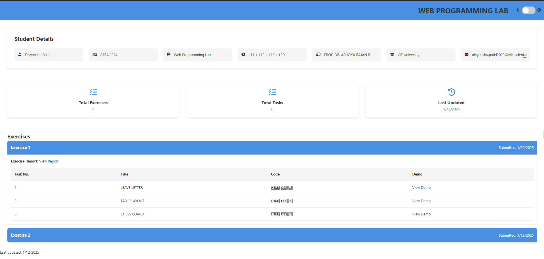

QUE 1. Stacked Panel: A CSS Layout Exploration
https://23bai1214-divyanshu-exercise-3-t-1.netlify.app/


<!-- 1. Stacked Panel: A CSS Layout Exploration -->

<!-- index.html -->
<!DOCTYPE html>
<html lang="en">
<head>
<meta charset="UTF-8">
<meta name="viewport" content="width=device-width, initial-scale=1.0">
<title>Stacked Panel: A CSS Layout Exploration</title>
<link rel="stylesheet" href="styles.css">
</head>
<body>
<div class="stacked-panel">
<div class="panel"></div>
<div class="panel"></div>
</div>
</body>
</html>

/* styles.css */

body {
margin: 0;
padding: 0;
display: flex;
justify-content: center;
align-items: center;
height: 100vh;
background-color: #f0f0f0;
}

.stacked-panel {
display: flex;
flex-direction: column;
gap: 10px;
}

.panel {
width: 100px;
height: 150px;
background-color: red;
}

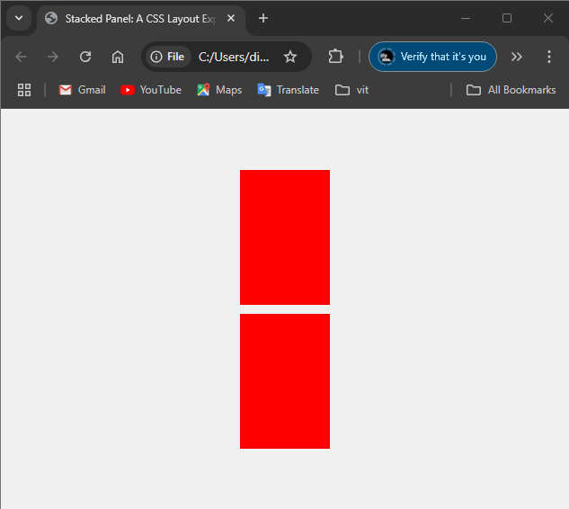

QUE 2. Side-by-Side Panels: A CSS Layout Exploration
https://23bai1214-divyanshu-exercise-3-t-2.netlify.app/


<!-- 2. Side-by-Side Panels: A CSS Layout Exploration -->

<!-- index.html -->
<!DOCTYPE html>
<html lang="en">
<head>
<meta charset="UTF-8">
<meta name="viewport" content="width=device-width, initial-scale=1.0">
<title>Side-by-Side Panel: A CSS Layout Exploration</title>
<link rel="stylesheet" href="styles.css">
</head>
<body>
<div class="side-panel">
<div class="panel"></div>
<div class="panel"></div>
</div>
</body>
</html>

/* styles.css */
body {
margin: 0;
padding: 0;
display: flex;
justify-content: center;
align-items: center;
height: 100vh;
background-color: #f0f0f0;
}

.side-panel {
display: flex;
flex-direction: row;
gap: 10px;
}

.panel {
width: 100px;
height: 100px;
background-color: red;
}

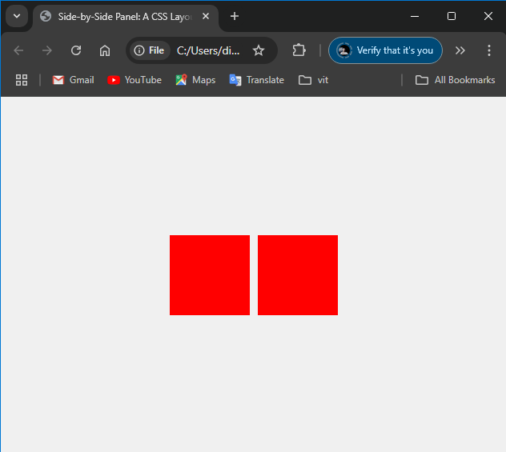

QUE 3. Login Page
https://23bai1214-divyanshu-exercise-3-t-3.netlify.app/
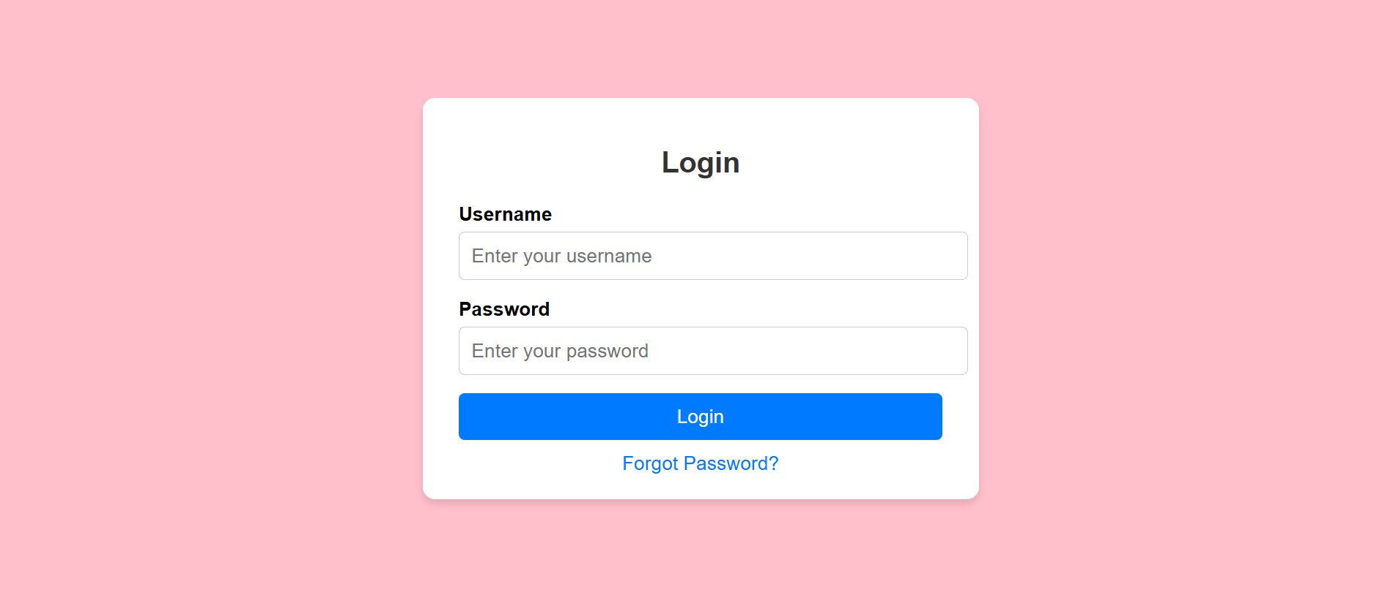
<!-- 3. Login Page -->

<!-- index.html -->
<!DOCTYPE html>
<html lang="en">
<head>
<meta charset="UTF-8">
<meta name="viewport" content="width=device-width, initial-scale=1.0">
<title>Login Page</title>
<link rel="stylesheet" href="styles.css">
</head>
<body>
<div class="login-container">
<h2>Login</h2>
<form>
<label for="username">Username</label>
<input type="text" id="username" placeholder="Enter your username" required>

<label for="password">Password</label>
<input type="password" id="password" placeholder="Enter your password" required>

<button type="submit">Login</button>
<a href="#" class="forgot-password">Forgot Password?</a>
</form>
</div>
</body>
</html>

/* styles.css */
/* Background styling */
body {
margin: 0;
padding: 0;
font-family: Arial, sans-serif;
background-color: #ffc0cb; /* Light pink background */
display: flex;
justify-content: center;
align-items: center;
height: 100vh;
}

/* Login container styling */
.login-container {
background-color: #ffffff;
padding: 40px 30px;
border-radius: 10px;
box-shadow: 0 2px 10px rgba(0, 0, 0, 0.1);
width: 350px;
text-align: center;
}

/* Heading */
.login-container h2 {
margin-bottom: 20px;
color: #333333;
}

/* Label styling */
.login-container label {
display: block;
text-align: left;
margin-bottom: 5px;
font-weight: bold;
color: #333333;
}

/* Input field styling */
.login-container input[type="text"],
.login-container input[type="password"] {
width: 100%;
padding: 10px;
margin-bottom: 15px;
border: 1px solid #ccc;
border-radius: 5px;
box-sizing: border-box;
}

/* Button styling */
.login-container button {
width: 100%;
padding: 10px;
background-color: #007bff;
color: #ffffff;
border: none;
border-radius: 5px;
cursor: pointer;
font-size: 16px;
}

.login-container button:hover {
background-color: #0056b3;
}

/* Forgot password link */
.login-container .forgot-password {
display: block;
margin-top: 15px;
font-size: 14px;
color: #007bff;
text-decoration: none;
}

.login-container .forgot-password:hover {
text-decoration: underline;
}

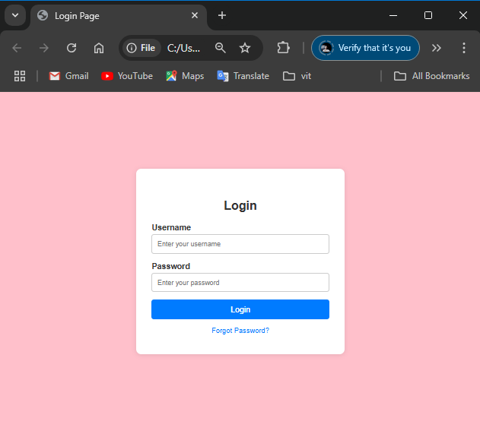
QUE 4. Navigation Bar – Horizontal
https://23bai1214-divyanshu-exercise-3-t-4.netlify.app/

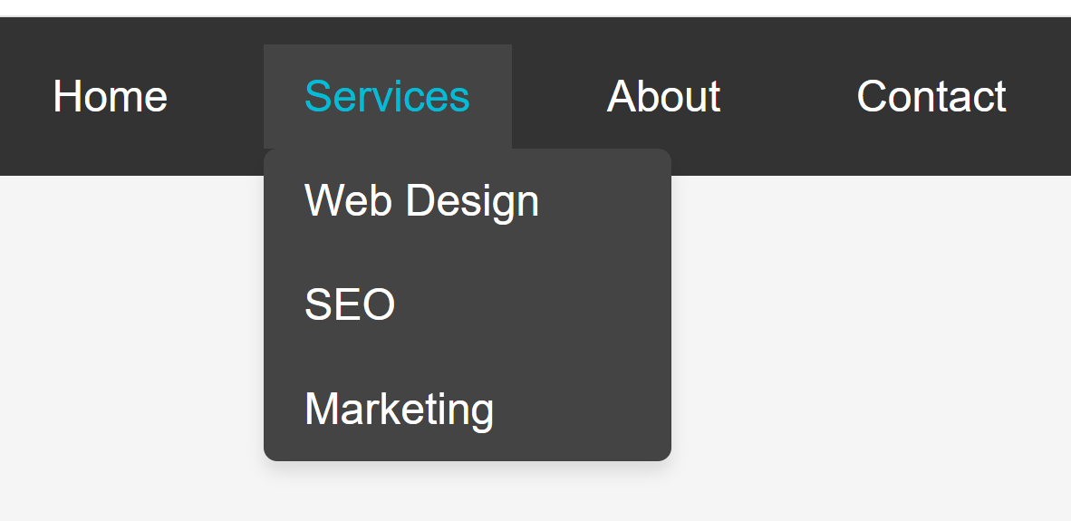
<!-- 4. Navigation Bar - Horizontal -->

<!-- index.html -->
<!DOCTYPE html>
<html lang="en">
<head>
<meta charset="UTF-8">
<meta name="viewport" content="width=device-width, initial-scale=1.0">
<title>Navigation Menu</title>
<link rel="stylesheet" href="styles.css">
</head>
<body>
<nav class="navbar">
<ul class="nav-list">
<li><a href="#home">Home</a></li>
<li class="dropdown">
<a href="#services" class="active">Services</a>
<ul class="dropdown-content">
<li><a href="#web-design">Web Design</a></li>
<li><a href="#seo">SEO</a></li>
<li><a href="#marketing">Marketing</a></li>
</ul>
</li>
<li><a href="#about">About</a></li>
<li><a href="#contact">Contact</a></li>
</ul>
</nav>
</body>
</html>

/* styles.css */
.navbar {
background-color: #333;
padding: 15px 0;
font-family: Arial, sans-serif;
}

.nav-list {
list-style: none;
margin: 0;
padding: 0;
display: flex;
justify-content: flex-start;
gap: 20px;
padding-left: 20px;
}

.nav-list li a {
color: white;
text-decoration: none;
font-size: 20px;
padding: 10px 15px;
}

.active {
color: #00ffff !important;
}

/* Dropdown styles */
.dropdown {
position: relative;
}

.dropdown-content {
display: none;
position: absolute;
top: 100%;
left: 0;
background-color: #444;
min-width: 180px;
padding: 10px 0;
border-radius: 4px;
box-shadow: 0 2px 5px rgba(0,0,0,0.2);
}

.dropdown-content li {
padding: 5px 0;
}

.dropdown-content li a {
color: white;
padding: 8px 20px;
display: block;
font-size: 18px;
}

.dropdown:hover .dropdown-content {
display: block;
}

.dropdown-content li a:hover {
background-color: #555;
}

/* Hover effects */
.nav-list li a:hover {
color: #00ffff;
}

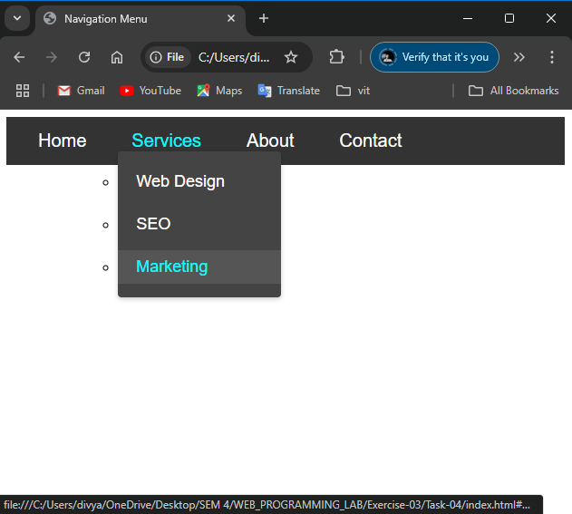
QUE 5. Navigation Bar – Vertical
https://23bai1214-divyanshu-exercise-3-t-5.netlify.app/

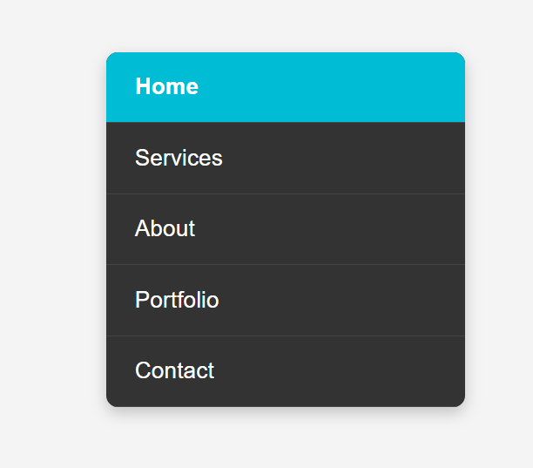
<!-- 5. Navigation Bar - Vertical -->

<!-- index.html -->
<!DOCTYPE html>
<html lang="en">
<head>
<meta charset="UTF-8">
<meta name="viewport" content="width=device-width, initial-scale=1.0">
<title>Vertical Navigation Menu</title>
<link rel="stylesheet" href="styles.css">
</head>
<body>
<nav class="nav-menu">
<div class="nav-header">
<a href="#home">Home</a>
</div>
<ul class="nav-list">
<li><a href="#services">Services</a></li>
<li><a href="#about">About</a></li>
<li><a href="#portfolio">Portfolio</a></li>
<li><a href="#contact">Contact</a></li>
</ul>
</nav>
</body>
</html>

/* styles.css */
.nav-menu {
width: 250px;
background-color: #333;
border-radius: 10px;
overflow: hidden;
box-shadow: 0 4px 8px rgba(0,0,0,0.1);
}

.nav-header {
background-color: #00c1d4;
padding: 15px 20px;
}

.nav-header a {
color: white;
text-decoration: none;
font-size: 24px;
font-weight: bold;
}

.nav-list {
list-style: none;
margin: 0;
padding: 0;
}

.nav-list li {
border-bottom: 1px solid #444;
}

.nav-list li:last-child {
border-bottom: none;
}

.nav-list li a {
color: white;
text-decoration: none;
padding: 15px 20px;
display: block;
font-size: 20px;
transition: background-color 0.3s ease;
}

.nav-list li a:hover {
background-color: #444;
}

body {
display: flex;
justify-content: center;
align-items: center;
min-height: 100vh;
margin: 0;
background-color: #f5f5f5;
font-family: Arial, sans-serif;
}

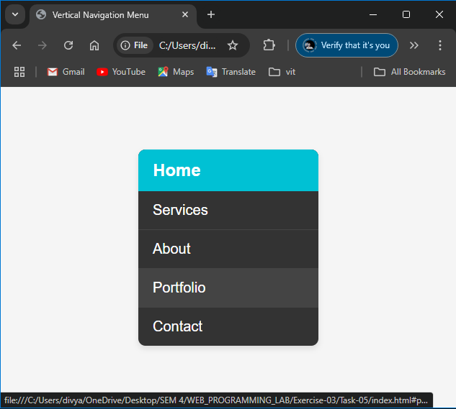

QUE 6. Display ACER and Projector Info
https://23bai1214-divyanshu-exercise-3-t-6.netlify.app/

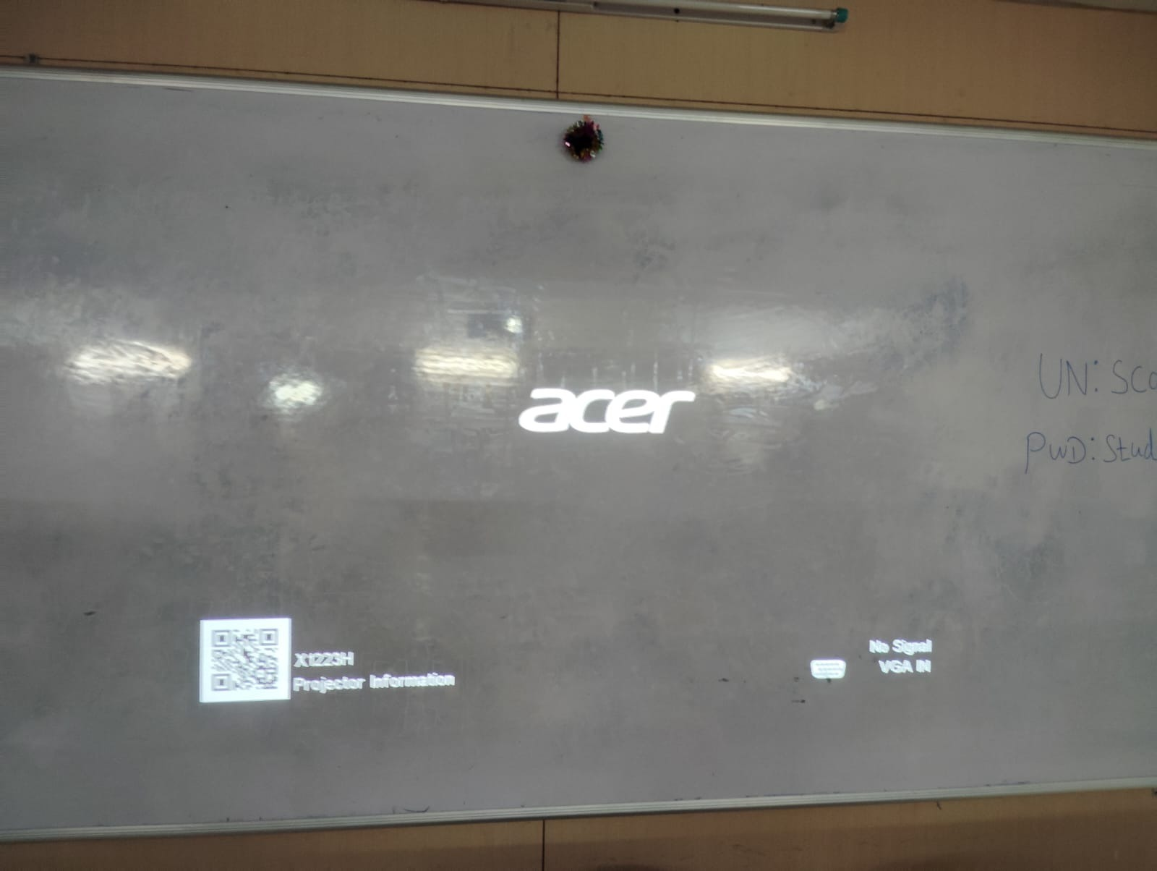
<!-- 6. Display ACER and Projector Info -->

<!-- index.html -->
<!DOCTYPE html>
<html lang="en">
<head>
<meta charset="UTF-8">
<meta name="viewport" content="width=device-width, initial-scale=1.0">
<title>Acer Projector Display</title>
<link rel="stylesheet" href="styles.css">
<link href="https://fonts.googleapis.com/css2?family=Roboto:wght@300;400&display=swap" rel="stylesheet">
</head>
<body>
<div class="projector-screen">
<div class="logo"><b>acer</b></div>
<div class="bottom-info">
<div class="qr-section">
<img src="qr-scanner.jpg" alt="QR Code" class="qr-code">
<span class="qr-text">X1223H<br>Projector Information</span>
</div>
<div class="signal-info">
<img src="hdmi.png" alt="HDMI" class="hdmi-icon">
<span class="signal-text">No Signal<br>HDMI IN</span>
</div>
</div>
</div>
</body>
</html>

/* styles.css */
* {
margin: 0;
padding: 0;
box-sizing: border-box;
}

body {
margin: 0;
padding: 0;
min-height: 100vh;
background-color: #000;
font-family: 'Roboto', sans-serif;
overflow: hidden;
}

.projector-screen {
width: 100vw;
height: 100vh;
background-color: #000;
position: relative;
display: flex;
flex-direction: column;
justify-content: space-between;
padding: 40px;
}

.logo {
color: white;
font-size: 72px;
position: absolute;
top: 50%;
left: 50%;
transform: translate(-50%, -50%);
font-style: italic;
letter-spacing: 2px;
font-weight: 300;
}

.bottom-info {
display: flex;
justify-content: space-between;
align-items: flex-end;
color: white;
position: absolute;
bottom: 40px;
left: 40px;
right: 40px;
}

.qr-section {
display: flex;
align-items: center;
gap: 20px;
}

.qr-code {
width: 80px;
height: 80px;
background-color: white;
padding: 5px;
}

.qr-text {
line-height: 1.6;
font-weight: 300;
font-size: 24px;
}

.signal-info {
display: flex;
align-items: center;
gap: 20px;
}

.hdmi-icon {
width: 40px;
height: auto;
filter: brightness(0) invert(1);
}

.signal-text {
line-height: 1.6;
text-align: right;
font-weight: 300;
font-size: 24px;
}

