

**WEB PROGRAMMING LAB**

**BCSE203E**

**SLOT: L11 + L12 + L19 + L20**

LAB MANUAL

Project & Exercise Tasks Links

<https://23bai1214-divyanshu-web-v0.netlify.app/>

Date: 31-03-2025

**SUBMITTED TO:**

**PROF. DR. ASHOKA RAJAN R**

**SUBMITTED BY:**

**DIVYANSHU PATEL  
23BAI1214**

**School of Computer Science and Engineering**

Vellore Institute of Technology, Chennai

Chennai 600127, Tamil Nadu

**My Portfolio and Project Links**

**PORTFOLIO LINKS:**

**- Web Programming Exercise Portfolio:**

[**https://23bai1214-divyanshu-web-v0.netlify.app/**](https://23bai1214-divyanshu-web-v0.netlify.app/)

**- Personal Portfolio:**

[**https://divyanshupatel17.github.io/divyanshu-portfolio/**](https://divyanshupatel17.github.io/divyanshu-portfolio/)

**GITHUB REPOSITORY:**

**- Main Repository:** [**https://github.com/divyanshupatel17/23BAI1214_WEB_LAB**](https://github.com/divyanshupatel17/23BAI1214_WEB_LAB)

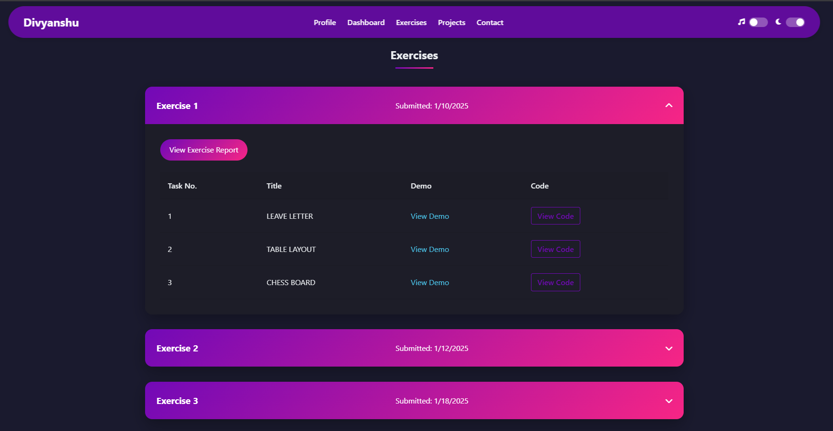

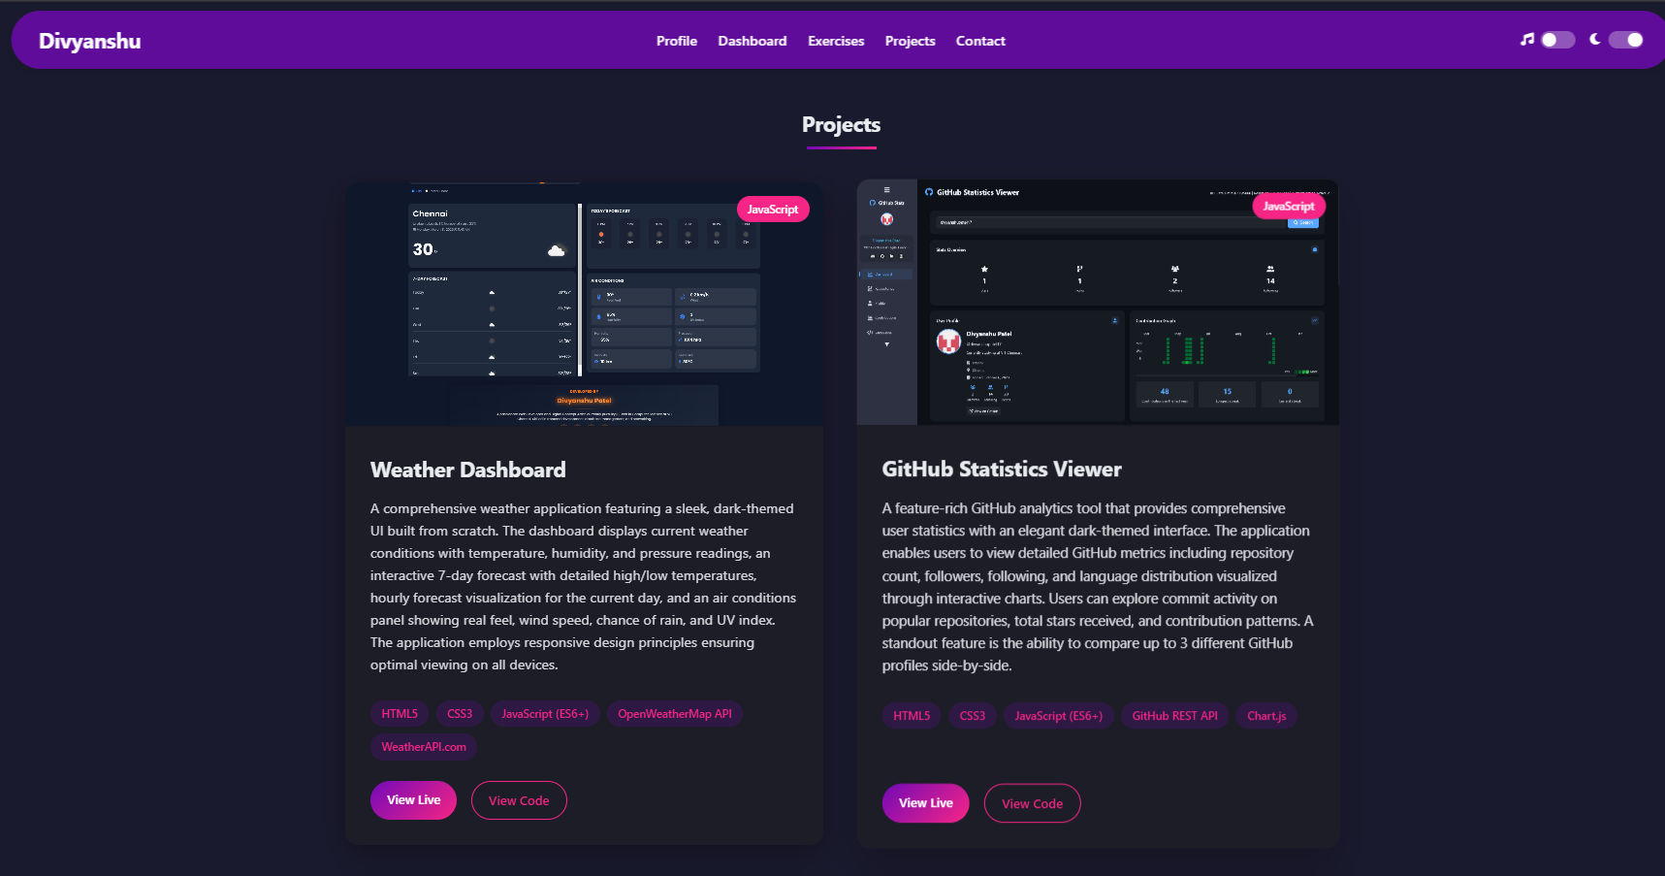

**EXERCISE LINKS:**

Exercise 01 (HTML Basics & Layouts):

- Task 01 - Leave Letter Application: <https://23bai1214-divyanshu-exercise-1-t-1.netlify.app/>

- Task 02 - Table Layout Implementation: <https://23bai1214-divyanshu-exercise-1-t-2.netlify.app/>

- Task 03 - Interactive Chessboard: <https://23bai1214-divyanshu-exercise-1-t-3.netlify.app/>

- Documentation: <https://github.com/divyanshupatel17/23BAI1214_WEB_LAB/blob/main/Exercise-01/23BAI1214_Exercise_01_pdf.pdf>

Exercise 02 (Advanced Styling & Forms):

- Task 01 - The Coffee Shop Website: <https://23bai1214-divyanshu-exercise-2-t-1.netlify.app/>

- Task 02 - CSS Animations Showcase: <https://23bai1214-divyanshu-exercise-2-t-2.netlify.app/>

- Task 03 - Job Registration Portal: <https://23bai1214-divyanshu-exercise-2-t-3.netlify.app/>

- Documentation: <https://github.com/divyanshupatel17/23BAI1214_WEB_LAB/blob/main/Exercise-02/23BAI1214_Exercise_02_pdf.pdf>

Exercise 03 (Advanced CSS Layouts):

- Task 01 - Stacked Panel Layout: <https://23bai1214-divyanshu-exercise-3-t-1.netlify.app/>

- Task 02 - Side-by-Side Panels: <https://23bai1214-divyanshu-exercise-3-t-2.netlify.app/>

- Task 03 - Modern Login Interface: <https://23bai1214-divyanshu-exercise-3-t-3.netlify.app/>

- Task 04 - Horizontal Navigation: <https://23bai1214-divyanshu-exercise-3-t-4.netlify.app/>

- Task 05 - Vertical Navigation: <https://23bai1214-divyanshu-exercise-3-t-5.netlify.app/>

- Task 06 - Product Information Display: <https://23bai1214-divyanshu-exercise-3-t-6.netlify.app/>

- Documentation: <https://github.com/divyanshupatel17/23BAI1214_WEB_LAB/blob/main/Exercise-03/23BAI1214_Exercise_03_pdf.pdf>

Exercise 04 (Advanced Animations):

- Task 01 - W3Schools Animated Box: <https://23bai1214-divyanshu-exercise-4-t-1.netlify.app/>

- Task 02 - Square Path Animation: <https://23bai1214-divyanshu-exercise-4-t-2.netlify.app/>

- Task 03 - Dynamic Star Animation: <https://23bai1214-divyanshu-exercise-4-t-3.netlify.app/>

- Task 04 - Responsive Web Design: <https://23bai1214-divyanshu-exercise-4-t-4.netlify.app/>

- Documentation: <https://github.com/divyanshupatel17/23BAI1214_WEB_LAB/blob/main/Exercise-04/23BAI1214_Exercise_04_pdf.pdf>

Exercise 05 (JavaScript Applications):

- Task 01 - Interactive Traffic Light: <https://23bai1214-divyanshu-exercise-5-t-1.netlify.app/>

- Task 02 - Random Quote Generator: <https://23bai1214-divyanshu-exercise-5-t-2.netlify.app/>

- Task 03 - To-Do List Application: <https://23bai1214-divyanshu-exercise-5-t-3.netlify.app/>

- Task 04 - Interactive Shape Drawing: <https://23bai1214-divyanshu-exercise-5-t-4.netlify.app/>

- Task 05 - Number Guessing Game: <https://23bai1214-divyanshu-exercise-5-t-5.netlify.app/>

- Task 06 - Emoji Generator: <https://23bai1214-divyanshu-exercise-5-t-6.netlify.app/>

- Documentation[: https://github.com/divyanshupatel17/23BAI1214_WEB_LAB/blob/main/Exercise-05/23BAI1214_Exercise_05_word.docx](:%20https:/github.com/divyanshupatel17/23BAI1214_WEB_LAB/blob/main/Exercise-05/23BAI1214_Exercise_05_word.docx)

Exercise 06 (Advanced JavaScript):

- Task 01 - Weather Dashboard: <https://23bai1214-divyanshu-exercise-6-t-1.netlify.app/>

- Task 02 - Image Gallery: <https://23bai1214-divyanshu-exercise-6-t-2.netlify.app/>

- Task 03 - Form Validation: <https://23bai1214-divyanshu-exercise-6-t-3.netlify.app/>

- Documentation: <https://github.com/divyanshupatel17/23BAI1214_WEB_LAB/blob/main/Exercise-06/23BAI1214_Exercise_06_pdf.pdf>

Exercise 07 (Frameworks & Libraries):

- Task 01 - React Card Component: <https://23bai1214-divyanshu-exercise-7-t-1.netlify.app/>

- Documentation: <https://github.com/divyanshupatel17/23BAI1214_WEB_LAB/blob/main/Exercise-07/23BAI1214_Exercise_07_pdf.pdf>

Exercise 08 (Responsive Design & PWA):

- Task 01 - React Data Table: <https://23bai1214-divyanshu-exercise-8-t-1.netlify.app/>

- Documentation: <https://github.com/divyanshupatel17/23BAI1214_WEB_LAB/blob/main/Exercise-08/23BAI1214_Exercise_08_pdf.pdf>

Exercise 09 (Profile card):

- Task 01 - React Data Table: <https://23bai1214-divyanshu-exercise-9-t-1.netlify.app/>

- Documentation:<https://github.com/divyanshupatel17/23BAI1214_WEB_LAB/blob/main/Exercise-09/23BAI1214_Exercise_09_pdf.pdf>

Exercise 10 (Movie Cards):

- Task 01 - React Data Table:

<https://23bai1214-divyanshu-exercise-10-t-1.netlify.app/>

- Documentation: <https://github.com/divyanshupatel17/23BAI1214_WEB_LAB/blob/main/Exercise-10/23BAI1214_Exercise_10_pdf.pdf>

**PROJECT LINKS:**

**JavaScript Projects:**

- Weather Dashboard: <https://weather-dashboard-divyanshu.netlify.app>

- GitHub Statistics Viewer: <https://github-stats-viewer-divyanshu.netlify.app>

- NEUMORPHISM UI Generator: <https://make-your-own-neumorphism-divyanshu.netlify.app/>

- VIT Timeline: <https://vit-timeline-divyanshu.netlify.app>

**React Projects:**

- E-Shop: <https://e-shop-divyanshu.netlify.app>

- Quiz App: <https://quiz-app-divyanshu.netlify.app>

**PROJECT SNAPSHOTS:**

**Weather Dashboard:**

[**https://weather-dashboard-divyanshu.netlify.app**](https://weather-dashboard-divyanshu.netlify.app)

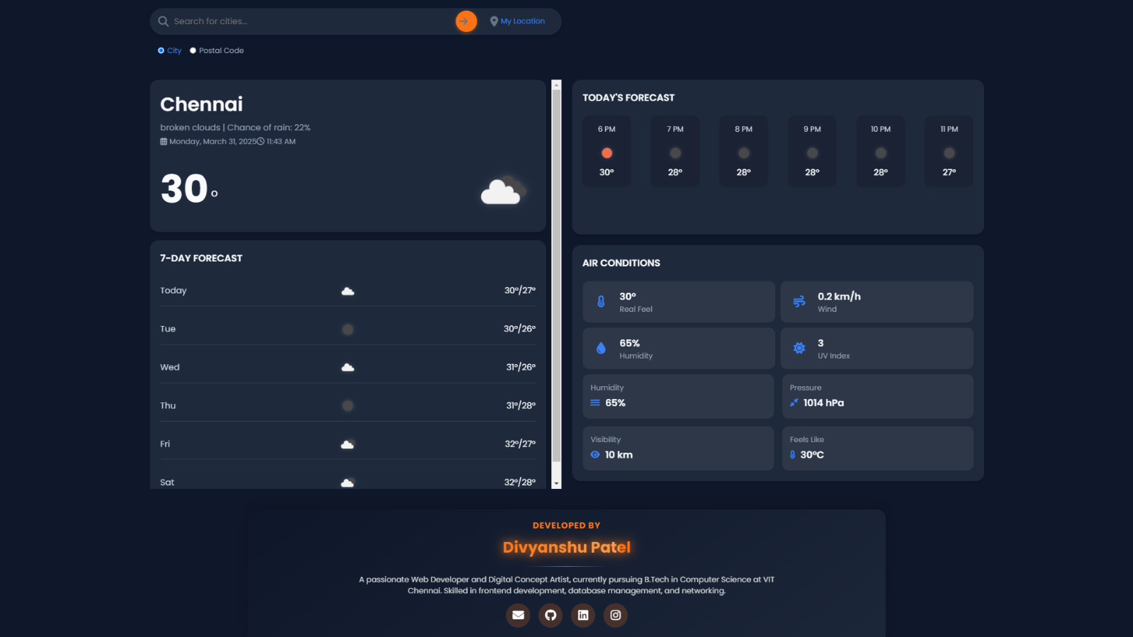

**VIT Timeline:**

[**https://vit-timeline-divyanshu.netlify.app**](https://vit-timeline-divyanshu.netlify.app)

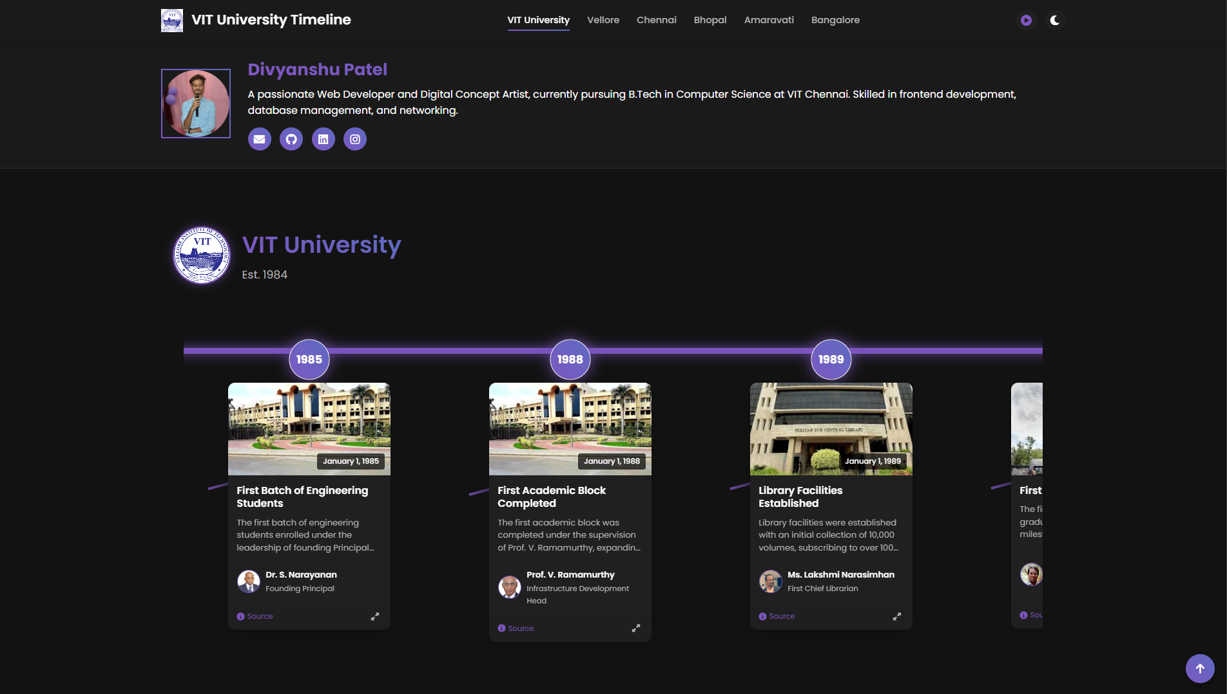

**Quiz App:**

[**https://quiz-app-divyanshu.netlify.app**](https://quiz-app-divyanshu.netlify.app)

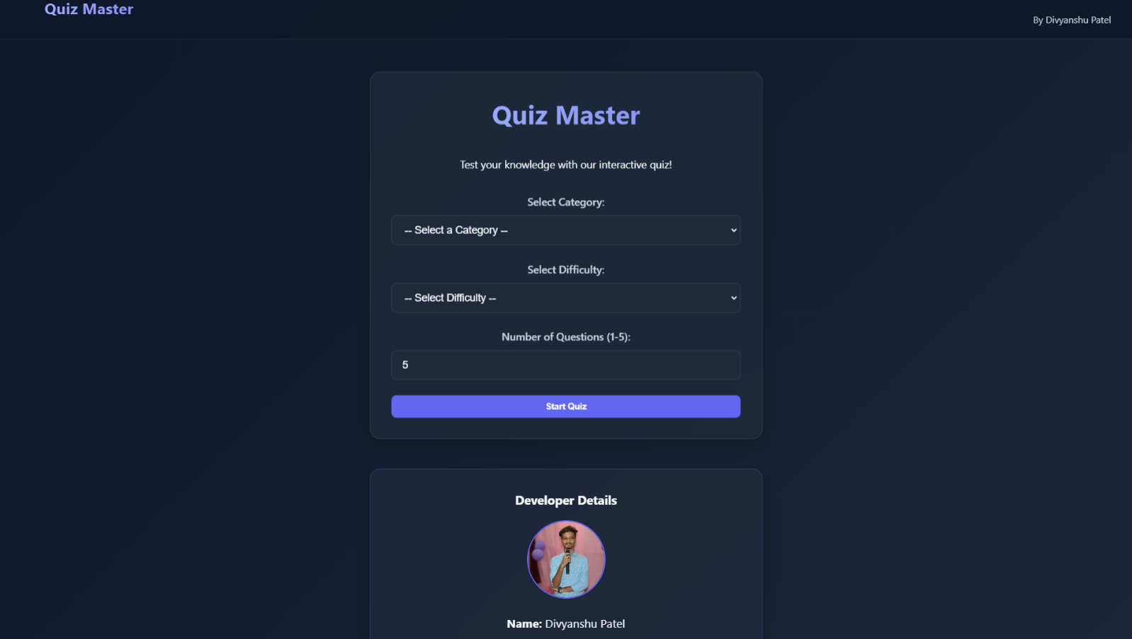

**E-Shop:**

[**https://e-shop-divyanshu.netlify.app**](https://e-shop-divyanshu.netlify.app)

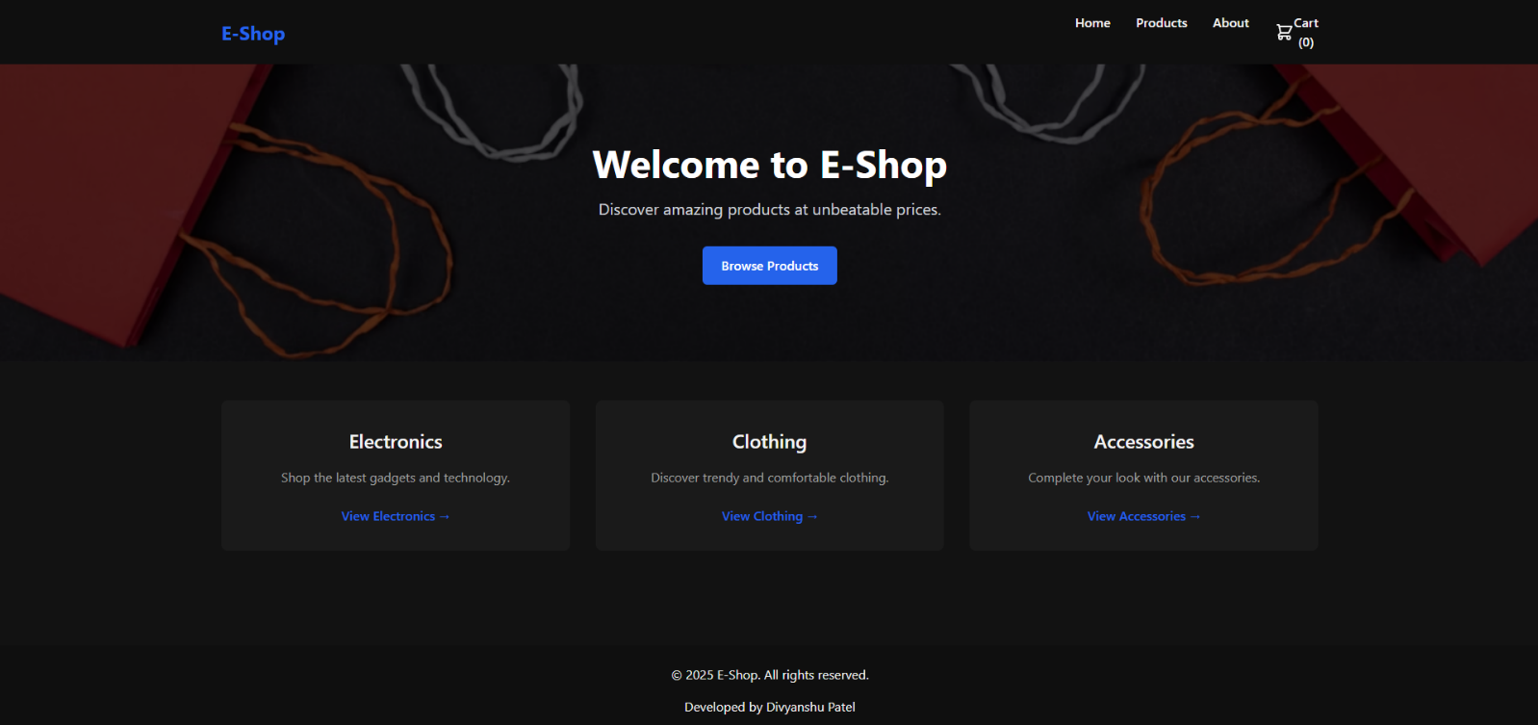

**NEUMORPHISM UI Generator:**

[**https://make-your-own-neumorphism-divyanshu.netlify.app/**](https://make-your-own-neumorphism-divyanshu.netlify.app/)

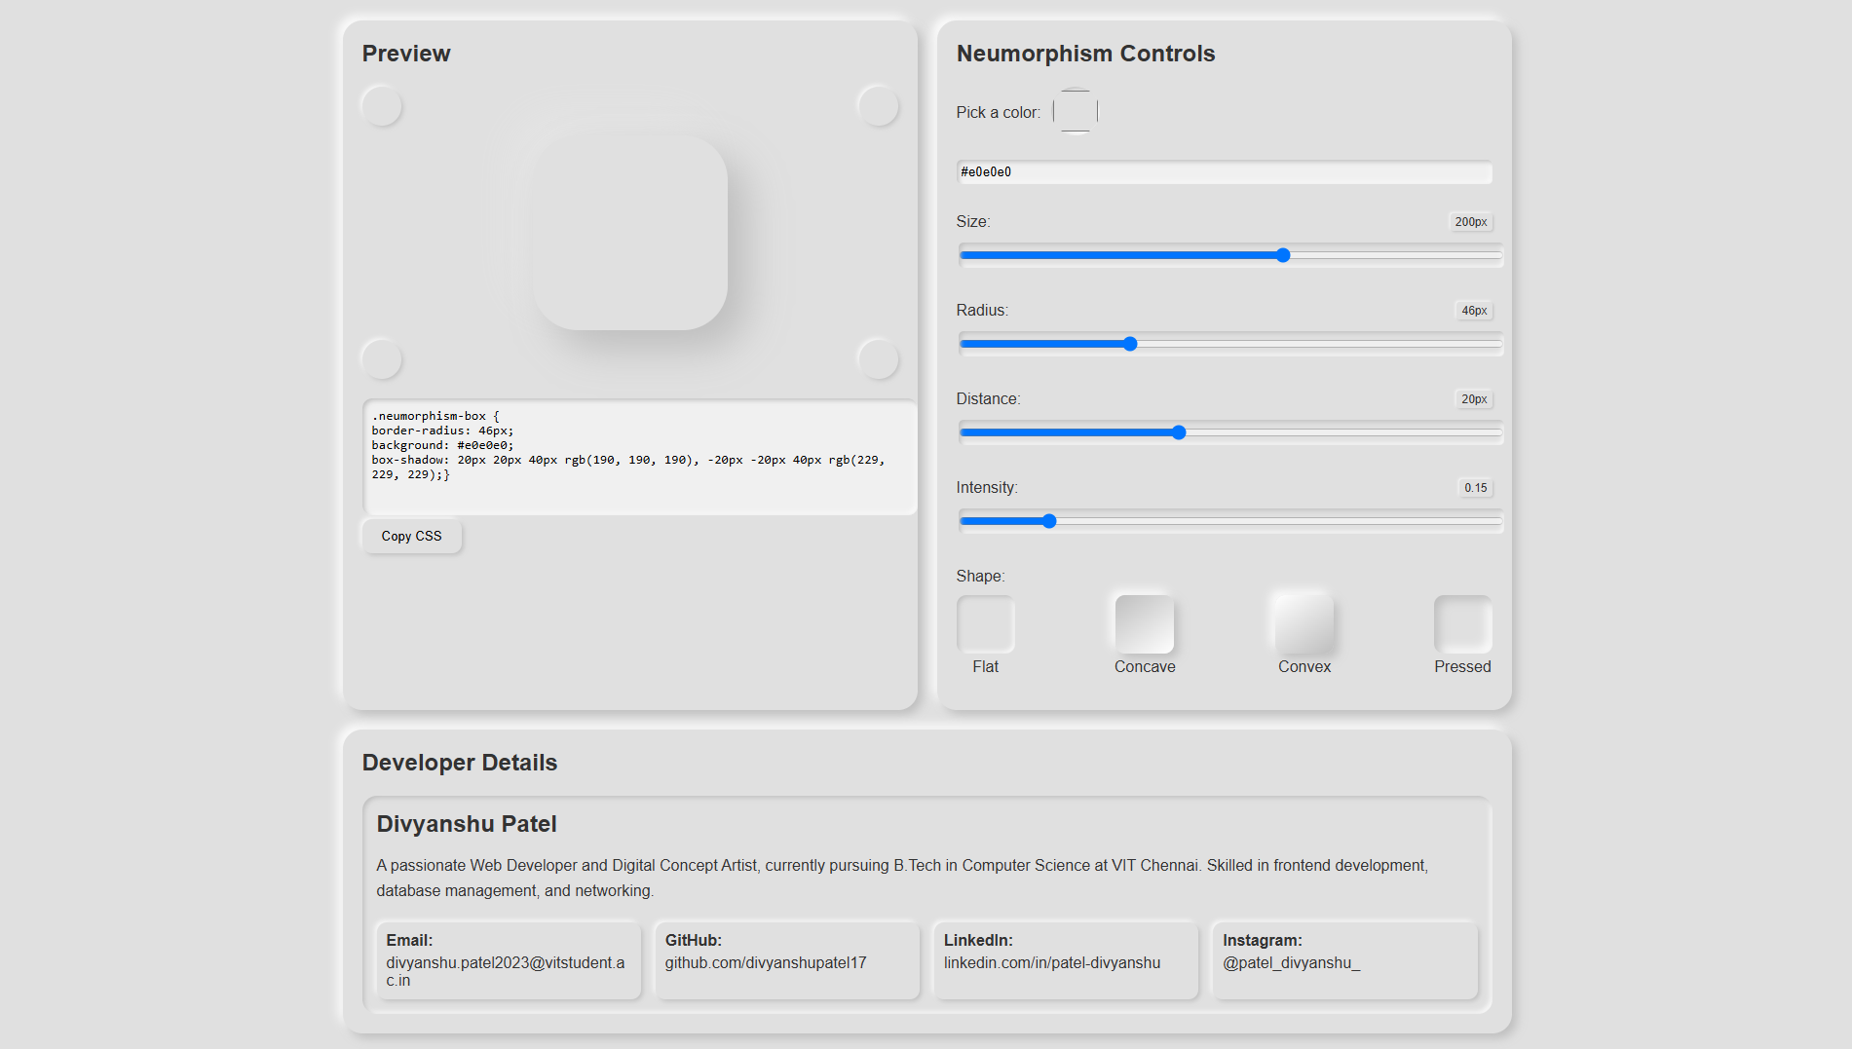

**GitHub Statistics Viewer:**

[**https://github-stats-viewer-divyanshu.netlify.app**](https://github-stats-viewer-divyanshu.netlify.app)

