# DIVYANSHU PATEL

# 23BAI1214

# Lab-8-Peterson's Algorithm

[GITHUB Link LAB 8 (divyanshupatel17)](https://github.com/divyanshupatel17/Operating-System/tree/b75bebe41320ebb6a356d52b94e60faf5ebeab2b/LAB-8-peterson-algorithm)

* 1. Develop a minimal banking application for a single account. Father credits the account with 1000rs and brother debits the account with 200 rs using appropriate synchronization technique

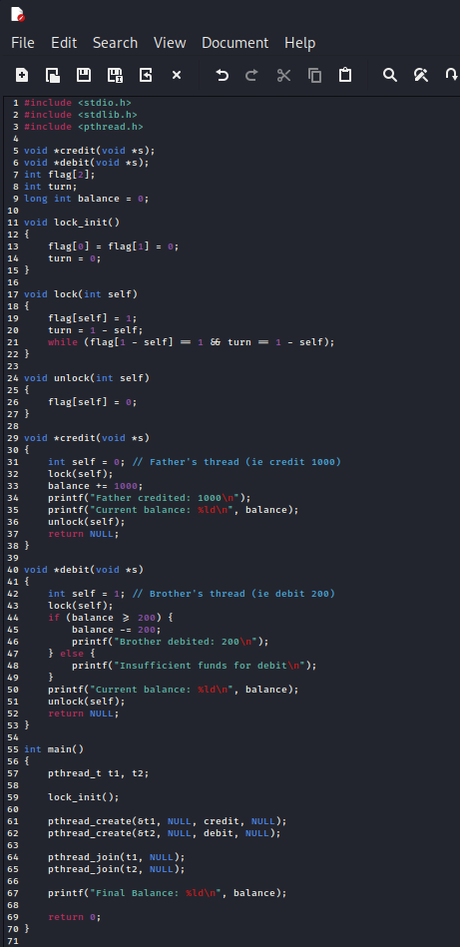

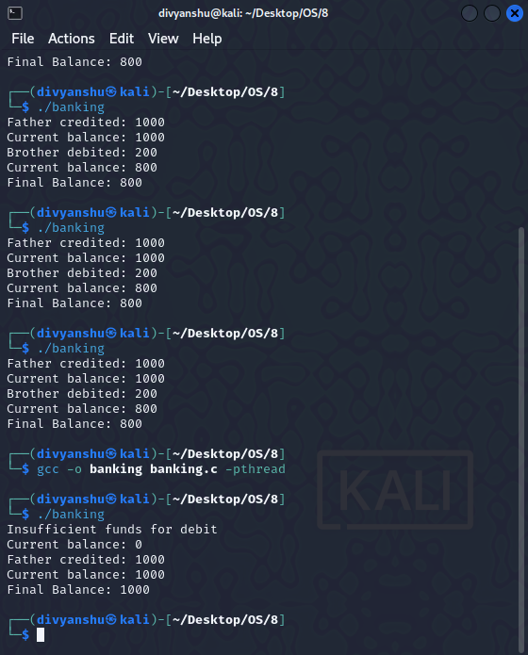

1. Process A and B shares the value of i. its initial value is your registration number last two digits. Process A increments the value of i and B decrements the value of i

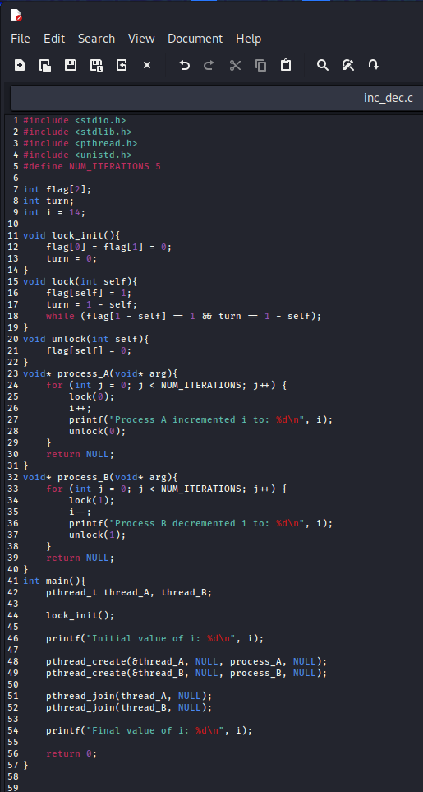

My Reg No:

23BAI1214

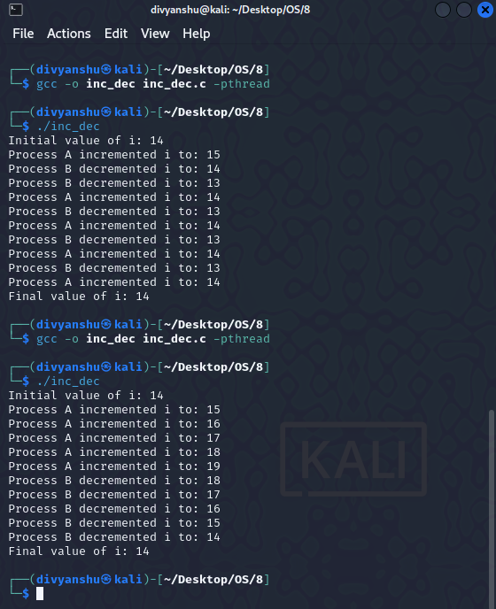

1. Create two threads A and B. One thread prints "A"  10000 times. Other thread B prints the i value from 1 to 100000. Discuss the concurrency of this case study with and without peter's synchronization and submit as a written assignment. along with corresponding code.

