AeroGard: Hyperlocal 24-Hour Air-Quality Forecasting and Personal Exposure Estimation for Respiratory Health Alerts
Author Name 1  Roll No.: ____________  Department of Computer Science and Engineering  Presidency University | Author Name 2  Roll No.: ____________  Department of Computer Science and Engineering  Presidency University | Author Name 3  Roll No.: ____________  Department of Computer Science and Engineering  Presidency University

Abstract—People with asthma or chronic obstructive pulmonary disease (COPD) usually learn about air pollution from a city-wide index that describes the present, not the air around them tomorrow, and says nothing about their own exposure. We are building AeroGard, a software prototype that forecasts air quality 24 hours ahead at a user’s location, estimates personal exposure and will turn both into personalised respiratory-risk alerts. For Bengaluru we ingested 753,481 hourly observations from 14 regulatory monitoring stations (February 2025 to September 2026) together with hourly reanalysis weather, with validation, unit correction and quality flagging. A direct multi-horizon LightGBM model built on 35 leakage-audited features reached a mean absolute error of 5.78 µg/m³ for 24-hour PM_{2.5} forecasts on an untouched test period, 23% better than persistence and 16% better than a same-hour-yesterday baseline. Gains for PM₁₀ and NO₂ were similar, while for O₃ the same-hour-yesterday baseline remained competitive. Exposure is estimated by distance-weighted matching to nearby monitors scaled by microenvironment factors, and all results are served through an authenticated, consent-aware API. The respiratory-risk layer is in progress and will be evaluated on clearly labelled synthetic outcome data.
Index Terms—air quality forecasting, PM2.5, LightGBM, exposure assessment, asthma, COPD, spatial interpolation, data leakage

I. Introduction
Air pollution is one of the leading environmental risks to health worldwide [1]. In India it was linked to about 1.67 million deaths in 2019 [2]. Short-term rises in particulate matter, nitrogen dioxide and ozone are associated with higher mortality [3] and with more asthma emergency visits and hospital admissions [4], so people living with asthma or COPD are among those who most need timely and relevant warnings.
In practice most people check a city-level Air Quality Index. That number describes the city now, not the neighbourhood tomorrow, and it ignores where a person spends their time and how sensitive they are. Building even a reliable picture of the present is harder than it looks: monitoring stations are sparse, public feeds arrive late, readings drop out, and, as we found, units can be mislabelled.
Here we describe AeroGard, a system that forecasts air quality for each of the next 24 hours at a user’s location, estimates personal exposure from location and microenvironment, and, in the part still under development, converts this into a calibrated personal risk and an alert. This paper reports three completed contributions: (1) a validated ingestion pipeline for Bengaluru’s regulatory monitors, including the detection and correction of a unit error in the public feed; (2) a leakage-audited 24-hour forecaster compared on equal terms with two baselines; and (3) a transparent exposure estimate and a secured API that serve these results.

II. Problem Statement and Objectives
Generic air-quality monitoring reports environmental conditions but does not answer the question a patient actually has: given the air expected around me, my recent exposure and my health, what is my respiratory risk over the next 24 hours? There is a need for a system that produces location-specific forecasts, estimates exposure honestly, and communicates risk without making clinical claims.
Our objectives are to (1) collect and validate hourly pollutant and weather data for Bengaluru; (2) match a user’s location to nearby monitors; (3) forecast pollutant concentrations for each of the next 24 hours and evaluate the forecasts against observed data; (4) estimate personal exposure from location and activity context; (5) predict calibrated asthma and COPD risk and map it to alert levels; and (6) deliver the results through a secure API and an Android application. Objectives (1)–(4) and the API are complete; (5) and the application are in progress.

III. Literature Review
Table I lists ten studies we reviewed, with the method and data each used, its main finding and its main limitation.
TABLE I
Summary of Related Work
Ref. | Year | Method / Data | Key Finding | Limitation
[2] | 2021 | Burden-of-disease estimates for Indian states | Air pollution linked to about 1.67 M deaths in India in 2019 | Population level; no individual risk
[3] | 2020 | Meta-analysis of short-term exposure studies | PM, NO₂ and O₃ associated with higher mortality | Pooled effects; not a prediction tool
[4] | 2015 | Meta-analysis of time-series studies | Pollutants associated with asthma ER visits and admissions | Aggregate outcomes, not personal
[5] | 2012 | Review of real-time AQ forecasting | Surveys chemical-transport and statistical approaches | Predates current ML methods
[6] | 2017 | LSTM with spatio-temporal inputs, Beijing | Outperformed statistical baselines for PM_{2.5} | One city; data-hungry model
[7] | 2012 | Multi-step forecasting strategies, NN5 data | Direct and multi-output strategies beat recursive | Not specific to air quality
[8] | 2004 | Interpolation of monitor data (IDW, kriging, others) | Method choice changes exposure estimates | Depends on monitor density
[9] | 2011 | Review of indoor/outdoor particle relationships | I/O ratios vary with building and ventilation | Few South-Asian buildings
[10] | 2022 | Connected inhaler, peak-flow and wearable data + ML | Framework for predicting asthma attacks | Protocol stage; no AQ forecast
[11] | 2014 | Review of air pollution in Indian cities | Documents sources and sparse monitoring | Descriptive; no forecasting

Epidemiological work establishes that short-term exposure matters [1]–[4], but its results are population averages rather than personal predictions. Forecasting research ranges from chemical-transport models to data-driven methods [5]; deep sequence models can outperform statistical baselines [6], and the choice between recursive and direct multi-step strategies affects accuracy [7]. Exposure studies show that an outdoor monitor is an imperfect proxy for what a person breathes: the interpolation method [8] and indoor infiltration [9] both change the estimate. Connected-device asthma studies [10] predict attacks from physiological and inhaler data but do not use air-quality forecasts. Finally, results in this area are easy to inflate through data leakage, where information unavailable at prediction time enters the model [12].
Research gap. Existing work treats air-quality forecasting, exposure estimation and respiratory risk separately. We found few systems for Indian cities that combine station-level 24-hour forecasts, a transparent exposure estimate and personal risk in one traceable pipeline, evaluated with explicit leakage checks against simple baselines.

IV. Proposed Methodology
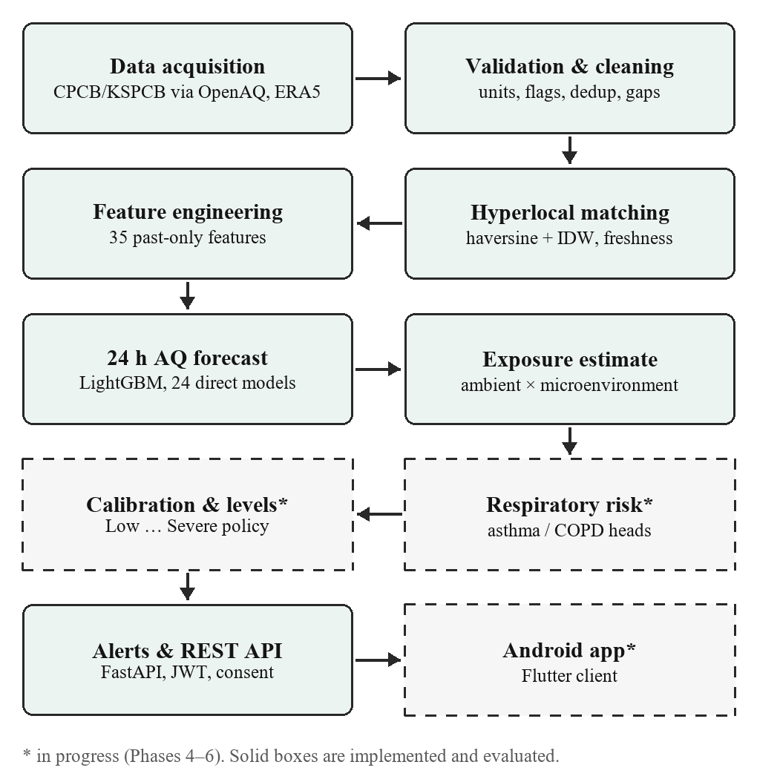
Fig. 1. Methodology pipeline. Dashed stages are in progress.
Fig. 1 shows the pipeline. Hourly pollutant means from regulatory monitors are obtained through the OpenAQ API [13], and hourly ERA5 reanalysis weather [14] through Open-Meteo [15]. Records are validated and cleaned, matched to the user’s location, turned into features and passed to the 24-hour forecaster. The forecast and the user’s location history drive the exposure estimate, which, together with the health profile, will feed the respiratory-risk model, its calibration and the alert engine.
Validation and cleaning. Every record is converted to a canonical form: a UTC timestamp at the end of the averaging hour, a pollutant identity, and a concentration in µg/m³. Gases reported in ppb are converted at 25 °C and 1 atm (µg/m³ = ppb × M / 24.45, with M the molecular weight). Records with missing timestamps, unknown pollutants, invalid coordinates, or missing, non-finite or negative values are rejected and the reason is counted. Hours with fewer than 75% of their sub-hourly readings, provider flags or physically implausible values are kept but flagged. Short gaps of up to 3 h are forward-filled from past values only, and outliers are flagged with a trailing robust z-score (median and MAD over the previous 24 h) rather than deleted.
Hyperlocal matching. For a location we find reference monitors within 10 km by haversine distance, discard readings older than 3 h or later than the query time, and combine up to four stations by inverse-distance weighting with power 2 [8], halving the weight of low-coverage readings. If no usable station remains, the system reports the value as unavailable instead of extrapolating.

V. Dataset
The study area is Bengaluru, India. A 25 km search around the city centre returned 14 CPCB/KSPCB reference monitors with data in the study period; low-cost sensors listed on the same platform were excluded from ground truth. All stations share a gap from about October 2022 to February 2025, when the source feed changed, so we use 18 February 2025 to 21 September 2026, about 19 months. Hourly weather (13,992 h) comes from ERA5 at the city centre. Table II summarises the pollutant data; about 0.3% of fetched records were rejected, all for missing values.
TABLE II
Dataset Composition (Bengaluru, Feb 2025 – Sep 2026)
Pollutant | Stations | Hourly rows | Flagged | Median (µg/m³)
SO₂ | 14 | 133,264 | 13.1% | 19.0
PM₁₀ | 14 | 131,429 | 11.7% | 68.7
NO₂ | 14 | 130,878 | 12.0% | 32.9
CO | 14 | 129,348 | 15.0% | 600.0
O₃ | 12 | 114,773 | 12.5% | 23.7
PM_{2.5} | 12 | 113,789 | 12.3% | 25.3

The current feed labels CO, NO₂ and SO₂ in ppb. For CO this cannot be right: at BTM Layout the median reading was 0.49 in June–September 2025 against 1,260 µg/m³ on the older feed in the same months of 2021, and ambient CO is typically several hundred ppb. The values match CPCB’s reporting unit for CO, mg/m³ [16], so all CO rows were converted accordingly. For NO₂ and SO₂ the comparison is ambiguous; their absolute levels are therefore treated as unverified and are not used in alert thresholds. This does not affect forecasting, because tree-based models are unchanged by a constant rescaling of an input.

VI. Model Development
Each training row is a (station, origin hour t) pair with 35 features: the current value of the target pollutant and whether it was filled; lags of 1, 6, 12, 24 and 48 h; the 1-h difference; rolling mean, maximum and standard deviation over 6 h and 24 h; the number of observed hours in the last day; the current values of the other pollutants; weather at t (temperature, humidity, wind speed and direction as sine and cosine, pressure, precipitation and its 24-h total); calendar terms in Indian Standard Time; and station coordinates. Every feature declares how far back it reads, and an automated test confirms that altering any data after t leaves the features at t unchanged, guarding against leakage [12].
We use a direct multi-horizon strategy [7]: one LightGBM gradient-boosted tree model [17] per horizon h = 1, …, 24, each trained on log(1 + y) and back-transformed, with negative outputs clipped to zero. No forecast is ever fed back in as an input. We chose LightGBM because it trains quickly on a CPU, handles missing values natively, performs well on tabular data and produces small artifacts that are easy to deploy. Two baselines complete the comparison: persistence, ŷ(t+h) = y(t), and seasonal naive, ŷ(t+h) = y(t+h−24).
Targets are observed values from hours flagged valid. Inputs may still use flagged hours, but isolated PM_{2.5} readings of 600–900 µg/m³ during the monsoon, mostly at 25–50% coverage, looked like sensor faults and were not used as ground truth. Results on all observed hours are reported as a secondary check.

VII. Experimental Setup
Table III gives the training configuration and the environment used for the experiments.
TABLE III
Experimental Setup
Item | Value
Split (chronological) | Train 18 Feb 2025 – 31 Jan 2026; validation 1 Feb – 30 Apr 2026; test 1 May – 21 Sep 2026
Origins (PM_{2.5}) | Train 72,342; validation 18,576; test 22,396
Embargo | 24 h before each boundary, so no target crosses a split
Model | LightGBM, 24 direct models per pollutant
Hyperparameters | ≤ 600 trees, learning rate 0.03, 31 leaves, min. 50 samples per leaf, row and column subsampling 0.8, L2 = 1
Early stopping | 50 rounds on validation (best 65–233 trees)
Target transform | log(1 + y)
Evaluation | Test period used once; all models scored on identical pairs
Software | Python 3.14, LightGBM 4.7, scikit-learn 1.9, pandas 3.0, PostgreSQL 16
Hardware | Consumer laptop CPU, Windows 11; no GPU

VIII. Evaluation Metrics
We report mean absolute error (MAE), root mean squared error (RMSE), the coefficient of determination (R²), mean bias, and skill relative to persistence. With ŷ_{i} the forecast, y_{i} the observation and n the number of forecast–observation pairs,
MAE = (1/n) Σ |ŷ_{i} − y_{i}| (1)
RMSE = √[(1/n) Σ (ŷ_{i} − y_{i})²] (2)
R² = 1 − Σ (ŷ_{i} − y_{i})² / Σ (y_{i} − ȳ)² (3)
Skill = 1 − MAE_{model} / MAE_{persistence} (4)
where ȳ is the mean observation. Metrics are computed per horizon and pooled over all 24 horizons. To keep the comparison fair, every model is scored on the same (origin, horizon) pairs, namely those where all models produce a forecast and a valid observation exists; otherwise a baseline that cannot forecast difficult cases would look better than it is.

IX. Results
Table IV gives pooled test-set performance for four pollutants and Table V the PM_{2.5} error by horizon. The test period covers the monsoon season.
TABLE IV
Test Set Performance (Valid Hours)
Pollutant | Model | MAE (µg/m³) | RMSE (µg/m³) | R² | Skill
PM_{2.5} | LightGBM | 5.78 | 15.67 | 0.31 | +23%
PM_{2.5} | Seasonal naive | 6.92 | 22.96 | −0.49 | +8%
PM_{2.5} | Persistence | 7.51 | 22.82 | −0.47 | +0%
PM₁₀ | LightGBM | 14.01 | 26.12 | 0.56 | +26%
PM₁₀ | Seasonal naive | 15.61 | 34.34 | 0.24 | +18%
PM₁₀ | Persistence | 19.03 | 38.80 | 0.03 | +0%
NO₂ | LightGBM | 5.74 | 37.69 | 0.24 | +28%
NO₂ | Seasonal naive | 6.83 | 45.79 | −0.13 | +14%
NO₂ | Persistence | 7.93 | 45.39 | −0.11 | +0%
O₃ | Seasonal naive | 4.83 | 11.32 | 0.52 | +28%
O₃ | LightGBM | 5.02 | 10.51 | 0.59 | +25%
O₃ | Persistence | 6.68 | 14.53 | 0.21 | +0%

TABLE V
PM_{2.5} MAE by Forecast Horizon
Model (MAE, µg/m³) | 1 h | 3 h | 6 h | 12 h | 18 h | 24 h
LightGBM | 3.18 | 4.99 | 5.71 | 5.97 | 6.12 | 6.39
Seasonal naive | 7.24 | 7.01 | 6.87 | 6.85 | 6.88 | 7.02
Persistence | 3.32 | 6.08 | 7.66 | 8.47 | 8.18 | 7.02

LightGBM had the lowest MAE for PM_{2.5}, PM₁₀ and NO₂, improving on persistence by 23%, 26% and 28%. Table V shows where the gain comes from: at 1 h ahead persistence is almost as good, but its error grows quickly with horizon, whereas LightGBM’s grows slowly and stays below the seasonal baseline at every horizon. The same ordering held on the validation period (February–April, the dry season, when PM_{2.5} is higher): MAE 12.63 for LightGBM against 14.38 for seasonal naive and 16.98 for persistence.
Three results qualify this picture. For O₃, the seasonal-naive baseline has the lowest MAE, although LightGBM has the lower RMSE and higher R²; ozone follows the daily cycle of sunlight so closely that yesterday’s value at the same hour is hard to beat. For NO₂ at 1 h ahead, persistence beats LightGBM. For PM_{2.5}, RMSE is well above MAE and R² is modest, which means the model improves typical hours but does not anticipate sudden spikes. All forecasts are slightly biased low (PM_{2.5} bias −1.60 µg/m³), as expected from training on a log scale. Scoring against all observed hours, including flagged ones, gives the same conclusion (PM_{2.5} MAE 5.95 against 7.67 for persistence).

X. Exposure Estimation
Exposure is an estimate, not a measurement: no personal sensor is used. For each hour we take the ambient concentration at the user’s location from the matching in Section IV and multiply it by a factor for the user’s microenvironment (Table VI). The factors are central assumptions drawn from indoor/outdoor studies [9], not values calibrated to AeroGard users.
TABLE VI
Microenvironment Factors (Exposure / Ambient)
Setting | PM_{2.5} | PM₁₀ | NO₂ | O₃ | CO
Outdoors / unknown | 1.0 | 1.0 | 1.0 | 1.0 | 1.0
Indoors, home | 0.8 | 0.6 | 0.6 | 0.3 | 0.9
Indoors, other | 0.6 | 0.5 | 0.5 | 0.2 | 0.8
In traffic | 1.3 | 1.3 | 1.6 | 0.8 | 1.8

If no location fix exists in the two hours before a given hour, that hour’s exposure is reported as missing rather than guessed, and an unknown microenvironment is treated as outdoors and flagged. Six-, 24- and 72-hour means, maxima and cumulative exposure (µg/m³·h) are reported together with their coverage and marked incomplete below 75%. Because the factors are assumptions, results that depend on them will be re-run with all non-outdoor factors scaled up and down as a sensitivity analysis.

XI. System Architecture and Implementation
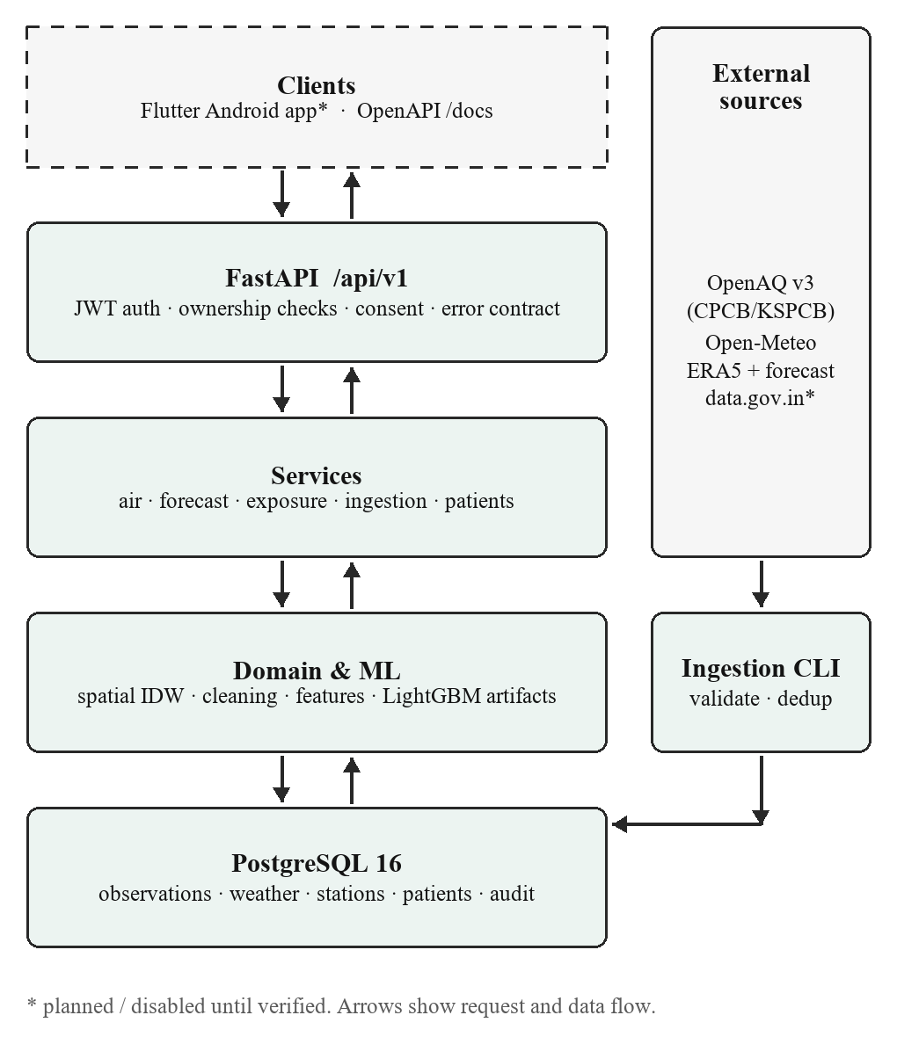
Fig. 2. System architecture of the platform.
Fig. 2 shows the architecture. Clients call a versioned REST API built with FastAPI. Routes stay thin and delegate to services, which use repositories for database access and the domain and machine-learning modules for matching, cleaning, features and inference. An ingestion command-line tool pulls data from the external sources, validates it and writes it to PostgreSQL.
Backend. The API exposes current and forecast air quality for a location, the list of reference stations, location upload, and current and historical exposure. Forecasts come from frozen, versioned model files; each carries a metadata record with its training period, metrics and checksum, and the service refuses to load a file whose checksum or feature list does not match the code. If no model is available the API returns an explicit error rather than a placeholder value.
Security and privacy. Passwords are hashed with Argon2 and sessions use short-lived JSON Web Tokens with rotating refresh tokens. Every patient-scoped operation checks ownership, so one user cannot read another user’s data, and location and exposure require recorded consent. Sensitive actions are written to an audit log that stores counts and field names, never health or location values.
Testing. An automated suite of 232 tests runs against a separate database built through the real migrations. It covers authentication and token misuse, patient isolation, source adapters under malformed input, timeouts and partial failure, validation and unit conversion, idempotent reloading, spatial edge cases, leakage guards, forecast horizons and artifact checks.

XII. Respiratory Risk Layer (In Progress)
The next stage predicts, for each patient, the probability of a respiratory exacerbation in the next 24 hours from exposure, forecast air quality and the health profile, using a shared representation with separate asthma and COPD outputs. Probabilities will be calibrated and evaluated with AUROC, AUPRC, the Brier score and calibration error, then mapped to Low, Moderate, High and Severe levels by a versioned threshold policy that can change without retraining. Generic, disease-specific and adaptive thresholds will be compared, and explanations will use SHAP attributions [18], worded to avoid causal claims. Because real patient outcomes are not available within the project, this layer will be trained and evaluated on a clearly labelled synthetic cohort; those results will demonstrate the pipeline and will not constitute clinical validation.

XIII. Conclusion
We built the data, forecasting and exposure layers of a respiratory-alert system for Bengaluru. Careful validation mattered: it exposed a CO unit error in the public feed, isolated suspect sensor spikes, and caught a leakage bug in our own gap filling. On an untouched test period the direct LightGBM forecaster reduced 24-hour PM_{2.5} error to 5.78 µg/m³, 23% better than persistence, with similar gains for PM₁₀ and NO₂, while for ozone a same-hour-yesterday baseline remained as good. The system serves these results through a secured, consent-aware API, and the risk and alert layers are being built on the same traceable pipeline.

XIV. Future Scope
Future work includes the calibrated asthma and COPD risk model and alert engine, the Android application with optional Health Connect data, verification of NO₂ and SO₂ units against CPCB’s own feed, evaluation over a full year including winter, comparison with sequence models such as LSTM [6], forecast-driven weather inputs, and validation of the exposure factors with personal sensors.

References
[1] GBD 2019 Risk Factors Collaborators, “Global burden of 87 risk factors in 204 countries and territories, 1990–2019: A systematic analysis for the Global Burden of Disease Study 2019,” Lancet, vol. 396, no. 10258, pp. 1223–1249, Oct. 2020.
[2] India State-Level Disease Burden Initiative Air Pollution Collaborators, “Health and economic impact of air pollution in the states of India: The Global Burden of Disease Study 2019,” Lancet Planet. Health, vol. 5, no. 1, pp. e25–e38, Jan. 2021.
[3] P. Orellano, J. Reynoso, N. Quaranta, A. Bardach, and A. Ciapponi, “Short-term exposure to particulate matter (PM10 and PM2.5), nitrogen dioxide (NO2), and ozone (O3) and all-cause and cause-specific mortality: Systematic review and meta-analysis,” Environ. Int., vol. 142, Art. no. 105876, Sep. 2020.
[4] X.-Y. Zheng, H. Ding, L.-N. Jiang, S.-W. Chen, J.-P. Zheng, M. Qiu, Y.-X. Zhou, Q. Chen, and W.-J. Guan, “Association between air pollutants and asthma emergency room visits and hospital admissions in time series studies: A systematic review and meta-analysis,” PLoS ONE, vol. 10, no. 9, Art. no. e0138146, Sep. 2015.
[5] Y. Zhang, M. Bocquet, V. Mallet, C. Seigneur, and A. Baklanov, “Real-time air quality forecasting, part I: History, techniques, and current status,” Atmos. Environ., vol. 60, pp. 632–655, Dec. 2012.
[6] X. Li, L. Peng, X. Yao, S. Cui, Y. Hu, C. You, and T. Chi, “Long short-term memory neural network for air pollutant concentration predictions: Method development and evaluation,” Environ. Pollut., vol. 231, pp. 997–1004, Dec. 2017.
[7] S. Ben Taieb, G. Bontempi, A. F. Atiya, and A. Sorjamaa, “A review and comparison of strategies for multi-step ahead time series forecasting based on the NN5 forecasting competition,” Expert Syst. Appl., vol. 39, no. 8, pp. 7067–7083, Jun. 2012.
[8] D. W. Wong, L. Yuan, and S. A. Perlin, “Comparison of spatial interpolation methods for the estimation of air quality data,” J. Expo. Anal. Environ. Epidemiol., vol. 14, no. 5, pp. 404–415, 2004.
[9] C. Chen and B. Zhao, “Review of relationship between indoor and outdoor particles: I/O ratio, infiltration factor and penetration factor,” Atmos. Environ., vol. 45, no. 2, pp. 275–288, Jan. 2011.
[10] K. C. H. Tsang, H. Pinnock, A. M. Wilson, D. Salvi, and S. A. Shah, “Predicting asthma attacks using connected mobile devices and machine learning: The AAMOS-00 observational study protocol,” BMJ Open, vol. 12, no. 10, Art. no. e064166, 2022.
[11] S. K. Guttikunda, R. Goel, and P. Pant, “Nature of air pollution, emission sources, and management in the Indian cities,” Atmos. Environ., vol. 95, pp. 501–510, Oct. 2014.
[12] S. Kaufman, S. Rosset, C. Perlich, and O. Stitelman, “Leakage in data mining: Formulation, detection, and avoidance,” ACM Trans. Knowl. Discov. Data, vol. 6, no. 4, Art. no. 15, Dec. 2012.
[13] OpenAQ, “OpenAQ API v3 documentation.” [Online]. Available: https://docs.openaq.org (accessed Sep. 2026).
[14] H. Hersbach et al., “The ERA5 global reanalysis,” Q. J. R. Meteorol. Soc., vol. 146, no. 730, pp. 1999–2049, Jul. 2020.
[15] P. Zippenfenig, “Open-Meteo.com weather API.” [Online]. Available: https://open-meteo.com (accessed Sep. 2026).
[16] Central Pollution Control Board, “National Ambient Air Quality Standards,” Gazette of India, Ministry of Environment and Forests, New Delhi, India, Nov. 2009.
[17] G. Ke, Q. Meng, T. Finley, T. Wang, W. Chen, W. Ma, Q. Ye, and T.-Y. Liu, “LightGBM: A highly efficient gradient boosting decision tree,” in Proc. Adv. Neural Inf. Process. Syst. (NeurIPS), Long Beach, CA, USA, 2017, pp. 3146–3154.
[18] S. M. Lundberg and S.-I. Lee, “A unified approach to interpreting model predictions,” in Proc. Adv. Neural Inf. Process. Syst. (NeurIPS), Long Beach, CA, USA, 2017, pp. 4765–4774.

