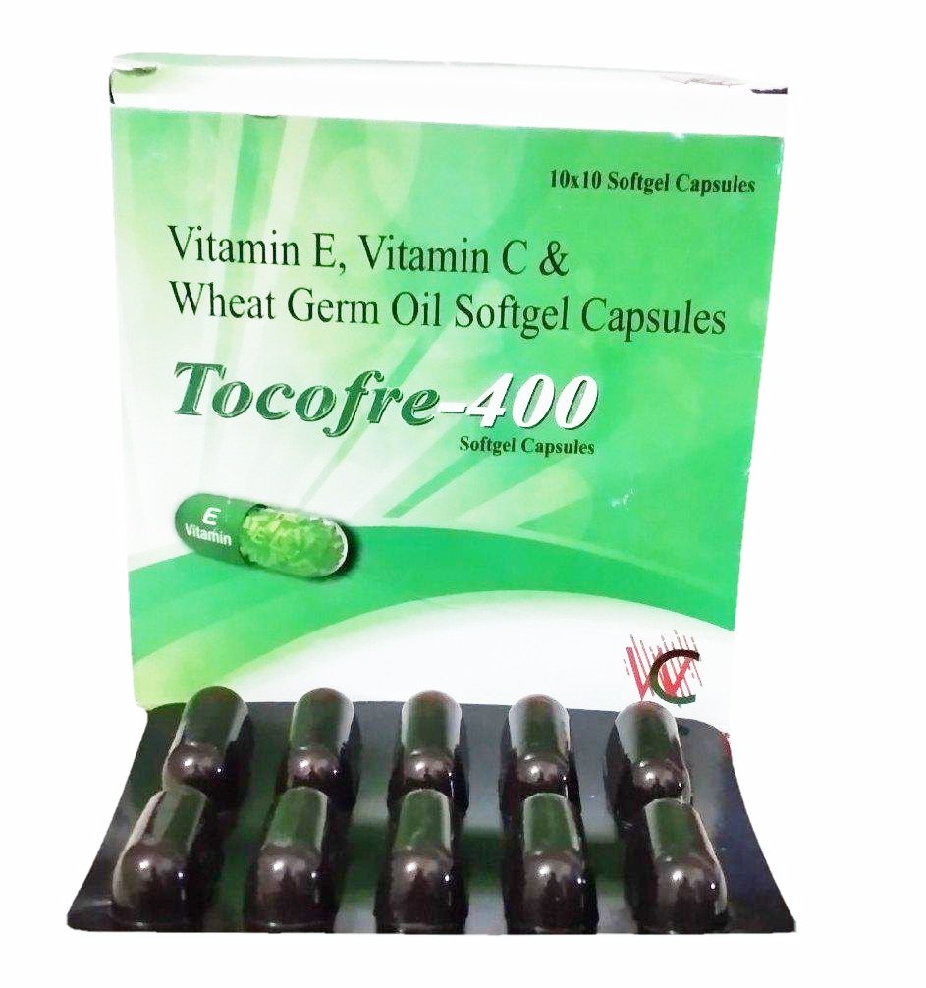

Vitamin E, Vitamin C &

**10x10 Softgel Capsules**

Wheat Germ Oil Softgel Capsules

***Tocofre-400***

**Softgel Capsules**

E

Vitamin