Project 3: LLM Spend Control Center
Primary topic: LLMOps Secondary: Cost optimisation, Model routing, Budgets, Observability
A gateway in front of every LLM call that routes by complexity, enforces team budgets before the call, and proves the savings did not cost quality.

1. Problem
Once several teams ship AI features, every request defaults to the strongest model, nobody owns the bill, and finance finds out at month end. Cutting cost blindly breaks quality; nobody can show which requests actually needed the expensive model.

Why it matters
- Most traffic is extraction, formatting and classification, which cheap models handle well.
- Budgets must be enforced before the provider call, but the true cost is only known after it.
- Savings claims are only credible with a quality check on the cheap path.
- Per-team and per-feature attribution turns cost into an engineering metric.

2. Goals and success criteria
Goal | Success criterion
Single gateway contract | One request/response schema across OpenAI, Anthropic and local models
Complexity-based routing | Tier 1-3 classifier with feature overrides in config
Budget enforcement | Warn at 80%, block low priority at 100%, override for normal/high
Quality-safe savings | 10% async verification sample; routing misses recorded
Cost visibility | Spend by team/feature, projection, savings vs all-strong counterfactual

Non-goals
- Learning the router from data in V1 (heuristic tiers first, measured by the verifier).
- Real-time Grafana; the dashboard is a generated report over the SQLite audit trail.

3. Architecture
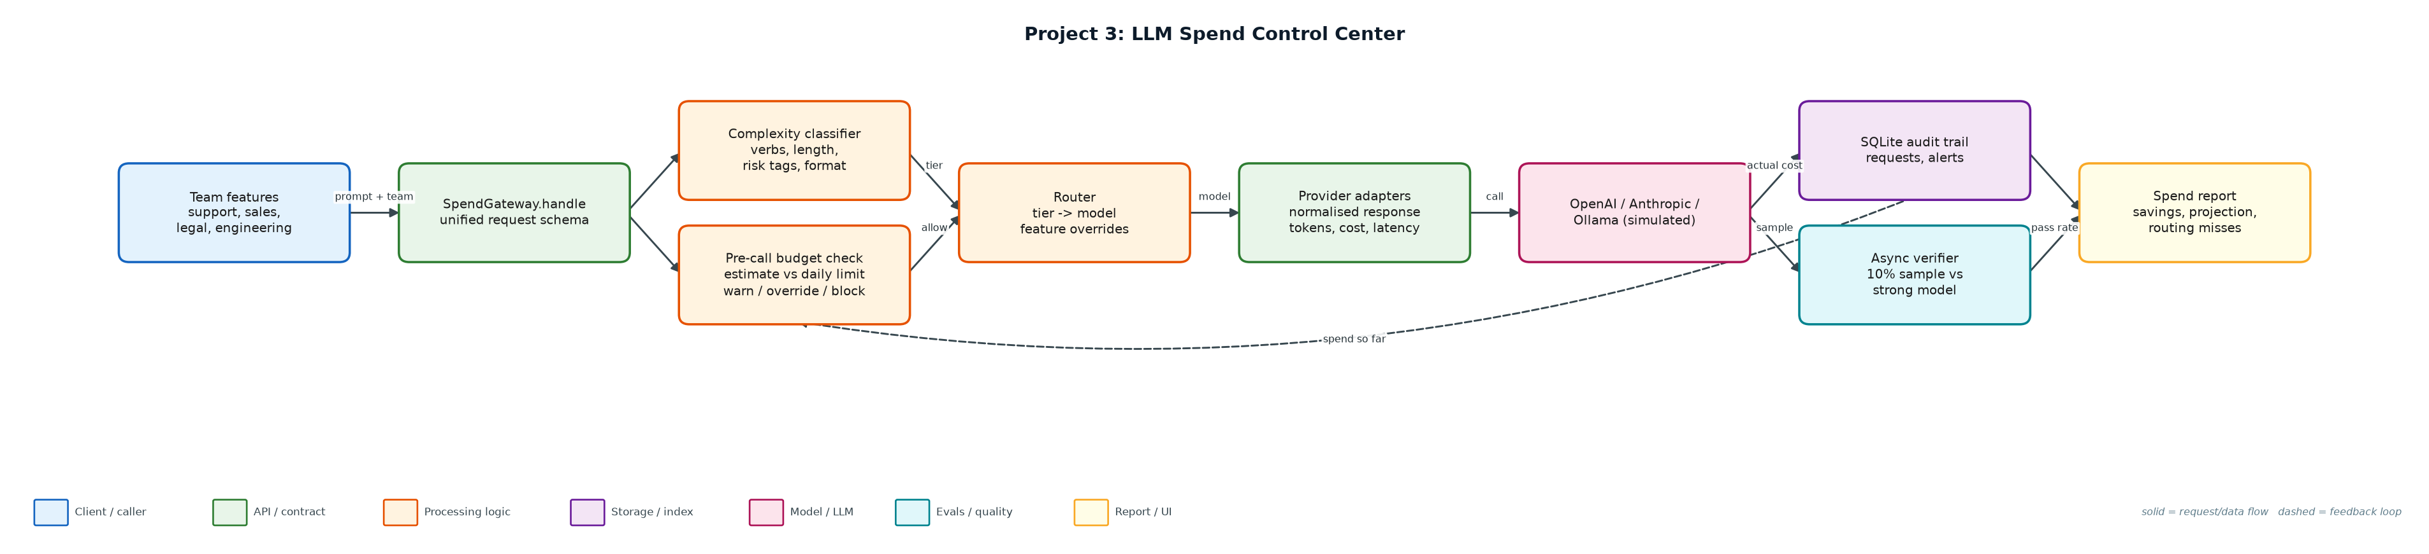
Figure 1. Architecture: solid arrows are the request/data path, dashed arrows are feedback loops.

Components
Component | File | Responsibility
Classifier | classifier.py | Assigns tier 1-3 from instruction verbs, context length, output format and risk tags.
Gateway | gateway.py | Routing, pre-call budget enforcement, escalation for high-priority low-confidence answers, audit logging.
Provider adapters | providers.py | Normalised responses; simulated provider uses registry prices, latency and a quality model.
Model registry | ../common/pricing.py | Model name, provider, tier, input/output price, latency profile, quality.
Config | config/routing.json, config/budgets.json | Tier mapping, overrides, sample rate, team budgets.
Simulation & report | simulate.py | Seeded 1,000-request workload and spend report over the audit DB.

4. Request / data flow
- A feature sends prompt, team, feature, priority and risk tags to the gateway.
- The classifier assigns a tier and records why (verb, length, risk tag, output format).
- The router maps tier to a model unless a feature override (e.g. contract_review) pins a stronger one.
- The budget check estimates the cost and compares spend-so-far + estimate with the team's daily limit.
- Over the limit: low priority is blocked with a clear error; normal/high is served and flagged as an override. At 80% an alert fires once per team per day.
- The provider adapter returns text, tokens, latency and actual cost; high-priority low-confidence answers are escalated to the strong model.
- Every request is written to the audit table; 10% of cheap-model responses are verified against the strong model and misses are recorded.
- The report aggregates spend, projection, model mix, latency, verifier pass rate, routing misses and alerts.

5. Key design decisions
Decision | Why | Trade-off
Enforce on estimate, settle on actual | Blocking must happen before money is spent. | Estimates can be wrong; reconcile from the audit log.
Priority-aware blocking | Low-priority batch work can wait; customer-facing work should not fail. | Overrides can exceed budgets; they are flagged and alerted.
Heuristic router + verifier | Explainable routing now, measured quality, data to train a router later. | Heuristics miss hidden difficulty (seen as routing misses).
Feature overrides in config | Some features (legal) must always use the strongest model. | Overrides reduce savings; visible per feature.
Counterfactual savings | Compare with 'everything on the strongest model' using the same tokens. | Assumes equal token counts across models.

6. Evaluation and metrics
- Savings vs all-strong counterfactual on the same workload (67% in the seeded simulation).
- Verifier pass rate on sampled cheap-model responses (~89%) and a list of routing misses.
- Blocked requests, budget overrides and alerts per team per day.
- p50/p95 latency per model and escalation rate.

7. How to run
python simulate.py --requests 1000
sqlite3 reports/spend.db 'select team, round(sum(cost_usd),4) from requests group by team'
python -m unittest discover -s tests

Sample output
Command: python3 simulate.py --requests 1000
# LLM spend report (1000 simulated requests over 3 days)

- Served: 981 · blocked by budget: 19 · budget overrides: 60
- Actual spend: $0.8814 · all-claude-sonnet counterfactual: $2.6691 · **savings 67.0%**
- Monthly projection at this rate: $8.81
- Verifier pass rate: 89.1% on 92 sampled cheap-model responses
- Escalation rate: 1.4%

## Spend by team
...
Full report: reports/spend_report.md · audit trail: reports/spend.db

8. Project structure
Path | Purpose
classifier.py | Tier classifier
gateway.py | Gateway, budgets, escalation, audit
providers.py | Provider adapters + simulated quality oracle
config/ | Routing and budget configuration
simulate.py | Workload simulation and spend report
reports/ | spend_report.md and spend.db (generated)
tests/ | Unit tests

9. Interview talking points
- Budgets are enforced before the call, but the final cost is only known after the response; the audit log reconciles the two.
- Savings without a quality check is not a result. The verifier shows the cheap path passes ~89% of sampled checks and lists the misses.
- Routing misses are training data for a learned router later.
- Priority matters: low-priority work is blocked, customer-facing work is served and flagged.
- Per-feature attribution showed contract_review and log_triage dominate spend, which is where optimisation effort should go.

10. Production roadmap
- Expose the gateway as a FastAPI proxy with OpenAI-compatible endpoints; move counters to Redis.
- Move verification to Celery/RQ workers and alert to Slack.
- Train a small classifier on logged features + verifier outcomes to replace the heuristics.
- Grafana dashboard on Postgres with monthly projections and anomaly alerts.

11. Resume bullet
Built an LLM spend gateway with complexity-based routing, pre-call team budgets and sampled quality verification; cut simulated spend 67% vs an all-strong-model baseline with an ~89% verifier pass rate.

