Project 7: RAG Freshness & Drift Monitor
Primary topic: RAG Secondary: Data quality, Observability, Incremental indexing
Detects when the deployed RAG index has fallen behind its source documents, ranks changes by business impact, and proves an incremental rebuild fixes the stale answers.

1. Problem
RAG systems silently go stale. Prices change, policies flip, docs are deleted, and the vector index keeps serving last quarter's facts with full confidence. Teams only find out when a customer quotes the wrong refund window back to support.

Why it matters
- Stale answers are confidently wrong, the worst failure mode for a support bot.
- Embedding similarity barely moves when '30 days' becomes '14 days'.
- Full re-indexing is slow and expensive; most chunks did not change.
- Doc owners need a review SLA, not just engineers.

2. Goals and success criteria
Goal | Success criterion
Content manifest with hashes | Per-chunk sha256 of normalised text; whitespace-only edits ignored
Classify each change | cosmetic / minor / material using numbers, polarity words, semantic shift
Rank by impact | severity x criticality x probe traffic
Prove drift with probes | Deployed vs candidate answers; stale answers counted by traffic
Cheap incremental rebuild | Re-embed only material/minor/added chunks; report cost avoided

Non-goals
- Answer generation quality (see Project 1); answers are the best matching sentence.
- Crawling sources: KB folders stand in for Confluence/Notion/Git connectors.

3. Architecture
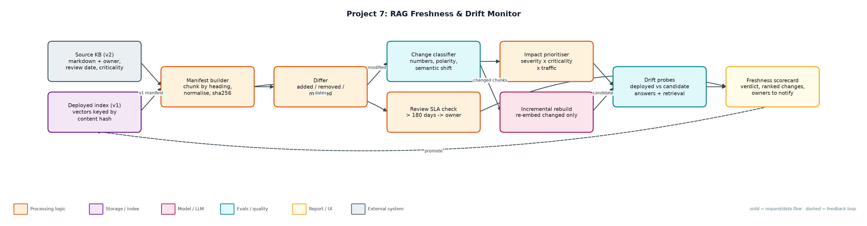
Figure 1. Architecture: solid arrows are the request/data path, dashed arrows are feedback loops.

Components
Component | File | Responsibility
Manifest + classifier | freshness.py | Front-matter parsing, heading chunks, hashing, diff, change severity, review SLA.
Index + probes | drift.py | Hash-keyed vector index with embed-call counting; probe runner comparing deployed and candidate answers.
Monitor CLI | monitor.py | Builds both indexes, ranks changes, runs probes, prints and writes the scorecard.
Knowledge bases | data/kb_v1, data/kb_v2 | Five docs each: price changes, refund window, SCIM flip, typo fix, removed and added docs.
Probes | data/probes.jsonl | Ten production-style questions with the current fact and traffic weight.

4. Request / data flow
- Parse every source and deployed doc into heading-level chunks with owner, review date and criticality.
- Hash normalised text: whitespace-only edits produce the same hash and are ignored.
- Diff the manifests into added, removed and modified chunks.
- Classify modified chunks: any numeric change or polarity flip (not/now/only/removed) is material, even if the embedding barely moved.
- Rank changes by severity x doc criticality x how much probe traffic the chunk currently serves.
- Build a candidate index by re-embedding only changed and added chunks; cosmetic edits update text but keep the vector.
- Run probes against deployed and candidate; count stale answers weighted by traffic.
- Write the scorecard with a verdict, ranked changes, probe table and owners past their review SLA.

5. Key design decisions
Decision | Why | Trade-off
Rules before embeddings for change severity | Semantic shift for '30 -> 14 days' was only 0.041. | Rules need extending for new fact types (dates, names).
Traffic-weighted freshness | A stale pricing chunk matters more than a stale footnote. | Needs real query logs to estimate traffic.
Hash-keyed vectors | Makes incremental rebuild trivial and auditable. | Chunking changes invalidate all hashes.
Probes with current facts | Proves user-visible drift, not just file changes. | Probe set must be maintained (see Project 5).
Owner SLA in front-matter | Pushes freshness to the people who own the content. | Depends on accurate metadata.

6. Evaluation and metrics
- 7 changes detected: 6 material, 1 cosmetic; the whitespace-only edit correctly produced no change.
- Embedding shift for numeric changes was 0.018-0.045, proving similarity alone would miss them.
- Traffic-weighted freshness 39% deployed -> 100% after incremental rebuild; 5 of 10 probes were stale and all fixed.
- Rebuild re-embedded 5 of 9 chunks (44% embedding cost avoided).
- 6 unit tests covering classification, hashing, diff, rebuild correctness, SLA and embed caching.

7. How to run
python monitor.py
python monitor.py --deployed data/kb_v1 --source data/kb_v2 --today 2026-11-06
python -m unittest discover -s tests

Sample output
Command: python3 monitor.py
Deployed chunks: 9 · source chunks: 9
Changes: 7 (6 material, 0 minor, 1 cosmetic)

Prioritised changes:
p= 26.1 modified material pricing#plans sem=0.018 traffic=190 numeric fact changed ['25 -> 29']
p= 22.5 modified material refunds#refund-window sem=0.041 traffic=150 numeric fact changed ['30 -> 14']
p= 16.2 modified material pricing#annual-billing sem=0.045 traffic=80 numeric fact changed ['15% -> 20%']
p= 8.1 modified material sso#scim-provisioning sem=0.521 traffic=35 polarity words changed: ['not', 'now']
p= 6.0 added material data-export#export-api sem=1.0 traffic=0 new chunk not yet indexed
p= 4.65 removed material legacy-export#csv-export sem=1.0 traffic=55 chunk deleted at source
p= 0.0 modified cosmetic refunds#how-to-request sem=0.043 traffic=40 typo / whitespace only

Probes (deployed -> candidate):
p01 STALE -> fixed drift=answer How much does the Pro plan cost per user?
p02 STALE -> fixed drift=answer What discount do I get for annual billing?
p03 STALE -> fixed drift=answer How many days do I have to get a refund on a monthly plan?
p04 ok -> ok drift=answer How long does it take for refunds to be processed?
p05 STALE -> fixed drift=answer Is SCIM user provisioning supported?
p06 ok -> ok drift=- Which plan includes SAML SSO?
p07 ok -> ok drift=- What is the API rate limit per minute?
p08 ok -> ok drift=- How many items does a list endpoint return per page?
p09 STALE -> fixed drift=retrieval+answer How do I export my workspace data?
p10 ok -> ok drift=- How much does the Starter plan cost?

Traffic-weighted freshness: 39% deployed -> 100% after incremental rebuild
Incremental rebuild re-embedded 5 of 9 chunks (44% embedding cost avoided)
Docs past review SLA (180 days): sso (identity-team, 340d)
Verdict: REBUILD NOW
Wrote reports/freshness_scorecard.md and reports/source_manifest.json

8. Project structure
Path | Purpose
freshness.py | Manifest, diff, change classification
drift.py | Vector index and drift probes
monitor.py | CLI and scorecard
data/ | kb_v1, kb_v2, probes
reports/ | freshness_scorecard.md, source_manifest.json

9. Interview talking points
- Embeddings are bad at detecting factual change: 30 to 14 days moved similarity by only 4%.
- I combine cheap deterministic signals (hashes, numbers, polarity) with semantic shift.
- Freshness is traffic-weighted so the scorecard reflects user impact, not file counts.
- Incremental rebuild keyed by content hash avoided 44% of embedding calls here; far more at scale.
- Owners get notified when docs pass their review SLA, so freshness is a shared responsibility.

10. Production roadmap
- Connectors for Confluence, Notion, Google Drive and Git with webhooks for change events.
- Run on a schedule and on source webhooks; alert in Slack with the top 5 ranked changes.
- LLM-based fact extraction to compare claims between versions.
- Blue/green index promotion with probes as the gate.

11. Resume bullet
Built a RAG freshness monitor that hashes and classifies source changes, ranks them by traffic impact and rebuilds incrementally, lifting traffic-weighted answer freshness from 39% to 100% while avoiding 44% of embedding cost.

