Project 9: Multimodal Document Intake Pipeline
Primary topic: Multimodal Secondary: OCR, Structured extraction, Business rules, Human review
Reads scanned invoices, receipts and purchase orders, falls back to a vision model only when OCR is unreliable, validates against business rules and routes by field confidence.

1. Problem
Finance and ops teams still key in invoices by hand. Sending every page to a vision LLM is accurate but expensive and still makes silent mistakes on handwritten totals. The goal is high straight-through processing with zero wrong values auto-approved.

Why it matters
- Document intake is one of the highest-ROI enterprise AI use cases.
- Extraction errors in money fields are costly and hard to spot later.
- Vision models cost ~8x OCR here; use them only where they add accuracy.
- Auditors need to see why each document was approved or held.

2. Goals and success criteria
Goal | Success criterion
OCR quality gate | Mean token confidence < 0.75 triggers vision fallback
Typed extraction per document type | Invoice (10 fields), receipt (4), PO (4) with normalisation
Repair OCR confusions | O->0, l->1, S->5, B->8 in numeric fields, logged
Business rules | Totals add up, VAT 23%, dates, VAT-id format, PO in ERP, duplicates
Zero-escape routing | Auto-approve only if all fields >= 0.85 and rules pass

Non-goals
- Real OCR/vision inference: token streams with confidence are simulated; Tesseract/Textract/GPT-4o plug in at the same interface.
- Line-item table extraction.

3. Architecture
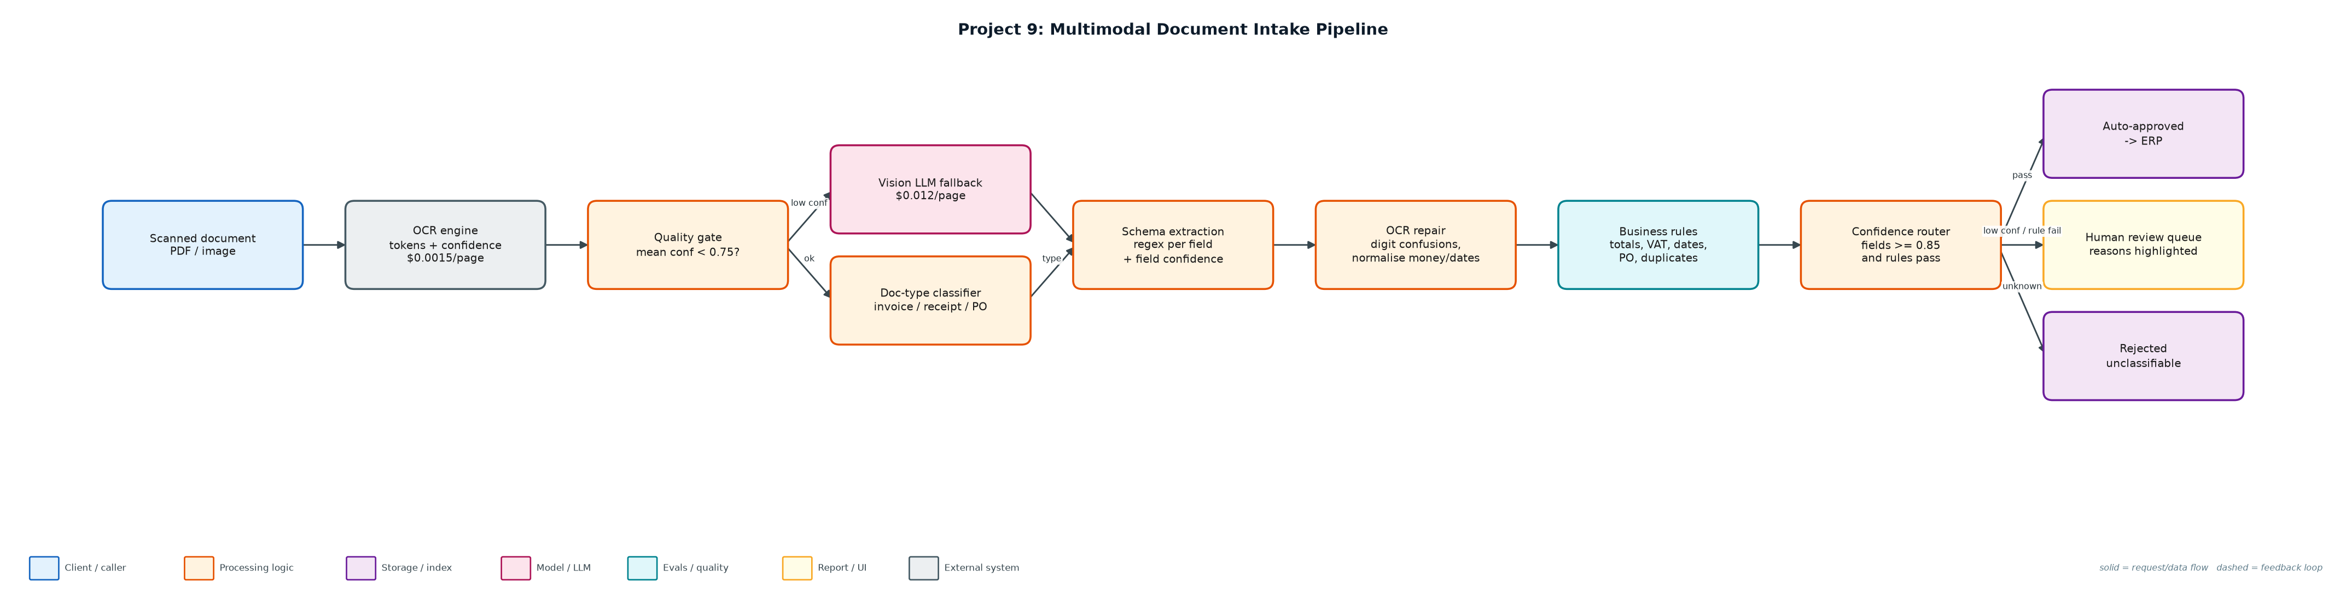
Figure 1. Architecture: solid arrows are the request/data path, dashed arrows are feedback loops.

Components
Component | File | Responsibility
Document generator | generate_docs.py | 80 seeded documents across 5 scenarios: clean, OCR noise, handwritten total, bad scan, business error.
Intake pipeline | intake.py | Quality gate, vision fallback, classifier, schemas, normalisation, business rules, routing.
Runner + evaluation | run_intake.py | Processes all docs, scores against ground truth, writes approved/review/rejected JSONL.
Outputs | outputs/*.jsonl | Approved extractions, review queue with reasons, rejections.

4. Request / data flow
- OCR returns tokens with confidence for every line of the page.
- If mean confidence is below 0.75, the page is re-read by the vision model (8x cost).
- The document type is classified by keyword evidence; unknown documents are rejected.
- Fields are extracted with a schema per type; each field's confidence is the minimum of its tokens.
- Numeric fields are repaired for OCR digit confusions and normalised (money, ISO dates, ids).
- Business rules check arithmetic, VAT rate, date order, VAT-id format, PO existence and duplicate invoice numbers.
- Documents with any low-confidence field or rule failure go to human review with the reasons; the rest are auto-approved.

5. Key design decisions
Decision | Why | Trade-off
Vision only as fallback | Bad scans are ~10% of volume; cost/doc stays at $0.003. | A second model to monitor.
Min-token confidence per field | One bad digit should hold the whole amount. | More conservative routing.
Rules are the safety net | Handwritten totals passed OCR but failed arithmetic. | Rules must be written per document type.
Log every repair | Reviewers and auditors see what was changed. | Noisier logs.
Optimise for zero escapes, then STP | Wrong auto-approved money is the costly error. | Lower straight-through rate.

6. Evaluation and metrics
- 80 documents: 100% type accuracy, 98.9% field accuracy over 614 fields.
- 78% straight-through processing, 0 auto-approved documents with any wrong field.
- All 3 business-rule issues (duplicate invoice, totals mismatch) caught; all 7 handwritten totals held for review.
- Vision fallback used on the 10 bad scans only: $0.0030/doc vs $0.0135/doc if every page used vision.
- 6 unit tests for repair, classification, clean path, fallback, handwritten totals and duplicates.

7. How to run
python generate_docs.py --n 80
python run_intake.py
python -m unittest discover -s tests

Sample output
Command: python3 run_intake.py
Documents: 80 · type accuracy 100% · field accuracy 98.9% (614 fields)
Routing: {'human_review': 18, 'auto_approve': 62} · straight-through rate 78%
Auto-approved with an error (escapes): 0 []
Business-rule issues caught: 3/3
Vision fallback: 10 docs · total cost $0.2400 ($0.00300/doc vs $0.0135/doc if every page used vision)
OCR corrections applied: 8

Route by scenario:
bad_scan {'auto_approve': 10}
business_error {'human_review': 3}
clean {'auto_approve': 50}
handwritten_total {'human_review': 7}
ocr_noise {'human_review': 8, 'auto_approve': 2}

Sample review items:
doc-000 (ocr_noise): low confidence: total
doc-001 (handwritten_total): low confidence: total
doc-002 (business_error): subtotal + VAT (1273.05) != total (1283.05)
doc-012 (handwritten_total): subtotal + VAT (4102.05) != total (4102.06)
doc-027 (ocr_noise): low confidence: total

Field accuracy:
total 73/80
supplier 63/63
invoice_number 49/49
invoice_date 49/49
due_date 49/49
vat_id 49/49
po_number 63/63
buyer 49/49
subtotal 49/49
vat 49/49
order_date 14/14
merchant 17/17
date 17/17
card_last4 17/17

8. Project structure
Path | Purpose
generate_docs.py | Synthetic scanned documents with ground truth
intake.py | Pipeline stages
run_intake.py | Runner and evaluation
data/documents.jsonl | OCR token streams + truth
outputs/ | approved, review_queue, rejected

9. Interview talking points
- Confidence routing is the product: 78% straight-through with zero wrong values auto-approved.
- OCR first, vision as fallback: 4.5x cheaper than sending every page to a multimodal model.
- Business rules caught what confidence could not: a handwritten total off by one cent.
- Every OCR repair is logged so a reviewer can see '2O5' became '205'.
- The same interface accepts Textract, Azure Document Intelligence or GPT-4o vision.

10. Production roadmap
- Plug in Tesseract/Textract for OCR and GPT-4o/Claude vision with structured output for fallback.
- Streamlit review UI showing the page image with low-confidence fields highlighted.
- Feed reviewer corrections back as few-shot examples and to tune thresholds per field.
- ERP integration for PO matching and payment scheduling.

11. Resume bullet
Built a document intake pipeline with OCR quality gating, vision-LLM fallback, OCR repair and business-rule validation, reaching 78% straight-through processing with zero erroneous auto-approvals at $0.003/document.

