Project 11: AI Trace Explorer & Root-Cause Analyzer
Primary topic: Observability Secondary: Tracing, Debugging, Regression detection, Evals
Traces every step of an AI workflow, classifies what went wrong, points at the span that caused it, and turns failures into eval cases.

1. Problem
When an AI feature gives a bad answer, logs show only the final output. Was it retrieval, the reranker, a 429 storm, a tool outage or the new prompt version? Without step-level traces, every incident becomes guesswork and the same failure ships again.

Why it matters
- AI failures are multi-step; the root cause is rarely the LLM call.
- Prompt-version regressions only show up in aggregate.
- On-call engineers need an owner and a fix, not a stack trace.
- Failures are the best source of new eval cases.

2. Goals and success criteria
Goal | Success criterion
Step-level tracing | OpenTelemetry-shaped spans with parent ids and attributes in SQLite
Failure taxonomy | 9 categories with owner and suggested fix
Root cause per trace | Highest-severity, earliest finding; 100% vs injected faults
Regression detection | Error rate and categories by prompt version
Close the loop | Failing traces exported as draft eval cases

Non-goals
- Replacing Langfuse/Phoenix/Datadog: the span schema is OTel-shaped so it can export there.
- Real provider calls: a simulated clock and seeded faults make 300 traces run instantly.

3. Architecture
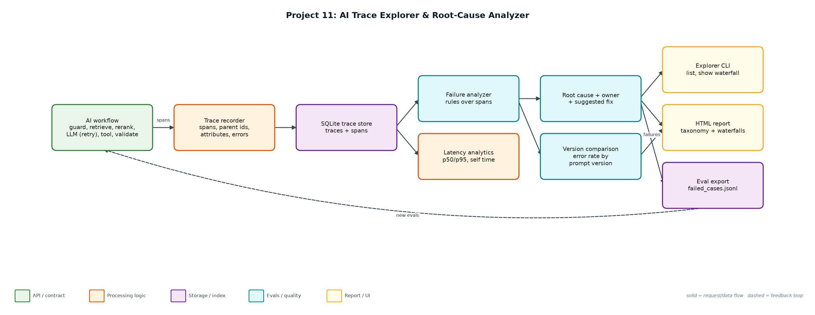
Figure 1. Architecture: solid arrows are the request/data path, dashed arrows are feedback loops.

Components
Component | File | Responsibility
Span model + store | trace_store.py | SimClock, TraceRecorder with nested spans, SQLite persistence and queries.
Workflow + faults | workflow.py | Six-step support workflow with retries and 8 seeded fault types; prompt v8 adds a JSON regression.
Analyzer | analyzer.py | Rules over spans, severity ordering, owner/hint taxonomy, self-time.
Explorer CLI | explorer.py | simulate, summary, list, show (ASCII waterfall), report (HTML), export.
Outputs | reports/, evals/ | trace_report.html and failed_cases.jsonl.

4. Request / data flow
- Each request opens a root span; each step opens a child span with attributes (hits, tokens, grounding, HTTP status).
- Errors propagate up the span tree; 429 retries are separate error spans followed by a successful attempt.
- Traces and spans are stored in SQLite.
- The analyzer applies rules per span: timeouts, context overflow, tool errors, invalid JSON, empty retrieval, low grounding, latency SLOs, 429s.
- Findings are ordered by severity and time; the first one is the root cause, with an owner and a suggested fix.
- Aggregates show the taxonomy, p50/p95 per span, where time goes and error rate by prompt version.
- Failing traces are exported as draft eval cases for the dataset builder (Project 5).

5. Key design decisions
Decision | Why | Trade-off
OTel-shaped spans | Portable to Langfuse, Phoenix, Jaeger. | More fields than a flat log.
Rules before an LLM judge | Deterministic, cheap, explainable root causes. | New failure types need new rules.
Severity, then time | A timeout outranks a slow rerank in the same trace. | Secondary causes are listed, not ranked.
Simulated clock | Thousands of traces in seconds, reproducible. | No real network jitter.
Owner per category | Routes incidents to the right team. | Ownership map must be maintained.

6. Evaluation and metrics
- 300 traces, 18% hard failures; root-cause accuracy vs injected faults 111/111 with 0 false alarms on healthy traces.
- Detected the prompt regression: support-v8 had 29 schema_invalid vs 9 for v7 (error rate 12.7% -> 23.3%).
- Latency: request p95 3.6 s; the LLM call is 93% of self time, so reranker tuning would not help.
- 90 failing traces exported as draft eval cases.
- 3 unit tests: span nesting/persistence, classifier vs injected faults, error propagation.

7. How to run
python explorer.py demo
python explorer.py simulate --n 300 && python explorer.py summary
python explorer.py list --category schema_invalid
python explorer.py show <trace_id>
python -m unittest discover -s tests

Sample output
Command: python3 explorer.py demo
Simulated 300 traces; injected faults: {'none': 176, 'schema_invalid': 38, 'retrieval_empty': 19, 'ungrounded': 17, 'rate_limited': 14, 'tool_error': 11, 'slow_rerank': 10, 'llm_timeout': 10, 'context_overflow': 5}

Traces: 300 · hard failures: 54 (18%) · traces with any finding: 111

Root-cause taxonomy (owner -> suggested fix):
38 schema_invalid [prompt] Output was not valid JSON: use structured output / JSON mode; compare prompt versions.
19 retrieval_empty [rag] No documents retrieved: check query rewriting and index freshness before blaming the model.
17 ungrounded [quality] Answer has low grounding and no citations: enforce citations via the output guardrail.
11 rate_limited_recovered [platform] Recovered after 429 retries; latency cost of backoff is visible in the waterfall.
10 latency_slo [performance] Span exceeded its latency SLO: profile this dependency or cache its results.
10 llm_timeout [provider] Set a per-call timeout budget and fail over to a second model (gateway routing).
4 tool_error [integrations] Downstream API failed: add a circuit breaker and a graceful 'cannot check order' answer.
2 context_overflow [rag] Retrieved context exceeds the model window: lower k, trim chunks or summarise before generation.
Root-cause accuracy vs injected faults: 111/111 (100%) · false alarms on healthy traces: 0

Latency by span (p50 / p95 ms):
request 1908 3623
retrieve 67 88
rerank 44 60
llm.generate 1670 2415
tool.lookup_order 99 132
Where time goes (self time): llm.generate 93%, rerank 3%, retrieve 2%

By prompt version:
support-v7: error rate 12.7% · schema_invalid 9 of 150
support-v8: error rate 23.3% · schema_invalid 29 of 150
REGRESSION: support-v8 schema_invalid 29 vs 9 in v7 -> roll back or fix the prompt's JSON instructions

Example trace b78e429dee9a42ce (rate_limited_recovered):
request |########################################| 4127 ms
guard.input |# | 5 ms
retrieve |# | 55 ms
rerank |# | 32 ms
llm.generate |XXXXXX | 622 ms HTTP 429 rate limited
llm.generate | XXXXXXXXXXX | 1112 ms HTTP 429 rate limited
llm.generate | ##################### | 2190 ms
tool.lookup_order | # | 106 ms
validate.output | #| 5 ms

Wrote reports/trace_report.html
... (1 more lines)

8. Project structure
Path | Purpose
trace_store.py | Span model and SQLite store
workflow.py | Traced workflow with fault injection
analyzer.py | Failure taxonomy and root cause
explorer.py | CLI, HTML report, eval export
data/traces.db | Trace database

9. Interview talking points
- Most AI incidents are not the model: here a third of root causes were retrieval or integrations.
- Self-time analysis showed 93% of latency is generation, so I would not spend time on the reranker.
- Comparing prompt versions caught a 3x JSON-failure regression the day it shipped.
- Every root cause has an owner and a fix, which is what on-call actually needs.
- Failures flow straight into the eval dataset, so each incident becomes a regression test.

10. Production roadmap
- Emit real OpenTelemetry spans (OTLP) and view them in Phoenix/Langfuse alongside this analyzer.
- LLM-assisted root-cause summaries for traces the rules cannot classify.
- Alerting on category spikes per prompt version, wired into the rollout monitor (Project 13).
- Streamlit explorer with search by user, feature and version.

11. Resume bullet
Built an AI trace explorer with OTel-shaped spans, a 9-category failure taxonomy and owner-routed fix hints; diagnosed 111/111 injected faults, caught a prompt-version regression (3x JSON failures) and exported 90 failures as eval cases.

