Project 13: AI Feature Rollout Monitor
Primary topic: LLMOps Secondary: Progressive delivery, A/B statistics, Guardrails, Audit
Ships a new model or prompt through 1% -> 5% -> 25% -> 50% -> 100% with statistical quality checks, segment analysis, automatic pause/rollback and a full audit trail.

1. Problem
A new prompt looks better in offline evals, ships to everyone, and German users get worse answers for a week before anyone notices. AI changes need the same progressive delivery as code, but judged on quality, safety, latency and cost, with statistics that respect small samples.

Why it matters
- Offline evals cannot cover every segment of real traffic.
- Average metrics hide segment regressions.
- Safety incidents need immediate automatic rollback, not a dashboard.
- Regulated customers ask who approved each rollout step.

2. Goals and success criteria
Goal | Success criterion
Sticky, monotonic assignment | Consistent hashing; raising % only adds users
Staged rollout | 1 / 5 / 25 / 50 / 100% with minimum samples per stage
Statistical guardrails | One-sided z-tests on bad-answer and thumbs-down rates
Segment analysis | Per-locale and per-plan tests catch hidden regressions
Automatic actions + audit | promote / hold / pause / rollback, every decision logged

Non-goals
- A full experimentation platform (LaunchDarkly/Statsig); this is the AI-specific decision layer.
- Sequential testing corrections beyond a stricter alpha for segments.

3. Architecture
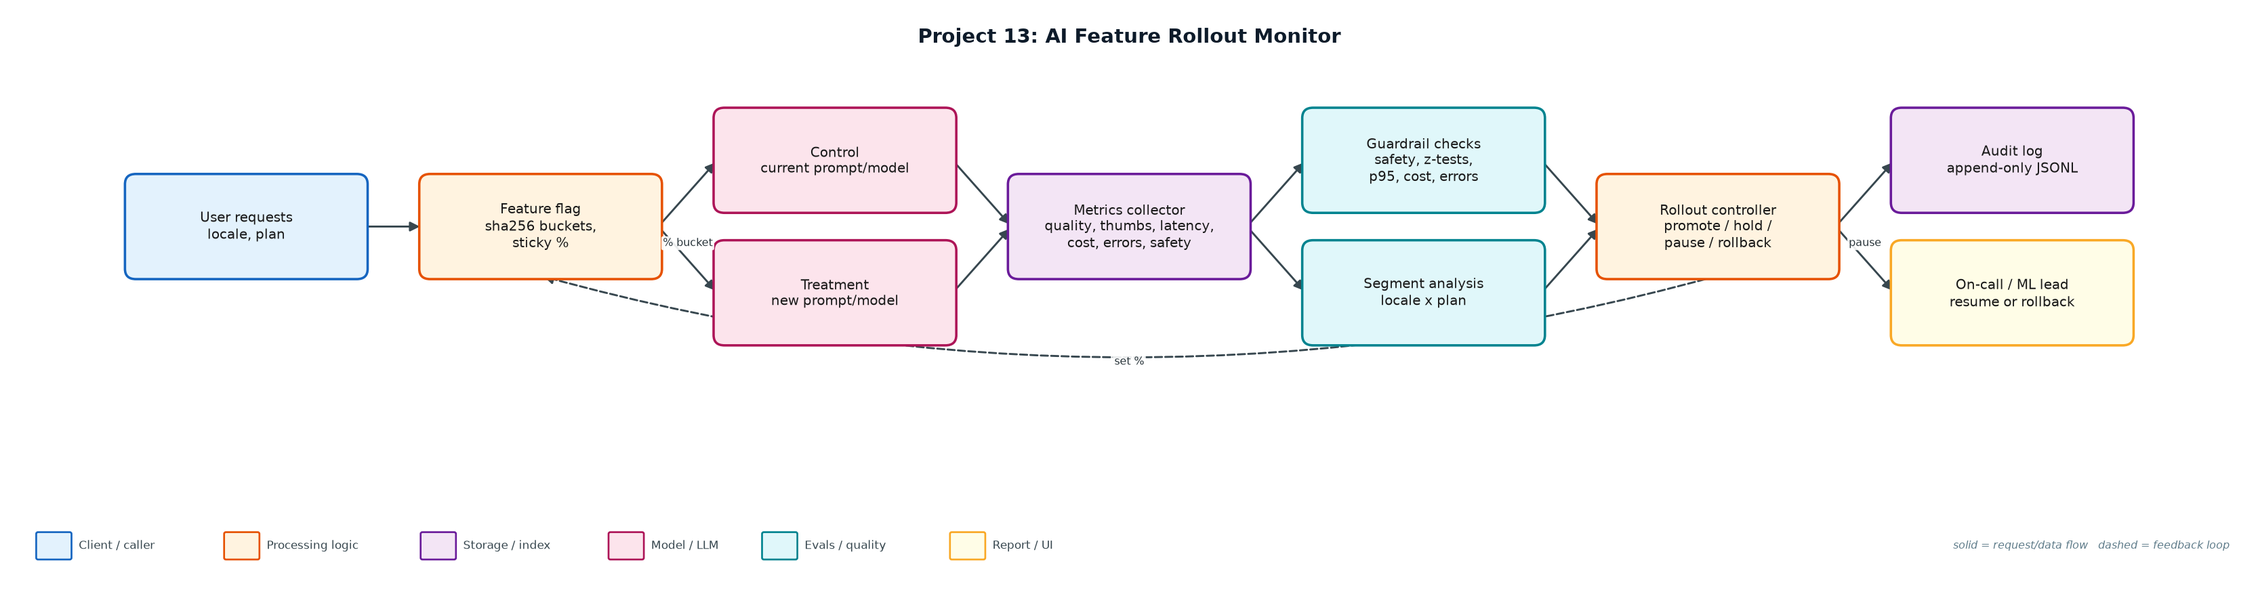
Figure 1. Architecture: solid arrows are the request/data path, dashed arrows are feedback loops.

Components
Component | File | Responsibility
Feature flags | flags.py | sha256 bucketing per feature; deterministic and monotonic.
Statistics | stats_tests.py | One-sided two-proportion z-test and sample-size calculator.
Controller | rollout.py | Guardrails config, stage machine, segment tests, decisions, human resume/rollback, audit log.
Scenarios | simulate.py | 50k users, 4,000 requests/hour; healthy, segment regression, safety incident, latency regression.
Audit trail | audit/*.jsonl | Every decision with metrics snapshot, reasons and actor.

4. Request / data flow
- Each request's user is hashed into one of 10,000 buckets; the user is in treatment if their bucket is below the stage percentage.
- Both arms log quality (judge bad answer), thumbs-down, latency, cost, errors and safety violations.
- Every hour the controller evaluates the current stage.
- Two or more safety violations above 0.2% roll back immediately, at any sample size.
- Below 400 treatment samples the decision is hold.
- Quality and thumbs-down are tested one-sided (alpha 0.01, at least 2pp worse); each locale and plan segment is tested with a stricter alpha.
- p95 latency above 1.2x, cost above 1.3x or error rate +1pp also pause.
- Green stages promote; pauses wait for a human to resume or roll back; everything is written to the audit log.

5. Key design decisions
Decision | Why | Trade-off
Consistent hashing | Users keep a stable experience; metrics are not polluted by flip-flopping. | Bucket skew needs monitoring.
Pause, not auto-rollback, for quality | Quality signals can be noisy; a human decides. | Slower reaction to quality issues.
Auto-rollback for safety | Harm outweighs false-positive cost. | Requires a trustworthy safety classifier.
Segment tests with stricter alpha | Many segments means many tests. | Small segments only catch large regressions.
Minimum samples per stage | Avoids promoting on noise at 1%. | Early stages take longer.

6. Evaluation and metrics
- Healthy candidate: promoted 1 -> 5 -> 25 -> 50 -> 100% in 18 simulated hours with all guardrails green.
- Segment regression (German answers 21% bad vs 8%): overall looked fine; caught at 25% by the locale=de test (+17.6pp) and rolled back.
- Safety incident: rolled back at 1% after 2 violations; at most 468 of 50,000 users exposed.
- Latency regression (p95 x1.41): paused at 1% and rolled back by on-call.
- Power check: detecting +2pp on an 8% base needs ~2,500 samples per arm, which explains why early stages only catch large effects.
- 6 unit tests: sticky assignment, z-test, hold, safety rollback, latency pause + audit, segment scenario.

7. How to run
python simulate.py
python simulate.py --scenario segment_regression
python -m unittest discover -s tests

Sample output
Command: python3 simulate.py
Power check: detecting a +2pp rise in an 8% bad-answer rate needs ~2,532 samples per arm (guardrail minimum per stage: 400; small stages only catch large regressions).

=== healthy_candidate ===
hour 12 @ 1%: PROMOTE guardrails green with 425 treatment samples [treatment n=425, bad=7.1%, p95=1895 ms]
hour 15 @ 5%: PROMOTE guardrails green with 560 treatment samples [treatment n=560, bad=5.4%, p95=1962 ms]
hour 16 @ 25%: PROMOTE guardrails green with 994 treatment samples [treatment n=994, bad=6.1%, p95=1969 ms]
hour 17 @ 50%: PROMOTE guardrails green with 1991 treatment samples [treatment n=1991, bad=6.7%, p95=1980 ms]
hour 18 @ 100%: COMPLETE all guardrails green at 100% [treatment n=4000, bad=7.2%, p95=1991 ms]
final state: complete · max users exposed: 50,000 of 50,000 · audit -> audit/healthy_candidate.jsonl

=== segment_regression ===
hour 12 @ 1%: PROMOTE guardrails green with 425 treatment samples [treatment n=425, bad=10.1%, p95=2067 ms]
hour 15 @ 5%: PROMOTE guardrails green with 560 treatment samples [treatment n=560, bad=7.5%, p95=2141 ms]
hour 16 @ 25%: PAUSE segment locale=de: bad_quality +17.6% (p=0.0000, n=137) [treatment n=994, bad=8.4%, p95=2148 ms]
hour 16: human reviewed segment breakdown -> rollback to 0%
final state: rolled_back · max users exposed: 12,586 of 50,000 · audit -> audit/segment_regression.jsonl

=== safety_incident ===
hour 5 @ 1%: ROLLBACK 2 safety violations (1.14% > 0.20%) [treatment n=175, bad=8.6%, p95=1937 ms]
final state: rolled_back · max users exposed: 468 of 50,000 · audit -> audit/safety_incident.jsonl

=== latency_regression ===
hour 12 @ 1%: PAUSE p95 latency 3014 ms vs 2136 ms (x1.41) [treatment n=425, bad=7.8%, p95=3014 ms]
hour 12: human rollback by on-call -> 0%
final state: rolled_back · max users exposed: 468 of 50,000 · audit -> audit/latency_regression.jsonl

8. Project structure
Path | Purpose
flags.py | Consistent-hash feature flags
stats_tests.py | z-test and sample size
rollout.py | Controller and guardrails
simulate.py | Four rollout scenarios
audit/ | Decision audit logs

9. Interview talking points
- AI changes deserve progressive delivery: prompts and models are deployments.
- The average hid a German-locale regression; segment tests caught it at 25% exposure.
- Safety rolls back automatically; quality pauses for a human, because the cost of each error is different.
- I show the power calculation so stakeholders understand what 1% can and cannot detect.
- Every decision is in an append-only audit log with the metrics that justified it.

10. Production roadmap
- Integrate with LaunchDarkly/Unleash for flag delivery and a warehouse for metrics.
- Use the eval service (Project 14) as the online quality judge on sampled traffic.
- Sequential testing (mSPRT) so stages can stop early safely.
- Slack approvals for resume with the segment breakdown attached.

11. Resume bullet
Built an AI rollout controller with sticky hashing, staged exposure, z-tested quality guardrails and segment analysis; caught a hidden German-locale regression at 25% and auto-rolled back a safety incident with <1% of users exposed.

