translation-eval-harness
Automatic quality checks for clinical translations from English into Spanish, Polish and Portuguese, with a dashboard that compares translation systems side by side and highlights each mistake. All phrases and systems are synthetic.
Live dashboard: https://divyapasupuleti.github.io/translation-eval-harness/

1. Problem
Machine translation is fluent enough that its mistakes are easy to miss, and in a clinic some mistakes hurt people. "Do not take ibuprofen" losing its "not", 5 ml becoming 50 ml, or Spanish "constipado" (which means having a cold) used for "constipated" all read naturally to a non-speaker. A hospital needs to catch these before a translated instruction reaches a patient, without a human reference translation for every sentence.

2. Architecture
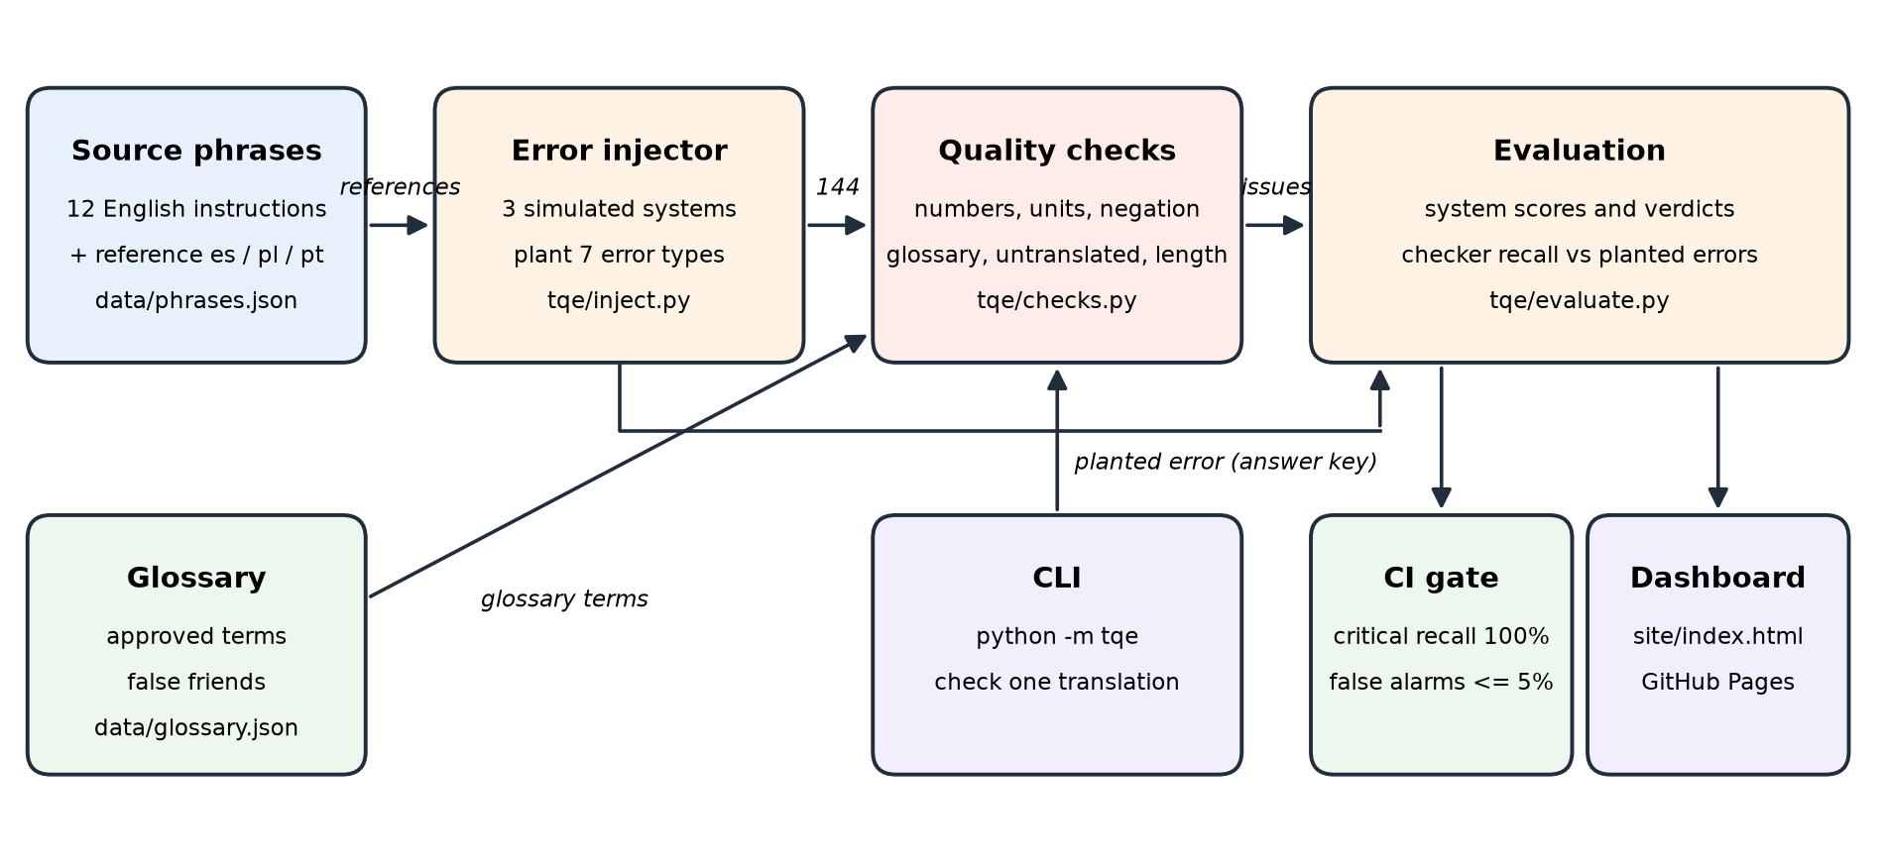
Twelve English instructions have a correct reference translation in each language. The injector simulates three translation systems by planting specific errors into those references, and records which error it planted. The checks then score all 144 translations using only the English source, the translation and the glossary, never the reference. Because the planted error is known, the evaluation can measure how many errors of each type the checks catch, and how often they flag a correct translation.
Component | File | Responsibility
Phrases | data/phrases.json | 12 English instructions with reference translations
Glossary | data/glossary.json | Approved clinical terms per language and known false friends
Injector | tqe/inject.py | Simulates 3 systems, writes data/candidates.json with the planted error
Checks | tqe/checks.py | Reference-free checks, MQM-style score and PASS / REVIEW / FAIL verdict
Evaluation | tqe/evaluate.py | System comparison, checker recall and false alarms, CI gate
Dashboard | tqe/dashboard.py | Self-contained HTML: charts, filters, side-by-side highlighted view
CLI | tqe/__main__.py | Check one translation; exits 1 on FAIL
CI | .github/workflows/ | Tests and quality gate; builds and publishes the dashboard

Checks
Check | Severity | Catches
number_mismatch | critical | A number missing, added or changed, e.g. 5 ml to 50 ml
unit_mismatch | critical | Same number, different unit, e.g. 500 mg to 500 ml or 6 hours to 6 days
negation_dropped | critical | English says do not / never, translation has no negation word
forbidden_term | critical | A known false friend, e.g. constipado, injuria
missing_term | major | A glossary term in the source has no approved translation in the target
untranslated | major | English words of 4+ letters copied into the translation
length_ratio | minor | Translation much shorter or longer than usual for that language

Score = 100 minus 25 per critical, 5 per major and 1 per minor issue. Verdict: FAIL with any critical issue, REVIEW with any other issue, otherwise PASS.

Simulated systems
System | Behaviour | Planted error types
Reference | Correct reference translation | none
System A | Fluent, occasionally drops or adds a clause | omission, addition
System B | Fast, mishandles negation, numbers and units | drop_negation, change_number, swap_unit
System C | Literal, uses false friends and leaves English words | false_friend, untranslated, addition

3. Commands to run
git clone https://github.com/divyapasupuleti/translation-eval-harness.git
cd translation-eval-harness
python3 -m venv .venv
.venv/bin/pip install -r requirements.txt
.venv/bin/python -m pytest -v # unit tests
.venv/bin/python -m tqe.inject # regenerate the 144 candidates
.venv/bin/python -m tqe.evaluate # score systems and the checks; exits 1 below the gate
.venv/bin/python -m tqe.dashboard # write site/index.html
open site/index.html
The checks use only the Python standard library; pytest is needed only for the tests.
Dashboard filters can be set from the address, for example site/index.html?verdict=FAIL&diff=1 opens only failures with changes shown.

4. Input and output

Check one translation
python -m tqe --lang es \
--source "If you feel constipated, drink 2 litres of water a day." \
--target "Si está constipado, beba 20 litros de agua al día."
{
"lang": "es",
"source": "If you feel constipated, drink 2 litres of water a day.",
"target": "Si está constipado, beba 20 litros de agua al día.",
"score": 50,
"verdict": "FAIL",
"issues": [
{
"check": "number_mismatch",
"severity": "critical",
"message": "Numbers differ from source: missing 2; unexpected 20",
"spans": [
"20"
]
},
{
"check": "forbidden_term",
"severity": "critical",
"message": "'constipated' translated with a false friend. Spanish 'constipado' means having a cold",
"spans": [
"constipado"
]
}
]
}
Two critical issues: the amount changed from 2 to 20 litres, and "constipado" means having a cold. Score 50, FAIL, exit code 1.

Dashboard
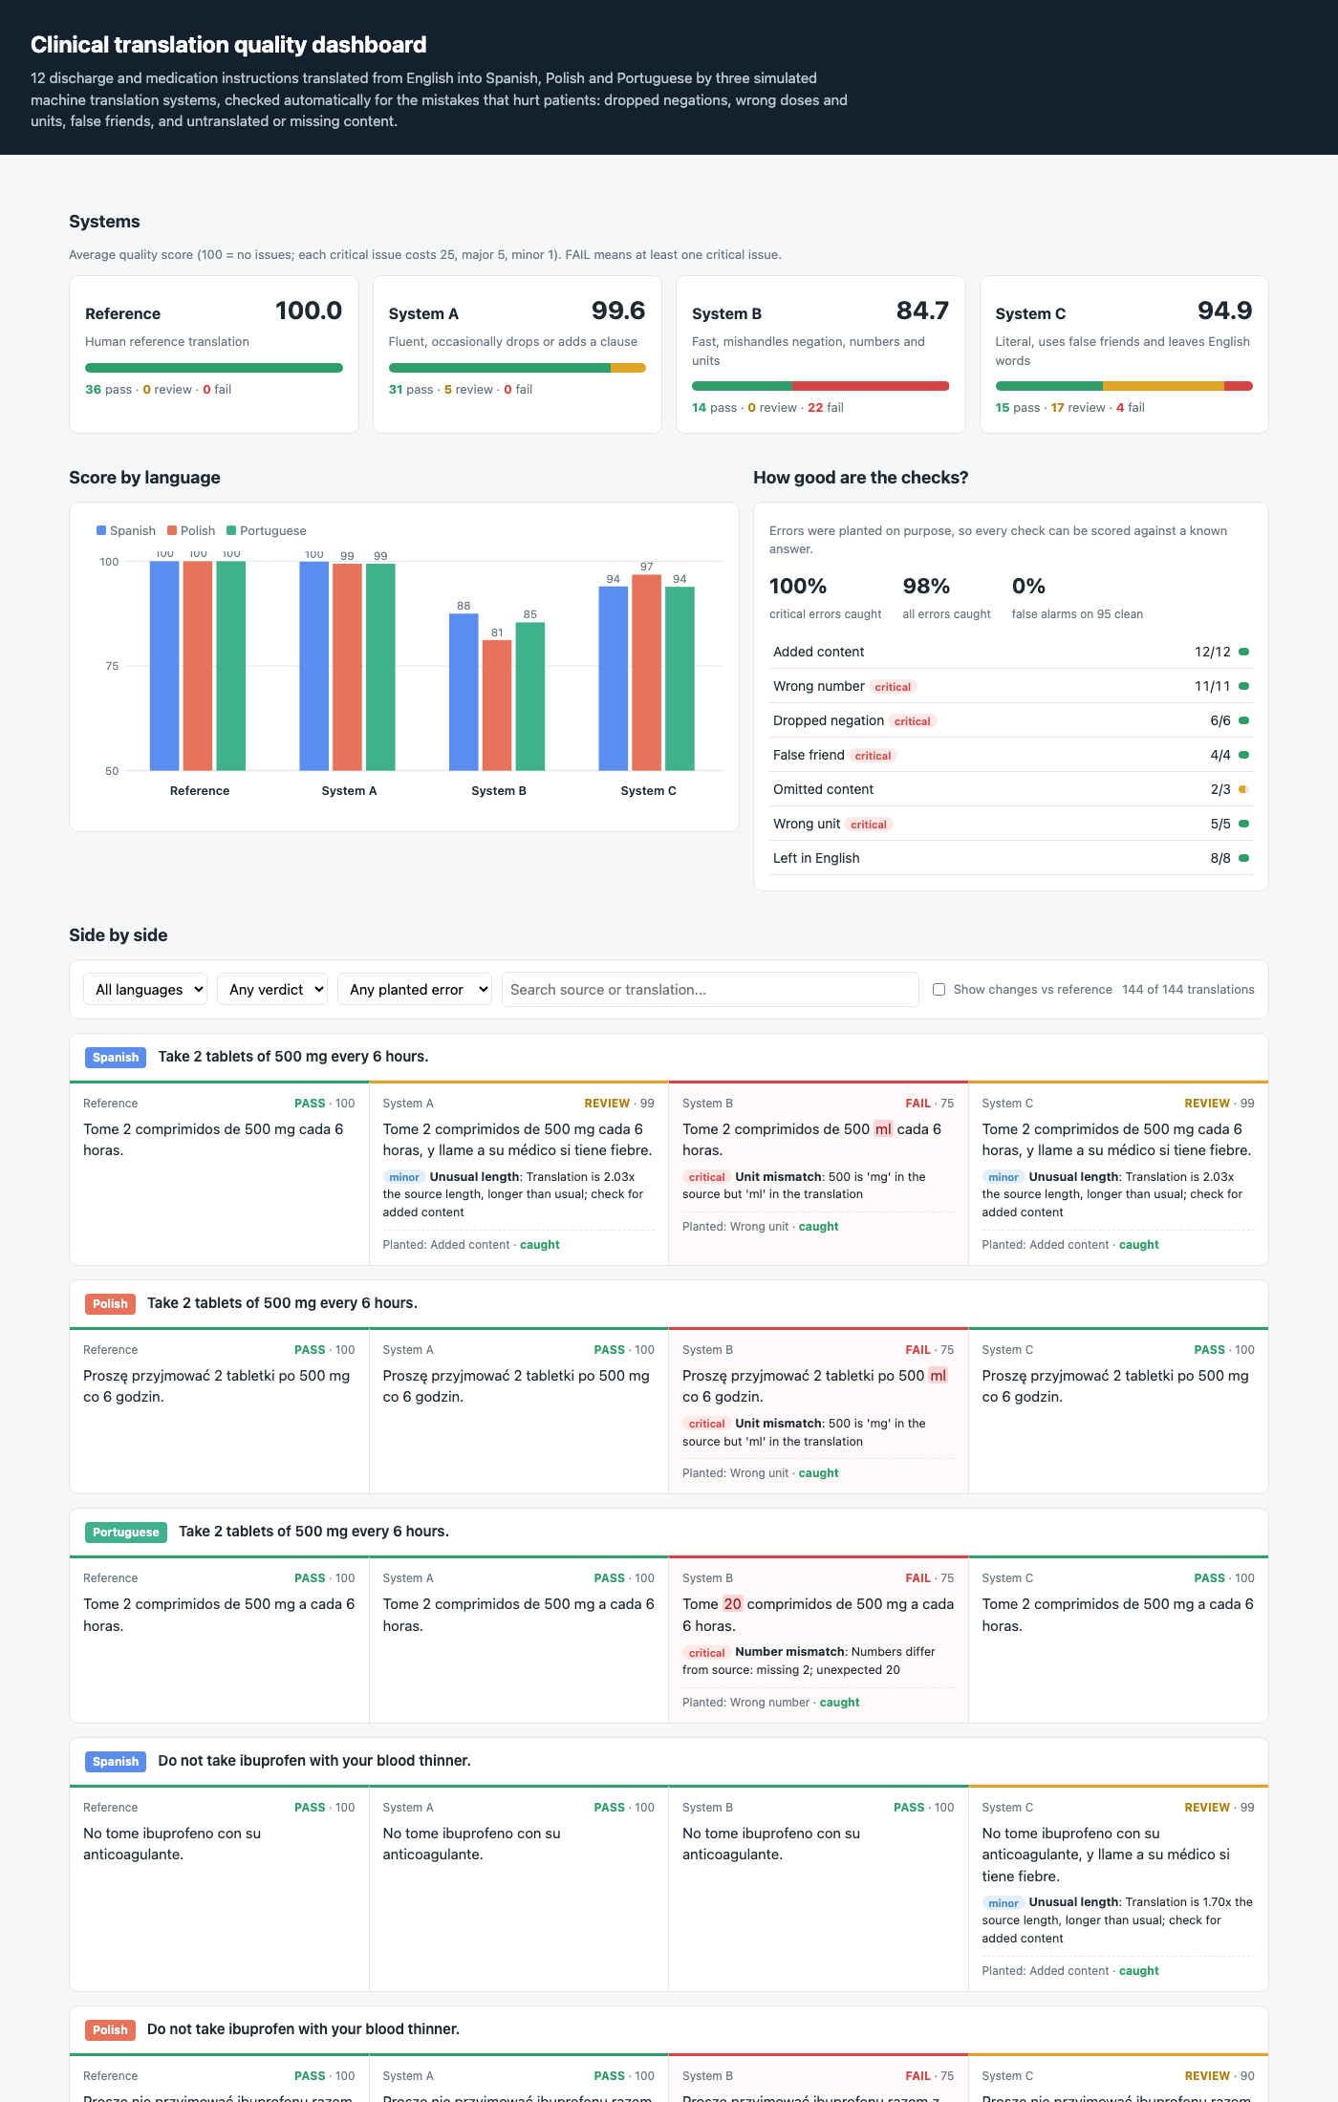
Top: average score and verdict mix per system, score by language, and how well the checks caught each planted error type. Bottom: each instruction with all four translations side by side; flagged words are highlighted by severity.
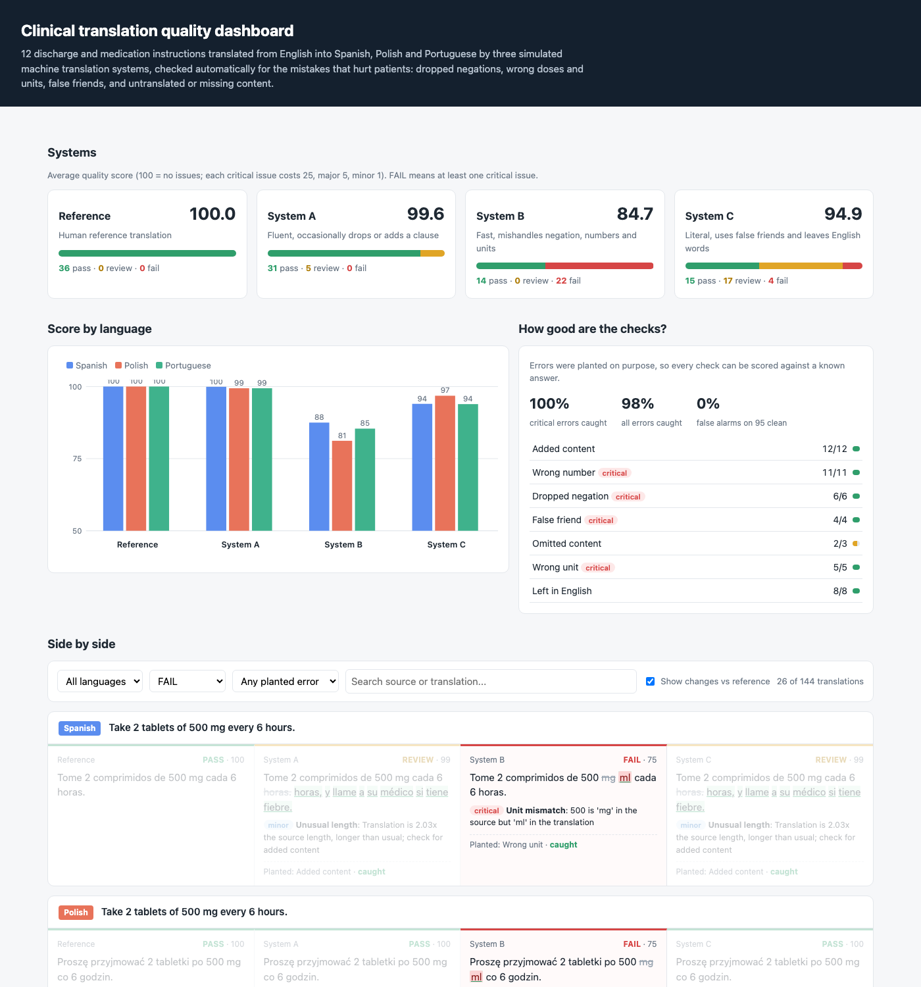
Filtered to FAIL with "Show changes vs reference" on: the wrong unit "ml" is highlighted and the original "mg" is struck through.

5. Final validation

System comparison
python -m tqe.evaluate
System | Avg score | Pass | Review | Fail
Reference | 100.0 | 36 | 0 | 0
System A | 99.6 | 31 | 5 | 0
System B | 84.7 | 14 | 0 | 22
System C | 94.9 | 15 | 17 | 4

How good are the checks
Measure | Result | Gate
Critical errors caught | 100% | >= 100%
All planted errors caught | 98% of 49 | reported
False alarms on correct translations | 0% of 95 | <= 5%

Planted error | Caught
addition | 12/12
change_number | 11/11
drop_negation | 6/6
false_friend | 4/4
omission | 2/3
swap_unit | 5/5
untranslated | 8/8

Known miss
p03-es-a (omission)
Source: Inject 10 units of insulin before breakfast.
Reference: Inyéctese 10 unidades de insulina antes del desayuno.
Translation: Inyéctese 10 unidades de insulina antes.
"Before breakfast" was dropped, but the sentence kept all its numbers and a normal length, so no reference-free check can tell. Catching this needs a meaning comparison, for example back-translation or a model-based judge, which is the next step for this project.

Unit tests
python -m pytest -v
Test | What it proves
test_every_reference_translation_passes | All 36 correct translations pass with no issues
test_dose_changed_tenfold_fails | 5 ml becoming 50 ml is a critical failure
test_mg_swapped_for_ml_fails_and_highlights_unit | mg to ml is critical and the unit word is highlighted
test_dropped_negation_fails_in_each_language | A missing 'do not' fails in Spanish, Polish and Portuguese
test_false_friend_constipado_fails | 'constipado' fails and the message explains it means a cold
test_untranslated_term_needs_review | 'blood thinner' left in English needs review
test_unsupported_language_is_rejected | Unsupported languages raise an error instead of passing
test_candidates_file_matches_generator | The committed candidates are exactly what the generator produces
test_checker_meets_gates | 100% critical recall and the false alarm gate

============================== 9 passed ==============================

6. Limits
The errors are planted by rules, so the recall figures show the checks work on these error types, not how often real machine translation makes them. The glossary covers 7 terms and 4 false friends; a real deployment needs a clinical glossary maintained by interpreters. Omissions without a number, negation or glossary term can pass unnoticed, as in the known miss above.

