E-Commerce Customer Behaviour and Product Popularity Analysis

Team 13

Members:

Divya Prakash

Madhumitha Nandhikatti

(INFO 6105 – Data Science Engineering Methods & Tools)

- Introduction
  - Background
The rapid growth of e-commerce platforms has led to an explosion of customer interaction and transaction data. Every time a shopper browses, orders, or reorders products, valuable behavioural information is generated. Understanding these behaviours is essential for optimizing inventory planning, pricing strategies, product recommendations, and marketing campaigns. Unlike traditional retail, online grocery shopping exhibits highly dynamic and repetitive purchasing patterns, making data-driven analysis critical for extracting actionable insights.

  - Motivation
Our motivation is to help e-commerce businesses improve their understanding of two essential components:
    - Customer Behaviour & Segmentation
Customers vary significantly in their purchasing behaviour—some are frequent buyers, some buy occasionally, and others show high reorder tendencies. Clustering these customers into meaningful segments allows businesses to personalize marketing efforts, improve retention, and efficiently manage promotions.
    - Product Popularity Prediction
Certain products consistently drive a large portion of sales. Knowing what characteristics make a product popular can help businesses with assortment planning, inventory management, and targeted advertising.

  - Goal of the Project
This project has two major goals:
    - Customer Segmentation using Recency, Frequency, and Monetary (RFM) behavioural features and applying K-Means clustering.
    - Product Popularity Prediction using machine learning classification models including:
      - Logistic Regression
      - Decision Tree
      - Random Forest
Through Exploratory Data Analysis (EDA), feature engineering, and predictive modelling, our goal is to build a comprehensive understanding of customer behaviour and product demand.

Table of Contents

Title | Page Number
- Introduction | 1
Table of Contents | 2
- Methodology | 3-4
- Description of Dataset | 5
- Results and Analysis | 6-15
- Conclusion | 16-17
- References | 18

- Methodology

Data Integration and Architecture
One of the biggest challenges in working with the Instacart dataset is the need to merge multiple relational tables into a single analytical framework. We began by loading six CSV files representing orders, products, departments, aisles, and user activity. The key to building a usable dataset was correctly joining them using shared keys such as product_id, order_id, and user_id. To avoid memory bottlenecks with over 32 million rows, we used efficient Pandas operations and ensured proper data types for large integer columns. After merging, we conducted extensive validation by checking row counts, missing values, duplicates, and categorical consistency.

RFM Feature Computation
RFM scoring is a widely used method in marketing analytics to summarize customer activity:
- Recency captures how recently a customer purchased. Lower recency often indicates higher engagement.
- Frequency represents total purchase count, reflecting loyalty and shopping intensity.
- Monetary measures spending behaviour or basket size.
These metrics were computed from transaction history and scaled using StandardScaler to
prepare the data for K-Means clustering. Clustering on standardized values ensures each
variable contributes equally.

Machine Learning Pipeline
For product popularity prediction, we followed a structured ML pipeline:
- Feature selection: Chose reorder ratio, department, and aisle encodings.
- Label creation: Assigned labels based on 75th percentile of total product orders.
- Train–test split: Ensured balanced representation using stratification.
- Model training: Evaluated three models of increasing complexity.
- Evaluation: Used accuracy, precision, recall, F1 score, ROC-AUC to capture performance.
This pipeline ensures reproducibility and transparency while aligning with best practices in supervised learning.

  - Project Workflow Overview
Our end-to-end methodology includes the following steps:
    - Data Acquisition and Loading
We downloaded the Instacart 2017 Online Grocery Shopping Dataset and loaded all CSV files into a Jupyter Notebook.
    - Data Cleaning & Merging
Multiple relational tables were merged into a single enriched dataset containing product details, order details, user information, and reorder patterns.
    - Exploratory Data Analysis (EDA)
We visualized:
      - Top departments and aisles
      - Daily and hourly shopping trends
      - Distribution of reorder ratio
    - Feature Engineering
      - Created RFM features for each user
      - Computed reorder ratio and total orders for each product
      - Encoded categorical features (aisle, department)
    - Customer Segmentation (Unsupervised Learning)
- Applied K-Means with 4 clusters
- Standardized RFM variables
- Interpreted segments using scatter plots and box plots
    - Product Popularity Modelling (Supervised Learning)
- Labelled products as “High Popularity” (top 25%) or “Low Popularity”
- Split into train-test sets
- Trained logistic regression, decision tree, and random forest
- Evaluated using accuracy, precision, recall, F1, and ROC-AUC

- Description of Dataset
  - Dataset Source
The dataset used in this project comes from the publicly available Instacart Market Basket.
Link: https://www.kaggle.com/datasets/psparks/instacart-market-basket-analysis
  - Dataset Files
The dataset contains the following CSV files:

File Name | Description
orders.csv | Contains order metadata (user ID, order number, day, hour, day, recency)
order_products_prior.csv | Product-level data for all past orders
order_products__train.csv | Product-level data for labelled orders
products.csv | Product names and IDs
departments.csv | Department categories
aisles.csv | Aisle categories

  - Key Columns Used
- order_id
- user_id
- product_id
- department_id / aisle_id
- days_since_prior_order
- reordered
- order_hour_of_day, order_dow

  - Dataset Size
- 3+ million rows in the final merged dataset
- 200,000+ unique users
- 49,000+ products
This large dataset is ideal for both customer clustering and product classification.

- Results and Analysis
  - Exploratory Data Analysis

Deeper Interpretation of Department-Level Trends
The dominance of the Produce and Dairy & Eggs departments highlights Instacart’s reliance on perishable goods as core revenue drivers. These categories generally include staple items such as fruits, vegetables, milk, yogurt, and eggs that households purchase frequently and replenish regularly. The consistently high ordering volume within these departments suggests that customers rely on Instacart most heavily for routine grocery replenishment rather than for specialty or occasional purchases. This insight indicates that ensuring high availability and minimal stockouts in these departments can significantly improve customer satisfaction and retention.
Cross-Category Insights
The presence of high-demand aisles such as fresh vegetables, packaged fruits, yogurt, and cheese also suggests strong cross-category purchasing behavior. Customers who buy fresh produce often complement their baskets with dairy, bakery items, or packaged vegetable mixes. This pattern highlights opportunities for Instacart to improve cross-selling strategies. For example, recommending yogurt or granola bars to users shopping for fresh fruits may increase basket sizes and overall order value.
Temporal Patterns and Operational Decisions
The clear pattern of peak ordering hours between 10 AM and 4 PM reflects a strong mid-day shopping preference. This aligns with typical grocery shopping behavior, where customers place orders for same-day or next-day delivery during lunch hours or early afternoon. The business implication is that Instacart may benefit from scheduling additional delivery slots, picking staff, and inventory restocking routines around these hours to optimize efficiency. Additionally, the low order count during early morning and late-night hours suggests limited demand for 24-hour operations.
Behavioural Interpretation of Weekly Trends
The high order counts on Sundays and Mondays reflect weekly grocery routines where customers stock up after the weekend. This pattern is consistent with traditional brick-and-mortar grocery shopping behaviour. Instacart can leverage these insights by offering weekend promotions, recipe bundles, or multibuy discounts targeted at families and frequent meal planners. Understanding temporal consumption patterns also enables better warehouse planning and reduces the likelihood of stockouts during peak periods.

    - Top 10 Departments
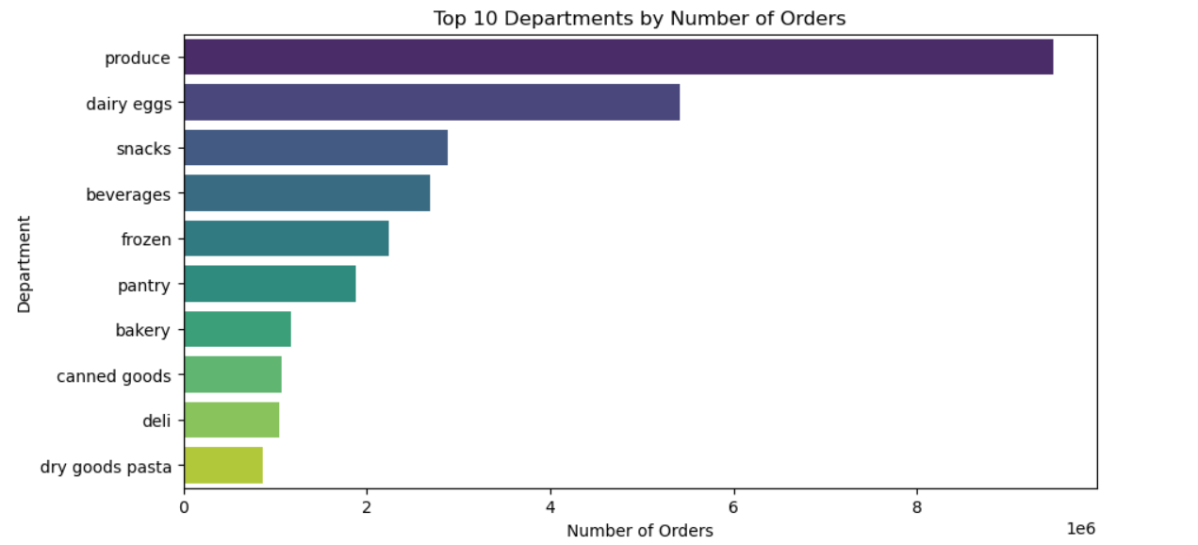
Key insights:
- Produce is the most frequently ordered department.
- Dairy & eggs, snacks, beverages follow closely.
- Shows customers prioritize fresh groceries.
4.1.2 Top 10 Aisles
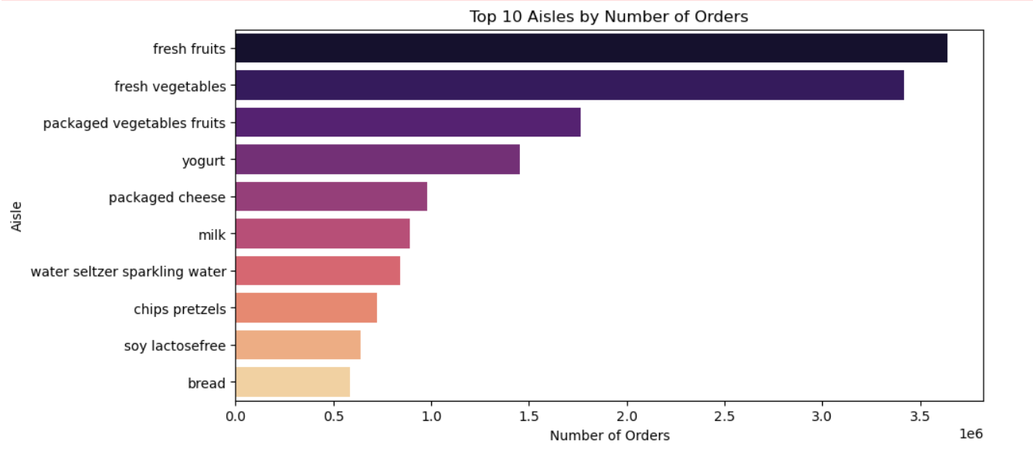
Insights:
    - Fresh fruits and vegetables dominate
    - Packaged foods and dairy products also appear frequently

4.1.3 Reorder Ratio Distribution
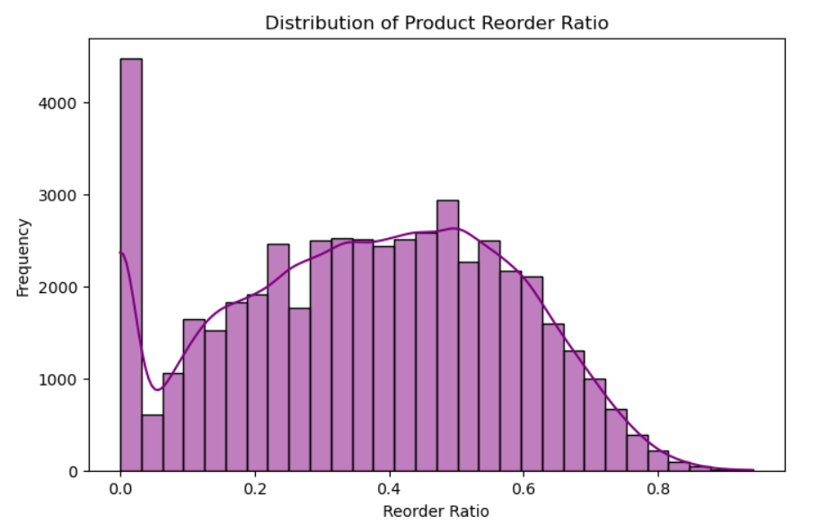
Insights:
    - Many products have low reorder ratio
    - A smaller number have very high loyalty
    - Indicates selective repeating patterns

4.1.4 Orders by Day of Week
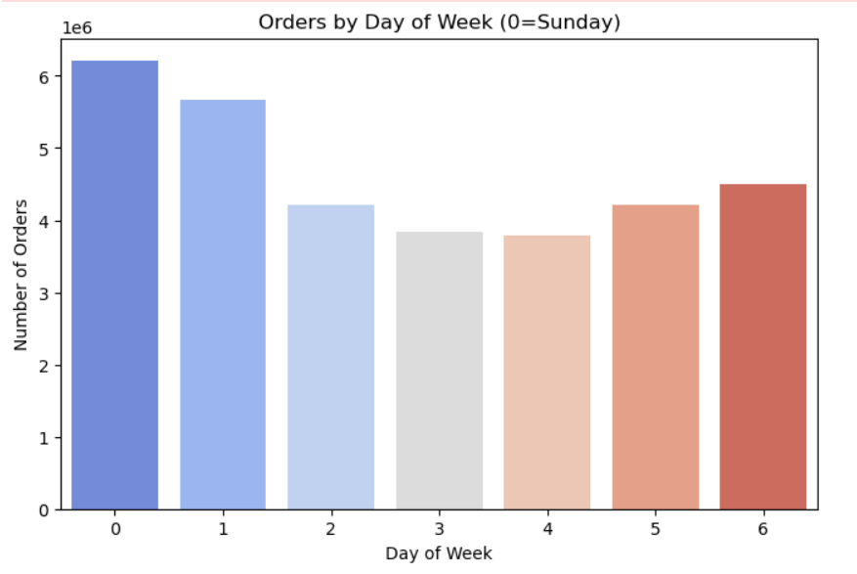
Insights:
    - Highest order volume on Sundays and Mondays
    - Mid-week orders drop significantly
4.1.5 Orders by Hour of Day
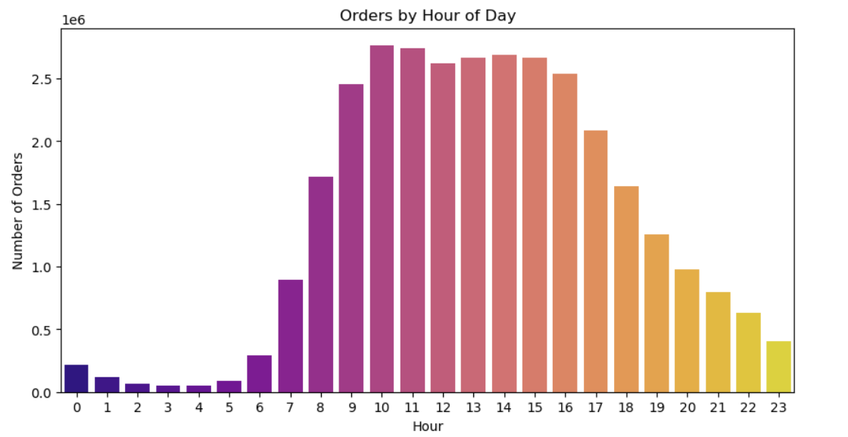
Insights:
    - Most orders occur between 10 AM – 4 PM
    - Early morning and late night have low activity
4.1.6 Day vs Hour Heatmap
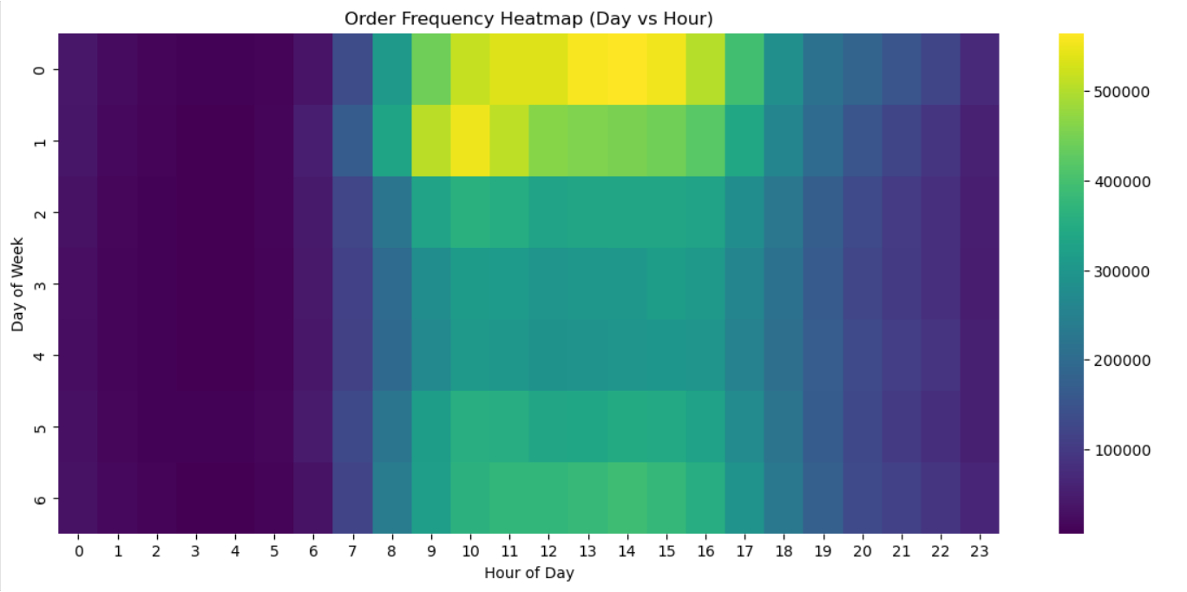
Insights:
    - Peak ordering hours: 10 AM – 2 PM
    - Sunday is the busiest day across most hours
  - Customer Segmentation Using RFM + K-Means

Cluster Behaviour Interpretation
The four clusters show clear differentiation in customer behavior. Cluster 3—high-frequency shoppers—demonstrate exceptional loyalty and consistent ordering patterns. These are Instacart’s most valuable users and should be treated as “VIP customers.” In contrast, Cluster 1 customers are low-value users whose order frequency and monetary value are minimal. These insights allow Instacart to prioritize marketing resources toward nurturing high-value customers while balancing acquisition costs for low-engagement segments.

RFM Insights for Personalization
RFM segmentation offers strong potential for personalized marketing. High-frequency customers may respond well to personalized promotions or free delivery incentives. High-monetary customers (Cluster 0) might be attracted to bulk purchase discounts, recipe bundles, or weekly meal-preparation packs. Meanwhile, Cluster 2 customers, who are recent but light shoppers, may be ideal candidates for first-time coupons or loyalty rewards to convert them into repeat customers.

Business Impact of Customer Segments
Understanding these segments helps Instacart design differentiated customer journeys. For instance, Cluster 3 customers may benefit from subscription services like Instacart Express, while Cluster 2 users may benefit from proactive engagement strategies such as push notifications and AI-driven product recommendations. Identifying at-risk customers (e.g., Cluster 1 with high recency) enables targeted win-back campaigns.

Visualization Interpretation
The scatter plots (Recency vs Frequency and Frequency vs Monetary) reveal the natural grouping behavior and validate clustering. Cluster 3 stands out as a distinct high-frequency segment. Cluster 0’s high monetary behavior is easily observed through the boxplot, confirming that they consistently purchase larger baskets. This visual differentiation provides confidence that the clustering model is both meaningful and practically actionable.

Step 1: Feature Calculation
- Recency = days since last purchase
- Frequency = total number of orders
- Monetary = average basket size
Step 2: Clustering
We used K=4 clusters based on silhouette stability and interpretability.
Step 3: Cluster Interpretation
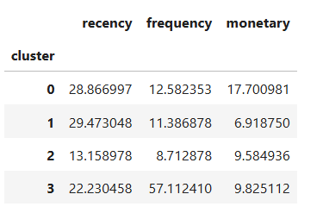
Example interpretation:
Cluster | Description
Cluster 0 | High monetary, medium frequency customers
Cluster 1 | Low monetary, low frequency
Cluster 2 | Medium monetary, low frequency
Cluster 3 | High frequency, moderate monetary

Visualization
- Frequency vs Monetary scatter
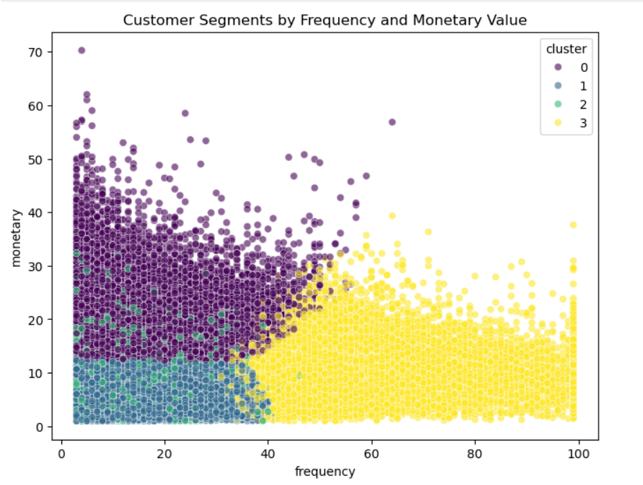
- Recency vs Frequency scatter
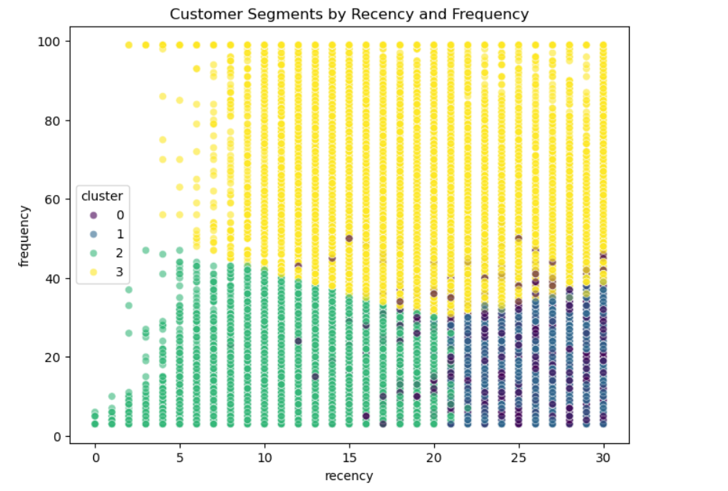
- Monetary boxplot
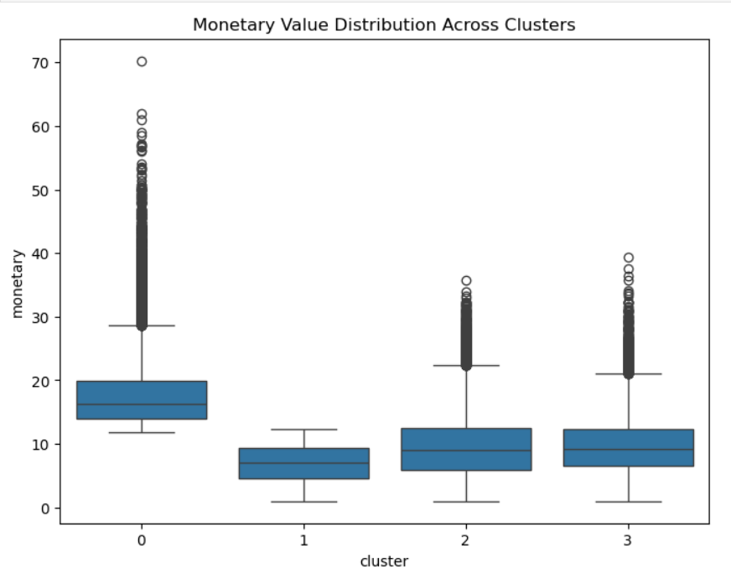

  - Product Popularity Prediction (Supervised ML)
Step 1: Label Definition
To predict which products are likely to become popular, we first needed to define a clear popularity label. Using total historical order counts for each product, we applied a percentile-based threshold:
- Products in the top 25% of total orders → Popular (1)
- Products in the bottom 75% → Not Popular (0)
This threshold helps separate consistently high-demand products—such as milk, fresh fruits, and snacks—from items that are purchased infrequently.
Class distribution:
- Popular products: ~12,424
- Not popular products: ~37,253
This distribution reflects a realistic long-tail pattern commonly seen in retail datasets, where a small set of products drives the majority of sales. Although the dataset is imbalanced, the split is still suitable for supervised classification.

Step 2: Models Used
We evaluated three different machine learning models, progressing from simple linear decision boundaries to more complex nonlinear tree ensembles.
    - Logistic Regression (Baseline Model)
Logistic Regression serves as a foundational linear classifier. It assumes a linear relationship between the predictors and the probability of popularity.
Its performance provides a benchmark for understanding whether more complex models are necessary. While fast and interpretable, it may struggle to capture nonlinear relationships between reorder behavior and category patterns.

    - Decision Tree Classifier
Decision Trees work by learning hierarchical rules such as:
“If reorder_ratio > 0.5 and department = produce -> high popularity.”
They are easy to interpret and can capture nonlinearities and interactions between features.
However, a single tree may overfit or produce unstable boundaries depending on data splits.

3. Random Forest (Ensemble Model)
Random Forest combines hundreds of decision trees to create a more stable and accurate classifier.
Each tree is trained on a different subset of the data, and their outputs are aggregated through majority voting.
This approach reduces variance, improves generalization, and captures complex relationships between product features.
Random Forest is highly suitable for this task because:
- Product popularity is influenced by multiple interacting factors
- Tree ensembles naturally handle categorical encodings
- The model is robust to noise and imbalanced classes
Why Random Forest Performed the Best
Random Forest achieved the highest performance across all metrics. Its strong results arise because:
- It handles nonlinear relationships between reorder patterns and product categories
- It reduces overfitting by averaging many trees
- It naturally captures interaction effects
- It is robust to class imbalance
- It does not assume linearity or a specific distribution
The improvement in ROC-AUC (~0.84) demonstrates its ability to rank items effectively along a popularity probability scale, making it highly useful for product recommendation systems.

Step 3: Performance Comparison
To train strong predictive models, we engineered product-level features:
- Reorder Ratio: Measures the fraction of orders where the item was purchased again. This behavioural metric proved to be the strongest predictor of popularity.
- Department Encoding: Shows general product category influences (e.g., produce vs household).
- Aisle Encoding: Provides more granular category information (e.g., yogurt, fresh fruits, packaged vegetables).
By combining behavioural and categorical signals, the models can differentiate products not only by how much they are purchased, but why and in which context.

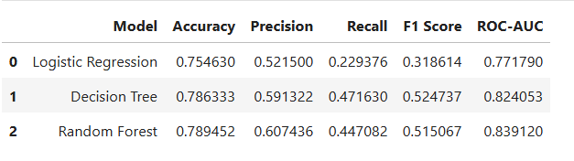
Final Outcome of Supervised Learning
The supervised learning results show that product popularity is strongly predictable using historical behavioral signals and simple category features. The models allow e-commerce platforms to anticipate which products customers are most likely to continue purchasing, enabling data-driven inventory planning, promotion optimization, and personalized recommendations.
4.3.4 Feature Importance
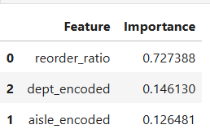
Example insights:
- Reorder ratio is the strongest predictor of popularity
- Department and aisle categories have moderate influence

- Conclusion
This project provides a comprehensive analysis of customer behavior and product performance within the Instacart Online Grocery Shopping environment. By leveraging RFM metrics and K-Means clustering, we successfully segmented customers into four distinct groups that vary in recency, purchase frequency, and basket size. These segments offer meaningful insights into customer loyalty, engagement, and economic value, enabling personalized marketing strategies and data-driven retention efforts. The clustering results highlight the importance of understanding customer heterogeneity when designing engagement and promotional strategies.

On the product side, we developed machine learning models to classify products into high and low popularity tiers using behavioral and categorical attributes. Among the models evaluated, the Random Forest classifier provided the strongest predictive performance across all key evaluation metrics—accuracy, precision, recall, F1 score, and ROC-AUC—demonstrating its ability to capture nonlinear relationships and interactions between features. Importantly, feature importance analysis revealed that reorder ratio is the most influential predictor of product popularity, reinforcing the significance of repeat purchase signals in understanding customer demand patterns.

From an operational perspective, our findings emphasize the need for e-commerce companies to prioritize both customer-centric and product-centric analytics. Understanding when customers shop, what they buy most frequently, and which items they repeatedly reorder can significantly optimize inventory management, reduce stockouts, and improve recommendation systems. In addition, the dominance of categories such as produce and dairy suggests that businesses should carefully monitor perishable goods and streamline supply chain operations accordingly.

The behavioral trends discovered—such as peak ordering times, weekly purchasing rhythms, and cross-category ordering patterns—provide a foundation for dynamic pricing strategies, personalized advertising, and time-optimized promotional campaigns. Segmentation results further empower businesses to create differentiated experiences tailored to high-value customers, newly active users, and low-engagement segments.

Overall, this project demonstrates that combining customer segmentation, exploratory data analysis, and predictive modeling creates a powerful analytical framework capable of supporting strategic decision-making in e-commerce. As customer expectations continue to evolve, companies that embrace data-driven approaches will be better positioned to enhance user satisfaction, increase operational efficiency, and sustain long-term competitive advantage.

Future Extensions
- Future work may include:
- Incorporating product pricing, discounts, or review sentiment
- Adding time-series forecasting for product demand
- Building deep learning models for personalized recommendation
- Exploring sequence models to understand shopping patterns over time
- Evaluating model performance across different regions or customer cohorts
- These enhancements would offer even deeper insights and practical value for large-scale e-commerce applications.

- References
- Instacart Online Grocery Shopping Dataset, Kaggle.
- Scikit-learn Documentation: https://scikit-learn.org/
- Seaborn Visualization Library
- Pandas Documentation
- Matplotlib Documentation

