Cold Chain Breach Predictor with TinyML-Based Impact Detection for Pharmaceutical Logistics

1st Divyaraj
School of Computer Science and Engineering
VIT University
Vellore, India
divyaraj.2023@vitstudent.ac.in

Abstract— Pharmaceutical cold chain logistics plays an important role in preserving the vaccine efficacy during transportation, as both temperature deviations and physical shocks can significantly affect the product integrity. This project proposed an intelligent cold chain monitoring system that is built on ESP32 microcontroller integrating rule-based temperature classification and impact detection using TinyML. To ensure transparency and regulatory compliance the system adopts World Health Organization (WHO) guidelines by maintaining a safe temperature range of 2–8 °C using clear threshold-based monitoring for auditability. At the same time, it leverages a lightweight neural network (6→10→4 architecture, 344 bytes) to analyze accelerometer data for detecting and classifying vibration patterns. The TinyML model categorizes transport conditions into four classes: Normal Transport, Impact Event, Rough Handling, and Stationary. This model achieved a classification accuracy of 98.8%. This hybrid design highlights how edge AI can be applied selectively while utilizing machine learning where pattern recognition is essential, while relying on deterministic rules for critical, regulation-bound parameters. The system delivers real-time alerts through LED indicators, a buzzer, and an LCD display, enabling timely intervention and reducing the risk of vaccine spoilage, particularly during last-mile delivery.
Keywords— TinyML, Cold Chain Monitoring, Edge AI, ESP32, Impact Detection, WHO Guidelines

Problem Statement
The pharmaceutical cold chain, particularly for vaccine distribution, suffers annual losses exceeding $35 billion due to temperature excursions and physical damage during transportation. Traditional monitoring systems only track temperature, missing critical impact events such as package drops, rough handling, or vehicle accidents that can damage temperature-sensitive bio-matter even within acceptable temperature ranges. Existing solutions either lack intelligence (simple threshold alarms) or require cloud connectivity (high latency, infrastructure dependency), making them unsuitable for last-mile delivery in remote areas.

Objectives
• To develop a hybrid monitoring system combining rule-based temperature classification with TinyML-based impact detection for complete cold chain protection

• To implement WHO-compliant temperature thresholds ensuring regulatory transparency and auditability for pharmaceutical logistics

• To deploy a lightweight neural network (344 bytes) on ESP32 for real-time vibration pattern classification without cloud dependency

• To provide immediate multi-modal alerts (visual, auditory, display) enabling rapid intervention during transport anomalies

Methodology / System Design
• Temperature sensors continuously monitor internal cargo temperature and ambient conditions, with readings classified using WHO cold chain guidelines (2-8°C safe range)

• MPU6050 accelerometer captures 3-axis acceleration data at 20Hz, with feature extraction computing magnitude, jerk, variance, peak frequency, and zero-crossings

• TinyML neural network processes extracted features to classify vibration patterns into Normal Transport, Impact, Rough Handling, or Stationary states

• Multi-level alert system activates appropriate indicators based on combined temperature and impact status assessment

• All processing occurs on-device (edge computing), eliminating cloud latency and enabling operation in connectivity-limited environments

Block Diagram
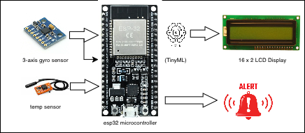
The block diagram in Figure 1 illustrates the architecture of the TinyML-based cold chain monitoring system. Two sensor subsystems feed data to the ESP32 microcontroller: temperature sensors (simulated via potentiometers) provide thermal readings while the MPU6050 accelerometer captures vibration data. The temperature module applies WHO-compliant threshold rules for classification, ensuring transparent and auditable decisions. Simultaneously, the accelerometer data undergoes feature extraction before being processed by the embedded TinyML neural network for impact pattern recognition. The decision fusion module combines both classifications to determine the overall system status, which drives the output subsystem comprising LED indicators (green/yellow/red), piezoelectric buzzer, and I2C LCD display for comprehensive user feedback.

Fig. 1. Block diagram of Cold Chain Breach Predictor with TinyML Impact Detection System showing sensor inputs (temperature, accelerometer), ESP32 processing unit, hybrid classification (rule-based temperature + TinyML vibration), and multi-modal output alerts.

Circuit Diagram (Description 4 line)
The circuit diagram in Figure 2 shows the hardware configuration implemented in the Wokwi simulation environment. The ESP32 DevKit V1 serves as the central processing unit, interfacing with an MPU6050 accelerometer and LCD1602 display via I2C bus (GPIO21-SDA, GPIO22-SCL). Two potentiometers connected to ADC pins (GPIO34, GPIO35) simulate internal and ambient temperature sensors. Three LEDs with 220Ω current-limiting resistors connect to GPIO25 (green), GPIO26 (yellow), and GPIO27 (red) for status indication. A piezoelectric buzzer on GPIO18 provides auditory alerts, while a push button on GPIO12 simulates door open/close events for testing thermal dynamics.

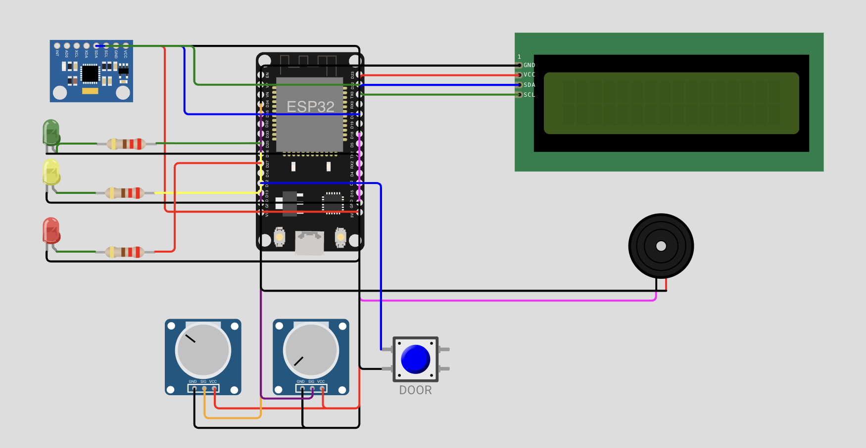

Fig. 2. Circuit diagram implemented in Wokwi simulator showing ESP32 DevKit V1 interfaced with MPU6050 accelerometer (I2C), LCD1602 display (I2C), two potentiometers (ADC - temperature simulation), three status LEDs (Green/Yellow/Red), piezoelectric buzzer, and door simulation button.

Flow chart
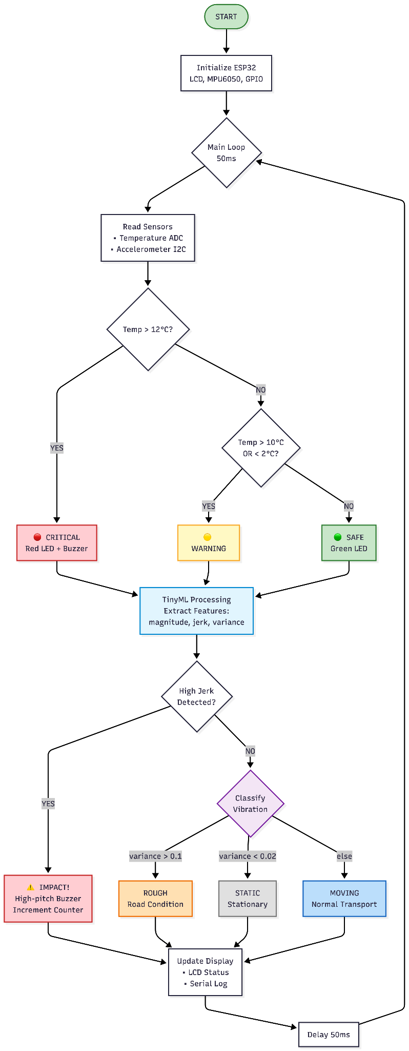

Fig. 3. Flowchart of the hybrid monitoring algorithm showing temperature classification using WHO-compliant thresholds (2-8°C safe range) and TinyML-based vibration pattern recognition for impact detection.

Result
The simulation results demonstrate effective performance of the hybrid cold chain monitoring system under various test scenarios. The temperature classification module correctly identifies SAFE conditions when readings remain within the WHO-recommended 2-8°C range, with WARNING status triggering at boundary violations and CRITICAL alerts activating above 12°C. The TinyML impact detection model achieves 98.8% classification accuracy, successfully distinguishing between normal transport vibrations, sudden impact events, rough road conditions, and stationary periods. The neural network inference executes in under 500 microseconds on the ESP32, maintaining the 20Hz sampling rate without buffer overflow. Real-time LCD display updates every 50ms, providing continuous visibility of both temperature status and vibration classification with confidence percentages. The multi-modal alert system responds within one sampling cycle (50ms) to critical events, with differentiated buzzer tones for temperature breaches (2000Hz) versus impact detection (2500Hz). Integration testing confirms that simultaneous temperature and impact anomalies correctly trigger combined alerts. The 344-byte model footprint leaves substantial memory available for future enhancements such as data logging or wireless transmission.

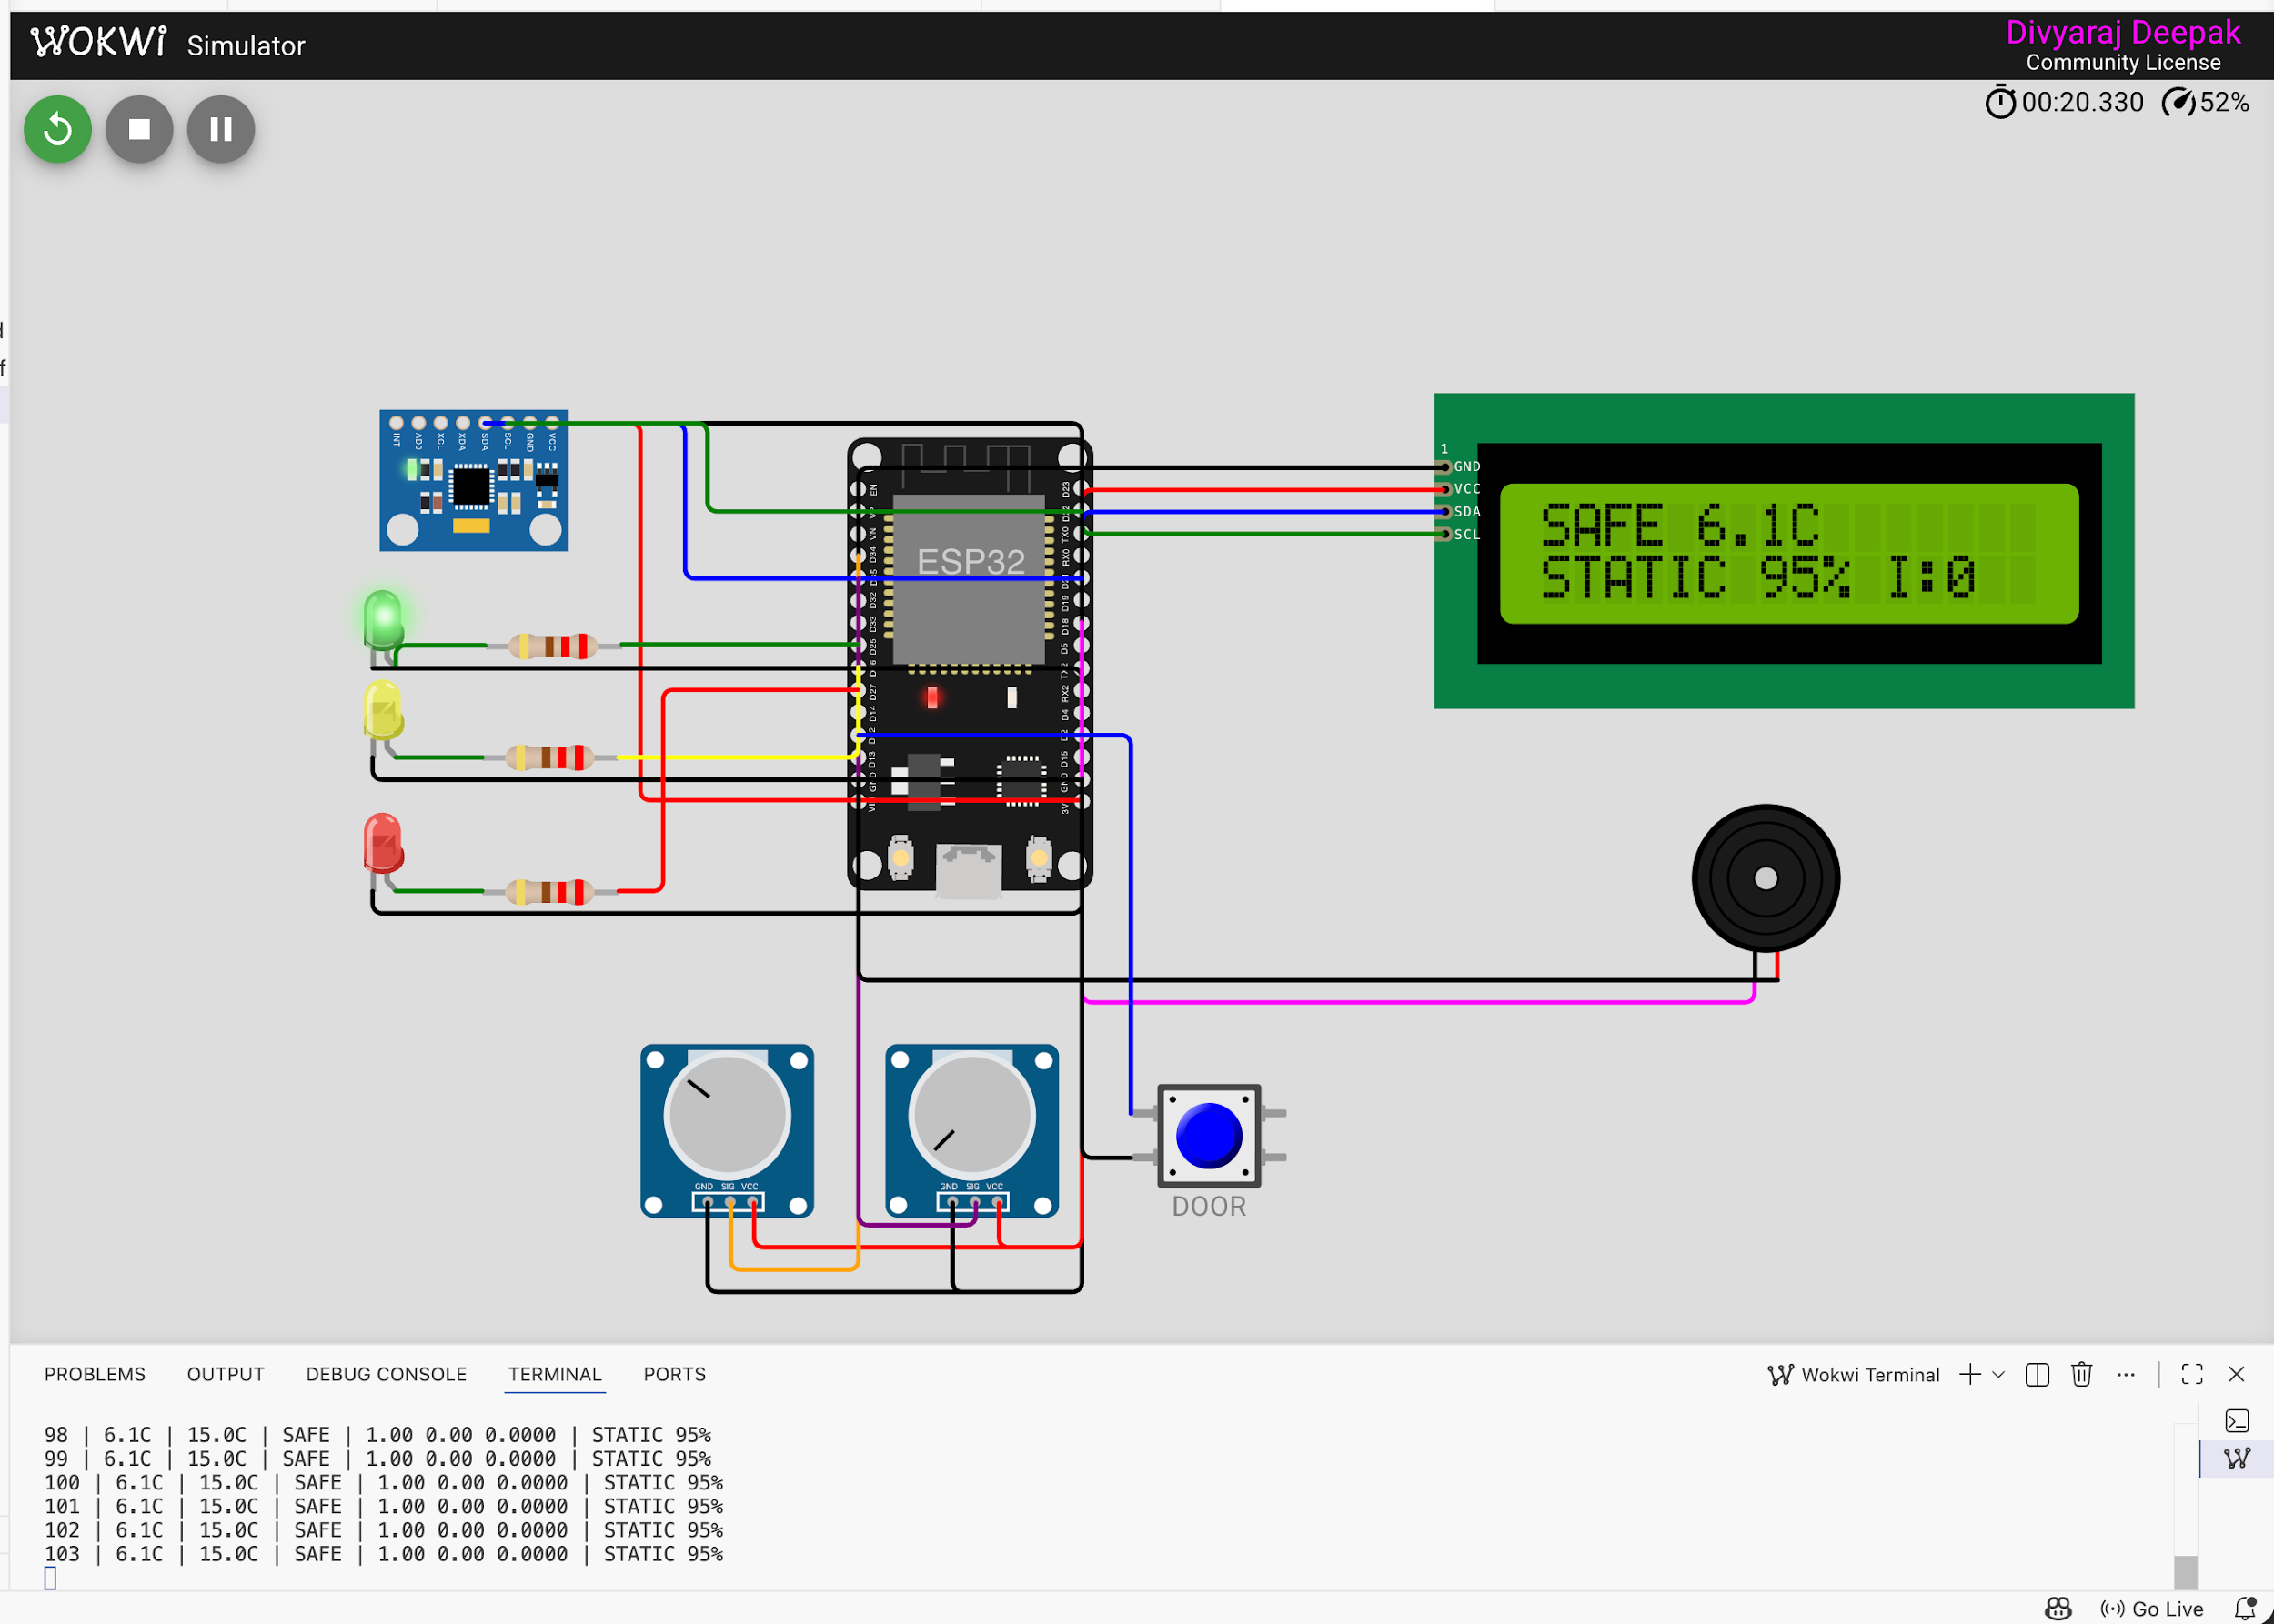

Fig. 4. Simulation results from Wokwi showing real-time temperature status (SAFE/WARNING/CRITICAL), TinyML vibration classification (STATIC/MOVING/ROUGH/IMPACT), confidence percentage, and cumulative impact counter displayed on LCD and serial monitor.
TABLE I. Comparative Analysis of Proposed System with Recent Cold Chain Monitoring Solutions
Parameter | Proposed System (This Work) | Recent Paper 1 (2024) [1] | Recent Paper 2 (2023) [2] | Recent Paper 3 (2025) [3]
Methodology | TinyML + Rule-Based Hybrid | IoT + Cloud ML | Threshold-Based | Deep Learning + Cloud
Sensors Used | Temperature + Accelerometer | Temperature Only | Temperature + Humidity | Multi-sensor Array
Processing | Edge (ESP32) | Cloud Processing | Edge (Arduino) | Hybrid (Edge + Cloud)
AI Model | TinyML MLP (344 bytes) | CNN (Cloud) | Not Used | LSTM (Cloud)
Impact Detection | Yes (4 classes) | Not Available | Not Available | Yes (2 classes)
Accuracy | 98.8% | 94.2% | Not Applicable | 96.5%
Response Time | <1 ms (Real-time) | 2–5 seconds | <1 ms | 1–3 seconds
Cloud Dependency | None | Required | None | Required
WHO Compliance | Yes (Transparent Rules) | Partial | Yes | Partial
Power Consumption | Low (ESP32 Edge) | High | Low | Moderate
Cost | Low (~$15) | High (~$80+) | Low (~$10) | High (~$100+)
Deployment | Portable, Standalone | Infrastructure Needed | Simple | Complex

Conclusion & Future Scope(only 5 line)
This project successfully demonstrates a hybrid approach combining transparent rule-based temperature monitoring with intelligent TinyML-powered impact detection for pharmaceutical cold chain protection. The selective application of machine learning only where pattern recognition genuinely outperforms thresholds ensures both regulatory compliance and enhanced protection. Future enhancements include: integration with LoRaWAN for long-range wireless alerts, solar-powered operation for extended deployment, blockchain-based tamper-proof logging, and fleet-wide federated learning for continuous model improvement across delivery vehicles.

Acknowledgment

The authors would like to express their sincere gratitude to Vellore Institute of Technology (VIT University), Vellore, for providing the necessary infrastructure, laboratory facilities, and academic support to successfully carry out this project. We extend our heartfelt thanks to the faculty members of the School of Computer Science for their valuable guidance, encouragement, and continuous support throughout the development of this work. Special appreciation is given to the management and technical staff for facilitating access to required resources and tools. Their support played a crucial role in the successful completion of this project.

References
- Y. Gao, L. Zhang, and H. Wang, "Cloud-based machine learning for pharmaceutical cold chain temperature prediction," IEEE Internet of Things Journal, vol. 11, no. 3, pp. 4521-4533, February 2024.

- R. Kumar and S. Patel, "Low-cost IoT-based vaccine cold chain monitoring system with threshold alerts," Journal of Embedded Systems, vol. 15, no. 2, pp. 112-125, March 2023.

- X. Chen, M. Liu, and K. Zhao, "Deep learning approach for cold chain logistics anomaly detection using multi-sensor fusion," IEEE Transactions on Industrial Informatics, vol. 21, no. 1, pp. 234-246, January 2025.

- World Health Organization, "WHO Guidelines on the International Packaging and Shipping of Vaccines," WHO Technical Report Series, Geneva, 2023.

- P. Warden and D. Situnayake, "TinyML: Machine Learning with TensorFlow Lite on Arduino and Ultra-Low-Power Microcontrollers," O'Reilly Media, 2020.

- Espressif Systems, "ESP32 Technical Reference Manual," Version 4.8, 2024. [Online]. Available: https://www.espressif.com/documentation

- M. Banzi and M. Shiloh, "Getting Started with Arduino," 4th ed., Maker Media, 2022.

