

|  |  |
| --- | --- |
| Department | Computer Engineering and Application |
| Program | B. Tech CSE (spec. AIML and IOT) |
| University Roll no. | 2315510070 |
| Section | CB |
| Class Roll no. | 13 |
| Assignment | 03 |
| Subject Name | Web Technology - 1 |
| Subject Code | BCSC 0062 |
| Date Of Allotment | 17-11-2023 |
| Date Of Submission | 24-11-2023 |

**Submitted By:**

Divya Raj Varshney

**Submitted To:**

Dr. Shashi Bhushan Sir

**Submitted By:**

**Submitted To:**

Q 1. Design Online Registration Form described as follows: a web page that serves as an online registration form. The form should collect basic information from users, such as their name, email, and a password. Additionally, implement client-side and server-side validation for the form. a. HTML Form: • Create an HTML form with fields for the following information:

• Full Name

• Email

• Password

• Confirm Password

• Use appropriate input types and labels.

• Implement a "Submit" button. b. CSS Styling:

• Apply CSS styling to make the form visually appealing.

• Use proper formatting for labels, input fields, and buttons.

• Ensure that the design is responsive and looks good on both desktop and mobile devices. c. Client-side Validation:

• Implement JavaScript to perform basic client-side validation.

• Validate that all fields are filled out before submission.

• Validate that the email follows a valid email format.

• Ensure that the password and confirm password fields match. d. PHP Processing:

• Create a PHP script to process the form data when submitted.

• Sanitize and validate the input data on the server side.

• If there are errors, display appropriate error messages.

• If there are no errors, display a success message along with the submitted information.

Solution:

In this que I made an “index.php” file over replit and perform this question.

After making “index.php” file I created another file name “function” file.

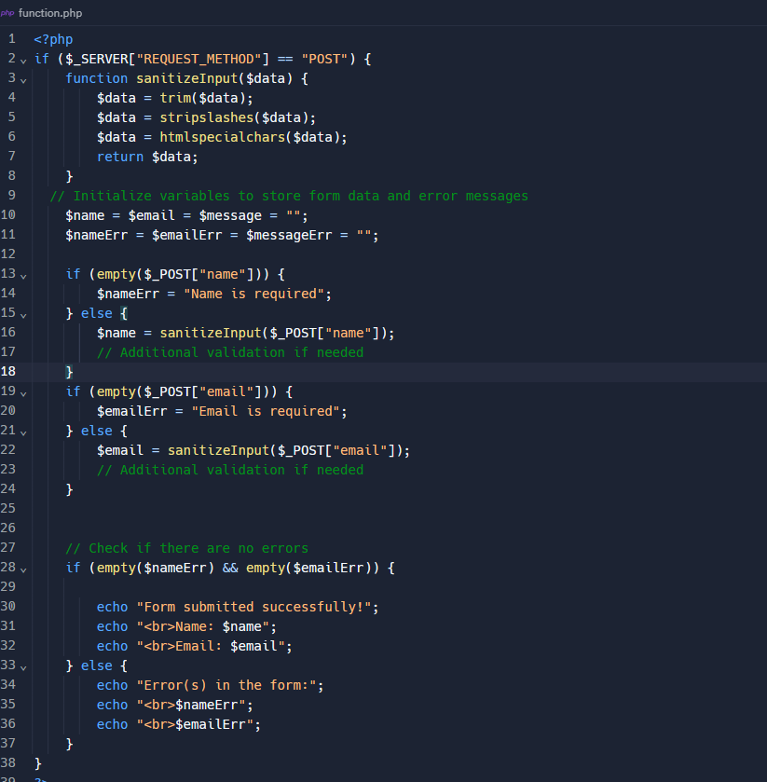

Output:

Q 2. Write a PHP script that reads the content of a text file named "sample.txt" and displays each line of

the file with line numbers. Ensure that the file exists before attempting to read it, and handle the case

where the file is not found gracefully.

Solution: First, I created “sample.txt” file and write few lines on that file.

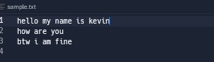

Now on the Replit server I have written my code and save the file with name “index.php”.

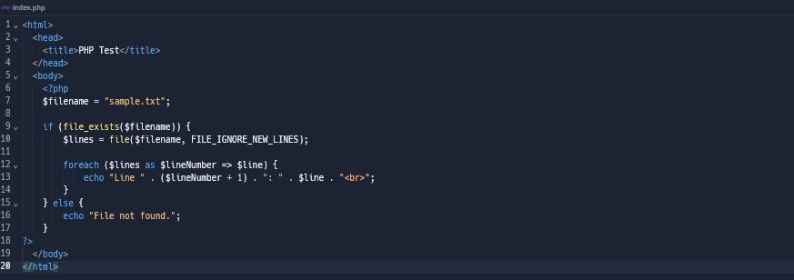

I've used the file function to read all lines from the file into an array. The FILE_IGNORE_NEW_LINES flag is used to exclude newline characters from each line. Then, a simple foreach loop is used to iterate through the lines, displaying each line with its line number. The line number is adjusted by adding 1 to $lineNumber to start from 1 instead of 0.

OUTPUT:

Q 3.Create a PHP script that takes user input through a form (using HTML and PHP) and appends the

input data to a file named "log.txt." The form should include fields for a user's name and a comment.

The script should validate the input (ensure that both fields are filled) and then append the user's name

and comment to the file, each on a new line. If the file does not exist, create it. Test the script by

submitting multiple entries through the form.

Solution: Over replit I first created a new html file with name “index.html” and on that file I made a form.

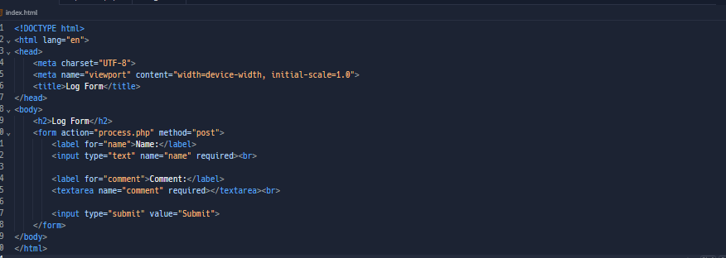

Now in the form I joined a new file name “process.php” for creating a new text document i.e., “log.txt” on the computer by taking data from the server.

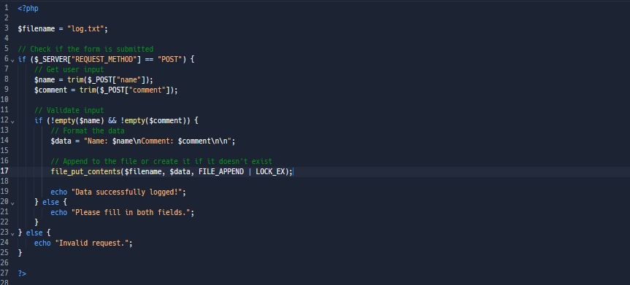

When I run this file on the server a new window open on browser asking me my name and some comment over browser.

OUTPUT:



When I submitted my log for or clicked on the “Submit” button a new “log.txt” file created.

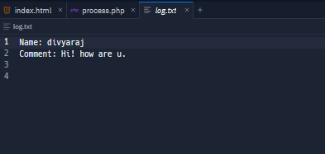

Q4. Write a PHP script that initializes an array of integers and performs the following operations:

• Find and display the sum of all elements in the array.

• Identify and display the maximum and minimum values in the array.

• Remove any duplicate values from the array and display the modified array.

• Sort the array in ascending order and display the sorted array.

• Ensure that the script is dynamic and works with different arrays of integers.

Solution: For this que I made a new PHP file name “index.php ” on replit .

Here I used some keywords in this code which are define as:

* array_sum: Calculates the sum of values in an array.
* max: Finds the highest value in an array.
* min: Finds the lowest value in an array.
* array_unique: Removes duplicate values from an array.
* implode(', ', $numbers) is used for the sorted array.
* implode(', ', $uniqueNumbers) is used to concatenate the elements of the $uniqueNumbers array into a string with commas separating each element.

OUTPUT:

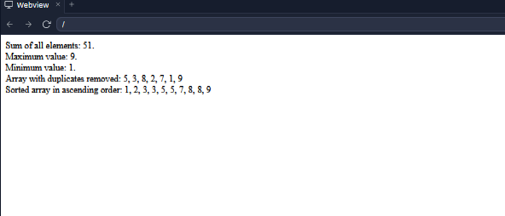

Q5. Write a PHP script to sort the following associative array :

array("Sophia"=>"31","Jacob"=>"41","William"=>"39","Ramesh"=>"40") in

a) ascending order sort by value

b) ascending order sort by Key

c) descending order sorting by Value

d) descending order sorting by Key

Solution: I make a “keyvalue.php” file on the replit for performing this que.

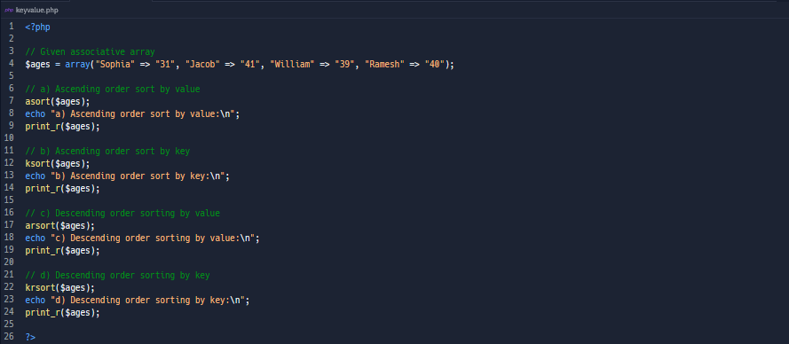

In this code I used some inbuilt functions which are listed below:

* asort: Sorts an associative array in ascending order according to the values, maintaining key-value associations.
* ksort: Sorts an associative array in ascending order according to the keys.
* arsort: Sorts an associative array in descending order according to the values, maintaining key-value associations.
* krsort: Sorts an associative array in descending order according to the keys.

Output:

Q6. Write a PHP function to change the following array's all values to upper or lower case.

Sample arrays :

$Color = array('A' => 'Blue', 'B' => 'Green', 'c' => 'Red');

Expected Output :

Values are in lower case:

Array ( [A] => blue [B] => green [c] => red )

Values are in upper case:

Array ( [A] => BLUE [B] => GREEN [c] => RED )

Solution : In this I again made a new file with name “ index.php” on replit platform.

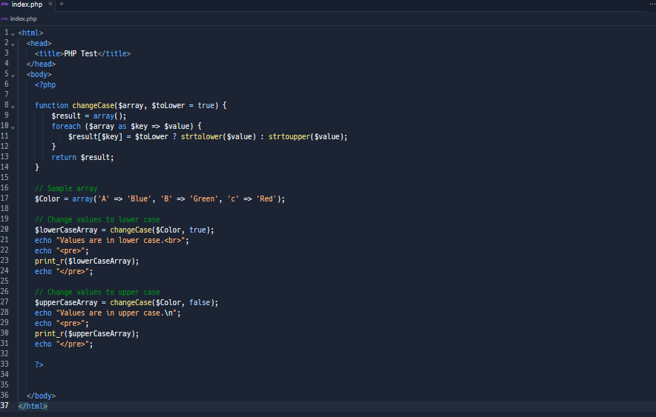

There are some built in functions which I have used in the above code:

* The changeCase function accepts an associative array ($array) and a boolean parameter ($toLower) which determines whether to convert the values to lower or upper case.
* Inside the function, a loop iterates through the array, and each value is converted to lower or upper case based on the value of $toLower.
* The modified array is then returned.

Output:

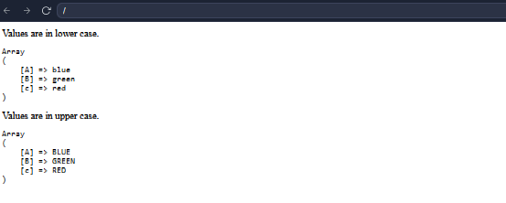

Q7. Write a PHP program to reverse the digits of an integer.

Sample :

x = 234, return 432

x = -234, return -432

Solution: In this code I have created a new file with name “reversing_the_digit.php” on replit.

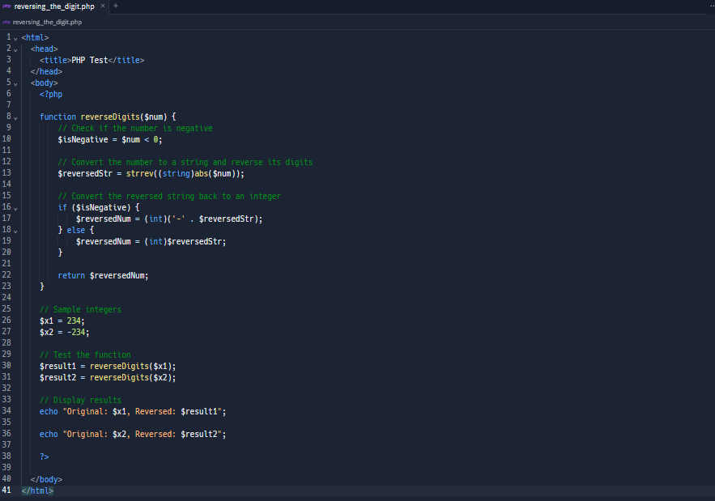

Some built in function which I have used in my code are:

1. reverseDigits: which takes an integer as input and returns the integer with its digits reversed. 2.strrev function to reverse the string representation of the absolute value of the number .

Output:

