

Pattern mining and recommender systems

Group: #38
Abin Shoby a1933920
Divyarashmi Gurram a1917395
Rohan Sai Vijaykumar Kosuri a1907138

The University of Adelaide
4533_COMP_SCI_7306 Mining Big Data
Lecturer: Dr. Alfred Krzywicki

Table of Contents
1. Executive Summary 2
2. Introduction 2
3. Exploratory Analysis 3
4. Implementation 5
4.1. Task 1: Frequent Pattern Mining 5
4.2. Task 2: Collaborative Filtering 5
4.2.1. Method Selection 5
4.2.2. Utility Matrix, Purchase Recency and Data Preprocessing 6
4.2.3. Model Training and Hyperparameters 6
4.2.4. Recommendation from Raw Data 6
4.2.5. Recommendation from Frequent Patterns 7
4.3. Task 3: System Integration 7
4.3.1. Literature Survey and Key Idea 7
4.3.2. Overall Code Flow 7
5. Testing and Results 8
6. Conclusion and Recommendations 11
7. Contributions and Reflections 11
7.1. Contributions 11
7.2. Reflection on Task 1 11
7.3. Reflection on Task 2 12
7.4. Reflection on Task 3 12
8. References 13
A. Appendix: Additional materials 14
A.1. Additional Notes on Data Preprocessing 14
A.2. Results of Hyperparameter Tuning 14

Executive Summary
The research addresses the limitations of a standalone frequent pattern mining or collaborative filtering techniques by combining them to provide personalised recommendations to the customers, thereby boosting the grocery sales. Moreover, the hybrid system employs a novel recommendation scoring method to prioritise recently purchased items, offering trending and frequently bought items to improve customer satisfaction. The results of the hybrid recommender system, compared with standalone frequent pattern mining and collaborative filtering algorithms using the ranking metrics, indicate superior performance of the proposed system with a 97.42% F1@5 score compared to a 7.81% F1@5 score in a standalone collaborative filtering method. Moreover, the proposed system is 34 times faster (15 seconds response time) than a standalone frequent pattern mining method (514 seconds response time). Thus, the new system offers personalised and trending recommendations without compromising the system’s efficiency, paving the way for yielding profits through cross-selling and customer satisfaction.

Introduction
Recommender systems are widely used to provide personalised recommendations to customers while increasing the sales of products or services. It is employed in many online platforms such as Amazon e-commerce website, Netflix, Google Play Store, and offline shopping platforms such as Coles, Woolworths, K-mart and ALDI. Our work focuses on providing efficient recommendations for customers registered with an offline grocery store.
The grocery store manager noticed that certain items are frequently purchased together and wants to use these frequent patterns to provide personalised recommendations to the customers. Moreover, the store has customer purchase data (Krzywicki 2025) collected through their loyalty program, and we aim to develop the recommender system prototype using this dataset.
There are numerous ways to construct a recommender system. These include collaborative filtering, content-based filtering, and frequent pattern mining (Kotu & Deshpande 2019, p. 351). Collaborative filtering methods recommend items based on the similarity between users or the similarity between the purchased items. Content-based filtering methods recommend items based on the item properties, user preferences or user profile. Frequent pattern mining algorithms extract frequent purchase patterns to generate association rules, which are used to recommend items. However, the implementation differs based on the domain and the format of available data. Since the grocery purchase data contains only the transaction date, user ID and item purchased, collaborative filtering or frequent pattern mining methods are feasible. Using collaborative filtering alone might suffer from the cold-start problem when some users have purchased only a few items, and the purchase data is insufficient to find a similar user or transaction. Considering frequent pattern mining, it can suffer from the long-tail problem, where the least popular items are never recommended (Leskovec, Rajaraman & Ullman 2019, p. 321). Therefore, instead of a standalone collaborative filtering method, we propose a novel hybrid recommender system that combines collaborative filtering and frequent pattern mining algorithms to solve cold-start and long-tail problems to a certain extent. In this way, the grocery sales can be boosted through efficient recommendations from a hybrid system compared to a standalone collaborative filtering technique. Moreover, a new item ranking method is proposed to prioritise items based on purchase recency so that customers can buy trending items. It also allows merchants to stock trending items to yield a better margin.
The overview of the proposed hybrid recommender system is shown in Figure 1. The frequent pattern mining method accepts grocery transaction data and extracts frequent patterns and association rules. These patterns are used by the collaborative filtering method, including the transaction history and user ID, to generate top N recommendations to the user.
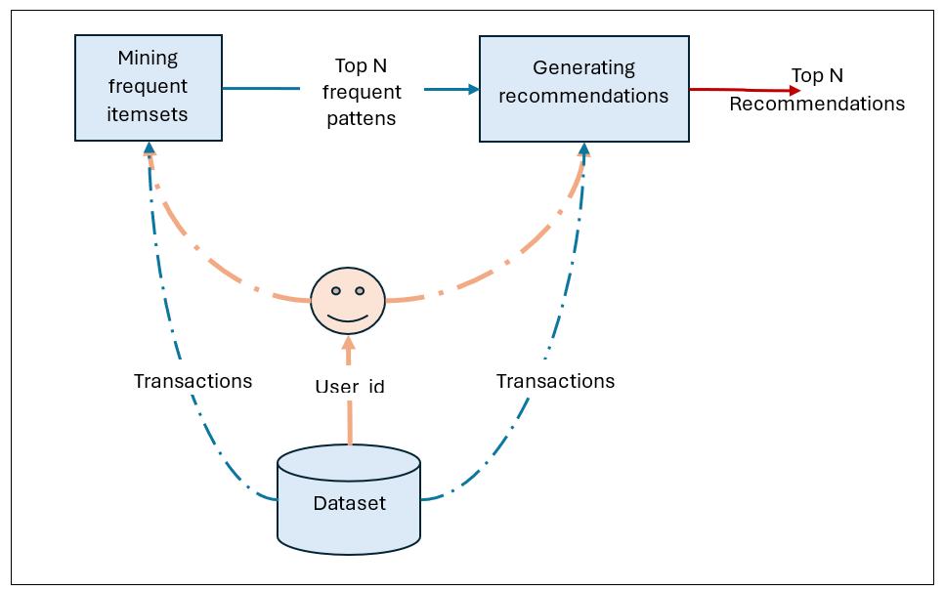
Figure 1: Hybrid recommender system architecture (Krzywicki, 2025)

The content of the report is organised as follows. The upcoming section discusses the results of exploratory data analysis to obtain suitable insights to develop the hybrid architecture. Later in Section 4, the system implementation is explained, including pattern mining, collaborative filtering and their integration. Moreover, the data preprocessing, hyperparameter tuning and scoring formula are discussed in this section. Further in Section 5, the results of recommender systems with and without frequent pattern mining are compared using suitable ranking metrics. Additionally, these systems are tested using some sample inputs, and the results are discussed. Finally, the report is concluded in Section 6 with limitations and further development ideas. Additionally, the contributions from each team member are mentioned in Section 7.

Exploratory Analysis
The analysis of grocery purchase data can yield suitable ideas for implementing the hybrid recommender system with collaborative filtering and frequent pattern mining. Moreover, it can give some insights into developing a suitable item ranking score. Therefore, a heatmap of user-item interaction is constructed using sampled users and items, shown in Figure 2. From the chart, it is evident that the user-item interaction matrix or utility matrix is very sparse, and some items, including citrus fruit, napkins, and cream cheese, are rarely bought. However, items like whole milk, soda, and other-vegetables are frequently purchased. Therefore, some technique must be applied to fill the sparse matrix to provide good recommendations.
To understand the relationship between the purchase date and items purchased, a recency trend analysis is performed as shown in Figure 3. The graph shows the percentage of purchases that match the purchases on the previous day. The graph follows an oscillating pattern. To develop a suitable relationship between the recency of an item and the chance of purchasing it again, the Augmented Dickey-Fuller (ADF) test (Dickey & Fuller 1979) is performed to determine if the series is stationary. The p-value from the ADF test is 0, indicating that a linear combination of recency indication value can be used to determine the likelihood of repeated purchase.

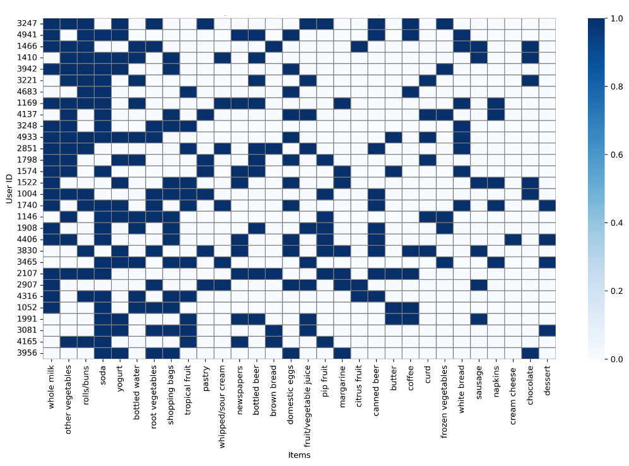
Figure 2: The heatmap illustrates a user-item interaction matrix.
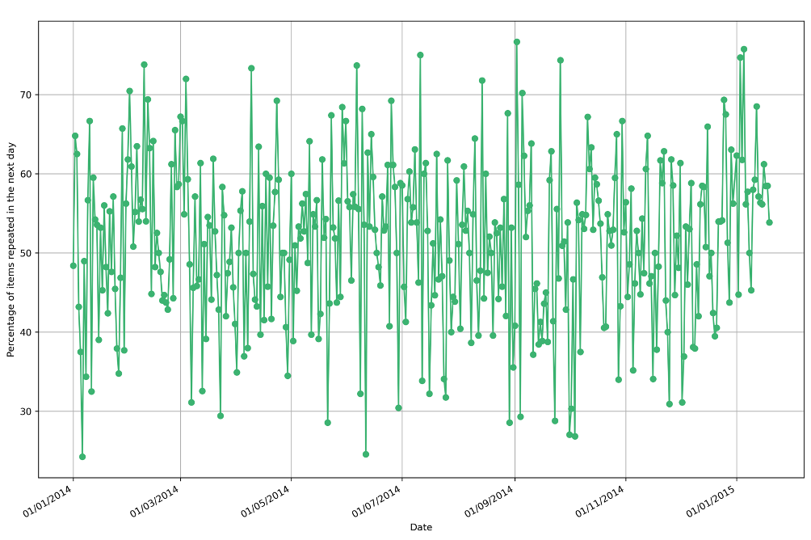
Figure 3: Percentage of purchases that match recently bought items.

Implementation

Task 1: Frequent Pattern Mining
Frequent pattern mining aids in capturing the general grocery purchase pattern of customers. It provides association rules from purchase patterns that can be used to provide recommendations. In general, an association rule has the form X→Y, where X is the antecedent and Y is the consequent. This means that if a customer buys a set of items X, it is highly likely that the customer will buy a set of items Y. Moreover, a pattern can be defined as the set of items repeatedly bought together. Since many association rules are possible, they are refined based on their support value. The support (Krzywicki 2025) of an itemset X in a transaction set T with N transactions is:
$$\begin{aligned}S\left(X\right) =\frac{\left|T:X⊆T\right|}{N} \#\left(1\right)\end{aligned}$$
Consequently, the support of a rule (Krzywicki 2025) is given as:
$$\begin{aligned}S\left(X→Y\right) =S\left(X∪Y\right) \#\left(2\right)\end{aligned}$$
The common frequent itemset mining methods are Apriori and Frequent Pattern (FP) - growth. Even though FP-growth is fast and appropriate for large datasets, in this work, we used the Apriori algorithm, which is simple to implement for a small dataset. To filter the best patterns, an optimal support value ≥ 0.1% is chosen by hyperparameter tuning discussed in section 4.3.2. The pattern mining algorithm is run on the training set using the optimal minimum support value to obtain the patterns. Further, association rules are obtained from patterns with a lift score ≥ 1 to ignore any rules with independent itemsets. The lift metric indicates how likely two itemsets X and Y are to occur together (Krzywicki 2025). The lift score is defined by:
$$\begin{aligned}lift\left(X→Y\right) =\frac{S\left(X∪Y\right)}{S\left(X\right)⋅S\left(Y\right)} \#\left(3\right)\end{aligned}$$
Finally, the rules are ranked by confidence and support metrics. The confidence (Krzywicki 2025) of an association rule is:
$$\begin{aligned}conf\left(X→Y\right) =\frac{S\left(X∪Y\right)}{S\left(X\right)} \#\left(4\right)\end{aligned}$$
To provide recommendations to a user in the test set, the antecedents of all rules are compared against the purchase history (raw input) of the user. If any subset of the purchase history occurs in an antecedent, then the items in the corresponding consequent of the rule are selected, ignoring the items already purchased by the user. From the final set of association rules, already ranked by confidence and support, the top five items are recommended to the user, highlighted by their confidence score.

Task 2: Collaborative Filtering

Method Selection
The collaborative filtering (CF) methods recommend items based on the similarity between users or the similarity between the purchased items (Kotu & Deshpande 2019). A user-based collaborative filtering method recommends items purchased or rated by users with a similar profile or preferences by computing the user-user similarity. On the other hand, item-based collaborative filtering recommends items analogous to the purchased items based on the item-item similarity score. Since the grocery purchase dataset does not contain sufficient information to categorise similar items, a user-based collaborative filtering approach is employed to find similar users based on their purchase history.
User-based collaborative filtering can be achieved through the K-Nearest Neighbours (KNN) or Matrix Factorisation algorithms. KNN is simple to implement and matches the requirement to provide the top five recommendations, as it gives the top-k similar users. Moreover, the grocery transaction data does not contain ratings, and some items are rarely bought. The Matrix Factorisation method may not produce significant performance for these situations, as it is suited for rating prediction (Kotu & Deshpande 2019). However, KNN can provide good recommendations in these conditions. Therefore, the KNN algorithm is used for user-user collaborative filtering.

Utility Matrix, Purchase Recency and Data Preprocessing
For providing the input to KNN, a utility matrix or user-item interaction matrix is constructed from the training data. The rows correspond to the user’s ID, and the columns map to grocery items. Each matrix cell is filled with the support score $s_{ij}^{'}$ of the item $j$ for the corresponding user $i,$making it a probabilistic value between 0 and 1. Since the values are probabilistic, there is no need for further normalisation.
Since it is required to give higher priority to a recently purchased item, a recency score is calculated for each transaction in the original training data. Moreover, from the analysis in Section 3, we can see that the repeated purchase trend is stationary by the ADF test. This means that the recommendations can be linearly weighted using the recency score. The recency score for an item $j$ purchased d days ago is computed as:
$$\begin{aligned}recency_{j} = \frac{1}{1+d} \#\left(5\right)\end{aligned}$$

Model Training and Hyperparameters
The model is trained on the utility matrix using the cosine metric for computing the similarity between users, and the optimal K value is chosen as 7 via hyperparameter tuning discussed in section 4.3.2. A cosine metric is used to quantify the similarity because it is suitable for a sparse utility matrix, and when the matrix values are between 0 and 1 (Kotu & Deshpande 2019).

Recommendation from Raw Data
The trained KNN model takes the raw input - purchase history indicated by the input user’s row in the utility matrix, to find the K similar users along with their distances for the input user $x$. Let $U_{x}$ be the list of users similar to input user $x$, $d_{xi}$ the distance between the input user and $i^{th}$similar user in $U_{x}$. Then the similarity with the user can be computed by:
$$\begin{aligned}sim_{xi} = \frac{1}{1+ \left|d_{xi}\right|} \#\left(6\right)\end{aligned}$$
For each item $j,$purchased by the $i^{th}$similar user, except for the items already purchased, a weighted support value is calculated as the recommendation score by modifying the weighted average rating formula (Krzywicki 2025) and applying the recency score. The recommendation score for an item $j$recommended to the input user $x$is given by:
$$\begin{aligned}score_{xj} = \frac{\left.\sum_{ i∈U_{x}}^{ }{sim_{xi}}⋅s_{ij}^{'}⋅recency_{ij}\right.}{\sum_{ i∈U_{x}}^{ }{sim_{xi}}} \#\left(7\right)\end{aligned}$$
The grocery items are ranked in decreasing order of recommendation score, and the top five items are suggested.

Recommendation from Frequent Patterns
When frequent patterns and user ID are provided as input, the neighbourhood users are found from the input user’s purchase history as explained in Section 4.2.4. However, before recommending the items, the utility matrix is modified using the association rules obtained via pattern mining (Parvatikar & Joshi 2015) (Saraei, Benali & Frayret 2025). The overall process is discussed in Section 4.3.1. The modified utility matrix is used for recommendation, while the remaining recommendation procedure and ranking are the same as mentioned in Section 4.2.4.

Task 3: System Integration

Literature Survey and Key Idea
The Frequent Pattern Mining procedure using Apriori and the Collaborative Filtering procedure using KNN are integrated to provide personalised recommendations to a user, benefiting from the recommendations provided by Apriori and KNN. However, it is tricky to combine two diverse methods having different outputs and inputs. The pattern mining results in association rules, whereas collaborative filtering finds similar users. Many ideas were suggested by different researchers. Lee et al. (Lee, Kim & Rhee 2001) suggest discovering association rules from similar users’ transactions. However, it is computationally intensive to run pattern mining for each similar user. Parvatikar et al. (Parvatikar & Joshi 2015) and Saraei et al. (Saraei, Benali & Frayret 2025) suggest populating the utility matrix using the association rules obtained via pattern mining and then applying collaborative filtering on the modified utility matrix. In this way, the pattern mining and collaborative filtering logic need not be modified and can be easily used independently. Moreover, Figure 2 shows that the interaction matrix is very sparse and needs more fillings to provide sufficient recommendations. This method can fill those gaps and provides more recommendations than a standalone collaborative filtering algorithm since items from pattern mining are consequently added to the recommendation list. Therefore, this approach is used in our recommender system.
As described in Section 4.1, a set of association rules is obtained by pattern mining along with their confidence score. Since the confidence score is also probabilistic, it can be directly assigned to the unfilled cells in the utility matrix. For each user-item row in the utility matrix matching a subset of the antecedent of an association rule, the unfilled item columns are filled by the respective confidence score of the consequent if present in the set of consequents. The modified utility matrix is used by the collaborative filtering algorithm as usual (see Section 4.2.5) to provide better recommendations.

Overall Code Flow
The integrated system provides both functionalities of a collaborative filtering integrated with pattern mining, and a standalone recommender system using collaborative filtering. The system accepts a user ID and allows users to choose recommendations with or without frequent pattern mining. The system verifies if the user is valid by searching the user ID in the test dataset, and then it checks if the user has a purchase history. If any of these conditions fail, an appropriate error message is shown.
The system follows a lazy approach for generating recommendations. So, after accepting the inputs, the system starts building the KNN and Apriori models. A hyperparameter tuning is performed using grid search to choose the optimal hyperparameters of the KNN and Apriori methods. For evaluating the parameters, the training set is further divided into training and dev sets according to the Pareto principle (Wikipedia 2025), where 80% samples are allocated to the training set and 20% assigned to the test set in a stratified manner. The stratification is achieved by ensuring that each user ID is present in both splits. For tuning the hyperparameters, the K value is selected from 7, 5, and 3 while the minimum support value is chosen from 10%, 1%, and 0.1%. The optimal K value is obtained separately for the systems with and without pattern mining (for more details, see section B.2). The F1@5 metric (Jadon & Patil 2025) is used to compare the performance using different hyperparameters. Once the optimal hyperparameters are estimated, the KNN model is trained on the full training set, and the Apriori algorithm is run on the entire training set to get association rules.
If the user requests recommendations with pattern mining, the system creates a utility matrix to find similar users via KNN using purchase history and user ID as input. Then the utility matrix is modified using the association rules to provide recommendations as described in Section 4.3.1. If the user opts for recommendations without pattern mining, all other procedures are the same except that the utility matrix will not be modified. In either case, the final list of top five recommendations is displayed along with their scores computed by Eq. 7.

Testing and Results
The recommender system should be evaluated to understand its benefits and drawbacks. There are three ways to provide recommendations, and these methods are evaluated.
- Standalone Frequent Pattern Mining-based recommendation
- Standalone Collaborative Filtering-based recommendation
- A hybrid approach using both Collaborative Filtering and Frequent Pattern Mining
For quantitatively comparing their performance, three ranking-based metrics (Jadon & Patil 2025) are used:
- Precision@k: It measures the fraction of recommended items in the top-k set that are relevant to the user. The formula is given by:
$$\begin{aligned}Precision@k= \frac{Number of relevant items in top k}{k} \#\left(8\right)\end{aligned}$$
- Recall@k: It estimates how many relevant items are recommended out of all possible relevant items. The formula is given by:

$$\begin{aligned}Recall@k= \frac{\left|\left\{Relevant items\right\}∩\left\{Top k recommended items\right\}\right|}{\left|\left\{Relevant items\right\}\right|} \#\left(9\right)\end{aligned}$$
- F1@k: It provides a unified measurement of Precision@k and Recall@k metrics by computing their harmonic mean. It is given by:

$$\begin{aligned}F1@k= 2×\frac{Precision@k× Recall@k}{Precision@k+Recall@k} \#\left(10\right)\end{aligned}$$
The k value is chosen as 5 since the top five recommendations are provided. Additionally, the methods are compared based on the time taken to generate recommendations on the entire test set.
The quantitative performance evaluation results of the three methods on the testing dataset are shown in Table 1. From the table, it is clear that the hybrid approach using both collaborative filtering and frequent pattern mining (F1@5: 97.42 %) outperforms the standalone methods. There is a significant difference in the performance across all metrics for the different implementations. Moreover, it is interesting that a standalone frequent pattern mining has a better F1@5 score (18.68%) than a standalone collaborative filtering method (7.81%). This means that frequent pattern mining extracts relevant rules from the data, improving the performance of a standalone system when combined with a collaborative filtering algorithm. However, a standalone pattern mining algorithm takes more response time due to the brute force approach required to compare antecedents and consequents of a rule. Moreover, the hybrid approach is faster than the frequent pattern mining algorithm but slightly slower than a standalone collaborative filtering due to the additional pattern mining and utility matrix modification steps.
Table 1. Performance metrics for the recommender system.

Method | Hybrid Method | Standalone Collaborative Filtering | Standalone Pattern Mining
Precision@5 (%) | 97.42 | 8.52 | 20.03
Recall@5 (%) | 97.42 | 8.57 | 20.90
F1@5 (%) | 97.42 | 7.81 | 18.68
Response Time (seconds) | 15 | 10 | 514

Additionally, these methods were evaluated qualitatively by running some example inputs. The system, with or without frequent pattern mining, gave recommendations listed in Table 2 for the user ID 1000. The recommendations are ranked using the custom score defined in Eq. 7.
Table 2. Top five recommendations for the user ID 1000 with and without Frequent Pattern Mining.
Rank | Recommended Items | Score
1 | Curd | 0.000083
2 | Specialty bar | 0.000083
3 | Rolls/buns | 0.000057
4 | Dessert | 0.000043
5 | Domestic Eggs | 0.000043

Similarly, to test the pattern mining outputs, the top five patterns are extracted and ranked based on confidence and support scores from the training set, as shown in Table 3. Moreover, two example recommendations are generated for each of these patterns, as shown in Table 4. It is interesting to note that whole milk appears in all the top five patterns. This is because whole milk is bought by most users, leading to a high support and confidence score. The result also validates dense assignment for whole milk in the user-item interaction matrix shown in Figure 2. As a result, the example recommendations using these patterns suggested whole milk for ten different users on the test data. This result also suggests that frequent pattern mining suffers from the long-tail problem. Also, user #2394 is not provided with any recommendation since whole milk appears in the user’s purchase history, hinting at the possibility of a cold start problem
Table 3. The top five frequent patterns on the training data, obtained via frequent pattern mining.
Antecedents | Consequents | Support  (Train set) | Confidence (Train set) | Support (Test set) | Confidence (Test set)
Domestic Eggs, Meat Spreads | Whole Milk | 0.002004 | 1.000 | 0.000929 | 1.000
White Bread, Brown Bread, Bottled Water | Whole Milk | 0.002004 | 1.000 | 0.000619 | 0.500
Rolls/buns, White Bread, Yogurt, Soda | Whole Milk | 0.001718 | 1.000 | 0.000929 | 0.600
White Bread, Ham | Whole Milk | 0.001718 | 1.000 | 0.001857 | 0.461
Other Vegetables, Sugar, Pip Fruit | Whole Milk | 0.001718 | 1.000 | 0.000929 | 0.333

Table 4. Example recommendations using the top five frequent patterns from Table 3.
Pattern | User ID | Recommended Items | Score
Domestic Eggs, Meat Spreads | 2394 | No Recommendations | N/A
Domestic Eggs, Meat Spreads | 2990 | Whole Milk | 1.0
White Bread, Brown Bread, Bottled Water | 1997 | Whole Milk | 1.0
White Bread, Brown Bread, Bottled Water | 2433 | Whole Milk | 1.0
Rolls/buns, White Bread, Yogurt, Soda | 2613 | Whole Milk | 1.0
Rolls/buns, White Bread, Yogurt, Soda | 3050 | Whole Milk | 1.0
White Bread, Ham | 1237 | Whole Milk | 1.0
White Bread, Ham | 1360 | Whole Milk | 1.0
Other Vegetables, Sugar, Pip Fruit | 2055 | Whole Milk | 1.0
Other Vegetables, Sugar, Pip Fruit | 2517 | Whole Milk | 1.0

Conclusion and Recommendations
The hybrid recommender system constructed using frequent pattern mining and collaborative filtering achieves the highest performance (97.42%) compared to a standalone collaborative filtering recommender system. It reveals that patterns extracted via frequent pattern mining can enhance the recommendations provided by a collaborative filtering algorithm. This is because the sparse user-item interaction matrix is filled using the association rules from frequent patterns to make it less sparse, thereby solving the cold start problem to some extent. Moreover, using collaborative filtering reduces the long-tail problem of a frequent pattern mining algorithm by recommending items from similar users rather than suggesting only the frequent items. Moreover, the hybrid system has a better response time than the frequent pattern mining algorithm, as it operates on a user-interaction matrix instead of matching several association rules.
Even though the hybrid recommendation system provides superior performance, it still suffers from the cold-start problem when the purchase history is absent. Therefore, other recommendation methods, such as content-based filtering, can be employed to resolve this problem. However, it requires gathering more user attributes, as the current grocery transaction dataset does not provide those details. Moreover, the prototype was developed for a small transaction dataset, and it should be evaluated on a large-scale dataset to determine its feasibility. Additionally, the running efficiency of the frequent pattern mining can be enhanced by using the FP-growth algorithm, which is faster than the Apriori algorithm. Finally, the user experience can be improved with a graphical interface and real-time transaction data.
Although the system suffers from some limitations, the performance shown by the hybrid recommendation offers the possibility of good profit via cross-selling and significant customer satisfaction with improved response time. Moreover, it can be employed in similar commercial sectors where item ratings are absent. Most importantly, the items are ranked based on purchase recency, allowing customers to buy trending and modern items. This ranking also enables merchants to stock trending items to enhance profit.

Contributions and Reflections

Contributions
The entire work was equally divided among the team members, and all the members contributed equally (33.33% each) to develop the recommender system. Task 1 for obtaining the frequent patterns was done by Divyarashmi, and she added the explanation for her task to the report. Task 2 for implementing the collaborative filtering was done by Rohan, along with an explanation for the code developed. Task 3 for integrating the frequent pattern mining and collaborative filtering algorithms was done by Abin, along with an explanation of the code in the report. He also suggested a novel method for scoring the recommendation using purchase recency and the way to combine Apriori and KNN algorithms. Moreover, Abin did the exploratory analysis, data preprocessing, hyperparameter tuning, and the explanation for the results.

Reflection on Task 1
The implementation of Frequent Pattern Mining (FPM) with the Apriori algorithm served as the basis for building my recommendation system. My first step involved writing data processing procedures to cleanse the transaction data and enforce proper data types. I divided the dataset into two separate sections for training purposes to evaluate artificial performance metrics on data that remained unseen.
Using the Apriori algorithm through mlxtend, I conducted support-driven frequent itemset identification before producing association rules through metrics, which included support and confidence and lift. The recommendation process involved applying these rules to suggest new items to users, but it placed confidence score-based priorities in front to promote accurate suggestions.
I struggled with resolving datatype discrepancies while deciding optimal thresholds for support and confidence that would limit the number of generated patterns during the project development period.
Working on this assignment helped me deepen my knowledge about unstructured learning algorithms and association pattern discovery, during which time I enhanced my skills to build robust coded systems for practical uses.

Reflection on Task 2
My recommendation system underwent a sequential process starting from data processing, moving to model training, before recommendation generation finished the development stages. The main obstacle I faced during my work was resolving data inconsistencies by cleaning up both column headings and data type configuration. The process of writing functions for accurate datatype conversion proved harder than I anticipated, in addition to functioning correctly for transaction sorting. Error debugging linked to missing or improperly formatted data taught me to remain prepared for real-world data problems.
Splitting the data using user-based partitioning generated training and development sections while teaching me by example about preventing user data contamination between sets. My work on constructing the user-item interaction matrix gave me strengthened knowledge about key data transformation methods needed for building recommendation systems.
The recommendation system adopted K-Nearest Neighbours (KNN) with cosine similarity for determining users sharing similar purchasing habits. The model development process for the KNN algorithm required that I solve both the n_neighbors parameter selection and establish an item recommendation ranking method that downplayed popular items.
I faced extra demands during the project as I needed to fix datatype problems and improve recommendation filters, yet it ultimately brought me great satisfaction. The work helped me confirm my skills in collaborative filtering methods and unstructured algorithms for learning while learning vital practices for developing scalable recommendation systems.

Reflection on Task 3
I, Abin Shoby, mainly worked on the integration task. Initially, I implemented the code to load the dataset (see code version 1). While loading the dataset, I found that all the columns have the object datatype. Since the numerical columns need to be analysed and used for computations, I converted them to floating-point and integer datatypes based on the purpose of these columns. Since I had to wait for the code for frequent pattern mining and collaborative filtering, the outputs of these algorithms were simulated to create a basic text interface (see code version 1). After that, I implemented the ranking metrics such as F1@k, Recall@k and Precision@k (see code version 2) by referring to a research article (Jadon & Patil 2025). Although many other metrics are mentioned in the article, I chose only these due to limited code development time.
Once I received the basic code for frequent pattern mining and collaborative filtering, I started researching how the results of pattern mining can be passed to the collaborative filtering algorithm. I came across a publication mentioned in the assignment specification authored by Lee et al. (Lee, Kim & Rhee 2001) stating that association rules from similar users can be used for recommendations. However, after implementing this approach, I realised it takes a lot of time to provide recommendations. Therefore, I searched for possible design concepts again and found two articles suggesting the same idea. One paper was obtained from the assignment specification authored by Parvatikar et al. (Parvatikar & Joshi 2015), and the other publication by Saraei et al. (Saraei, Benali & Frayret 2025) was found by searching the internet. They suggested that the user-interaction matrix can be modified using the rules from the pattern mining algorithm. This idea was implemented with basic input and output (see code version 3). After that, the recommendations were scored using the support value, and the entire code was refactored by using a class-based implementation for easier accommodation of changes (see code version 4). Moreover, the code for evaluating the performance of the test dataset was implemented. While developing this code, it was found that the user ID column in the test data has a different name compared to the training data. Therefore, the data pre-processing code was updated to make the column names uniform in all datasets (see code version 4).
Later, hyperparameter tuning was implemented to select the best K and minimum support values (see code version 5) by utilising the F1@k metrics. As the next step, comments and descriptions were added for the functions and classes for readability, as the code was becoming complex (see code version 6). Subsequently, an attempt was made to improve the performance of the recommender system by normalising the utility matrix (see code version 7). However, it did not prove useful. However, after closely reviewing the code, I found a bug in the recommendation logic. There was some performance improvement after fixing the bug (see code version 8). After that, I started thinking about scoring the recommendations by considering the time of grocery purchase. I also read the lecture slides to get some idea (Krzywicki 2025). There, I found a formula for computing the weighted average user rating. This formula gave me an intuition for combining some variable indicating the purchase recency. Also, I performed the recency trend analysis to conclude that the analysis graph is stationary. Consequently, I started developing the formula representing the recency of a purchase. After finding the variable formula, I combined that variable with the weighted average user rating formula to create the new scoring metric. This scoring metric gave more than a 60% performance gain on the test data (see code version 9).
Example recommendations using frequent pattern mining were implemented to compare the results of frequent pattern mining and the hybrid recommender system (see code version 10). The code quality was improved by adding a progress bar, analysis graphs, titles and references (see code versions 11-14). After the final review of the code, I found that there is an issue with the example recommendations generated by the frequent pattern mining algorithm. Therefore, it was fixed, and all the results were compared (see code version 15).
Finally, I started drafting the report and included the explanation for the implementations and the testing results (see document versions 1-4). Subsequently, results and explanations for them were added (see document versions 5-7). Then I added the references, summary, conclusion, updated the index table and the content was properly formatted (see document version 8). In the final document, contributions and reflections were added.

References

- Dickey, D. & Fuller, W. 1979, 'Distribution of the Estimators for Autoregressive Time Series With a Unit Root', Journal of the American Statistical Association, vol. 74, DOI:10.2307/2286348.
- Jadon, A. & Patil, A. 2025, 'A Comprehensive Survey of Evaluation Techniques for Recommendation Systems', in Bairwa, A.K., Tiwari, V., Vishwakarma, S.K., Tuba, M. & Ganokratanaa, T. (eds), Computation of Artificial Intelligence and Machine Learning, Springer Nature, Cham, pp. 281–304, DOI:10.1007/978-3-031-71484-9_25.
- Kotu, V. & Deshpande, B. 2019, Data science: concepts and practice, Morgan Kaufmann Publishers an imprint of Elsevier, Cambridge, MA.
- Krzywicki, A. 2025, 'Recommendation Systems', Lecture slides distributed for the week 10 of COMP SCI 7306 Mining Big Data course, The University of Adelaide on 07 April 2025.
- Krzywicki, A. 2025, Part 3a: Assignment 3 Pattern Mining and Recommender Systems: Individual Code, The University of Adelaide, viewed 13 April 2025, <https://myuni.adelaide.edu.au/courses/105130/assignments/424873/>.
- Leskovec, J., Rajaraman, A. & Ullman, J.D. 2019, Mining of Massive Datasets, 3rd edn, Cambridge University Press, USA, pp. 319-352.
- Lee, C.H., Kim, Y.H. & Rhee, P.K. 2001, 'Web personalization expert with combining collaborative filtering and association rule mining technique', Expert Systems with Applications, vol. 21, no. 3, pp. 131–137, DOI:10.1016/S0957-4174(01)00034-3.
- Parvatikar, S. & Joshi, B. 2015, 'Online book recommendation system by using collaborative filtering and association mining', in 2015 IEEE International Conference on Computational Intelligence and Computing Research (ICCIC), pp. 1–4, DOI:10.1109/ICCIC.2015.7435717.
- Saraei, T., Benali, M. & Frayret, J.M. 2025, 'A hybrid recommendation system using association rule mining, i-ALS algorithm, and SVD++ approach: A case study of a B2B company', Intelligent Systems with Applications, vol. 25, DOI:10.1016/j.iswa.2025.200477.
- Wikipedia contributors 2025, Pareto principle, Wikipedia, viewed 19 April 2025, <https://en.wikipedia.org/wiki/Pareto_principle/>.

Appendix: Additional materials

Additional Notes on Data Preprocessing
The following data pre-processing steps were also performed to use the dataset in various algorithms.
- A new column named ‘User_id’ was created for the test dataset since it is named as ‘user_id’ in the test dataset and ‘User_id’ in the training dataset. By giving the same column name, all the utility functions can be used uniformly across these datasets.
- User ID, Year, Month, Day, and Day of week columns are converted to integer type for calculations since they are of object datatype by default.

Results of Hyperparameter Tuning
A grid search algorithm was used to determine optimal K and minimum support for KNN and Apriori algorithms, respectively. The K value was determined separately for the system with and without frequent pattern mining. The performance of these systems on the dev set is used to determine the optimality. The results using various hyperparameters are shown in Table 5 and Table 6.

Table 5. Results of Hyperparameter tuning on the system without frequent pattern mining.
K | F1@5 (%)
3 | 4.91
5 | 4.50
7 | 3.58

Table 6. Results of Hyperparameter tuning on the system with frequent pattern mining.
K | Min. Support (%) | F1@5 (%)
3 | 0.1 | 96.29
3 | 1 | 47.00
3 | 10 | 3.58
5 | 0.1 | 96.30
5 | 1 | 47.19
5 | 10 | 4.50
7 | 0.1 | 96.30
7 | 1 | 47.40
7 | 10 | 4.91

