|  |  |  |  |
| --- | --- | --- | --- |
| **Signature Table** | | | |
|  | **Name** | **Department** | **Sign & Date** |

1. **Objective:**
2. **Scope:**
3. **Responsibility:**
4. **Definitions & Abbreviations:**

**Definitions:**

**Abbreviations:**

1. **Flow chart:**

1. **Procedure:**
2. **Related SOP/ Documents:**
3. **References:**
4. **List of Annexures:**
5. **Revision History:**

**ANNEXURE - 1**

**EMPLOYEE NAMES UPDATE SHEET**

|  |
| --- |
| **Issued by:**  **Date:** |

|  |  |  |  |  |  |  |
| --- | --- | --- | --- | --- | --- | --- |
| **Sl. No.** | **Employee Name** | **Employee Code** | **Date of Joining** | **Educational Qualification** | **Entered by**  **Sign/Date** | **Remarks** |
|  |  |  |  |  |  |  |
|  |  |  |  |  |  |  |
|  |  |  |  |  |  |  |
|  |  |  |  |  |  |  |
|  |  |  |  |  |  |  |
|  |  |  |  |  |  |  |
|  |  |  |  |  |  |  |
|  |  |  |  |  |  |  |

**ANNEXURE - 2**

**FLOW OF THE TRAINING PROGRAM FOR NEW RECRUITS**

|  |
| --- |
| **Issued by:**  **Date:** |

|  |  |
| --- | --- |
| **EMPLOYEE NAME :** | **EMPLOYEE CODE:** |

**HR Induction**

**Competency Profile**

**Quality Control Induction**

**Training Needs Identification**

**Training on SOPs, IOPS, GAMs**

**Analyst Qualification**

**Analyst Certification**

**Training on EHS system and procedures**

**Training on basic core laboratory skills/tests**

**Demonstration of analytical techniques to trainee**

**ANNEXURE - 3**

**PRESENTATION FORMAT FOR QC TRAINING**

|  |
| --- |
| **Issued by: NA** |



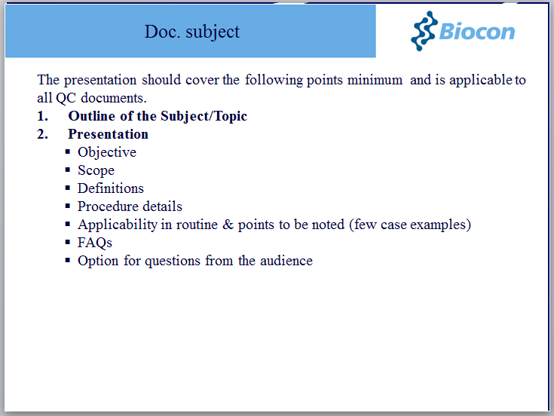

**ANNEXURE -5**

**INDUCTION PROGRAM**

|  |
| --- |
| **Issued by:**  **Date:** |

|  |  |
| --- | --- |
| **Employee name :** | |
| **Employee Code:** | **Date of joining :** |

|  |  |  |  |
| --- | --- | --- | --- |
| **Sl. No.** | **Title of the induction program** | **Training date** | **Trainee Signature / Date** |
|  |  |  |  |
|  |  |  |  |
|  |  |  |  |
|  |  |  |  |
|  |  |  |  |
|  |  |  |  |
|  |  |  |  |
|  |  |  |  |

**Remarks:**

This is to document that ______________________ has undergone the above mentioned induction program(s).

**Signature / Date (by Section in-charge / head):**

C/QC/SOP/0028-F5.1