Store longest palindrom value <http://localhost:8080/saveLongestPalindrome>

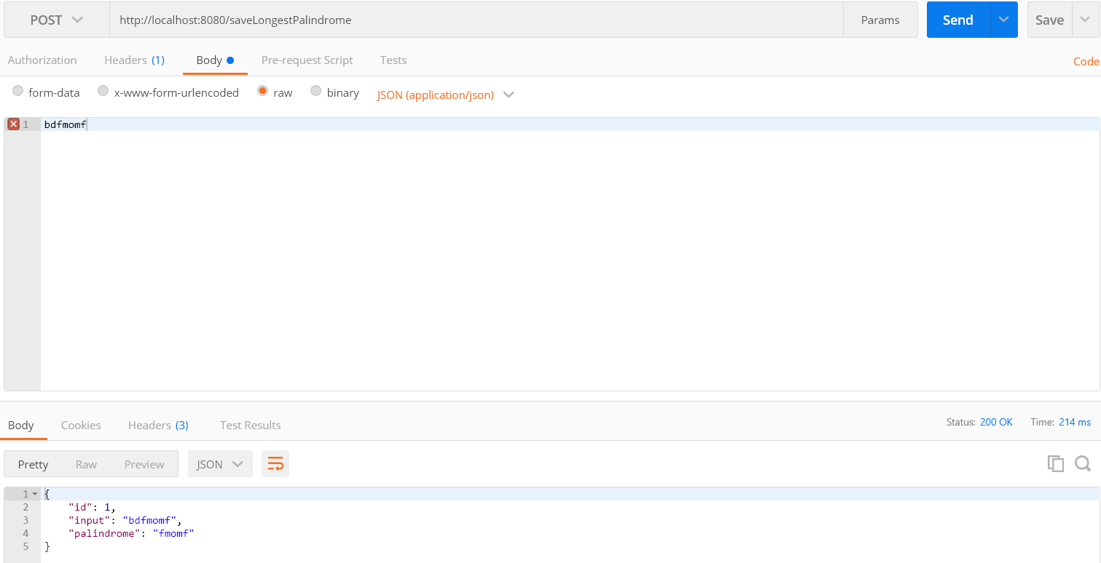

Check the stored values in H2 DB. 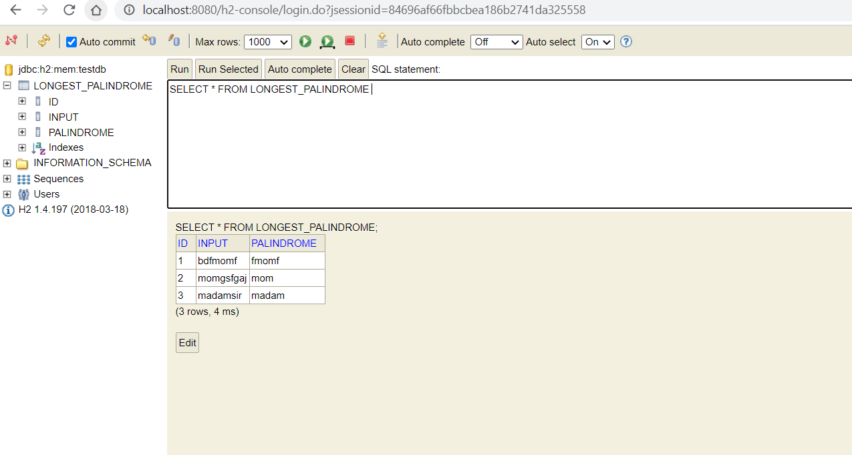

Input length is morethan 1000, we will get exception(“Please try with less than 1000 characters”)

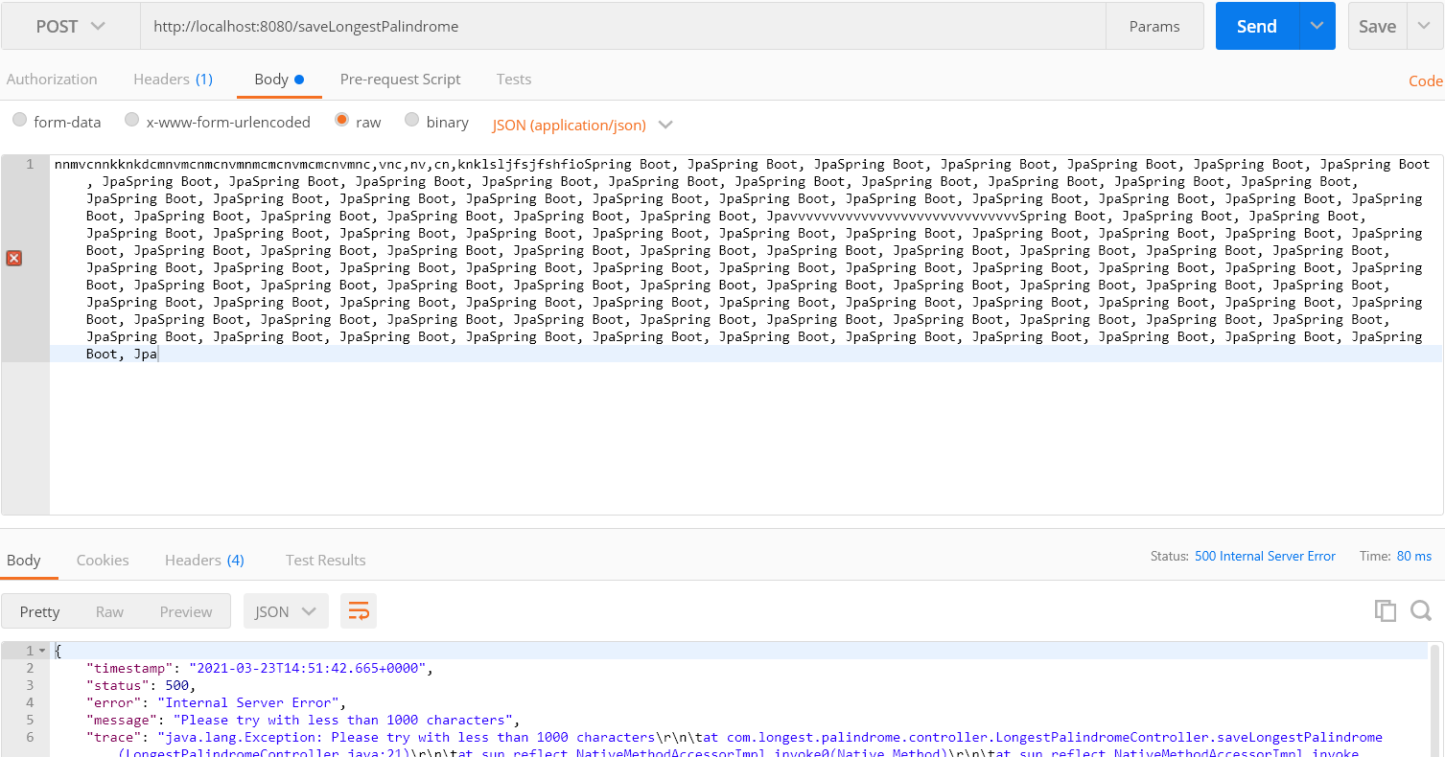

Get the longest palindrom value, <http://localhost:8080/getLongestPalindrome/bdfmomf>

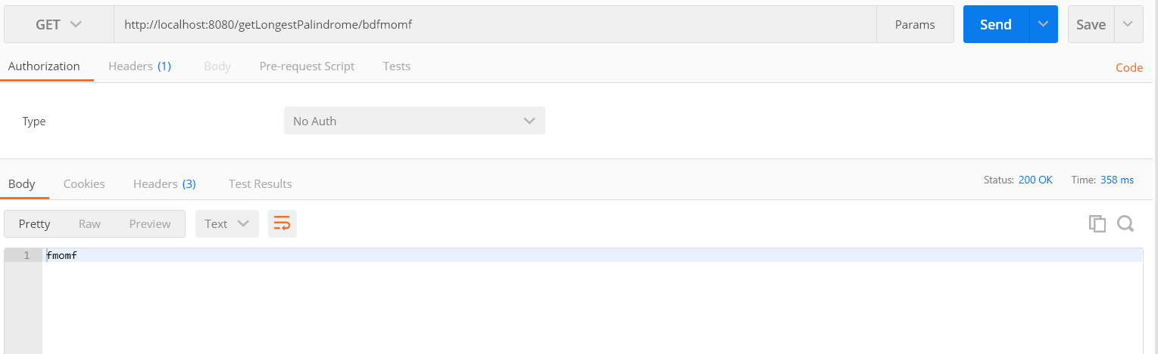

Incase of value is not available in Database

