Naive Bayes algorithm using K-Fold cross validation

Submitted By:

Divya Saxena (1001773376)

Table of Contents
1. Introduction 3
1. Naive Bayes 3
2. k-fold Cross-Validation 3
2. Dataset Details 4
3. Graph Representation 5
4. Naive Bayes from Weka using 10 Fold CrossValidation 11
5. Scores and Accuracy calculation for Naive Bayes using 10 Fold CrossValidation from UCI 20
6. Comparison 21
7. References 21

Introduction
We can use probability to make predictions in machine learning. Perhaps the most widely used example is called the Naive Bayes algorithm. Not only is it straightforward to understand, but it also achieves surprisingly good results on a wide range of problems.
How to calculate the probabilities required by the Naive Bayes algorithm.
- How to implement the Naive Bayes algorithm from scratch.
- How to apply Naive Bayes to a real-world predictive modeling problem.

Naive Bayes

Bayes’ Theorem provides a way that we can calculate the probability of a piece of data belonging to a given class, given our prior knowledge. Bayes’ Theorem is stated as:
- P(class|data) = (P(data|class) * P(class)) / P(data)
Where P(class|data) is the probability of class given the provided data.
For an in-depth introduction to Bayes Theorem, see the tutorial:
- A Gentle Introduction to Bayes Theorem for Machine Learning
Naive Bayes is a classification algorithm for binary (two-class) and multiclass classification problems. It is called Naive Bayes or idiot Bayes because the calculations of the probabilities for each class are simplified to make their calculations tractable.
Rather than attempting to calculate the probabilities of each attribute value, they are assumed to be conditionally independent given the class value.
This is a very strong assumption that is most unlikely in real data, i.e. that the attributes do not interact. Nevertheless, the approach performs surprisingly well on data where this assumption does not hold.

k-fold Cross-Validation

Cross-validation is a statistical method used to estimate the skill of machine learning models.
It is commonly used in applied machine learning to compare and select a model for a given predictive modeling problem because it is easy to understand, easy to implement, and results in skill estimates that generally have a lower bias than other methods.
In this tutorial, you will discover a gentle introduction to the k-fold cross-validation procedure for estimating the skill of machine learning models.
That k-fold cross validation is a procedure used to estimate the skill of the model on new data.
- There are common tactics that you can use to select the value of k for your dataset.
- There are commonly used variations on cross-validation such as stratified and repeated that are available in scikit-learn.

Dataset Details

Below data give details of each dataset. It provides Total Count , Mean, Standard Deviation, Minimum Value, Maximum Value of each feature in corresponding dataset.

  - Breast Cancer Dataset
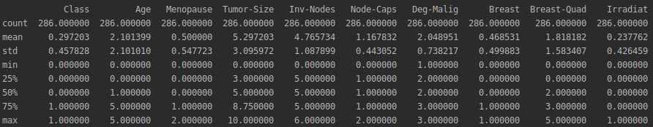

  - Car Dataset
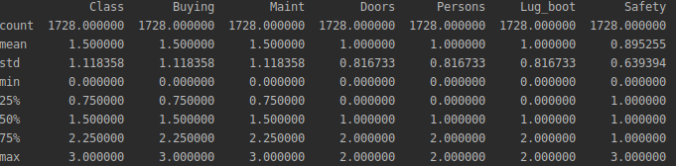

  - Hayes-Roth Dataset
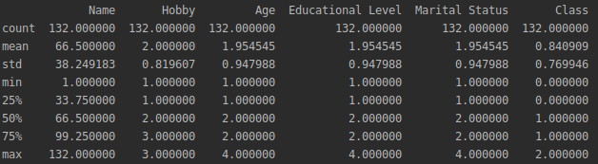

Graph Representation

Below Graphs have two parts:
Part a : Represent distribution for each feature in corresponding datasets
Part b : Represents scatter matrix .It is a estimation of covariance matrix when covariance cannot be calculated or costly to calculate. The scatter matrix is also used in lot of dimensionality reduction exercises.

- Breast Cancer Dataset
Part a:
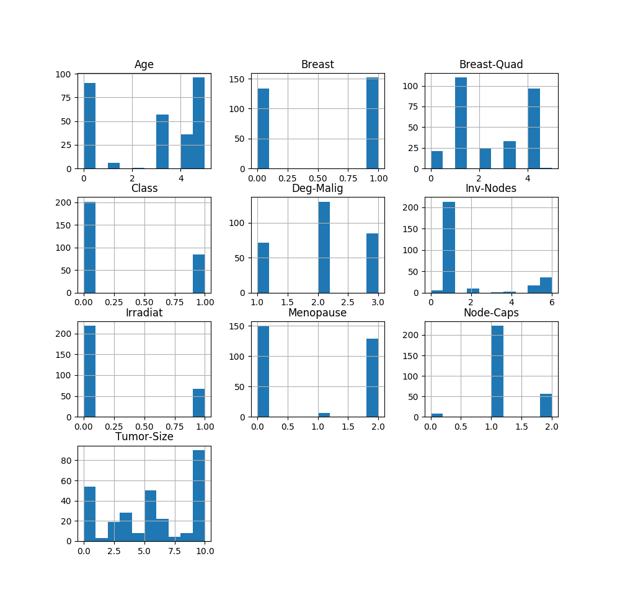

Part b:
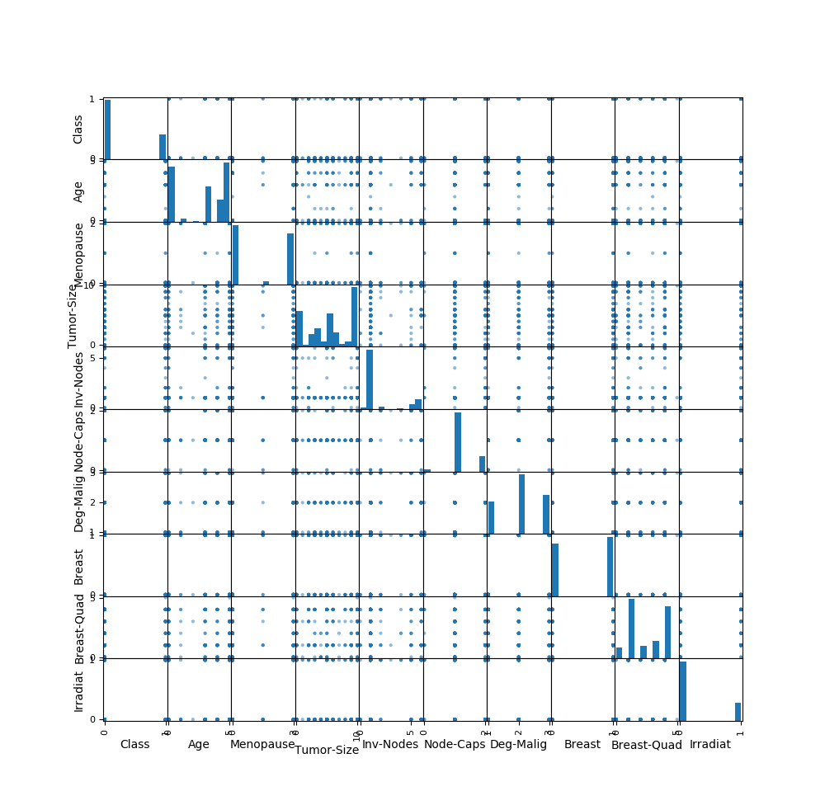

- Car Dataset
Part a:

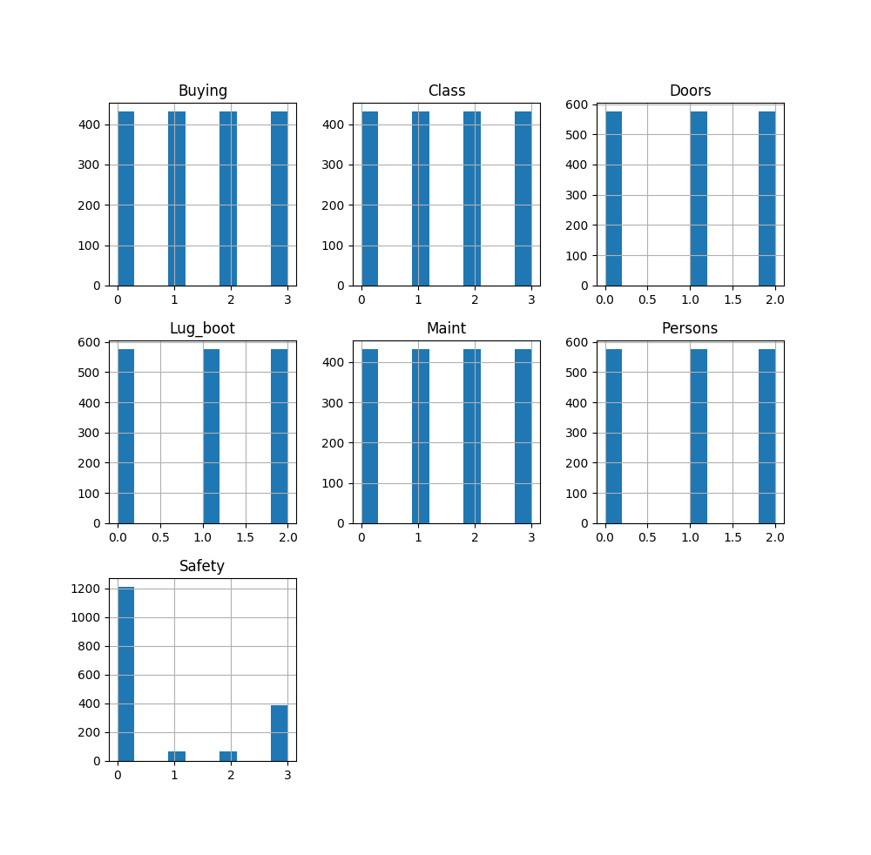

Part b:
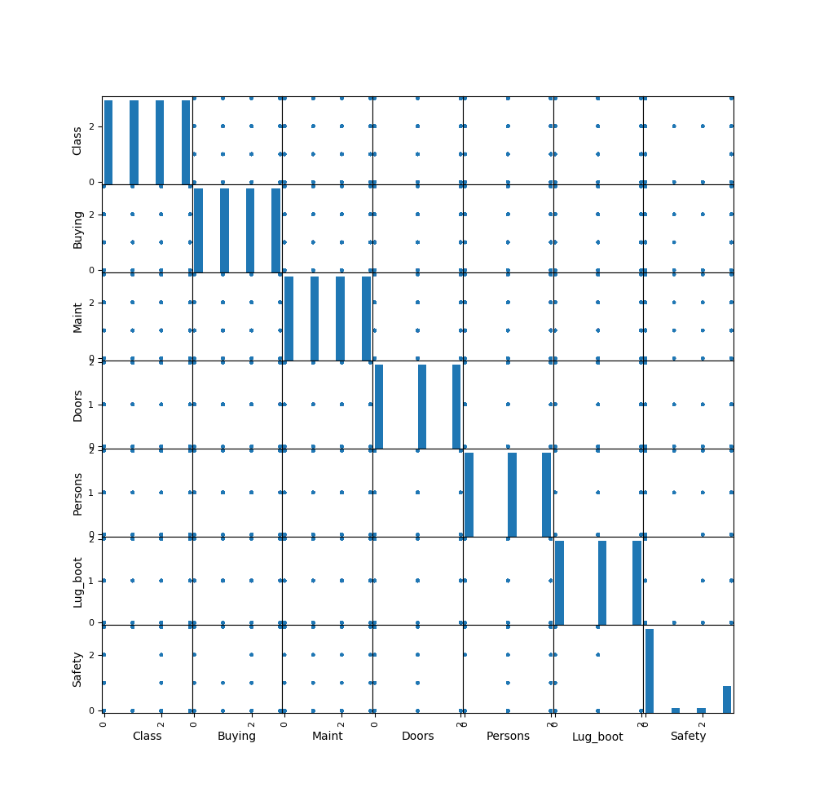

- Hayes-Roth Dataset
Part a:
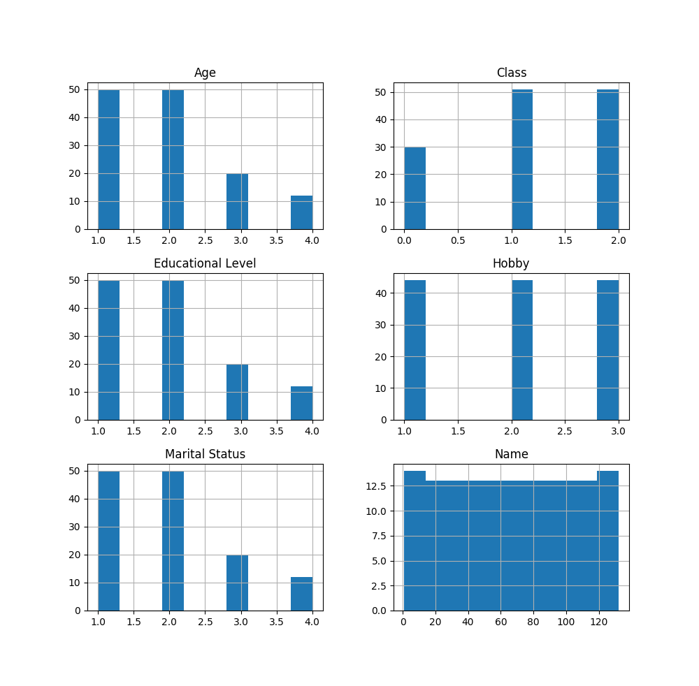

Part b:
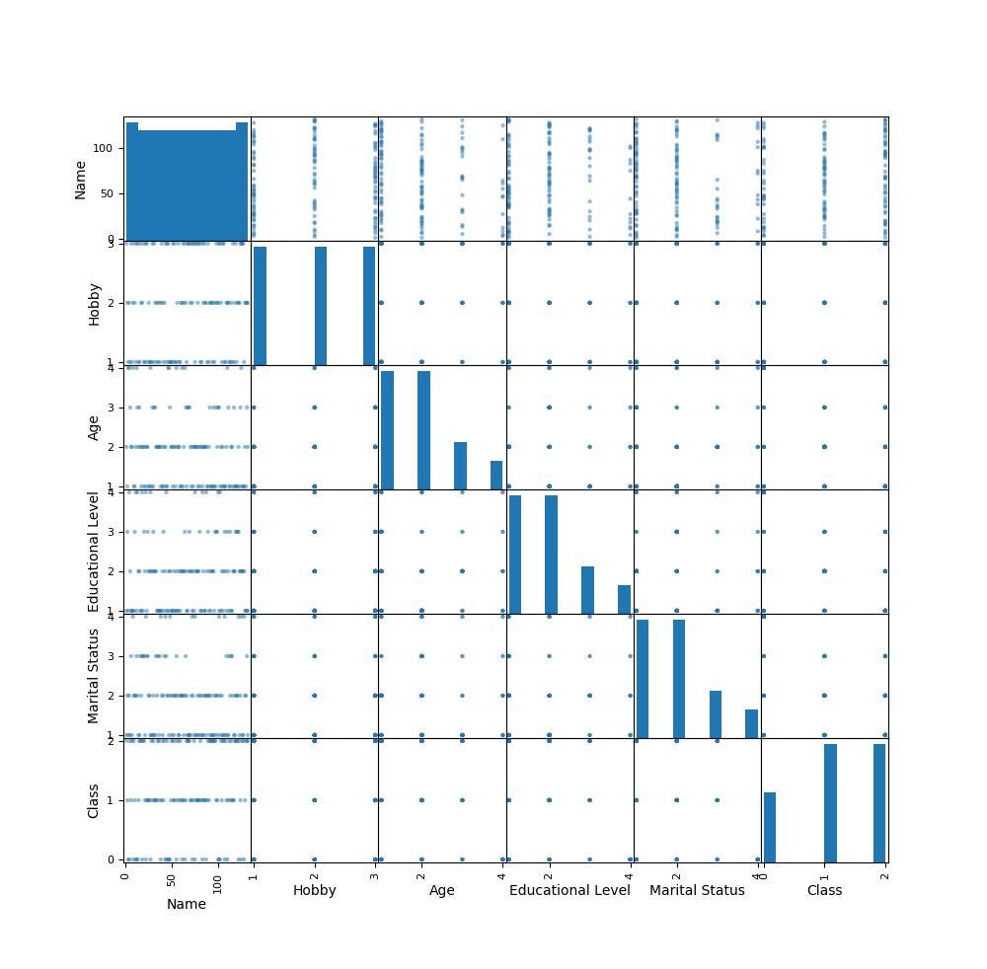

Naive Bayes from Weka using 10 Fold CrossValidation

Weka contains a collection of visualization tools and algorithms for data analysis and predictive modeling, together with graphical user interfaces for easy access to these functions.

Calculations for given datasets are as below:

- Breast Cancer Dataset
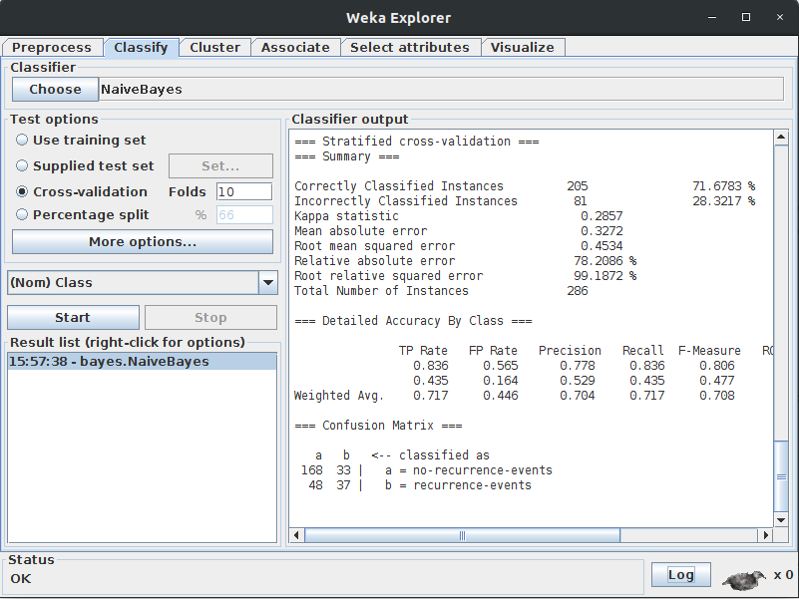

=== Run information ===

Scheme:weka.classifiers.bayes.NaiveBayes
Relation: breast-cancer
Instances: 286
Attributes: 10
age
menopause
tumor-size
inv-nodes
node-caps
deg-malig
breast
breast-quad
irradiat
Class
Test mode:10-fold cross-validation

=== Classifier model (full training set) ===

Naive Bayes Classifier

Class
Attribute no-recurrence-events recurrence-events
(0.7) (0.3)
=========================================================
age
10-19 1.0 1.0
20-29 2.0 1.0
30-39 22.0 16.0
40-49 64.0 28.0
50-59 72.0 26.0
60-69 41.0 18.0
70-79 6.0 2.0
80-89 1.0 1.0
90-99 1.0 1.0
[total] 210.0 94.0

menopause
lt40 6.0 3.0
ge40 95.0 36.0
premeno 103.0 49.0
[total] 204.0 88.0

tumor-size
0-4 8.0 2.0
5-9 5.0 1.0
10-14 28.0 2.0
15-19 24.0 8.0
20-24 35.0 17.0
25-29 37.0 19.0
30-34 36.0 26.0
35-39 13.0 8.0
40-44 17.0 7.0
45-49 3.0 2.0
50-54 6.0 4.0
55-59 1.0 1.0
[total] 213.0 97.0

inv-nodes
0-2 168.0 47.0
3-5 20.0 18.0
6-8 8.0 11.0
9-11 5.0 7.0
12-14 2.0 3.0
15-17 4.0 4.0
18-20 1.0 1.0
21-23 1.0 1.0
24-26 1.0 2.0
27-29 1.0 1.0
30-32 1.0 1.0
33-35 1.0 1.0
36-39 1.0 1.0
[total] 214.0 98.0

node-caps
yes 26.0 32.0
no 172.0 52.0
[total] 198.0 84.0

deg-malig
1 60.0 13.0
2 103.0 29.0
3 41.0 46.0
[total] 204.0 88.0

breast
left 104.0 50.0
right 99.0 37.0
[total] 203.0 87.0

breast-quad
left_up 72.0 27.0
left_low 76.0 36.0
right_up 21.0 14.0
right_low 19.0 7.0
central 18.0 5.0
[total] 206.0 89.0

irradiat
yes 38.0 32.0
no 165.0 55.0
[total] 203.0 87.0

Time taken to build model: 0 seconds

=== Stratified cross-validation ===
=== Summary ===

Correctly Classified Instances 205 71.6783 %
Incorrectly Classified Instances 81 28.3217 %
Kappa statistic 0.2857
Mean absolute error 0.3272
Root mean squared error 0.4534
Relative absolute error 78.2086 %
Root relative squared error 99.1872 %
Total Number of Instances 286

=== Detailed Accuracy By Class ===

TP Rate FP Rate Precision Recall F-Measure ROC Area Class
0.836 0.565 0.778 0.836 0.806 0.701 no-recurrence-events
0.435 0.164 0.529 0.435 0.477 0.701 recurrence-events
Weighted Avg. 0.717 0.446 0.704 0.717 0.708 0.701

=== Confusion Matrix ===

a b <-- classified as
168 33 | a = no-recurrence-events
48 37 | b = recurrence-events

- Car Dataset
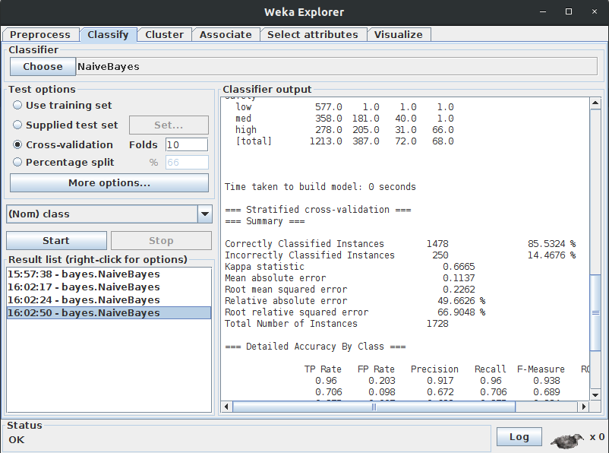

=== Run information ===

Scheme:weka.classifiers.bayes.NaiveBayes
Relation: car
Instances: 1728
Attributes: 7
buying
maint
doors
persons
lug_boot
safety
class
Test mode:10-fold cross-validation

=== Classifier model (full training set) ===

Naive Bayes Classifier

Class
Attribute unacc acc good vgood
(0.7) (0.22) (0.04) (0.04)
===========================================
buying
vhigh 361.0 73.0 1.0 1.0
high 325.0 109.0 1.0 1.0
med 269.0 116.0 24.0 27.0
low 259.0 90.0 47.0 40.0
[total] 1214.0 388.0 73.0 69.0

maint
vhigh 361.0 73.0 1.0 1.0
high 315.0 106.0 1.0 14.0
med 269.0 116.0 24.0 27.0
low 269.0 93.0 47.0 27.0
[total] 1214.0 388.0 73.0 69.0

doors
2 327.0 82.0 16.0 11.0
3 301.0 100.0 19.0 16.0
4 293.0 103.0 19.0 21.0
5more 293.0 103.0 19.0 21.0
[total] 1214.0 388.0 73.0 69.0

persons
2 577.0 1.0 1.0 1.0
4 313.0 199.0 37.0 31.0
more 323.0 187.0 34.0 36.0
[total] 1213.0 387.0 72.0 68.0

lug_boot
small 451.0 106.0 22.0 1.0
med 393.0 136.0 25.0 26.0
big 369.0 145.0 25.0 41.0
[total] 1213.0 387.0 72.0 68.0

safety
low 577.0 1.0 1.0 1.0
med 358.0 181.0 40.0 1.0
high 278.0 205.0 31.0 66.0
[total] 1213.0 387.0 72.0 68.0

Time taken to build model: 0 seconds

=== Stratified cross-validation ===
=== Summary ===

Correctly Classified Instances 1478 85.5324 %
Incorrectly Classified Instances 250 14.4676 %
Kappa statistic 0.6665
Mean absolute error 0.1137
Root mean squared error 0.2262
Relative absolute error 49.6626 %
Root relative squared error 66.9048 %
Total Number of Instances 1728

=== Detailed Accuracy By Class ===

TP Rate FP Rate Precision Recall F-Measure ROC Area Class
0.96 0.203 0.917 0.96 0.938 0.982 unacc
0.706 0.098 0.672 0.706 0.689 0.95 acc
0.275 0.007 0.633 0.275 0.384 0.98 good
0.415 0.001 0.931 0.415 0.574 0.998 vgood
Weighted Avg. 0.855 0.164 0.852 0.855 0.847 0.976

=== Confusion Matrix ===

a b c d <-- classified as
1161 48 1 0 | a = unacc
104 271 9 0 | b = acc
1 47 19 2 | c = good
0 37 1 27 | d = vgood

- Hayes-Roth Dataset
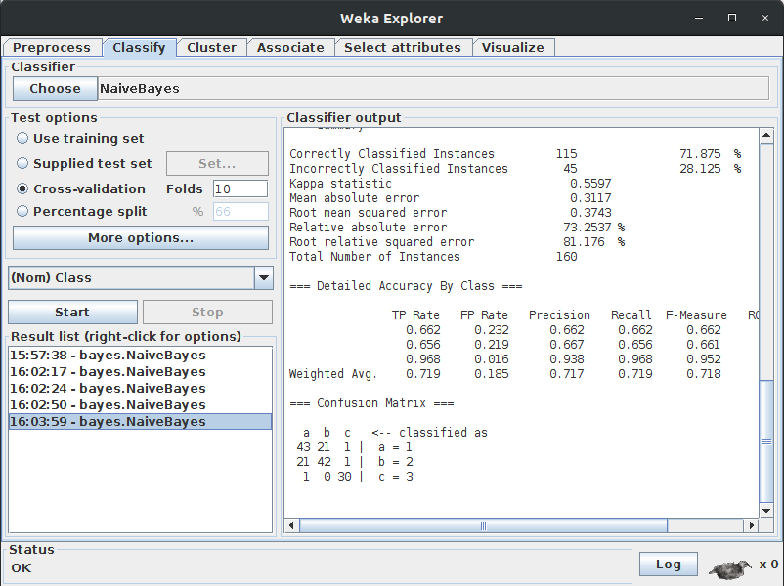

=== Run information ===

Scheme:weka.classifiers.bayes.NaiveBayes
Relation: R_data_frame
Instances: 160
Attributes: 5
V1
V2
V3
V4
Class
Test mode:10-fold cross-validation

=== Classifier model (full training set) ===

Naive Bayes Classifier

Class
Attribute 1 2 3
(0.4) (0.4) (0.2)
====================================
V1
mean 1.7846 1.7969 1.9677
std. dev. 0.8319 0.8325 0.8224
weight sum 65 64 31
precision 1 1 1

V2
mean 1.6308 1.9531 2.7419
std. dev. 0.776 0.6715 1.2173
weight sum 65 64 31
precision 1 1 1

V3
mean 1.6615 1.9219 2.7419
std. dev. 0.7899 0.6686 1.2173
weight sum 65 64 31
precision 1 1 1

V4
mean 1.6923 1.8906 2.7419
std. dev. 0.8024 0.6642 1.2173
weight sum 65 64 31
precision 1 1 1

Time taken to build model: 0 seconds

=== Stratified cross-validation ===
=== Summary ===

Correctly Classified Instances 115 71.875 %
Incorrectly Classified Instances 45 28.125 %
Kappa statistic 0.5597
Mean absolute error 0.3117
Root mean squared error 0.3743
Relative absolute error 73.2537 %
Root relative squared error 81.176 %
Total Number of Instances 160

=== Detailed Accuracy By Class ===

TP Rate FP Rate Precision Recall F-Measure ROC Area Class
0.662 0.232 0.662 0.662 0.662 0.762 1
0.656 0.219 0.667 0.656 0.661 0.849 2
0.968 0.016 0.938 0.968 0.952 0.996 3
Weighted Avg. 0.719 0.185 0.717 0.719 0.718 0.842

=== Confusion Matrix ===

a b c <-- classified as
43 21 1 | a = 1
21 42 1 | b = 2
1 0 30 | c = 3

Scores and Accuracy calculation for Naive Bayes using 10 Fold CrossValidation from UCI

- Breast Cancer Dataset

Scores: [76.16279069767442, 77.90697674418605, 72.09302325581395, 68.6046511627907, 76.74418604651163, 77.32558139534885, 71.51162790697676, 72.09302325581395, 76.16279069767442, 75.5813953488372]

Mean Accuracy: 74.419%

- Car Dataset

Scores: [80.23255813953489, 73.83720930232558, 68.02325581395348, 70.34883720930233, 77.32558139534885, 76.74418604651163, 68.6046511627907, 73.83720930232558, 75.0, 75.5813953488372]

Mean Accuracy: 73.953%

- Hayes-Roth Dataset
Scores: [46.15384615384615, 76.92307692307693, 69.23076923076923, 92.3076923076923, 61.53846153846154, 92.3076923076923, 53.84615384615385, 69.23076923076923, 69.23076923076923, 76.92307692307693]
Mean Accuracy: 70.769%

Comparison

Below is the comparison of accuracy of naive Bayes algorithm using 10-Fold cross validation on the given datasets from UCI-Machine Learning Repository and accuracy with that obtained with Naive Bayes from Weka using 10-Fold cross validation.

- Breast Cancer Dataset
The Accuracy of Naive Bayes using 10-Fold cross validation from UCI(our model) is 74.419% while accuracy of Naive Bayes from Weka using 10-Fold cross validation is 71.6783 %

Our Naive Bayes model performed better in identifying correct Instances as compared to Naive Bayes from Weka.

- Car Dataset
The Accuracy of Naive Bayes using 10-Fold cross validation from UCI(our model) is 73.953% while accuracy of Naive Bayes from Weka using 10-Fold cross validation is 85.5324 %

Naive Bayes from Weka model performed better in identifying correct Instances as compared to our Naive Bayes model

- Hayes-Roth Dataset
Mean Accuracy:
The Accuracy of Naive Bayes using 10-Fold cross validation from UCI(our model) is 70.769% while accuracy of Naive Bayes from Weka using 10-Fold cross validation is 71.875 %

Naive Bayes from Weka model performed better in identifying correct Instances as compared to our Naive Bayes model. Although the difference of identifying wrong instances is very less.

References

https://machinelearningmastery.com/naive-bayes-classifier-scratch-python/
https://machinelearningmastery.com/k-fold-cross-validation/
https://www.ritchieng.com/machine-learning-cross-validation/
https://www.cs.waikato.ac.nz/ml/weka/
https://machinelearningmastery.com/how-to-run-your-first-classifier-in-weka/

