When we increase the BETA it is not converage
Case 1:
BETA 0.1 (Beta1.dat)
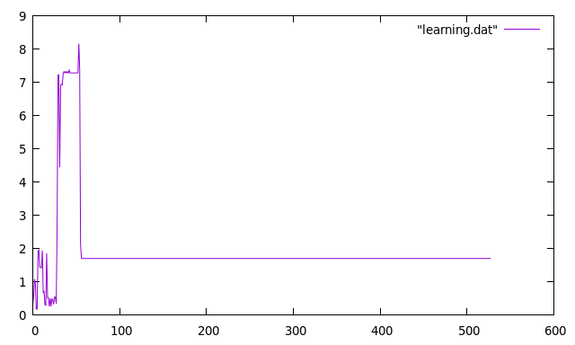
Case 2:
Beta 0.6(Beta2.dat)
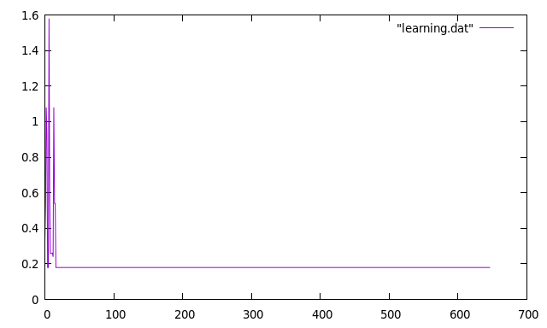
Case 3:
Beta 1.0(Beta3.dat)
When we increase the ALPHA it is not converage, it sticks to the wrong state
ALPHA 0.5(Alpha1.dat)
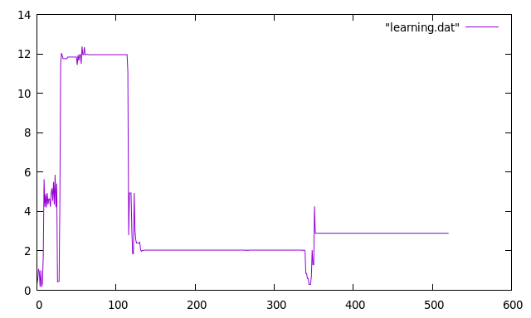
Case 4:
ALPHA 0.9(Alpha2.dat)
