Case 1:
EPSILON .001
ALPHA 0.1
GAMMA 0.95(learning1.dat)
The graph converges for given values
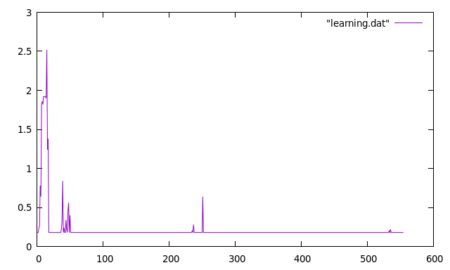
Case 2:
EPSILON .1
ALPHA 0.5
GAMMA 0.5(learning2.dat)
By increasing epsilon and alpha the model does not perform well and the graph also doesnot converge
