Case 1:
EPSILON .001
LAMDA 0.9
ALPHA 0.1
GAMMA 0.95(learning1.dat)
The model doesnot perform for given hyperparameter values, the graph doesnot converge.
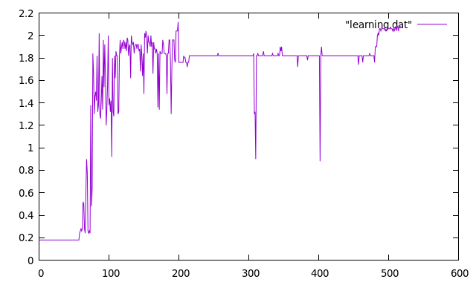
Case 2:
EPSILON .001
LAMDA 0.5
ALPHA 0.1
GAMMA 0.95(learning2.dat)
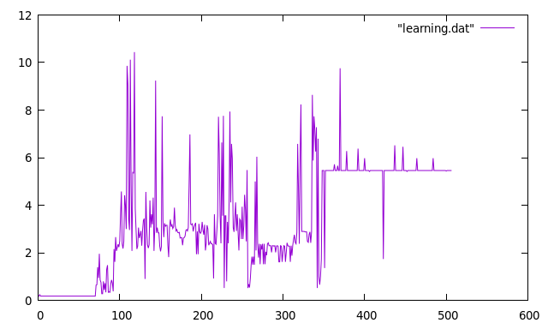
By decreasing lamda also, the model doesnot performed well. The graph doesnot converge.
Case 3:
EPSILON .0001
LAMDA 0.5
ALPHA 0.5
GAMMA 0.95(learning3.dat)
By decreasing epsilon and increasing learning rate the graph converges.
