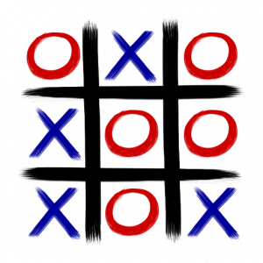
Tic-Tac-Toe

Submitted By:
Divya Saxena (1001773376)

Table of Contents
1. Introduction 3
2. Implementation Steps 3
3. Process 5
4. Graph Representation 6
5. Code Description 9
6. Pseudo Code for Unfair TicTacToe 10
7. Sample Game Steps 11
8. Conclusion 12

Introduction

I have implemented grid world game by iteratively updating Q value function, which is the estimating value of (state, action) pair. Let’s look into how to leverage reinforcement learning in adversarial game — tic-tac-toe, where there are more states and actions and most importantly, there is an opponent playing against our agent.
To play Tic Tac Toe against a computer player trained by playing 20,000 games against itself. This will bring up a simple GUI in which clicking on any of the buttons causes the mark "X" to appear and the computer to immediately respond with a countermove. I was unable to beat the Qplayer.
I have implemented two Tic-Tac-Toe. One is Fair and other is Unfair. In Unfair, one party randomly starts and there is a 10% chance that at any point, one of the players has to give up a turn (or in other terms where a move fails to deposit a token).
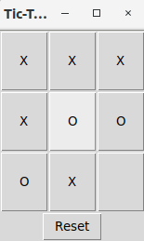

Alternatively, the user can also play against the "T-hand" player. The "T-hand" player makes winning moves if they are available and blocks those of opponents, otherwise choosing moves at random. Unlike the QPlayer, it can frequently be beaten with the right strategy.
Rewards earned by the agent as follows:
Player X won -> positive reward (+1)
Player O won -> negative reward ( -1)
A smaller positive reward for cat's game(Draw) (+0.5)
No reward if the game is not yet finished (0.0)

Implementation Steps

- What programming language is used - Python 3.5
- How the code is structured -
Components:
Python Files:
Code/TTT_Human_vs_TPlayer.py
Code/TTT_Human_vs_Qplayer.py
Code/TTT_Human_vs_QPlayer_fair.py
Code/TTT_Qplayer_training.py
Code/TTT_Qlearning.py
Code/TTT_Qplayer_training_fair.py
Code/TTT_QLearning_fair.py
Code/graphplt.py
Code/Player.py
Code/Board.py

Graphs Plotted:
Code/Qtraining.png
Code/Human_vs_Qplayer.png
Code/Human_vs_Tplayer.png
Code/Qtraining_Fair.png
Code/Human_vs_Qplayer_fair.png

Policy File:
Code/policy.p

- Libraries Needed -
- pickle
- numpy
- tkinter
- copy
- matplotlib
- Commands to Run -
There are two Tic Tac Toe games that need to be implemented.
      - First one is fair game:

For Training the model:
python TTT_Qlearning_fair.py
To play Human vs Qplayer:
python TTT_Human_vs_Qplayer_fair.py
To play Human vs Tplayer:
python Human_vs_Tplayer.py

- Second one is unfair game(10% chance of skipping current’s player turn):

For Training the model:
python TTT_Qlearning.py
To play Human vs Qplayer:
python TTT_Human_vs_Qplayer.py
To play Human vs Tplayer:
python Human_vs_Tplayer.py

Process

In the game of Tic Tac Toe, at each discrete time step t , the state of the system is defined by the marks on the board and which player's turn it is, and the available actions by the empty squares on the board. We are looking for a policy which tells us which action to take in which state to maximize our chance of winning.
Given a policy , at any given time each state has a certain value , which is the expected discounted reward from following that policy for all future time:
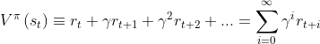
where is the reward at time step and represents the discount factor.
In our implementation of Tic Tac Toe, we adopt the 'sign convention' that reward is positive for player "X" -- specifically, a reinforcement of 1.0 is awarded when player "X" wins, -1.0 when player "O" wins, and 0.5 in the case of a tie. Hence, player "X" seeks to maximize value, whereas player "O" seeks to minimize it. The discount factor is given a value of 0.9. (Its value is not so important in Tic Tac Toe as the game is deterministic with a finite time horizon).
We seek to find the optimum policy such that the value achieves a unique optimum value . To this end, we define the evaluation function as the maximum discounted cumulative reward that can be obtained by starting from state and applying as first action:
,
where is the state that results from applying action in state .
However, to optimize the total future discounted reward, the action must be the one which maximizes :
which, upon inserting into the above equation, leads to Bellman's equation:
This recursive definition of provides the basis for Q-learning. Suppose we start with some initial estimate of and choose an action , thereby obtaining an immediate reward and arriving at a new state . If our estimate is correct, we would expect the difference
to be zero. If it is not zero, but slightly positive (negative), then the action and resulting reward can be viewed as 'evidence' that our estimate was too low (high).
The way this 'discrepancy' is handled is by simply adding this difference, weighted by a learning factor , to our previous estimate to obtain a revised estimate :
In this implementation of Q-learning for Tic Tac Toe, Q has the form of a dictionary, the keys of which are the states of the game (represented by the game's Board and the mark of player whose turn it is) and the values are again dictionaries containing the current estimate of the Q for each available move (i.e., empty square). Bellman's equation is implemented in the learn_Q method of the Game class, which is called on every move.
The game's Q is shared with any instances of QPlayer playing the game, which uses it to make its move decisions. Following the implementation , the QPlayer follows an "-greedy" policy, meaning that with probability it chooses a random move, and otherwise it follows the policy dictated by Q -- that is, if the player has mark "X" ("O"), choose the move with the highest (lowest) Q-value, in accordance with our 'sign convention'. During training, epsilon is set to a high value to encourage exploration, whereas for the actual match against a human, it is set to zero for optimal performance. This is for Fair Tic Tac Toe game, for unfair game, one party randomly starts and there is a 10% chance that at any point one of the players has to give up a turn.

Graph Representation

Graphs will be saved in /Code folder when corresponding python files run. Below are the graphs for games played:
- This graph is for Fair Tic Tac Toe game. It shows the average reward earned by “X” and “O”player in 20000 episodes using Qlearning(Human_vs_QPlayer_fair.png)

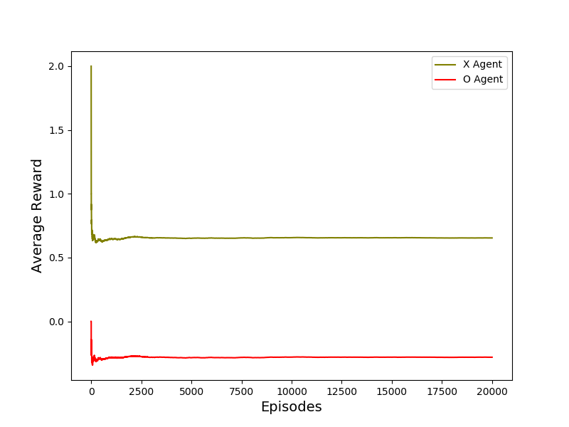
- This graph is for UnFair Tic Tac Toe(10% chance of skipping current’s player turn)game. It shows the average reward earned by “X” and “O”player in 20000 episodes using Qlearning.(Human_vs_QPlayer.png)
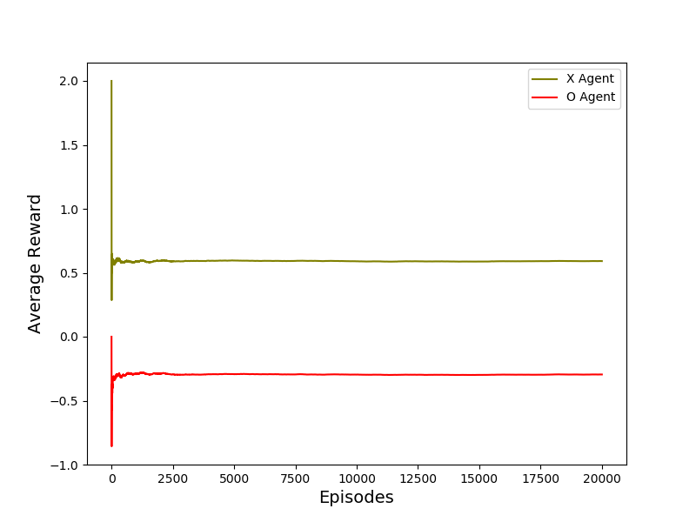

- This graph is for UnFair Tic Tac Toe game. It shows the reward earned by “X” and “O”player game played between Human vs Q player after getting trained (Human_vs_QPlayer.png)

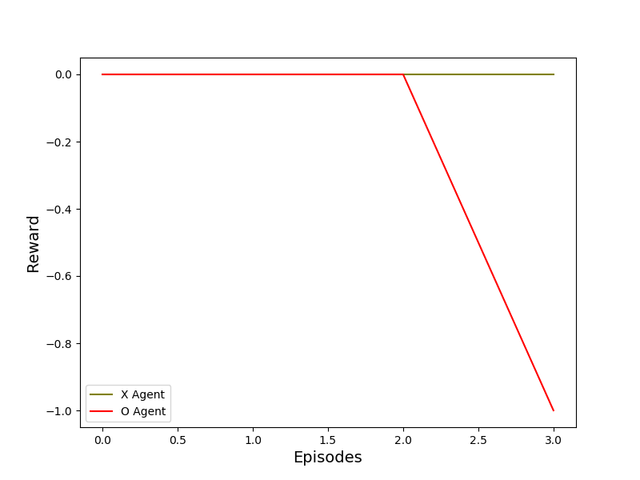
- This graph is for Fair Tic Tac Toe game. It shows the reward earned by “X” and “O”player game played between Human vs Q player after getting trained(Human_vs_QPlayer_fair.png)
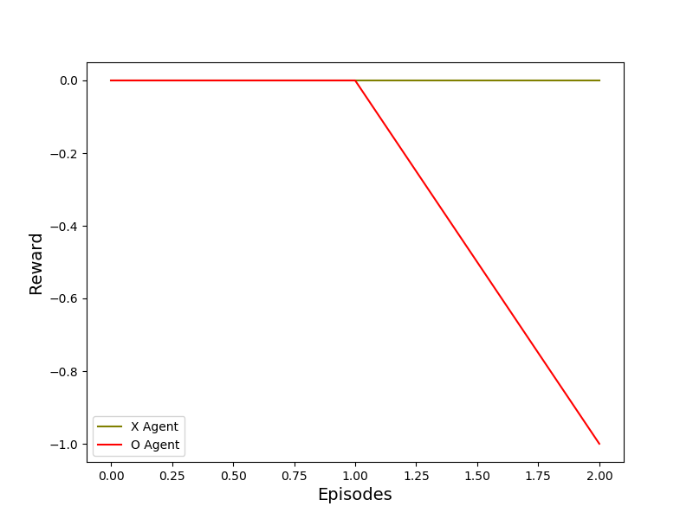

Code Description

- graphplt.py
This file is used to plot the graphs using matplotlib.

- Player.py
This file contains a class which is used to check the marks “X” or “O” for each player.

- Board.py
This file contains a class which is used for setting the board to play the game like setting of reward earned by each player, available moves, etc.

- TTT_Qlearning.py
This file has Q learning algorithm on which the model gets trained on in 20000 episodes. This file also contains the logic for unfair game i.e. one party randomly starts and there is a 10% chance that at any point one of the players has to give up a turn.

- TTT_Qlearning_fair.py
This file has Q learning algorithm on which the model gets trained on in 20000 episodes. This file contains the logic for fair game.

- TTT_Qplayer_training.py
This file triggers Q learning implemented in TTT_Qlearning.py and plot the graph average reward earned by each player in 20000 episodes. This is for unfair Tic Tac Toe. Policy file policy.p will be created and saved in /Code location.

- TTT_Qplayer_training_fair.py
This file triggers Q learning implemented in TTT_Qlearning.py and plot the graph average reward earned by each player in 20000 episodes. This is for fair Tic Tac Toe. Policy file policy.p will be created and saved in /Code location.

- TTT_Human_vs_Qplayer.py
This file will allow Human to play against Q player using Policy policy.p. If the model has been trained for fair Tic Tac Toe(TTT_Qplayer_training_fair.py), Human will play against it. If model has been trained for unfair(10 % chance of skipping current players chance) Tic Tac Toe(TTT_Qplayer_training.py), Human will play against it.

- TTT_Human_vs_Qplayer_fair.py
This file will allow Human to play against Q player using Policy policy.p. If the model has been trained for fair Tic Tac Toe(TTT_Qplayer_training_fair.py), Human will play against it. If model has been trained for fair Tic Tac Toe(TTT_Qplayer_training.py), Human will play against it.
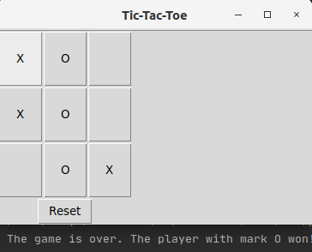

- TTT_Human_vs_Tplayer.py
This file will allow Human to play against T player. The "T-hand" player makes winning moves if they are available and blocks those of opponents, otherwise choosing moves at random. Unlike the QPlayer, it can frequently be beaten with the right strategy.

Pseudo Code for Unfair TicTacToe

To implement Tic-Tac-Toe where one party randomly starts and there is a 10% chance that at any point one of the players has to give up a turn (or in other terms where a move fails to deposit a token)

TTT_QPlayer_training.py
#10% chance ,player skips his turn
self.chance = round(np.random.random_sample(), 1)
if self.chance != 0.1:
if self.curr_player == self.player1:
self.curr_player = self.player2
self.other_player = self.player1
else:
self.curr_player = self.player1
self.other_player = self.player2
else:
print("Current Player chance skipped...")
if self.curr_player == self.player1:
self.curr_player = self.player1
self.other_player = self.player2
else:
self.curr_player = self.player2
self.other_player = self.player1

Sample Game Steps

Sample steps for Tic Tac Toe:
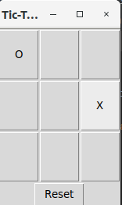
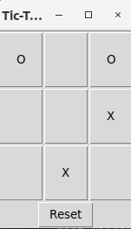

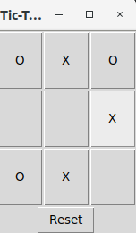
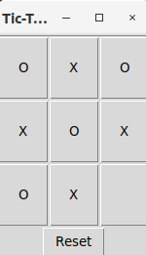

Unfair Tic Tac Toe : When player’s turn get skipped (Sample)
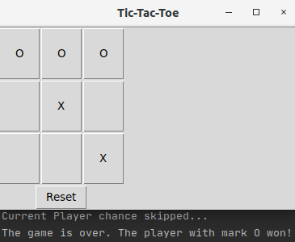

Fair Tic Tac Toe(Sample):

Conclusion

For Fair Tic Tac Toe, after 200,000 training games against itself with epsilon=0.9, the Q Player seems practically unbeatable by a human player. It would be instructive, however, to check this by putting it against a player following the minimax algorithm for many games. It would also be interesting to check the finding that a Q-learned player is able to beat the "T-hand" player maximum of the time and draw in remaining games.
For UnFair Tic Tac Toe, after 200,000 training games against itself with epsilon=0.9, the outcome becomes unpredictable. Most probable chance for wining the game is the player who plays first in the game when the game falls in 10% chance scenario.

