**Air Quality Analysis and Prediction in TamilNadu - Guidelines**

**Phase 2: Innovation**

**Short Explanation About My Project:**

Air quality analysis and prediction in Tamil Nadu involves the assessment and forecasting of air quality in the Indian state of Tamil Nadu. This process is essential for monitoring the concentration of various air pollutants, such as particulate matter (PM2.5 and PM10), nitrogen dioxide (NO2), sulfur dioxide (SO2), carbon monoxide (CO), ozone (O3), and volatile organic compounds (VOCs) in the atmosphere. Here's a short explanation of how this is done:

Innovating in air quality analysis and prediction for Tamil Nadu is crucial for addressing environmental and public health concerns. Here's a process to develop an innovative solution for this:

1. Data Collection and Integration: Gather comprehensive air quality data from various monitoring stations across Tamil Nadu. Integrate this data with other relevant datasets, such as weather patterns, traffic data, and geographical information.

2. Data Preprocessing: Clean and preprocess the collected data to handle missing values, outliers, and inconsistencies. Ensure data quality for accurate analysis.

3. Advanced Data Analytics: Utilize advanced data analytics techniques, including machine learning and statistical modeling, to analyze historical air quality data. Identify trends, correlations, and factors affecting air quality.

4. Real-time Monitoring: Implement a real-time monitoring system that continuously collects and updates air quality data from various sources. Use IoT devices and sensors for data collection.

5. Predictive Modeling: Develop predictive models that can forecast air quality levels for different regions in Tamil Nadu. These models should consider factors like meteorological conditions, pollution sources, and historical data.

6. Visualization and User Interface: Create a user-friendly interface or dashboard that displays real-time air quality information, historical trends, and predictive forecasts. Visualization tools can help users understand the data easily.

7. Alerting System: Implement an alerting system that notifies residents, government agencies, and relevant stakeholders when air quality reaches hazardous levels. Provide actionable recommendations based on the predictions.

8. Geographic Mapping: Use geographic mapping tools to visualize air quality variations across different regions of Tamil Nadu. This can help policymakers target interventions effectively.

9. Public Engagement: Encourage public engagement by providing accessible air quality information through mobile apps, websites, and social media platforms. Educate the public about the importance of air quality and sustainable practices.

10. Collaboration with Authorities: Collaborate with local environmental agencies, health departments, and academic institutions to ensure the accuracy and relevance of your predictions. Share data and insights to inform policy decisions.

11. Data Transparency: Ensure transparency in data collection, analysis, and reporting. Make the air quality data and methodologies used in prediction publicly accessible.

12. Continuous Improvement: Continuously update and refine your predictive models based on real-time data and feedback. Keep up with advancements in air quality monitoring technology.

13. Environmental Initiatives: Advocate for and support environmental initiatives and policies that aim to reduce pollution sources and improve air quality in Tamil Nadu.

14. Research and Development: Invest in research and development to explore innovative technologies like drones and satellite imagery for enhanced air quality monitoring and prediction.

15. Public Awareness Campaigns: Launch public awareness campaigns to educate residents about the impact of air quality on health and the environment. Promote sustainable practices and behaviors.

16. Regulatory Compliance: Ensure that your solution aligns with relevant environmental regulations and standards. Collaborate with regulatory bodies for compliance and guidance.

By following this process, you can innovate in air quality analysis and prediction for Tamil Nadu, contributing to better air quality management and improved public health in the region.

**Process:-**

**Creating a stock price prediction model involves several steps, from conceptualizing the design to implementing and deploying the model. Below, I'll outline a detailed step-by-step process for building a stock price prediction model:**

1. **Problem Definition and Data Collection**
2. **Data Preprocessing**
3. **Exploratory Data Analysis (EDA)**
4. **Data Splitting**
5. **Model Selection**
6. **Model Training**
7. **Model evaluation**
8. **Model Testing and model deployment**
9. **Maintenance**
10. **Documentation**

**Where I Bought The Dataset and It’s Details:**

I took the dataset from ( <https://tn.data.gov.in/resource> ) .The dataset is related to Air Quality data. The dataset contains Chennai daily data on Air Quality 2014.

Dataset link:

<https://tn.data.gov.in/resource/location-wise-daily-ambient-air-quality-tamil-nadu-year-2014>

**Details about our Dataset:**

* Stn code - It contains station code number.
* Sampling Date – It contains which date the air quality was check.
* State – It contains the state of the station.
* City/Town/Village/Area – It contains city or town or village or area of quality checked.
* Location of Monitoring Station – It contains the location of the Station.
* Agency – It contains Name of the which one is the controlling the station.
* Type of Location – It contains the Which type of areas.
* SO2 – It contain the value of sulfur dioxide (SO2).
* NO2 –It contains the value of nitrogen dioxide(NO2).
* RSPM/PM10 – It contains the value of Respirable Suspended Particulate Matter and Particulate Matter.
* PM 2.5 – It contains the value of Particulate Matter.

**Details of libraries:**

**How to import dataset:**

pip install pandas --to install pandas libraries

import pandas as pd

# Replace 'your_dataset.csv' with the actual path or URL to your dataset

dataset_path = 'your_dataset.csv'

# Read the dataset into a pandas DataFrame

df = pd.read_csv(dataset_path)

# Display the first few rows of the dataset to verify that it was read correctly

print(df.head())

**code:**

pip install matplotlib -- to install matplotlib libraries

Import matplotlib.pyplot as plt

From sklearn.datasets import make_blobs

From sklearn.cluster import kmeans

#generate synthetic dataset with 4 clusters

X,y=make_blobs(n_samples=40, cluster_std=1.0, random_state=42)

Print(x)

Print(y)

#To plot:

Plt.scatter(x[:, 0], x[:,1], s=50)

#Set title:

Plt.title(“My data”)

Plt.xlabel(“feature1”)

Plt.ylabel(“feature2”)

Plt.legend()

Plt.show() -----used to plot graph

**How to train and test:**

pip install scikit-learn -- to install the scikit learn libraries

import pandas as pd

from sklearn.model_selection import train_test_split

df = pd.read_csv('your_dataset.csv')

# Define your features (X) and target variable (y)

#Replacing columns

feature_columns = ['feature1', 'feature2', ...]

target_column = 'target'

X = df[feature_columns]

y = df[target_column]

# Split the dataset into training and testing sets (e.g., 80% training, 20% testing)

# You can adjust the test_size parameter to change the split ratio

X_train, X_test, y_train, y_test = train_test_split(X, y, test_size=0.2, random_state=42)

# Optionally, you can also split your data into validation sets if needed

# X_train, X_val, y_train, y_val = train_test_split(X_train, y_train, test_size=0.2, random_state=42)

**(The changes on air quality analysis will be vieweb with the help of below bardaigram)**

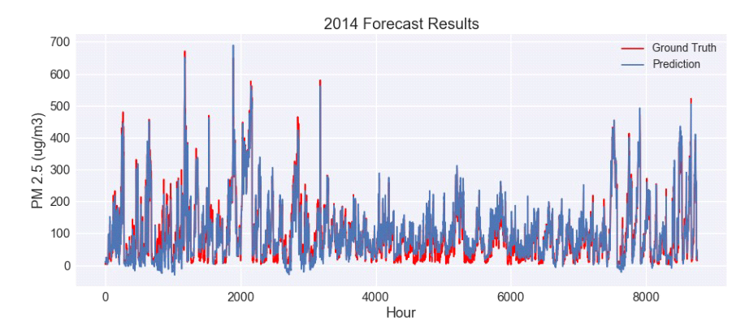

**Metrics used for accuracy check:**

When performing air quality analysis and prediction in Tamil Nadu, or any other region, it's important to use relevant metrics to assess the accuracy of your models and predictions. Here are some common metrics used for this purpose:

**1. Mean Absolute Error (MAE):** MAE measures the average absolute difference between predicted and actual air quality values. It provides a simple and interpretable way to assess prediction accuracy.

**2. Root Mean Square Error (RMSE):** RMSE is another widely used metric that calculates the square root of the average of the squared differences between predicted and actual values. It penalizes larger errors more than MAE, which makes it sensitive to outliers.

**3. Mean Absolute Percentage Error (MAPE):** MAPE expresses the prediction error as a percentage of the actual value. It is useful for understanding the relative accuracy of predictions. However, it should be used with caution when dealing with data containing zero values.

**4. R-squared (R2) Score:** R-squared measures the proportion of the variance in the dependent variable (air quality) that is explained by the independent variables (features in your model). A higher R-squared indicates a better model fit.

**5. Coefficient of Determination (COD):** COD is another measure of how well the model explains the variance in the data. It is often used in regression analysis.