1. Program Output for BCD Addition:

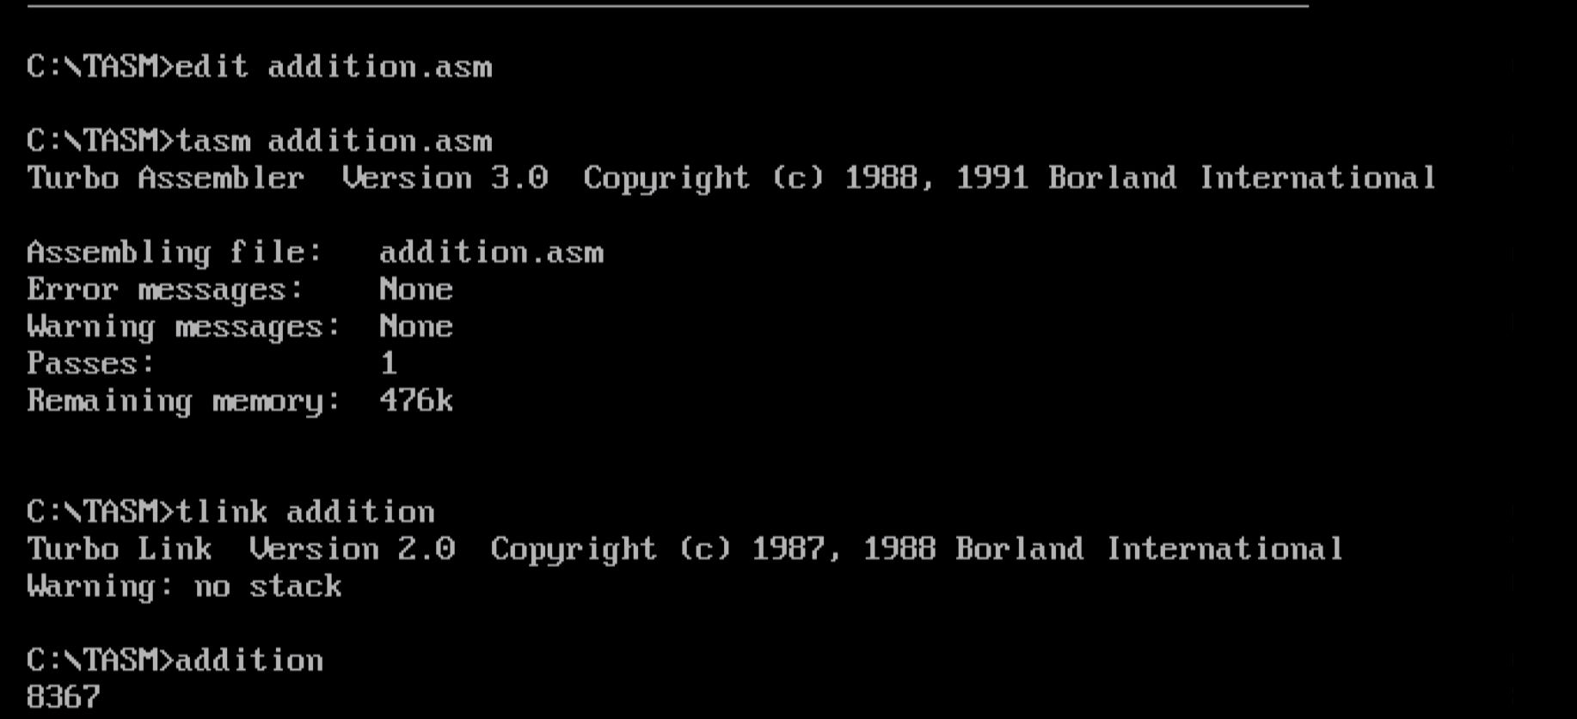

1. Program Output for packed to unpacked BCD

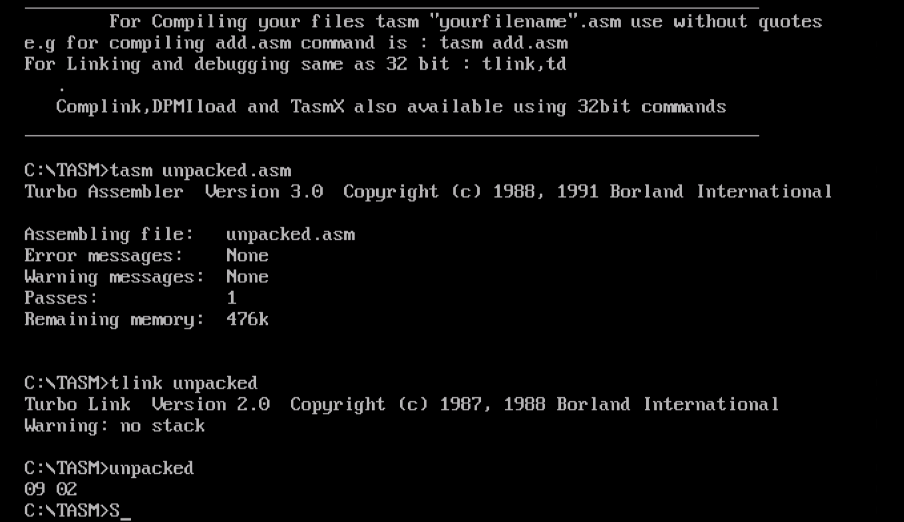

1. Program to move set of numbers from one memory block to another

