A

PROJECT REPORT ON

# AN ANDROID APPLICATION FOR PERSONAL HEALTH RECORD MANAGEMENT

**By**

**DIVYA SHAH (CE-120) (18CEUOD003) NIHAR SODHA (CE-128) (17CEUBG094) RAMYA SURATI (CE-130) (17CEUBS108)**

**B.Tech CE Semester-VI Subject: System Design Practice**

**Guided by:** Prof.Pandav K. Patel Assistant Professor Dept. of Comp. Engg.



**Faculty of Technology Department of Computer Engineering**

**Dharmsinh Desai University**



**Faculty of Technology Department of Computer Engineering**

**Dharmsinh Desai University**

**CERTIFICATE**

This is to certify that the practical / term work carried out in the subject of

**System Design Practice** and recorded in this journal is the bonafide work of

**DIVYA SHAH (CE-120) (18CEUOD003) NIHAR SODHA (CE-128) (17CEUBG094) RAMYA SURATI (CE-130) (17CEUBS108)**

of B.Tech semester **VI** in the branch of **Computer Engineering**

during the academic year **2019-2020**.

Prof. Pandav K. Patel Dr. C. K. Bhensdadia,

Assistant Professor, Head,

Dept. of Computer Engg., Dept. of Computer Engg.,

Faculty of Technology Faculty of Technology

Dharmsinh Desai University, Nadiad Dharmsinh Desai University, Nadiad

ABSTRACT

In today’s world of rapid modernization, the memory of human beings to remember different things has always been a difficult task. In the race of the world to earn more money, humans had never care about personal health. Number of new infections and diseases are growing very fast today. Also humans forgot the medication of their individuals and the family ones too. So to fulfill the gap of technology and personal health we here by developed an app called “**PHRM**”. This system is very boon for personal use because it covers a wide range of facilities. From managing the insurance details to the reminder of vaccination and lot more aspects related to the personal health are covered in the system.

**Contents**

1. Introduction 01
2. Software Requirement Specification 02
3. Design 09
   1. Use Case diagram 09
   2. Class diagram 11
   3. Sequence diagram 12
   4. Activity diagram 13
   5. State diagram 14
   6. E-R diagram 15
   7. Data dictionary 16
4. Implementation Detail 22
5. Testing 24
6. Screen-shots 25
7. Conclusion 28
8. Limitation and Future Extension 29
9. Bibliography 30

Personal Health Record Management System

# Introduction

**“PHRM, (Personal Health Record Management)”** is an android based application which focuses on the personal and family related health facilities. This platform helps the user to manage insurance details, doctor’s appointment, past medical records, prescription of medicines, allergies (if any) and many more other facilities are present in the system. This system also helps for the health management and the medical management. Also it takes care of the various appointment to the doctor and the vaccination details for the kids in the family. Alarms to take medicines time can be setup and the dosage can be taken in time without fail. Also, the platform helps to manage our medical documents and medical history, blood reports last but not the least the emergency contacts are also available to the system.

## Technology Used:

* Android
* Firebase by GOOGLE
* Emulator:

In computing, an emulator is hardware or software that enables one computer system to behave like another computer system. An emulator typically enables the host system to run software or use peripheral devices designed for the guest system.

* JAVA

## Hosting Platform:

* Android Device

**Tools Used:**

* Git hub(version control)
* Android Studio

Personal Health Record Management System

# Software Requirement Specification

### R-1) MANAGE_USERS_INFORMATION:

**DESCRIPTION:** This function allows the user to create his/her account while he/she is using the app for the first time. This function also allows the user to login through his/her account and proceed further according to the needs.

#### R-1.1) Add_User_Info:

**INPUT:** User enters the Name, email, password, phone.

**OUTPUT:** Details will be forwarded to the system and the system will assign the account accordingly.

PROCESS: The entered details will be authenticated internally. NEXT: The login page will be displayed.

#### R-1.2) User_Login:

**INPUT:** The login page will be available for users, with his/her email-id and Password he/she can log in.

**OUTPUT:** The homepage will be displayed.

PROCESS: The id and password will be authenticated and then the output will be provided if successful.

NEXT: The homepage will be shown.

#### R-1.3) Delete_User_Info:

**INPUT:** Customer Selection.

**OUTPUT:** Confirmation Message.

### R-2) MANAGE PERSONAL INFO:

**DESCRIPTION:** Users can manage personal info by this function in the system.

**R-2.1) Add_Personal_info: INPUT:** Personal info.

**OUTPUT:** Confirmation message.

**R-2.2) Update_Personal_info: INPUT:** Personal Info.

Personal Health Record Management System

**OUTPUT:** Confirmation message.

**R-2.3) Delete_Personal_info: INPUT:** User Selection.

**OUTPUT:** Confirmation message.

**R-2.4) Display_Personal_info: INPUT:** User Selection.

**OUTPUT:** The page will be displayed which will have all details about the selected personal information.

### R-3) MANAGE APPOINTMENTS & VISITS:

**DESCRIPTION:** Users can manage appointments and visit information by this function in the system.

**R-3.1) Add appointment and visits: INPUT:** Appointment and visit details. **OUTPUT:** Confirmation message.

**R-3.2) Update appointment and visits: INPUT:** Appointment and visit details **OUTPUT:** Confirmation message.

**R-3.3) Delete appointment and visits: INPUT:** Appointment and visit details. **OUTPUT:** Confirmation message.

**R-3.4) Display appointment and visits: INPUT:** User Selection.

**OUTPUT:** The page will be displayed which will have all details about the selected appointments and visit.

### R-4) MANAGE ALLERGIES:

**DESCRIPTION:** Users can manage allergies information by this function in the system.

#### R-4.1) Add allergies:

Personal Health Record Management System

**INPUT:** Allergy details.

**OUTPUT:** Confirmation message.

**R-4.2) Update allergies: INPUT:** Allergies details.

**OUTPUT:** Confirmation message.

#### R-4.3) Delete allergies:

**INPUT:** Allergies details.

**OUTPUT:** Confirmation message.

**R-4.4) Display allergies: INPUT:** User Selection.

**OUTPUT:** The page will be displayed which will have all details about the selected allergies.

### R-5) MANAGE MEDICAL DOCUMENTS:

**DESCRIPTION:** Users can manage medical documents this function in the system.

#### R-5.1) Add medical documents:

**INPUT:** Medical Documents details.

**OUTPUT:** Confirmation message.

**R-5.2) Update medical documents: INPUT:** Medical Documents details. **OUTPUT:** Confirmation message.

**R-5.3) Delete medical documents: INPUT:** Medical Documents details. **OUTPUT:** Confirmation message.

**R-5.4) Display medical documents: INPUT:** User Selection.

**OUTPUT:** The page will be displayed which will have all details about the selected allergies.

Personal Health Record Management System

### R-6) MANAGE MEDICAL HISTORY:

**DESCRIPTION:** Users can manage medical history details this function in the system.

#### R-6.1) Add medical history:

**INPUT:** Medical history details.

**OUTPUT:** Confirmation message.

**R-6.2) Update medical history: INPUT:** Medical history details.

**OUTPUT:** Confirmation message.

**R-6.3) Delete medical history: INPUT:** Medical history details.

**OUTPUT:** Confirmation message.

**R-6.4) Display medical history: INPUT:** User Selection.

**OUTPUT:** The page will be displayed which will have all details about the selected allergies.

### R-7) MANAGE BLOOD REPORT & TESTS:

**DESCRIPTION:** Users can manage blood report and tests details this function in the system.

#### R-7.1) Add Blood report and tests:

**INPUT:** Blood report and tests details.

**OUTPUT:** Confirmation message.

**R-7.2) Update Blood report and tests: INPUT:** Blood report and tests details. **OUTPUT:** Confirmation message.

**R-7.3) Delete Blood report and tests: INPUT:** Blood report and tests details. **OUTPUT:** Confirmation message.

#### R-7.4) Display Blood report and tests:

Personal Health Record Management System

**INPUT:** User Selection.

**OUTPUT:** The page will be displayed which will have all details about the selected Blood report and tests.

### R-8) MANAGE EMERGENCY CONTACTS:

**DESCRIPTION:** Users can manage emergency contact details this function in the system.

**R-8.1) Add Emergency Contacts: INPUT:** Emergency contact details. **OUTPUT:** Confirmation message.

**R-8.2) Update Emergency contact: INPUT:** Emergency contact details. **OUTPUT:** Confirmation message.

**R-8.3) Delete Emergency contact: INPUT:** Emergency contact details. **OUTPUT:** Confirmation message.

**R-8.4) Display Emergency contact: INPUT:** User Selection.

**OUTPUT:** The page will be displayed which will have all details about the selected Emergency contact.

### R-9) MANAGE EMERGENCY CONTACTS:

**DESCRIPTION:** Users can manage emergency contact details this function in the system.

**R-9.1) Add Emergency Contacts: INPUT:** Emergency contact details. **OUTPUT:** Confirmation message.

**R-9.2) Update Emergency contact: INPUT:** Emergency contact details. **OUTPUT:** Confirmation message.

Personal Health Record Management System

**R-9.3) Delete Emergency contact: INPUT:** Emergency contact details. **OUTPUT:** Confirmation message.

**R9.4) Display Emergency contact: INPUT:** User Selection.

**OUTPUT:** The page will be displayed which will have all details about the selected Emergency contact.

### R-10) MANAGE IMMUNIZATIONS:

**DESCRIPTION:** Users can manage immunizations details this function in the system.

#### R-10.1) Add Immunizations:

**INPUT:** Immunizations contact details.

**OUTPUT:** Confirmation message.

**R-10.2) Update Immunizations: INPUT:** Immunizations details. **OUTPUT:** Confirmation message.

**R-10.3) Delete Immunizations: INPUT:** Immunizations details.

**OUTPUT:** Confirmation message.

**R-10.4) Display Immunizations: INPUT:** User Selection.

**OUTPUT:** The page will be displayed which will have all details about the selected Immunizations.

### R-11) MANAGE DRUGS:

**DESCRIPTION:** Users can manage drugs details by this function in the system.

#### R-11.1) Add Drugs:

**INPUT:** Drug details.

**OUTPUT:** Confirmation message.

Personal Health Record Management System

#### R-11.2) Update Drug:

**INPUT:** Drug details.

**OUTPUT:** Confirmation message.

#### R-11.3) Delete Drug:

**INPUT:** Drug details.

**OUTPUT:** Confirmation message.

#### R-11.4) Display Drug:

**INPUT:** User Selection.

**OUTPUT:** The page will be displayed which will have all details about the selected Drug.

### R-12) MANAGE INSURANCE:

**DESCRIPTION:** Users can manage insurance details by this function in the system.

**R-12.1) Add Insurance: INPUT:** Insurance details.

**OUTPUT:** Confirmation message.

**R-12.2) Update Insurance: INPUT:** Insurance details.

**OUTPUT:** Confirmation message.

**R-12.3) Delete Insurance: INPUT:** Insurance details.

**OUTPUT:** Confirmation message.

**R-12.4) Display Insurance: INPUT:** User Selection.

**OUTPUT:** The page will be displayed which will have all details about the selected Insurance.

# Design

## Use Case Diagrams

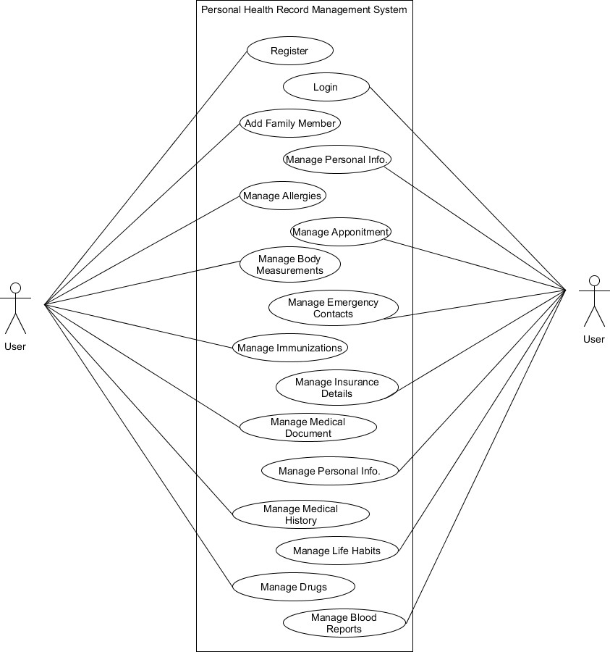

Fig 3.1.1 Use Case Diagram of Personal Health Record Management System

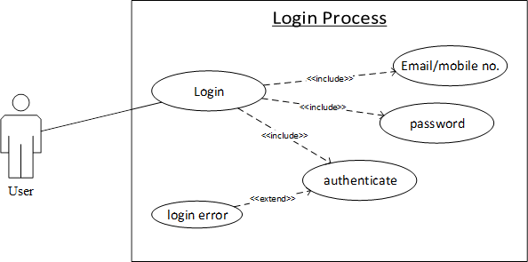

Fig. 3.1.2 Use Case Diagram of Login Process

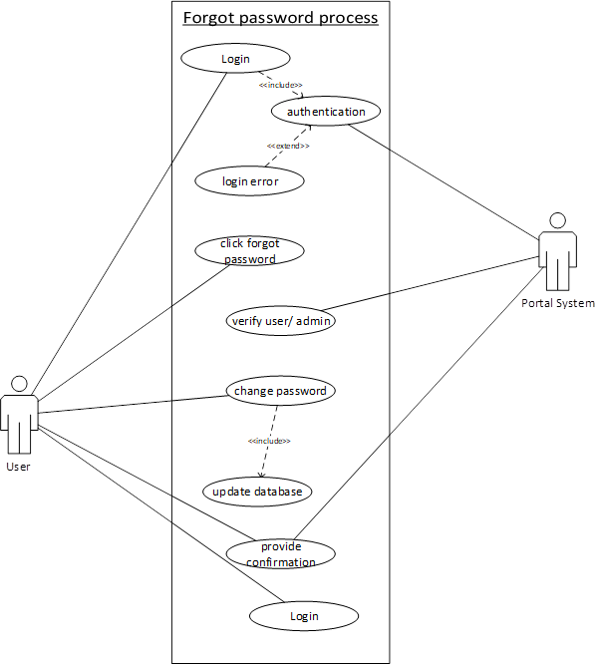

Fig. 3.1.3 Use Case Diagram of Forgot Password Process

## Class Diagram

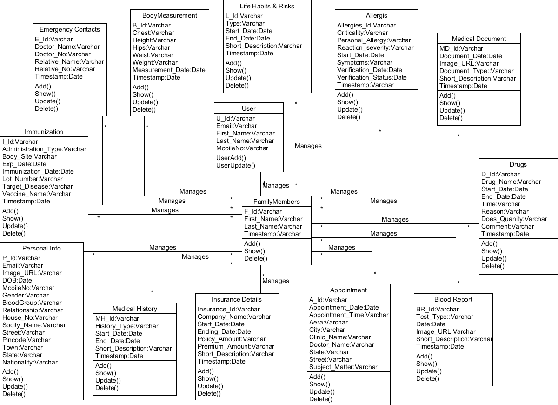

Fig 3.2.1 Class Diagram of Personal Health Record Management System

Personal Health Record Management System

## Sequence Diagrams

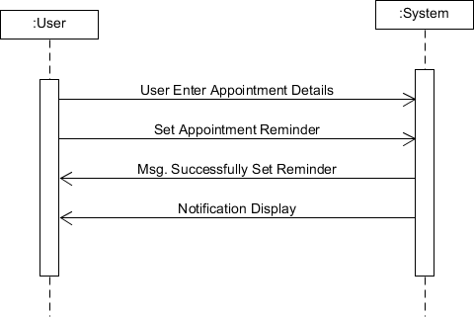

Fig 3.3.1 Sequence Diagram of Appointment Notification Process

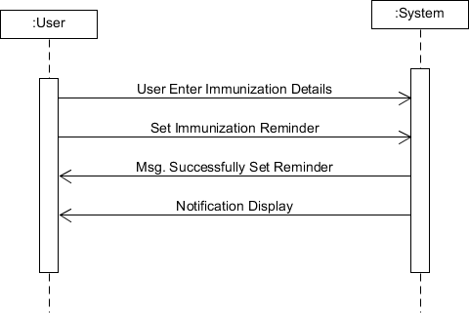

Fig 3.3.2 Sequence Diagram of Immunization Notification Process

Personal Health Record Management System

## Activity Diagrams

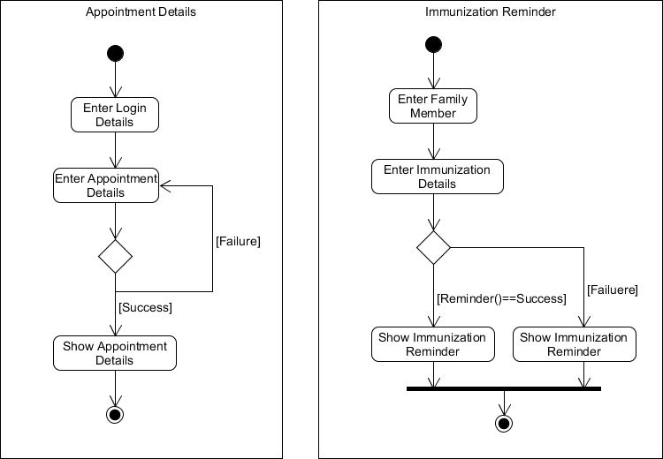

Fig 3.4.1 (i) Activity Diagram of Appointment Details

(ii) Activity Diagram of Immunization Reminder

Personal Health Record Management System

## State Diagram

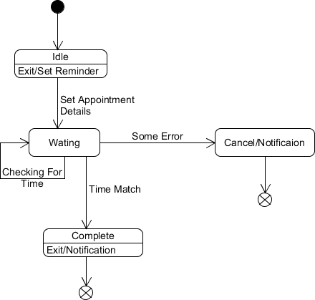

Fig 3.5.1 State Diagram of Appointment Notification

Personal Health Record Management System

## E-R Diagram

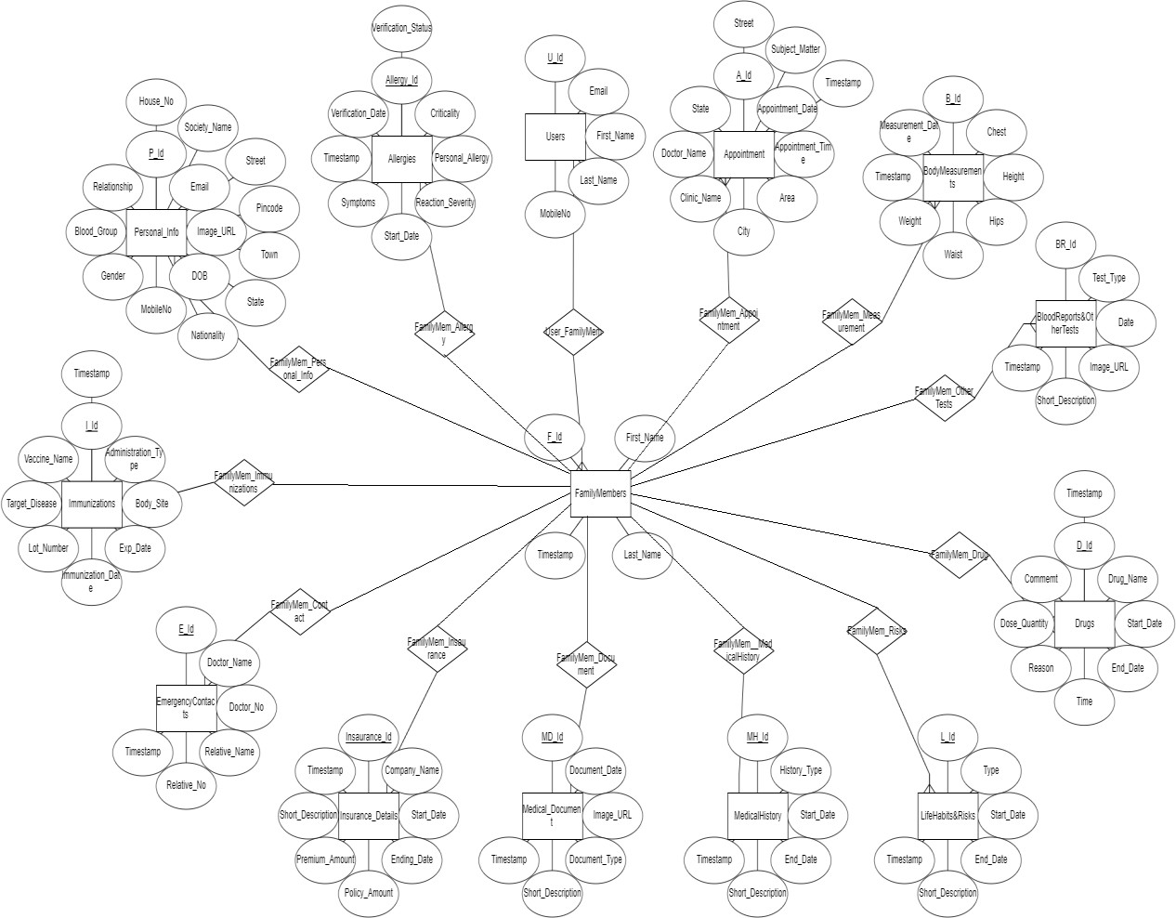

Fig 3.6.1 E-R Diagram of Personal Health Record Management System

## Data Dictionary

|  |  |  |  |  |  |  |  |  |
| --- | --- | --- | --- | --- | --- | --- | --- | --- |
| Users | | | | | | | | |
| Sr.  No. | Field Name | Data Type | Width | Required | Unique | PK/FK | Referenced Table | Description |
| 1. | U_Id | Varchar | 30 | Yes | Yes | PK |  |  |
| 2. | Email | Varchar | 30 | Yes | No |  |  |  |
| 3. | First_Name | Varchar | 30 | Yes | No |  |  |  |
| 4. | Last_Name | Varchar | 30 | Yes | No |  |  |  |
| 5. | MobileNo | Varchar | 10 | Yes | Yes |  |  |  |

|  |  |  |  |  |  |  |  |  |
| --- | --- | --- | --- | --- | --- | --- | --- | --- |
| Family Members | | | | | | | | |
| Sr.  No. | Field Name | Data Type | Width | Required | Unique | PK/FK | Referenced Table | Description |
| 1. | F_Id | Varchar | 30 | Yes | Yes | PK |  |  |
| 2. | U_Id | Varchar | 30 | Yes | Yes | FK | User |  |
| 3. | First_Name | Varchar | 30 | Yes | Yes |  |  |  |
| 4. | Last_Name | Varchar | 30 | Yes | No |  |  |  |
| 5. | Timestamp | Varchar | 10 | Yes | Yes |  |  |  |

|  |  |  |  |  |  |  |  |  |
| --- | --- | --- | --- | --- | --- | --- | --- | --- |
| Allergies | | | | | | | | |
| Sr.  No. | Field Name | Data Type | Width | Required | Unique | PK/FK | Referenced Table | Description |
| 1. | Allergies_Id | Varchar | 30 | Yes | Yes | PK |  |  |
| 2. | U_Id | Varchar | 30 | Yes | Yes | FK | User |  |
| 3. | F_Id | Varchar | 30 | Yes | Yes | FK | FamilyMembers |  |
| 4. | Criticality | Varchar | 20 | Yes | No |  |  |  |
| 5. | Personal_allergy | Varchar | 20 | Yes | No |  |  |  |
| 6. | Reaction_severity | Varchar | 20 | Yes | No |  |  |  |
| 7. | Start_Date | Date |  |  |  |  |  |  |
| 8. | Symptoms | Varchar | 20 | Yes | No |  |  |  |
| 9. | TimeStamp | Date |  |  |  |  |  |  |
| 10. | Verification_Date | Date |  |  |  |  |  |  |
| 11. | Verification_status | Varchar | 20 | Yes | No |  |  |  |

|  |  |  |  |  |  |  |  |  |
| --- | --- | --- | --- | --- | --- | --- | --- | --- |
| Appointment | | | | | | | | |
| Sr.  No. | Field Name | Data Type | Width | Required | Unique | PK/FK | Referenced Table | Description |
| 1. | A_Id | Varchar | 30 | Yes | Yes | PK |  |  |
| 2. | U_Id | Varchar | 30 | Yes | Yes | FK | User |  |
| 3. | F_Id | Varchar | 30 | Yes | Yes | FK | FamilyMembers |  |
| 4. | Appointment_Date | Date |  |  |  |  |  |  |
| 5. | Appointment_Time | Varchar | 20 | Yes | No |  |  |  |
| 6. | Area | Varchar | 20 | Yes | No |  |  |  |
| 7. | City | Varchar | 20 | Yes | No |  |  |  |
| 8. | Clinic_Name | Varchar | 20 | Yes | No |  |  |  |
| 9. | Doctor_Name | Varchar | 20 | Yes | No |  |  |  |
| 10. | State | Varchar | 20 | Yes | No |  |  |  |
| 11. | Street | Varchar | 20 | Yes | No |  |  |  |
| 12. | Subject_Matter | Varchar | 20 | Yes | No |  |  |  |

|  |  |  |  |  |  |  |  |  |
| --- | --- | --- | --- | --- | --- | --- | --- | --- |
| BodyMeasurements | | | | | | | | |
| Sr.  No. | Field Name | Data Type | Width | Required | Unique | PK/FK | Referenced Table | Description |
| 1. | B_Id | Varchar | 30 | Yes | Yes | PK |  |  |
| 2. | U_Id | Varchar | 30 | Yes | Yes | FK | User |  |
| 3. | F_Id | Varchar | 30 | Yes | Yes | FK | FamilyMembers |  |
| 4. | Chest | Varchar | 20 | Yes | No |  |  |  |
| 5. | Height | Varchar | 20 | Yes | No |  |  |  |
| 6. | Hips | Varchar | 20 | Yes | No |  |  |  |
| 7. | Waist | Varchar | 20 | Yes | No |  |  |  |
| 8. | Weight | Varchar | 20 | Yes | No |  |  |  |
| 9. | TimeStamp | Date |  |  |  |  |  |  |
| 10. | Measurement_Data | Date |  |  |  |  |  |  |

|  |  |  |  |  |  |  |  |  |
| --- | --- | --- | --- | --- | --- | --- | --- | --- |
| Emergency Contacts | | | | | | | | |
| Sr.  No. | Field Name | Data Type | Width | Required | Unique | PK/FK | Referenced Table | Description |
| 1. | E_Id | Varchar | 30 | Yes | Yes | PK |  |  |
| 2. | U_Id | Varchar | 30 | Yes | Yes | FK | User |  |
| 3. | F_Id | Varchar | 30 | Yes | Yes | FK | FamilyMembers |  |
| 4. | Doctor_Name | Varchar | 20 | Yes | No |  |  |  |
| 5. | Doctor_No. | Varchar | 10 | Yes | No |  |  |  |
| 6. | Relative_Name | Varchar | 20 | Yes | No |  |  |  |
| 7. | Relative_No | Varchar | 10 | Yes | No |  |  |  |
| 8. | Timestamp | Date |  |  |  |  |  |  |

|  |  |  |  |  |  |  |  |  |
| --- | --- | --- | --- | --- | --- | --- | --- | --- |
| Immunizations | | | | | | | | |
| Sr.  No. | Field Name | Data Type | Width | Required | Unique | PK/FK | Referenced Table | Description |
| 1. | I_Id | Varchar | 30 | Yes | Yes | PK |  |  |
| 2. | U_Id | Varchar | 30 | Yes | Yes | FK | User |  |
| 3. | F_Id | Varchar | 30 | Yes | Yes | FK | FamilyMembers |  |
| 4. | Administration_type | Varchar | 20 | Yes | No |  |  |  |
| 5. | Body_Site | Varchar | 20 | Yes | No |  |  |  |
| 6. | Exp_Date | Date |  |  |  |  |  |  |
| 7. | Immunization_Date | Varchar | 20 | Yes | No |  |  |  |
| 8. | Lot_Number | Varchar | 20 | Yes | No |  |  |  |
| 9. | Target_Disease | Varchar | 20 | Yes | No |  |  |  |
| 10. | Vaccine_Name | Varchar | 20 | Yes | No |  |  |  |
| 11. | Timestamp | Date |  |  |  |  |  |  |

|  |  |  |  |  |  |  |  |  |
| --- | --- | --- | --- | --- | --- | --- | --- | --- |
| Insurance Details | | | | | | | | |
| Sr.  No. | Field Name | Data Type | Width | Required | Unique | PK/FK | Referenced Table | Description |
| 1. | Insurance_Id | Varchar | 30 | Yes | Yes | PK |  |  |
| 2. | U_Id | Varchar | 30 | Yes | Yes | FK | User |  |
| 3. | F_Id | Varchar | 30 | Yes | Yes | FK | FamilyMembers |  |
| 4. | Company_Name | Varchar | 20 | Yes | No |  |  |  |
| 5. | Start_Date | Date |  |  |  |  |  |  |
| 6. | Ending_Date | Date |  |  |  |  |  |  |
| 7. | Policy_Amount | Varchar | 20 | Yes | No |  |  |  |
| 8. | Premium_Amount | Varchar | 20 | Yes | No |  |  |  |
| 9. | Short_Description | Varchar | 40 | Yes | No |  |  |  |
| 10. | Timestamp | Date |  |  |  |  |  |  |

|  |  |  |  |  |  |  |  |  |
| --- | --- | --- | --- | --- | --- | --- | --- | --- |
| Medical Document | | | | | | | | |
| Sr.  No. | Field Name | Data Type | Width | Required | Unique | PK/FK | Referenced Table | Description |
| 1. | MD_Id | Varchar | 30 | Yes | Yes | PK |  |  |
| 2. | U_Id | Varchar | 30 | Yes | Yes | FK | User |  |
| 3. | F_Id | Varchar | 30 | Yes | Yes | FK | FamilyMembers |  |
| 4. | Document_Date | Varchar | 20 | Yes | No |  |  |  |
| 5. | Image_URL | Varchar | 100 | Yes | No |  |  |  |
| 6. | Document_Type | Varchar | 20 | Yes | No |  |  |  |
| 7. | Short_Description | Varchar | 40 | Yes | No |  |  |  |
| 8. | Timestamp | Date |  |  |  |  |  |  |

|  |  |  |  |  |  |  |  |  |
| --- | --- | --- | --- | --- | --- | --- | --- | --- |
| Personal Info | | | | | | | | |
| Sr.  No. | Field Name | Data Type | Width | Required | Unique | PK/FK | Referenced Table | Description |
| 1. | P_Id | Varchar | 30 | Yes | Yes | PK |  |  |
| 2. | U_Id | Varchar | 30 | Yes | Yes | FK | User |  |
| 3. | F_Id | Varchar | 30 | Yes | Yes | FK | FamilyMembers |  |
| 4. | Email | Varchar | 30 | Yes | No |  |  |  |
| 5. | Image_URL | Varchar | 100 | Yes | No |  |  |  |
| 6. | DOB | Date |  |  |  |  |  |  |

|  |  |  |  |  |  |  |  |  |
| --- | --- | --- | --- | --- | --- | --- | --- | --- |
| 7. | MobileNo. | Varchar | 10 | Yes | No |  |  |  |
| 8. | Gender | Varchar | 20 | Yes | No |  |  |  |
| 9. | Blood Group | Varchar | 05 | Yes | No |  |  |  |
| 10. | Relationship | Varchar | 20 | Yes | No |  |  |  |
| 11. | House_No. | Varchar | 04 | Yes | No |  |  |  |
| 12. | Society_Name | Varchar | 20 | Yes | No |  |  |  |
| 13. | Street | Varchar | 20 | Yes | No |  |  |  |
| 14. | Pincode | Varchar | 06 | Yes | No |  |  |  |
| 15. | Town | Varchar | 20 | Yes | No |  |  |  |
| 16. | State | Varchar | 20 | Yes | No |  |  |  |
| 17. | Nationality | Varchar | 20 | Yes | No |  |  |  |

|  |  |  |  |  |  |  |  |  |
| --- | --- | --- | --- | --- | --- | --- | --- | --- |
| Medical History | | | | | | | | |
| Sr.  No. | Field Name | Data Type | Width | Required | Unique | PK/FK | Referenced Table | Description |
| 1. | MH_Id | Varchar | 30 | Yes | Yes | PK |  |  |
| 2. | U_Id | Varchar | 30 | Yes | Yes | FK | User |  |
| 3. | F_Id | Varchar | 30 | Yes | Yes | FK | FamilyMembers |  |
| 4. | History_Type | Varchar | 20 | Yes | No |  |  |  |
| 5. | Start_Date | Date |  |  |  |  |  |  |
| 6. | End_Date | Date |  |  |  |  |  |  |
| 7. | Short_Description | Varchar | 40 | Yes | No |  |  |  |
| 8. | Timestamp | Date |  |  |  |  |  |  |

|  |  |  |  |  |  |  |  |  |
| --- | --- | --- | --- | --- | --- | --- | --- | --- |
| Life Habits & Risks | | | | | | | | |
| Sr.  No. | Field Name | Data Type | Width | Required | Unique | PK/FK | Referenced Table | Description |
| 1. | L_Id | Varchar | 30 | Yes | Yes | PK |  |  |
| 2. | U_Id | Varchar | 30 | Yes | Yes | FK | User |  |
| 3. | F_Id | Varchar | 30 | Yes | Yes | FK | FamilyMembers |  |
| 4. | Type | Varchar | 20 | Yes | No |  |  |  |
| 5. | Start_Date | Date |  |  |  |  |  |  |
| 6. | End_Date | Date |  |  |  |  |  |  |
| 7. | Short_Description | Varchar | 40 | Yes | No |  |  |  |

|  |  |  |  |  |  |  |  |  |
| --- | --- | --- | --- | --- | --- | --- | --- | --- |
| Drugs | | | | | | | | |
| Sr.  No. | Field Name | Data Type | Width | Required | Unique | PK/FK | Referenced Table | Description |
| 1. | D_Id | Varchar | 30 | Yes | Yes | PK |  |  |
| 2. | U_Id | Varchar | 30 | Yes | Yes | FK | User |  |
| 3. | F_Id | Varchar | 30 | Yes | Yes | FK | FamilyMembers |  |
| 4. | Drug_Name | Varchar | 20 | Yes | No |  |  |  |
| 5. | Start_Date | Date |  |  |  |  |  |  |
| 6. | End_Date | Date |  |  |  |  |  |  |
| 7. | Time | Varchar | 20 | Yes | No |  |  |  |
| 8. | Reason | Varchar | 40 | Yes | No |  |  |  |
| 9. | Does_Quantity | Varchar | 20 | Yes | No |  |  |  |
| 12. | Comment | Varchar | 40 | Yes | No |  |  |  |
| 11. | Timestamp | Date |  |  |  |  |  |  |

|  |  |  |  |  |  |  |  |  |
| --- | --- | --- | --- | --- | --- | --- | --- | --- |
| Blood Report & Other Tests | | | | | | | | |
| Sr.  No. | Field Name | Data Type | Width | Required | Unique | PK/FK | Referenced Table | Description |
| 1. | BR_Id | Varchar | 30 | Yes | Yes | PK |  |  |
| 2. | U_Id | Varchar | 30 | Yes | Yes | FK | User |  |
| 3. | F_Id | Varchar | 30 | Yes | Yes | FK | FamilyMembers |  |
| 4. | Test_Type | Varchar | 20 | Yes | No |  |  |  |
| 5. | Date | Date |  |  |  |  |  |  |
| 6. | Image_URL | Varchar | 100 | Yes | No |  |  |  |
| 7. | Short_Description | Varchar | 40 | Yes | No |  |  |  |
| 8. | Timestamp | Date |  |  |  |  |  |  |

**Implementation Detail**

### Home Module:

This module allows users to select the option which he/she wants to work with i.e. he/she can select from either personal info, appointments, emergency contacts, immunizations, reports, insurance details, medical documents and allergies in the home module.

### Login and Sign up Module:

Users need to log in first before using the application, this module will facilitate users to Sign up if they are using the app for the first time or will let them log into the system if they already have an account.

### Personal Info Module:

Users can manage personal information like address, photograph, blood group, mobile number, email etc. Thus by providing the personal information to the system. The data will be saved to the database and success message will be prompted.

### Appointment and Visits Module:

Users can manage the appointments and visits to the doctors by providing data to filed such as doctor name, doctor address, reason, time and date to the system. The data will be saved to the database and success message will be prompted.

### Allergies Module:

Users can manage allergies record by providing allergy name, history, starting period, reason, symptoms. The data will be saved to the database and success message will be prompted.

### Family Member Module:

Users can manage family member record by providing family member details and relationship. All health management modules can be used for the family member also. The data will be saved to the database and success message will be prompted.

### Medical Documents Module:

Users can manage medical documents to the system like X-Ray, blood report, CT-Scan and many more medical documents. The data will be saved to the database and success message will be prompted.

### Immunizations Module:

Users can manage immunization details by providing proper vaccination details like name of vaccine, date to get injected, symptoms, reasons etc. System will prompted reminder

Personal Health Record Management System

notification in the system before the date of vaccine to inject. The data will be saved to the database and success message will be prompted.

### Emergency Contacts Module:

Users can manage emergency contacts details by providing information of closed ones and doctors if necessary. The data will be saved to the database and success message will be prompted.

### Insurance Details Module:

Users can manage insurance details of the whole family. Policy number, premium amount, date of expiration another necessary data can be given in the module. The data will be saved to the database and success message will be prompted.

### Drugs Module:

Users can manage medical drugs by maintaining prescription given by the doctor and the detail of the drug to the system. The data will be saved to the database and success message will be prompted.

Personal Health Record Management System

# Testing

Fig. 5.1 If User Enter Invalid Credentials Fig. 5.2 All Field Must be Required. Show Toast Message “Login Failed.”

# Screen-Shots

Fig 6.1 Home Screen of Application & User Fig 6.2 User Click on Name after then Open Add Family Member Click on Plus Button. This Page and select any out of them.

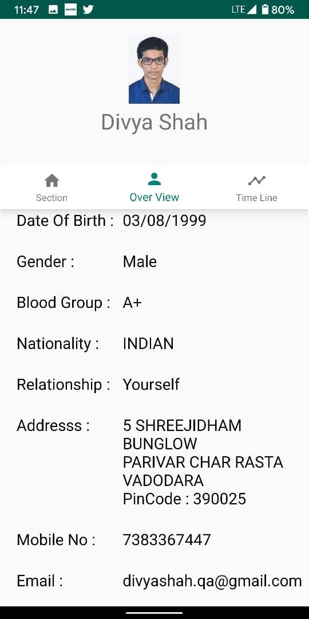 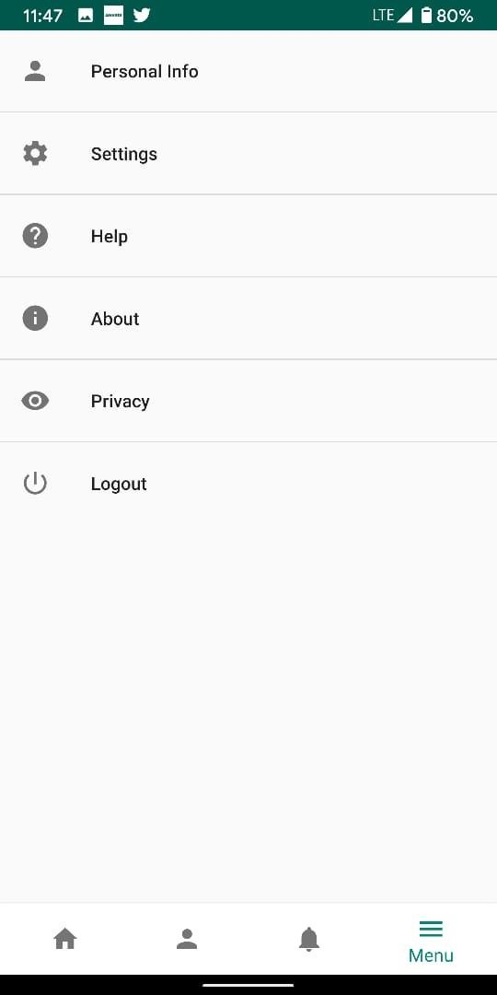

Fig 6.3 User Can Show All The Personal Info. Fig 6.4 This is Menu Activity in the Application

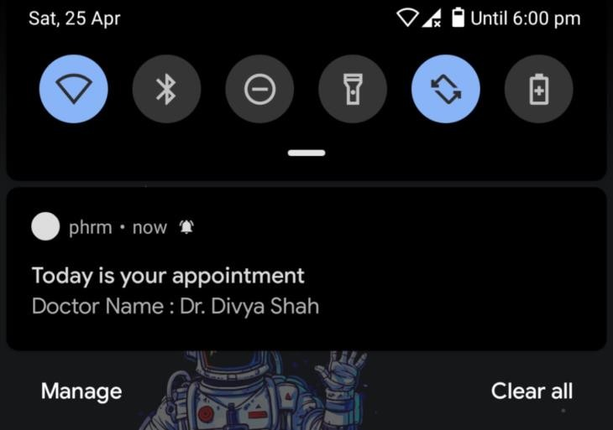

Fig 6.5 When User set Reminder For Appointment and Notification will be Pop Up.

# Conclusion

The above mentioned functionalities were implemented successfully after gathering all the requirements. The flow control was defined first and then the modules were integrated to the system. All the modules were tested before the deployment and requirements of the system were fulfill. Thus, all the requirements of the system were implemented successfully to the system.

Personal Health Record Management System

# Limitation & Future Extension

## Limitation:

* + - Supports only android operating system.
    - Not a light weight system.
    - Text message or calls cannot be done.
    - Minimum android version required is OREO.

## Future Enhancement:

* + - Support for ios.
    - Calls and text message can be done.

Personal Health Record Management System

# Bibliography

1. <https://developer.android.com/training/basics/firstapp/building-ui>
2. <https://codelabs.developers.google.com/>
3. <https://firebase.google.com/docs>
4. <https://www.tutorialspoint.com/android/index.htm>
5. <https://stackoverflow.com/>
6. <https://developer.android.com/training/notify-user/build-notification>