Design and implement a Pipelined Implementation of a MIPS Processor with Data Forwarding and Hazard Detection

Implementation Details -

The entire processor was designed using Verilog HDL and simulated on Xilinx Simulator (though it should work well with any other Verilog simulator too). The design follows a bottom-up approach i.e. all the building blocks (like Flip-flops, registers, ALU) were first designed and then instantiated in the top module. Also the design follows behavioural verilog modeling.
The figure below shows a simple pipelined MIPS processor without data forwarding and hazard detection units -

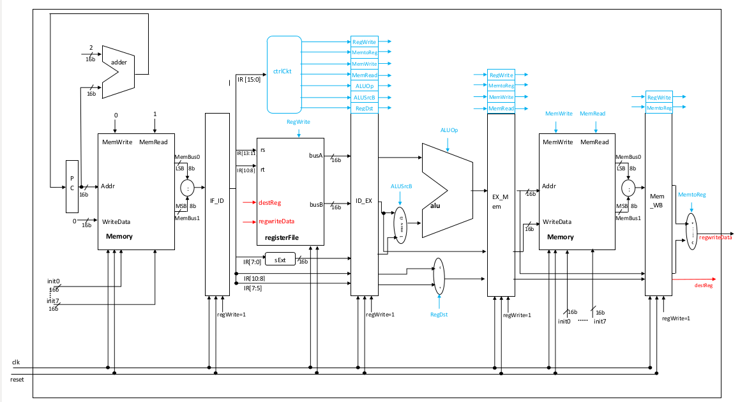
Fig – Simple Pipelined MIPS Processor (without Data forwarding and Hazard Detection)

The above figure shows the design with all the data path and control path signal shown. All the major building blocks are shown above in the figure. All the blocks were desinged from a basic small module and then instantiated in the main module.

About Pipelined Implementation -

Pipelining is an implementation technique in which multiple instructions are overlapped in execution. Today, pipelining is key in making processor fast. The pipelined approach takes less time as compared to a Simgle Cycle implementation where every instruction is executed in one clock cycle. The different pipelined stages of the MIPS processor are:

i) Fetch the instruction from the memory

ii) Read registers while decoding the instruction. The format of MIPS instructions allows reading and decoding the instruction to occur simulatneously.

iii) Execute the operation or calculate the address

iv) Access an operand in data memory

v) Write the result into the register

As a result, the MIPS pipeline has 5 stages. Since there are 5 pipeline stages, there is a need to divide an instruction into 5 stages which means that upto five instructions can will be in execution during any single clock cycle. Thus, the data path needs to separated into five different pieces, with each corresponding to a stage. The 5 different stages (shown in the diagram as well are)

i) IF: Instruction Fetch

ii) ID: Instruction Decode

iii) EX: Execution or address calculation

iv) MEM: Data memory access

v) WB: Write Back to register file

To show how these different 5 stages work, here is an example of an “lw” (load instruction) -

a) Instruction fetch – The instruction is read from the memory by the address pointed by PC and then placed in the IF/ID pipeline register. Also in the same stage the PC address is incremented to point to the address of the next instruction in the memory. The processor at this stage doesn't know which instruction is being executed.

b) Instruction Decode and register file read – In this pipeline stage the instructions are decoded and the contents of the registers are read from the register file. At the same time a 16-bit immediate value (sign extended to 32 bits) is also calculated. All the values are then stored to the ID/EX pipeline register.

c) Execute/address calculation – In this stage the processor knows that it is a Load instruction. Thus, the load instruction reads the contents of the register 1 and the sign extended immediate from the ID/EX register and adds them using the ALU. The result is placed – EX/MEM register.

d) Memory Access – With the address generated in the previous cycle, the load instructions uses that address to read the contents stored at that address in the Data memory. The contents are stored into MEM/WB pipeline register.

e) Write Back – In the final stage of the pipeline, the contents read are written back to the destination register and completing the instruction.

This is how a load instruction would be executed in the MIPS processor.

Need for Data forwarding and hazard detection

Though pipelining increases the processors performance but with pipeline certain hazards are introduced in the desgin. There are situations when some instruction cannot be executed along with the on-going instruction. Such events are called Hazards. The most common hazards are:

i) Structural Hazard – This simply means that the hardware cannot support the combination of instructions in the same cycle. For example if two instructions in different pipeline stages want to access ALU operation might not be able to do so since the processor has only a single ALU. This can be prevented by adding the required hardware.

ii) Data Hazard – Data hazard means that one step has to wait for another step to complete. For example consider the following instructions -

sub $s1, $s2, $s3
add $t0, $s1, $t1

This would potentially cause a data hazard as the “sub” instruction will not update the data until the fifth cycle but the “add” instruction access the contents of $s1 in the second cycle (third cycle for “sub”) itself. To protect this we can either stall the pipeline (i.e. perform null operation until the correct data is available) or since the data is ready by the third cycle we can by-pass this data to the next instruction. Adding extra hardware to get this information from the ALU is called “Data Forwarding”.

Iii) Control Hazard – This is the most common hazard which arises from the need to make a decision based on the result of the previous instruction. This potential hazard always occurs when there is a branch instruction as it changes the sequentially increasing PC. Unlike data hazard, the pipeline has no idea what the next address might be since it needs to update the PC as soon as it fetches the branch instruction. As a result there is a need to predict the branch address but this doesn't seem to be a very trivial thing. If the branch is mis-predicted all the instructions fetched before that needs to be undone and new instructions need to be fetched. There is a great deal of research going on to make branch predictors more efficient.

The following figure combines the above design with hardware to support data forwarding and hazard detection -

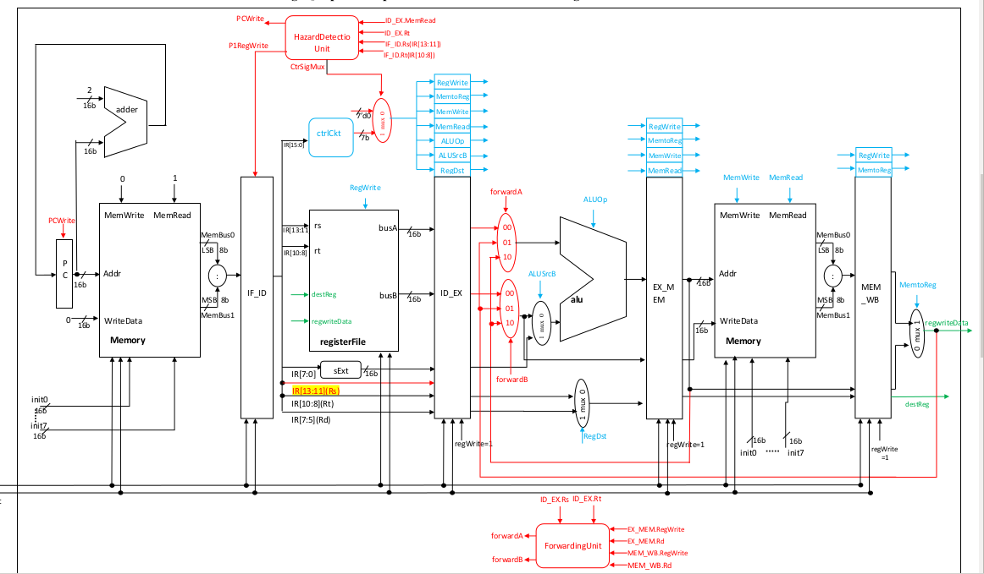

Description of different control signals -

The following table describes the various control signals and their meaning -

Signal Name | Effect
RegDst | Register destination number
RegWrite | Write the register with value on data input
ALUSrc | To select the second ALU operand
PCSrc | To select between branch target or the usual PC
MemRead | To read the data memory contents
MemWrite | To write to the data memory
MemtoReg | The value fed to register write data (input either from ALU or data memory)

Different building blocks -

i) D flip-flop – A basic sequential edge triggered element which stores one bit of information

Verilog module -

module D_ff (clk, reset, regWrite, decOut1b, d, q);
input clk, reset, regWrite, decOut1b, d;
output reg q;
always @(negedge clk)
begin
if (reset == 1)
q = 0;
else if ((regWrite == 1)&& (decOut1b == 1))
q = d;
end
endmodule

ii) Register – Combination of D flip-flops to hold x-bits of information where “x” depends on the number of times D flip-flop module is instantiated

Verilog Module for an 8 bit register-

module register32bit (clk, reset, regWrite, decOut1b, writeData, outR);
input clk, reset, regWrite, decOut1b;
input [31:0] writeData;
output [31:0] outR;

D_ff Dff0 (clk, reset, regWrite, decOut1b, writeData[0], outR[0]);
D_ff Dff1 (clk, reset, regWrite, decOut1b, writeData[1], outR[1]);
D_ff Dff2 (clk, reset, regWrite, decOut1b, writeData[2], outR[2]);
D_ff Dff3 (clk, reset, regWrite, decOut1b, writeData[3], outR[3]);
D_ff Dff4 (clk, reset, regWrite, decOut1b, writeData[4], outR[4]);
D_ff Dff5 (clk, reset, regWrite, decOut1b, writeData[5], outR[5]);
D_ff Dff6 (clk, reset, regWrite, decOut1b, writeData[6], outR[6]);
D_ff Dff7 (clk, reset, regWrite, decOut1b, writeData[7], outR[7]);

endmodule

iii) Decoder – A combinational element which converts n bits to (2^n -1) bits

Verilog Module -

module decoder(dstReg, decOut);
input [2:0] dstReg;
output reg [7:0] decOut;
always @(dstReg)
begin
decOut = 8'd0;
decOut[dstReg] = 1;
end
endmodule

iv) Mux – A multiplexor selects and gives a single output from n inputs depending on the control values

Verilog Module -

module mux8to1(outR0, outR1, outR2, outR3, outR4, outR5, outR6, outR7, Sel, outBus);
input [31:0] outR0, outR1, outR2, outR3, outR4, outR5, outR6, outR7;
input [2:0] Sel;
output reg [31:0] outBus;

always @(Sel)
begin
case (Sel)
3'd0: outBus = outR0;
3'd1: outBus = outR1;
3'd2: outBus = outR2;
3'd3: outBus = outR3;
3'd4: outBus = outR4;
3'd5: outBus = outR5;
3'd6: outBus = outR6;
3'd7: outBus = outR7;
endcase
end
endmodule

Using the above 4 building blocks different main units (ALU, Instruction Memory, Data Memory, Register File) were implemented -

i) Register File -

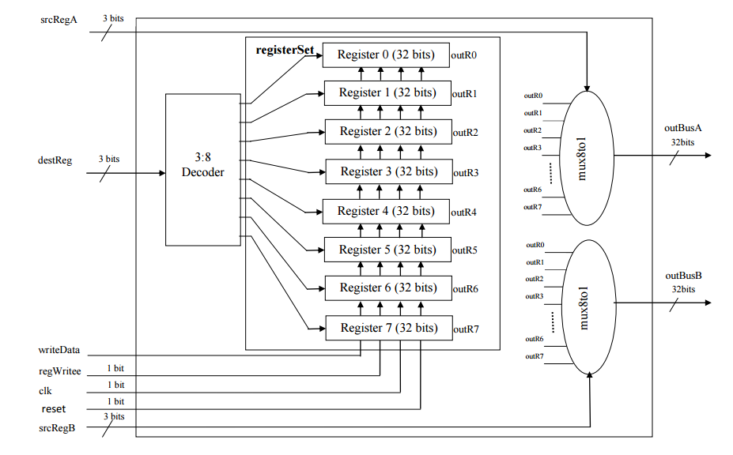
Fig – A simple Register File

The figure above shows the implementation of a register file used to select between 8 possible register currently. The register file is capable of reading two registers and writing to one register. It makes use of the above mentioned building blocks. The top level verilog module of the register file is shown below -

module registerFile (clk, reset, regWrite, srcRegA, srcRegB, dstReg, writeData, outBusA, outBusB);
input clk, reset, regWrite;
input [2:0] srcRegA, srcRegB, dstReg;
input [31:0] writeData;
output [31:0] outBusA, outBusB;
wire [31:0] outR0, outR1, outR2, outR3, outR4, outR5, outR6, outR7;
wire [7:0] decOut;

decoder Dec0 (dstReg, decOut);
registerSet RegSet0 (clk, reset, regWrite, decOut, writeData, outR0, outR1, outR2, outR3, outR4, outR5, outR6, outR7);
mux8to1 Mux0 (outR0, outR1, outR2, outR3, outR4, outR5, outR6, outR7, srcRegA, outBusA);
mux8to1 Mux1 (outR0, outR1, outR2, outR3, outR4, outR5, outR6, outR7, srcRegB, outBusB);

endmodule

Register holds all the physical registers and almost every instruction updates the register file in the Write back stage.

ii) ALU – The arithmetic logical Unit was also designed using the same buiding blocks and instantiating them in the top level. The ALU can perform the following functions -
a) ADD
b) SUB
c) SLT (set of less than)
d) Set Zero if the result is zero

The top level verilog implementation of the ALU is shown below -

module alu_extnd_32_bits (a, b, b_inv, opt, c_in, res, carry);
input [31:0] a, b;
input b_inv, c_in, opt;
output [31:0] res;
output carry;
wire set;
wire [32:1] C;
assign set = res[31];
assign carry = C[32];

alu_add_sub_slt ALU0 (a[0], b[0], b_inv, set, opt, c_in, res[0], C[1]);
alu_add_sub_slt ALU1 (a[1], b[1], b_inv, 0, opt, C[1], res[1], C[2]);
alu_add_sub_slt ALU2 (a[2], b[2], b_inv, 0, opt, C[2], res[2], C[3]);
alu_add_sub_slt ALU3 (a[3], b[3], b_inv, 0, opt, C[3], res[3], C[4]);
alu_add_sub_slt ALU4 (a[4], b[4], b_inv, 0, opt, C[4], res[4], C[5]);
alu_add_sub_slt ALU5 (a[5], b[5], b_inv, 0, opt, C[5], res[5], C[6]);
alu_add_sub_slt ALU6 (a[6], b[6], b_inv, 0, opt, C[6], res[6], C[7]);
alu_add_sub_slt ALU7 (a[7], b[7], b_inv, 0, opt, C[7], res[7], C[8]);

endmodule

where alu_add_sub_slt sub-module is -

module alu_add_sub_slt (data_a, data_b, b_inv, less_i, opt, c_in, res, carry);
input data_a, data_b, less_i, b_inv, c_in, opt;
output res, carry;
wire b_to_add;
wire add_out, c_out;
mux_2_to_1 mux0 (data_b, ~data_b, b_inv, b_to_add);
adder_1_bit add0 (data_a, b_to_add, c_in, add_out, carry);
mux_2_to_1 mux1 (add_out, less_i, opt, res);
endmodule

iii) Memory (Data and Instruction Memory(

Memories were designed by instantiating D-FF multiple times as shown below -

module D_ff_IM(input clk, input reset, input d, output reg q);
always @ (reset or posedge clk)
if(reset) q=d;
endmodule

module register_IM(input clk, input reset, input [15:0] d_in,output [15:0] q_out);
D_ff_IM dIM0 (clk, reset, d_in[0], q_out[0]);
D_ff_IM dIM1 (clk, reset, d_in[1], q_out[1]);
D_ff_IM dIM2 (clk, reset, d_in[2], q_out[2]);
D_ff_IM dIM3 (clk, reset, d_in[3], q_out[3]);
D_ff_IM dIM4 (clk, reset, d_in[4], q_out[4]);
D_ff_IM dIM5 (clk, reset, d_in[5], q_out[5]);
D_ff_IM dIM6 (clk, reset, d_in[6], q_out[6]);
D_ff_IM dIM7 (clk, reset, d_in[7], q_out[7]);
D_ff_IM dIM8 (clk, reset, d_in[8], q_out[8]);
D_ff_IM dIM9 (clk, reset, d_in[9], q_out[9]);
D_ff_IM dIM10 (clk, reset, d_in[10], q_out[10]);
D_ff_IM dIM11 (clk, reset, d_in[11], q_out[11]);
D_ff_IM dIM12 (clk, reset, d_in[12], q_out[12]);
D_ff_IM dIM13 (clk, reset, d_in[13], q_out[13]);
D_ff_IM dIM14 (clk, reset, d_in[14], q_out[14]);
D_ff_IM dIM15 (clk, reset, d_in[15], q_out[15]);
endmodule

Results -

To simulate the design, the instruction memory was populated with the following instructions -

lw R1, R0(2)
add R2, R1, R1
addi R3, R4, 6
sub R4, R3, R2
sw R4, R5(4)
add R4, R3, R1
lw R6, R5(0)
addi R5, R6, -2

The choice of these instruction was based on the fact to trigger some sort of hazards in the design. This would help us verify the hazard and forwarding unit as well. The following is the screenshot of the waves window to view different signals -

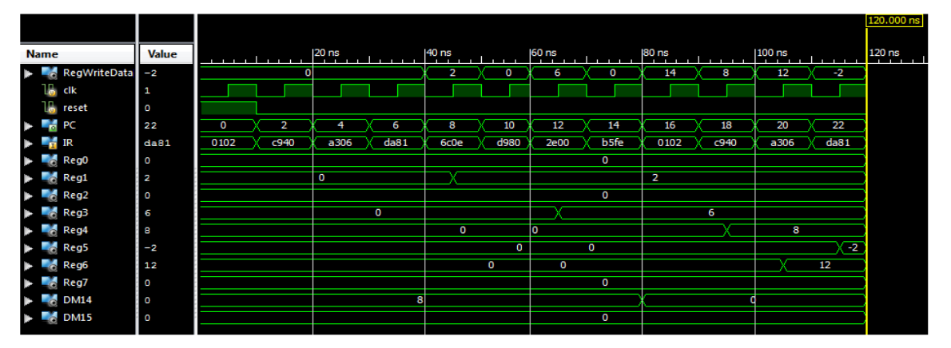

The design was also simulated using the following intructions -

addi R0, R4, 15
lw R1, R6(14)
addi R2, R0, 7
sub R6, R0, R5
sw R0, R4(12)
add R4, R4, R4
add R3, R0, R1

The simulated waveform is shown below -

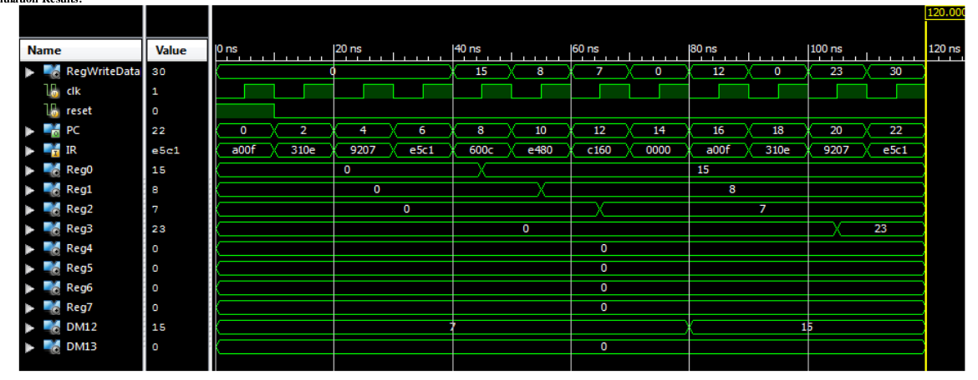

The result was verified by checking the values of different signals with the hand computed values. The results did matched and thus verified the entire design procedure.

Verilog Code -

module ctrlCkt (opcode, regDst, regWrite, aluSrc, aluOp, writeSrc, branch, jump);
input [4:0] opcode;
output reg regDst, regWrite, aluSrc, aluOp, writeSrc, branch, jump;
always @(opcode, regDst, regWrite, aluSrc, aluOp, writeSrc, branch, jump)
case (opcode)
5'b00001 : begin
regDst = 0; regWrite = 1; aluSrc = 1; aluOp = 0; writeSrc = 1; branch = 0; jump = 0;
end
5'b00010 : begin
regDst = 0; regWrite = 1; aluSrc = 1; aluOp = 0; writeSrc = 1; branch = 0; jump = 0;
end
5'b00011 : begin
regDst = 0; regWrite = 1; aluSrc = 1; aluOp = 0; writeSrc = 1; branch = 0; jump = 0;
end
5'b00100 : begin
regDst = 0; regWrite = 1; aluSrc = 1; aluOp = 0; writeSrc = 1; branch = 0; jump = 0;
end
5'b00101 : begin
regDst = 0; regWrite = 1; aluSrc = 1; aluOp = 0; writeSrc = 1; branch = 0; jump = 0;
end
5'b0100x : begin
regDst = 1; regWrite = 1; aluSrc = 0; aluOp = 0; writeSrc = 0; branch = 0; jump = 0;
end
5'b0101x : begin
regDst = 0; regWrite = 1; aluSrc = 1; aluOp = 0; writeSrc = 0; branch = 0; jump = 0;
end
5'b0110x : begin
regDst = 1; regWrite = 1; aluSrc = 0; aluOp = 1; writeSrc = 0; branch = 0; jump = 0;
end
5'b0111x : begin
regDst = 0; regWrite = 1; aluSrc = 1; aluOp = 1; writeSrc = 0; branch = 0; jump = 0;
end
5'b10xxx : begin
regDst = 0; regWrite = 0; aluSrc = 1; aluOp = 0; writeSrc = 0; branch = 1; jump = 0;
end
5'b11xxx : begin
regDst = 0; regWrite = 0; aluSrc = 1; aluOp = 0; writeSrc = 0; branch = 1; jump = 1;
end
endcase
endmodule

// ========= 32 BIT SHIFTER ===============

module mux2x1( input [2:0] in0, input [2:0] in1, input sel, output reg [2:0] muxOut);
always@(sel or in0 or in1)
case(sel)
1'b0: muxOut=in0;
1'b1: muxOut=in1;
endcase
endmodule

module mux8x1( input in0, input in1, input in2, input in3, input in4, input in5, input [2:0] sel, output reg muxOut);
always@(sel or in0 or in1 or in2 or in3 or in4 or in5)
case(sel)
3'b000: muxOut=in0;
3'b001: muxOut=in1;
3'b010: muxOut=in2;
3'b011: muxOut=in3;
3'b100: muxOut=in4;
3'b101: muxOut=in5;
3'b110: muxOut=1'b0;
3'b111: muxOut=1'b0;
endcase
endmodule

module shifter32b(input [31:0] rs, input [4:0] shiftAmt, input [2:0] opcode, output [31:0] shiftOut);

wire [2:0]muxsel1, muxsel2, muxsel3, muxsel4, muxsel5;
wire [31:0]s,r,q,p;

mux2x1 x1(3'b000,opcode,shiftAmt[0],muxsel1);
mux2x1 x2(3'b000,opcode,shiftAmt[1],muxsel2);
mux2x1 x3(3'b000,opcode,shiftAmt[2],muxsel3);
mux2x1 x4(3'b000,opcode,shiftAmt[3],muxsel4);
mux2x1 x5(3'b000,opcode,shiftAmt[4],muxsel5);

//First stage
mux8x1 mux311(rs[31],rs[31],1'b0,rs[0],rs[30],rs[30],muxsel1,s[31]);
mux8x1 mux301(rs[30],rs[31],rs[31],rs[31],rs[29],rs[29],muxsel1,s[30]);
mux8x1 mux291(rs[29],rs[30],rs[30],rs[30],rs[28],rs[28],muxsel1,s[29]);
mux8x1 mux281(rs[28],rs[29],rs[29],rs[29],rs[27],rs[27],muxsel1,s[28]);
mux8x1 mux271(rs[27],rs[28],rs[28],rs[28],rs[26],rs[26],muxsel1,s[27]);
mux8x1 mux261(rs[26],rs[27],rs[27],rs[27],rs[25],rs[25],muxsel1,s[26]);
mux8x1 mux251(rs[25],rs[26],rs[26],rs[26],rs[24],rs[24],muxsel1,s[25]);
mux8x1 mux241(rs[24],rs[25],rs[25],rs[25],rs[23],rs[23],muxsel1,s[24]);
mux8x1 mux231(rs[23],rs[24],rs[24],rs[24],rs[22],rs[22],muxsel1,s[23]);
mux8x1 mux221(rs[22],rs[23],rs[23],rs[23],rs[21],rs[21],muxsel1,s[22]);
mux8x1 mux211(rs[21],rs[22],rs[22],rs[22],rs[20],rs[20],muxsel1,s[21]);
mux8x1 mux201(rs[20],rs[21],rs[21],rs[21],rs[19],rs[19],muxsel1,s[20]);
mux8x1 mux191(rs[19],rs[20],rs[20],rs[20],rs[18],rs[18],muxsel1,s[19]);
mux8x1 mux181(rs[18],rs[19],rs[19],rs[19],rs[17],rs[30],muxsel1,s[18]);
mux8x1 mux171(rs[17],rs[18],rs[18],rs[18],rs[16],rs[16],muxsel1,s[17]);
mux8x1 mux161(rs[16],rs[17],rs[17],rs[17],rs[15],rs[15],muxsel1,s[16]);
mux8x1 mux151(rs[15],rs[16],rs[16],rs[16],rs[14],rs[14],muxsel1,s[15]);
mux8x1 mux141(rs[14],rs[15],rs[15],rs[15],rs[13],rs[13],muxsel1,s[14]);
mux8x1 mux131(rs[13],rs[14],rs[14],rs[14],rs[12],rs[12],muxsel1,s[13]);
mux8x1 mux121(rs[12],rs[13],rs[13],rs[13],rs[11],rs[11],muxsel1,s[12]);
mux8x1 mux111(rs[11],rs[12],rs[12],rs[12],rs[10],rs[10],muxsel1,s[11]);
mux8x1 mux101(rs[10],rs[11],rs[11],rs[11],rs[09],rs[09],muxsel1,s[10]);
mux8x1 mux091(rs[09],rs[10],rs[10],rs[10],rs[08],rs[08],muxsel1,s[9]);
mux8x1 mux081(rs[08],rs[09],rs[09],rs[09],rs[07],rs[07],muxsel1,s[8]);
mux8x1 mux071(rs[07],rs[08],rs[08],rs[08],rs[06],rs[06],muxsel1,s[7]);
mux8x1 mux061(rs[06],rs[07],rs[07],rs[07],rs[05],rs[05],muxsel1,s[6]);
mux8x1 mux051(rs[05],rs[06],rs[06],rs[06],rs[04],rs[04],muxsel1,s[5]);
mux8x1 mux041(rs[04],rs[05],rs[05],rs[05],rs[03],rs[03],muxsel1,s[4]);
mux8x1 mux031(rs[03],rs[04],rs[04],rs[04],rs[02],rs[02],muxsel1,s[3]);
mux8x1 mux021(rs[02],rs[03],rs[03],rs[03],rs[01],rs[01],muxsel1,s[2]);
mux8x1 mux011(rs[01],rs[02],rs[02],rs[02],rs[00],rs[00],muxsel1,s[1]);
mux8x1 mux001(rs[00],rs[01],rs[01],rs[01],rs[31],rs[31],muxsel1,s[0]);

//Second stage
mux8x1 mux312(s[31],s[31],1'b0,s[1],s[29],s[29],muxsel2,r[31]);
mux8x1 mux302(s[30],s[31],1'b0,s[0],s[28],s[28],muxsel2,r[30]);
mux8x1 mux292(s[29],s[31],s[31],s[31],s[27],s[27],muxsel2,r[29]);
mux8x1 mux282(s[28],s[30],s[30],s[30],s[26],s[26],muxsel2,r[28]);
mux8x1 mux272(s[27],s[29],s[29],s[29],s[25],s[25],muxsel2,r[27]);
mux8x1 mux262(s[26],s[28],s[28],s[28],s[24],s[24],muxsel2,r[26]);
mux8x1 mux252(s[25],s[27],s[27],s[27],s[23],s[23],muxsel2,r[25]);
mux8x1 mux242(s[24],s[26],s[26],s[26],s[22],s[22],muxsel2,r[24]);
mux8x1 mux232(s[23],s[25],s[25],s[25],s[21],s[21],muxsel2,r[23]);
mux8x1 mux222(s[22],s[24],s[24],s[24],s[20],s[20],muxsel2,r[22]);
mux8x1 mux212(s[21],s[23],s[23],s[23],s[19],s[19],muxsel2,r[21]);
mux8x1 mux202(s[20],s[22],s[22],s[22],s[18],s[18],muxsel2,r[20]);
mux8x1 mux192(s[19],s[21],s[21],s[21],s[17],s[17],muxsel2,r[19]);
mux8x1 mux182(s[18],s[20],s[20],s[20],s[16],s[16],muxsel2,r[18]);
mux8x1 mux172(s[17],s[19],s[19],s[19],s[15],s[15],muxsel2,r[17]);
mux8x1 mux162(s[16],s[18],s[18],s[18],s[14],s[14],muxsel2,r[16]);
mux8x1 mux152(s[15],s[17],s[17],s[17],s[13],s[13],muxsel2,r[15]);
mux8x1 mux142(s[14],s[16],s[16],s[16],s[12],s[12],muxsel2,r[14]);
mux8x1 mux132(s[13],s[15],s[15],s[15],s[11],s[11],muxsel2,r[13]);
mux8x1 mux122(s[12],s[14],s[14],s[14],s[10],s[10],muxsel2,r[12]);
mux8x1 mux112(s[11],s[13],s[13],s[13],s[09],s[09],muxsel2,r[11]);
mux8x1 mux102(s[10],s[12],s[12],s[12],s[08],s[08],muxsel2,r[10]);
mux8x1 mux092(s[09],s[11],s[11],s[11],s[07],s[07],muxsel2,r[9]);
mux8x1 mux082(s[09],s[10],s[10],s[10],s[06],s[06],muxsel2,r[8]);
mux8x1 mux072(s[07],s[09],s[09],s[09],s[05],s[05],muxsel2,r[7]);
mux8x1 mux062(s[06],s[08],s[08],s[08],s[04],s[04],muxsel2,r[6]);
mux8x1 mux052(s[05],s[07],s[07],s[07],s[03],s[03],muxsel2,r[5]);
mux8x1 mux042(s[04],s[06],s[06],s[06],s[02],s[02],muxsel2,r[4]);
mux8x1 mux032(s[03],s[05],s[05],s[05],s[01],s[01],muxsel2,r[3]);
mux8x1 mux022(s[02],s[04],s[04],s[04],s[00],s[00],muxsel2,r[2]);
mux8x1 mux012(s[01],s[03],s[03],s[03],1'b0,s[31],muxsel2,r[1]);
mux8x1 mux002(s[00],s[02],s[02],s[02],1'b0,s[30],muxsel2,r[0]);

//Third stage

mux8x1 mux313(r[31],r[31],1'b0,r[03],r[27],r[27],muxsel3,q[31]);
mux8x1 mux303(r[30],r[31],1'b0,r[02],r[26],r[26],muxsel3,q[30]);
mux8x1 mux293(r[29],r[31],1'b0,r[01],r[25],r[25],muxsel3,q[29]);
mux8x1 mux283(r[28],r[31],1'b0,r[00],r[24],r[24],muxsel3,q[28]);
mux8x1 mux273(r[27],r[31],r[31],r[31],r[23],r[23],muxsel3,q[27]);
mux8x1 mux263(r[26],r[30],r[30],r[30],r[22],r[22],muxsel3,q[26]);
mux8x1 mux253(r[25],r[29],r[29],r[29],r[21],r[21],muxsel3,q[25]);
mux8x1 mux243(r[24],r[28],r[28],r[28],r[20],r[20],muxsel3,q[24]);
mux8x1 mux233(r[23],r[27],r[27],r[27],r[19],r[19],muxsel3,q[23]);
mux8x1 mux223(r[22],r[26],r[26],r[26],r[18],r[18],muxsel3,q[22]);
mux8x1 mux213(r[21],r[25],r[25],r[25],r[17],r[17],muxsel3,q[21]);
mux8x1 mux203(r[20],r[24],r[24],r[24],r[16],r[16],muxsel3,q[20]);
mux8x1 mux193(r[19],r[23],r[23],r[23],r[15],r[15],muxsel3,q[19]);
mux8x1 mux183(r[18],r[22],r[22],r[22],r[14],r[14],muxsel3,q[18]);
mux8x1 mux173(r[17],r[21],r[21],r[21],r[13],r[13],muxsel3,q[17]);
mux8x1 mux163(r[16],r[20],r[20],r[20],r[12],r[12],muxsel3,q[16]);
mux8x1 mux153(r[15],r[19],r[19],r[19],r[11],r[11],muxsel3,q[15]);
mux8x1 mux143(r[14],r[18],r[18],r[18],r[10],r[10],muxsel3,q[14]);
mux8x1 mux133(r[13],r[17],r[17],r[17],r[09],r[09],muxsel3,q[13]);
mux8x1 mux123(r[12],r[16],r[16],r[16],r[08],r[08],muxsel3,q[12]);
mux8x1 mux113(r[11],r[15],r[15],r[15],r[07],r[07],muxsel3,q[11]);
mux8x1 mux103(r[10],r[14],r[14],r[14],r[06],r[06],muxsel3,q[10]);
mux8x1 mux093(r[09],r[13],r[13],r[13],r[05],r[05],muxsel3,q[9]);
mux8x1 mux083(r[08],r[12],r[12],r[12],r[04],r[04],muxsel3,q[8]);
mux8x1 mux073(r[07],r[11],r[11],r[11],r[03],r[03],muxsel3,q[7]);
mux8x1 mux063(r[06],r[10],r[10],r[10],r[02],r[02],muxsel3,q[6]);
mux8x1 mux053(r[05],r[09],r[09],r[09],r[01],r[01],muxsel3,q[5]);
mux8x1 mux043(r[04],r[08],r[08],r[08],r[00],r[00],muxsel3,q[4]);
mux8x1 mux033(r[03],r[07],r[07],r[07],1'b0,r[31],muxsel3,q[3]);
mux8x1 mux023(r[02],r[06],r[06],r[06],1'b0,r[30],muxsel3,q[2]);
mux8x1 mux013(r[01],r[05],r[05],r[05],1'b0,r[29],muxsel3,q[1]);
mux8x1 mux003(r[00],r[04],r[04],r[04],1'b0,r[28],muxsel3,q[0]);

//Fourth stage

mux8x1 mux314(q[31],q[31],1'b0,q[07],q[23],q[23],muxsel4,p[31]);
mux8x1 mux304(q[30],q[31],1'b0,q[06],q[22],q[22],muxsel4,p[30]);
mux8x1 mux294(q[29],q[31],1'b0,q[05],q[21],q[21],muxsel4,p[29]);
mux8x1 mux284(q[28],q[31],1'b0,q[04],q[20],q[20],muxsel4,p[28]);
mux8x1 mux274(q[27],q[31],1'b0,q[03],q[19],q[19],muxsel4,p[27]);
mux8x1 mux264(q[26],q[31],1'b0,q[02],q[18],q[18],muxsel4,p[26]);
mux8x1 mux254(q[25],q[31],1'b0,q[01],q[17],q[17],muxsel4,p[25]);
mux8x1 mux244(q[24],q[31],1'b0,q[00],q[16],q[16],muxsel4,p[24]);
mux8x1 mux234(q[23],q[31],q[31],q[31],q[15],q[15],muxsel4,p[23]);
mux8x1 mux224(q[22],q[30],q[30],q[30],q[14],q[14],muxsel4,p[22]);
mux8x1 mux214(q[21],q[29],q[29],q[29],q[13],q[13],muxsel4,p[21]);
mux8x1 mux204(q[20],q[28],q[28],q[28],q[12],q[12],muxsel4,p[20]);
mux8x1 mux194(q[19],q[27],q[27],q[27],q[11],q[11],muxsel4,p[19]);
mux8x1 mux184(q[18],q[26],q[26],q[26],q[10],q[10],muxsel4,p[18]);
mux8x1 mux174(q[17],q[25],q[25],q[25],q[09],q[09],muxsel4,p[17]);
mux8x1 mux164(q[16],q[24],q[24],q[24],q[08],q[08],muxsel4,p[16]);
mux8x1 mux154(q[15],q[23],q[23],q[23],q[07],q[07],muxsel4,p[15]);
mux8x1 mux144(q[14],q[22],q[22],q[22],q[06],q[06],muxsel4,p[14]);
mux8x1 mux134(q[13],q[21],q[21],q[21],q[05],q[05],muxsel4,p[13]);
mux8x1 mux124(q[12],q[20],q[20],q[20],q[04],q[04],muxsel4,p[12]);
mux8x1 mux114(q[11],q[19],q[19],q[19],q[03],q[03],muxsel4,p[11]);
mux8x1 mux104(q[10],q[18],q[18],q[18],q[02],q[02],muxsel4,p[10]);
mux8x1 mux094(q[09],q[17],q[17],q[17],q[01],q[01],muxsel4,p[9]);
mux8x1 mux084(q[08],q[16],q[16],q[16],q[00],q[00],muxsel4,p[8]);
mux8x1 mux074(q[07],q[15],q[15],q[15],1'b0,q[31],muxsel4,p[7]);
mux8x1 mux064(q[06],q[14],q[14],q[14],1'b0,q[30],muxsel4,p[6]);
mux8x1 mux054(q[05],q[13],q[13],q[13],1'b0,q[29],muxsel4,p[5]);
mux8x1 mux044(q[04],q[12],q[12],q[12],1'b0,q[28],muxsel4,p[4]);
mux8x1 mux034(q[03],q[11],q[11],q[11],1'b0,q[27],muxsel4,p[3]);
mux8x1 mux024(q[02],q[10],q[10],q[10],1'b0,q[26],muxsel4,p[2]);
mux8x1 mux014(q[01],q[09],q[09],q[09],1'b0,q[25],muxsel4,p[1]);
mux8x1 mux004(q[00],q[08],q[08],q[08],1'b0,q[24],muxsel4,p[0]);

//Fifth stage

mux8x1 mux315(p[31],p[31],1'b0,p[15],p[15],p[15],muxsel5,shiftOut[31]);
mux8x1 mux305(p[30],p[31],1'b0,p[14],p[14],p[14],muxsel5,shiftOut[30]);
mux8x1 mux295(p[29],p[31],1'b0,p[13],p[13],p[13],muxsel5,shiftOut[29]);
mux8x1 mux285(p[28],p[31],1'b0,p[12],p[12],p[12],muxsel5,shiftOut[28]);
mux8x1 mux275(p[27],p[31],1'b0,p[11],p[11],p[11],muxsel5,shiftOut[27]);
mux8x1 mux265(p[26],p[31],1'b0,p[10],p[10],p[10],muxsel5,shiftOut[26]);
mux8x1 mux255(p[25],p[31],1'b0,p[09],p[09],p[09],muxsel5,shiftOut[25]);
mux8x1 mux245(p[24],p[31],1'b0,p[08],p[08],p[08],muxsel5,shiftOut[24]);
mux8x1 mux235(p[23],p[31],1'b0,p[07],p[07],p[07],muxsel5,shiftOut[23]);
mux8x1 mux225(p[22],p[31],1'b0,p[06],p[06],p[06],muxsel5,shiftOut[22]);
mux8x1 mux215(p[21],p[31],1'b0,p[05],p[05],p[05],muxsel5,shiftOut[21]);
mux8x1 mux205(p[20],p[31],1'b0,p[04],p[04],p[04],muxsel5,shiftOut[20]);
mux8x1 mux195(p[19],p[31],1'b0,p[03],p[03],p[03],muxsel5,shiftOut[19]);
mux8x1 mux185(p[18],p[31],1'b0,p[02],p[02],p[02],muxsel5,shiftOut[18]);
mux8x1 mux175(p[17],p[31],1'b0,p[01],p[01],p[01],muxsel5,shiftOut[17]);
mux8x1 mux165(p[16],p[31],1'b0,p[00],p[00],p[00],muxsel5,shiftOut[16]);
mux8x1 mux155(p[15],p[31],p[31],p[31],1'b0,p[31],muxsel5,shiftOut[15]);
mux8x1 mux145(p[14],p[30],p[30],p[30],1'b0,p[30],muxsel5,shiftOut[14]);
mux8x1 mux135(p[13],p[29],p[29],p[29],1'b0,p[29],muxsel5,shiftOut[13]);
mux8x1 mux125(p[12],p[28],p[28],p[28],1'b0,p[28],muxsel5,shiftOut[12]);
mux8x1 mux115(p[11],p[27],p[27],p[27],1'b0,p[27],muxsel5,shiftOut[11]);
mux8x1 mux105(p[10],p[26],p[26],p[26],1'b0,p[26],muxsel5,shiftOut[10]);
mux8x1 mux095(p[09],p[25],p[25],p[25],1'b0,p[25],muxsel5,shiftOut[9]);
mux8x1 mux085(p[08],p[24],p[24],p[24],1'b0,p[24],muxsel5,shiftOut[8]);
mux8x1 mux075(p[07],p[23],p[23],p[23],1'b0,p[23],muxsel5,shiftOut[7]);
mux8x1 mux065(p[06],p[22],p[22],p[22],1'b0,p[22],muxsel5,shiftOut[6]);
mux8x1 mux055(p[05],p[21],p[21],p[21],1'b0,p[21],muxsel5,shiftOut[5]);
mux8x1 mux045(p[04],p[20],p[20],p[20],1'b0,p[20],muxsel5,shiftOut[4]);
mux8x1 mux035(p[03],p[19],p[19],p[19],1'b0,p[19],muxsel5,shiftOut[3]);
mux8x1 mux025(p[02],p[18],p[18],p[18],1'b0,p[18],muxsel5,shiftOut[2]);
mux8x1 mux015(p[01],p[17],p[17],p[17],1'b0,p[17],muxsel5,shiftOut[1]);
mux8x1 mux005(p[00],p[16],p[16],p[16],1'b0,p[16],muxsel5,shiftOut[0]);

endmodule

// ========== INSTRUCTION MEMORY ===========

module D_ff_IM(input clk, input reset, input d, output reg q);
always @ (reset or posedge clk)
if(reset) q=d;
endmodule

module register_IM(input clk, input reset, input [15:0] d_in,output [15:0] q_out);
D_ff_IM dIM0 (clk, reset, d_in[0], q_out[0]);
D_ff_IM dIM1 (clk, reset, d_in[1], q_out[1]);
D_ff_IM dIM2 (clk, reset, d_in[2], q_out[2]);
D_ff_IM dIM3 (clk, reset, d_in[3], q_out[3]);
D_ff_IM dIM4 (clk, reset, d_in[4], q_out[4]);
D_ff_IM dIM5 (clk, reset, d_in[5], q_out[5]);
D_ff_IM dIM6 (clk, reset, d_in[6], q_out[6]);
D_ff_IM dIM7 (clk, reset, d_in[7], q_out[7]);
D_ff_IM dIM8 (clk, reset, d_in[8], q_out[8]);
D_ff_IM dIM9 (clk, reset, d_in[9], q_out[9]);
D_ff_IM dIM10 (clk, reset, d_in[10], q_out[10]);
D_ff_IM dIM11 (clk, reset, d_in[11], q_out[11]);
D_ff_IM dIM12 (clk, reset, d_in[12], q_out[12]);
D_ff_IM dIM13 (clk, reset, d_in[13], q_out[13]);
D_ff_IM dIM14 (clk, reset, d_in[14], q_out[14]);
D_ff_IM dIM15 (clk, reset, d_in[15], q_out[15]);
endmodule

module mux32to1( input [15:0] outR0,outR1,outR2,outR3,outR4,outR5,outR6,outR7,outR8,outR9,outR10,outR11,outR12,outR13,
outR14,outR15,outR16,outR17,outR18,outR19,outR20,outR21,outR22,outR23,outR24,outR25,outR26,outR27,outR28,outR29,
outR30,outR31,input [4:0] Sel,output reg [15:0] outBus );

always@(outR0 or outR1 or outR2 or outR3 or outR4 or outR5 or outR6 or outR7 or outR8 or outR9 or outR10 or outR11 or outR12
or outR13 or outR14 or outR15 or outR16 or outR17 or outR18 or outR19 or outR20 or outR21 or outR22 or outR23 or outR24 or outR25 or
outR26 or outR27 or outR28 or outR29 or outR30 or outR31 or Sel)
case (Sel)
5'b00000: outBus=outR0; 5'b00001: outBus=outR1; 5'b00010: outBus=outR2; 5'b00011: outBus=outR3;
5'b00100: outBus=outR4; 5'b00101: outBus=outR5; 5'b00110: outBus=outR6; 5'b00111: outBus=outR7;
5'b01000: outBus=outR8; 5'b01001: outBus=outR9; 5'b01010: outBus=outR10; 5'b01011: outBus=outR11;
5'b01100: outBus=outR12; 5'b01101: outBus=outR13; 5'b01110: outBus=outR14; 5'b01111: outBus=outR15;
5'b10000: outBus=outR16; 5'b10001: outBus=outR17; 5'b10010: outBus=outR18; 5'b10011: outBus=outR19;
5'b10100: outBus=outR20; 5'b10101: outBus=outR21; 5'b10110: outBus=outR22; 5'b10111: outBus=outR23;
5'b11000: outBus=outR24; 5'b11001: outBus=outR25; 5'b11010: outBus=outR26; 5'b11011: outBus=outR27;
5'b11100: outBus=outR28; 5'b11101: outBus=outR29; 5'b11110: outBus=outR30; 5'b11111: outBus=outR31;
endcase
endmodule

module IM( input clk, input reset, input [31:0] pc, output [15:0] instr );
wire [15:0] Qout0, Qout1, Qout2, Qout3, Qout4, Qout5, Qout6, Qout7, Qout8, Qout9, Qout10, Qout11, Qout12, Qout13, Qout14, Qout15,
Qout16, Qout17, Qout18, Qout19, Qout20, Qout21, Qout22, Qout23, Qout24, Qout25, Qout26, Qout27, Qout28, Qout29, Qout30, Qout31;

register_IM rIM0 (clk, reset, 16'b01_01_010000_000_001, Qout0); //addi $r1, $r0, 16
register_IM rIM1 (clk, reset, 16'b01_01_000110_000_111, Qout1); //addi $r7, $r0, 6
register_IM rIM2 (clk, reset, 16'b00_011_00101_001_001, Qout2); //csr $r1, $r1, 5
register_IM rIM3 (clk, reset, 16'b00_010_11111_001_010, Qout3); //lsr $r2, $r1, 31
register_IM rIM4 (clk, reset, 16'b00_001_00001_001_001, Qout4); //asr $r1, $r1, 1
register_IM rIM5 (clk, reset, 16'b00_101_00010_001_001, Qout5); //csl $r1, $r1, 2
register_IM rIM6 (clk, reset, 16'b00_100_00001_010_010, Qout6); //lsl $r2, $r2, 1
register_IM rIM7 (clk, reset, 16'b01_00_000_011_011_010, Qout7); //add $r3, $r3, $r2
register_IM rIM8 (clk, reset, 16'b01_11_000001_001_001, Qout8); //subi $r1, $r1, 1
register_IM rIM9 (clk, reset, 16'b10_0000_0000_0000_01, Qout9); //bz 1
register_IM rIM10 (clk, reset, 16'b11_0000_0000_111_000, Qout10); //jr $r7
register_IM rIM11 (clk, reset, 16'b01_00_000_101_011_010, Qout11); //add $r5, $r3, $r2
register_IM rIM12 (clk, reset, 16'b01_10_000_100_011_010, Qout12); //sub $r4, $r3, $r2
register_IM rIM13 (clk, reset, 16'b01_11_000010_101_101, Qout13); //subi $r5, $r5, 2
register_IM rIM14 (clk, reset, 16'b00_010_00001_101_110, Qout14); //lsr $r6, $r5, 1
register_IM rIM15 (clk, reset, 16'b01_00_000_100_100_110, Qout15); //add $r4, $r4, $r6
register_IM rIM16 (clk, reset, 16'b00_011_00001_010_001, Qout16); //csr $r1, $r2, 1
register_IM rIM17 (clk, reset, 16'b01_01_111110_011_011, Qout17); //add $r3, $r3, -2
register_IM rIM18 (clk, reset, 16'b00_100_00001_011_110, Qout18); //lsl $r0, $r3, 1
register_IM rIM19 (clk, reset, 16'b01_00_000_111_110_001, Qout19); //add $r7, $r6, $r1
register_IM rIM20 (clk, reset, 16'b01_00_000_000_000_000, Qout20); //add $r0, $r0, $r0
register_IM rIM21 (clk, reset, 16'b0000000000000000, Qout21);
register_IM rIM22 (clk, reset, 16'b0000000000000000, Qout22);
register_IM rIM23 (clk, reset, 16'b0000000000000000, Qout23);
register_IM rIM24 (clk, reset, 16'b0000000000000000, Qout24);
register_IM rIM25 (clk, reset, 16'b0000000000000000, Qout25);
register_IM rIM26 (clk, reset, 16'b0000000000000000, Qout26);
register_IM rIM27 (clk, reset, 16'b0000000000000000, Qout27);
register_IM rIM28 (clk, reset, 16'b0000000000000000, Qout28);
register_IM rIM29 (clk, reset, 16'b0000000000000000, Qout29);
register_IM rIM30 (clk, reset, 16'b0000000000000000, Qout30);
register_IM rIM31 (clk, reset, 16'b0000000000000000, Qout31);

mux32to1 mIM(Qout0,Qout1,Qout2,Qout3,Qout4,Qout5,Qout6,Qout7,Qout8,Qout9,Qout10,Qout11,Qout12,Qout13,Qout14,Qout15,Qout16,Qout17,Qout18,Qout19,Qout20,Qout21,Qout22,Qout23,Qout24,Qout25,Qout26,Qout27,Qout28,Qout29,Qout30,Qout31,pc[4:0],instr);

endmodule

// ===== REGISTER FILE =====================

module D_ff(input clk, input reset, input regWrite, input decOut1b, input d,output reg q);
always@(negedge clk)
begin
if(reset==1)
q=0;
else
if(regWrite == 1 && decOut1b == 1)
begin
q = d;
end
end
endmodule

module register32bit(input clk, input reset, input regWrite, input decOut1b,input[31:0] writeData, output [31:0] outR);
D_ff a0(clk,reset,regWrite,decOut1b,writeData[0],outR[0]);
D_ff a1(clk,reset,regWrite,decOut1b,writeData[1],outR[1]);
D_ff a2(clk,reset,regWrite,decOut1b,writeData[2],outR[2]);
D_ff a3(clk,reset,regWrite,decOut1b,writeData[3],outR[3]);
D_ff a4(clk,reset,regWrite,decOut1b,writeData[4],outR[4]);
D_ff a5(clk,reset,regWrite,decOut1b,writeData[5],outR[5]);
D_ff a6(clk,reset,regWrite,decOut1b,writeData[6],outR[6]);
D_ff a7(clk,reset,regWrite,decOut1b,writeData[7],outR[7]);
D_ff a8(clk,reset,regWrite,decOut1b,writeData[8],outR[8]);
D_ff a9(clk,reset,regWrite,decOut1b,writeData[9],outR[9]);
D_ff a10(clk,reset,regWrite,decOut1b,writeData[10],outR[10]);
D_ff a11(clk,reset,regWrite,decOut1b,writeData[11],outR[11]);
D_ff a12(clk,reset,regWrite,decOut1b,writeData[12],outR[12]);
D_ff a13(clk,reset,regWrite,decOut1b,writeData[13],outR[13]);
D_ff a14(clk,reset,regWrite,decOut1b,writeData[14],outR[14]);
D_ff a15(clk,reset,regWrite,decOut1b,writeData[15],outR[15]);
D_ff a16(clk,reset,regWrite,decOut1b,writeData[16],outR[16]);
D_ff a17(clk,reset,regWrite,decOut1b,writeData[17],outR[17]);
D_ff a18(clk,reset,regWrite,decOut1b,writeData[18],outR[18]);
D_ff a19(clk,reset,regWrite,decOut1b,writeData[19],outR[19]);
D_ff a20(clk,reset,regWrite,decOut1b,writeData[20],outR[20]);
D_ff a21(clk,reset,regWrite,decOut1b,writeData[21],outR[21]);
D_ff a22(clk,reset,regWrite,decOut1b,writeData[22],outR[22]);
D_ff a23(clk,reset,regWrite,decOut1b,writeData[23],outR[23]);
D_ff a24(clk,reset,regWrite,decOut1b,writeData[24],outR[24]);
D_ff a25(clk,reset,regWrite,decOut1b,writeData[25],outR[25]);
D_ff a26(clk,reset,regWrite,decOut1b,writeData[26],outR[26]);
D_ff a27(clk,reset,regWrite,decOut1b,writeData[27],outR[27]);
D_ff a28(clk,reset,regWrite,decOut1b,writeData[28],outR[28]);
D_ff a29(clk,reset,regWrite,decOut1b,writeData[29],outR[29]);
D_ff a30(clk,reset,regWrite,decOut1b,writeData[30],outR[30]);
D_ff a31(clk,reset,regWrite,decOut1b,writeData[31],outR[31]);

endmodule

module registerSet(input clk, input reset, input regWrite, input [7:0] decOut,input [31:0] writeData,output [31:0] outR0, outR1, outR2,outR3,outR4,outR5,outR6,outR7);
register32bit r0(clk,reset,regWrite,decOut[0],writeData,outR0);
register32bit r1(clk,reset,regWrite,decOut[1],writeData,outR1);
register32bit r2(clk,reset,regWrite,decOut[2],writeData,outR2);
register32bit r3(clk,reset,regWrite,decOut[3],writeData,outR3);
register32bit r4(clk,reset,regWrite,decOut[4],writeData,outR4);
register32bit r5(clk,reset,regWrite,decOut[5],writeData,outR5);
register32bit r6(clk,reset,regWrite,decOut[6],writeData,outR6);
register32bit r7(clk,reset,regWrite,decOut[7],writeData,outR7);
endmodule

module decoder(input[2:0] destReg, output reg [7:0] decOut);
always@(destReg[0] or destReg[1] or destReg[2])
begin
case(destReg)
3'b000: decOut = 8'b00000001;
3'b001: decOut = 8'b00000010;
3'b010: decOut = 8'b00000100;
3'b011: decOut = 8'b00001000;
3'b100: decOut = 8'b00010000;
3'b101: decOut = 8'b00100000;
3'b110: decOut = 8'b01000000;
3'b111: decOut = 8'b10000000;
endcase
end
endmodule

module mux8to1(input [31:0] outR0,outR1,outR2,outR3,outR4,outR5,outR6,outR7,input [2:0] Sel,output reg [31:0] outBus);
always @ (Sel or outR0 or outR1 or outR2 or outR3 or outR4 or outR5 or outR6 or outR7)
begin
case(Sel)
3'b000: outBus = outR0;
3'b001: outBus = outR1;
3'b010: outBus = outR2;
3'b011: outBus = outR3;
3'b100: outBus = outR4;
3'b101: outBus = outR5;
3'b110: outBus = outR6;
3'b111: outBus = outR7;
endcase
end
endmodule

module registerFile(input clk, input reset, input regWrite, input [2:0] srcRegA, input [2:0] srcRegB, input [2:0] destReg, input [31:0] writeData, output [31:0] outBusA, output [31:0] outBusB);
wire [31:0] opR0,opR1, opR2, opR3, opR4, opR5, opR6, opR7;
wire [7:0] decop;
decoder d1(destReg,decop);
registerSet a1(clk, reset, regWrite, decop,writeData,opR0,opR1,opR2,opR3,opR4,opR5,opR6,opR7);
mux8to1 m1(opR0,opR1,opR2,opR3,opR4,opR5,opR6,opR7,srcRegA,outBusA);
mux8to1 m2(opR0,opR1,opR2,opR3,opR4,opR5,opR6,opR7,srcRegB,outBusB);
endmodule

// ========= Multiplexers =============

module mux2to1_3bits(input [2:0] in1, input [2:0] in2, input sel, output reg [2:0] muxout);
always @ (sel or in1 or in2)
begin
case(sel)
1'b0: muxout = in1;
1'b1: muxout = in2;
endcase
end
endmodule

module mux2to1_32bits(input [31:0] in1, input [31:0] in2, input sel, output reg [31:0] muxout);
always @ (sel or in1 or in2)
begin
case(sel)
1'b0: muxout = in1;
1'b1: muxout = in2;
endcase
end
endmodule

// ================ Sign Extension ===============

module signExt6to32(input [5:0] offset, output reg [31:0] signExtOffset);
always @ (offset)
begin
signExtOffset = {{26{offset[5]}},offset};
end
endmodule

module signExt14to32(input [13:0] offset, output reg [31:0] signExtOffset);
always @ (offset)
begin
signExtOffset = {{18{offset[13]}},offset};
end
endmodule

// ================ ALU, Dedicated Adder and setZeroFlag ==========

module alu(input [31:0] aluIn1, input [31:0] aluIn2, input aluOp, output reg [31:0] aluResult);
always @ (aluIn1 or aluIn2 or aluOp)
begin
case(aluOp)
1'b0: aluResult = aluIn1 + aluIn2;
1'b1: aluResult = aluIn1 - aluIn2;
endcase
end
endmodule

module adder(input [31:0] in1, input [31:0] in2, output reg [31:0] adder_out);
always @ (in1 or in2)
begin
adder_out = in1 + in2;
end
endmodule

module setZflag(input [31:0] Result, output reg zero);
always @ (Result)
begin
if(Result == 32'd0) zero = 1'b1;
else zero = 1'b0;
end
endmodule

// ========= TOP LEVEL MODULE ============

module singleCycle(input clk, input reset, output [31:0] Result);
//intermediate inputs

//intermediate ouputs
wire [31:0] pcOutput,adder1Op,adder2Op,branchAdd,muxPc1,shifterOp,pcInput,outBusA,addiBusB,outBusB,aluBusB,aluOutput;
wire [15:0] inst;
wire [2:0] rdest;
wire regDst, regWrite, aluSrc, aluOp, writeSrc, branch, jump;
wire zeroFlag,zFlagValue;

//make PC as a 32bit register. Since we always writing,so regWrite n decOut permanent 1.
register32bit PCregister(clk,reset,1'b1,1'b1,pcInput,pcOutput);
adder adder1(pcOutput, 32'd1,adder1Op);
IM im(clk, reset, pcOutput, inst);

//Ctrl circuit
ctrlCkt contrlCkt(inst[15:11], regDst, regWrite, aluSrc, aluOp, writeSrc, branch, jump);

signExt14to32 SignExtend14to32(inst[13:0],branchAdd);
adder adder2(adder1Op,branchAdd,adder2Op);
mux2to1_32bits MuxNum1(adder1Op,adder2Op,(zFlagValue & branch),muxPc1);
mux2to1_32bits muxForFinalPC(muxPc1,outBusA,jump,pcInput);

mux2to1_3bits muxForRd(inst[2:0],inst[8:6],regDst,rdest);
registerFile registFile(clk, reset, regWrite, inst[5:3], inst[2:0],rdest,Result,outBusA, outBusB);

alu aluUnit(outBusA,aluBusB, aluOp,aluOutput);
mux2to1_32bits muxForALUbusB(outBusB,addiBusB,aluSrc,aluBusB);
signExt6to32 signExtend6to32(inst[11:6],addiBusB);

shifter32b shifter32bit(outBusA,inst[10:6],inst[13:11],shifterOp);

mux2to1_32bits muxForFinalResult(aluOutput,shifterOp,writeSrc,Result);

D_ff zeroFlipFlop(clk,reset,regWrite,1'b1,zeroFlag,zFlagValue);
setZflag setZeroFlag(Result,zeroFlag);

endmodule

module testBench;
reg clk;
reg reset;
wire [31:0] Result;
singleCycle uut(.clk(clk), .reset(reset), .Result(Result));
always
#5 clk=~clk;
initial
begin
clk=0; reset=1;
#5 reset=0;
#300 $finish;
end
endmodule

