**Topic**

The effects of Energy Performance Certificates (EPC) ratings on house prices in Wales.

**Research Question:**

1. **How has the housing market changed since the introduction of energy performance regulations in Wales?**
2. **Do Energy Performance Certificates (EPC) impact housing prices across Wales?**
3. **What is the EPC?**

Energy Performance Certificates or EPCs are asset ratings intended to **inform potential purchasers about the intrinsic energy performance of a building and its associated services**. (Fuerst *et al.*, 2016)

In the UK an EPC assigns a rating to a dwelling on a scale of **bands from A to G** with A being the most efficient. The rating is **based on energy relevant building characteristics including age, size, construction details, space and water heating, lighting and ventilation** (Fuerst *et al.*, 2016).

1. **When was it established in England and Wales?**

In **2008** the measurement of energy use in new and existing buildings in the UK became obligatory following the implementation of the European Union’s Energy Performance of Buildings Directive. This required all buildings at the point of **construction completion, sale or rent (or every ten years)** to be issued with **certificates** that provide information about their energy performance. (Fuerst *et al.*, 2016)

1. **Motivation to study EPC.**

* Growing concern about **climate change** has stimulated another wave of research on energy performance and residential sale prices (Fuerst et al., 2016).
* There are several reasons for expecting house buyers to pay more for an energy efficient house relative to a very similar house that is less energy efficient. **Lower energy bills essentially result in higher household disposable income** (Fuerst et al., 2016).

1. **Why Wales?**

Wales was chosen as the study area because the **housing stock is relatively homogeneous in terms of age and building characteristics**. Compared to England the proportion of flats and apartments is much lower and this allows the analysis to focus on detached, semi-detached and terraced houses. (Fuerst et al., 2016)

1. **Description of each rate.**

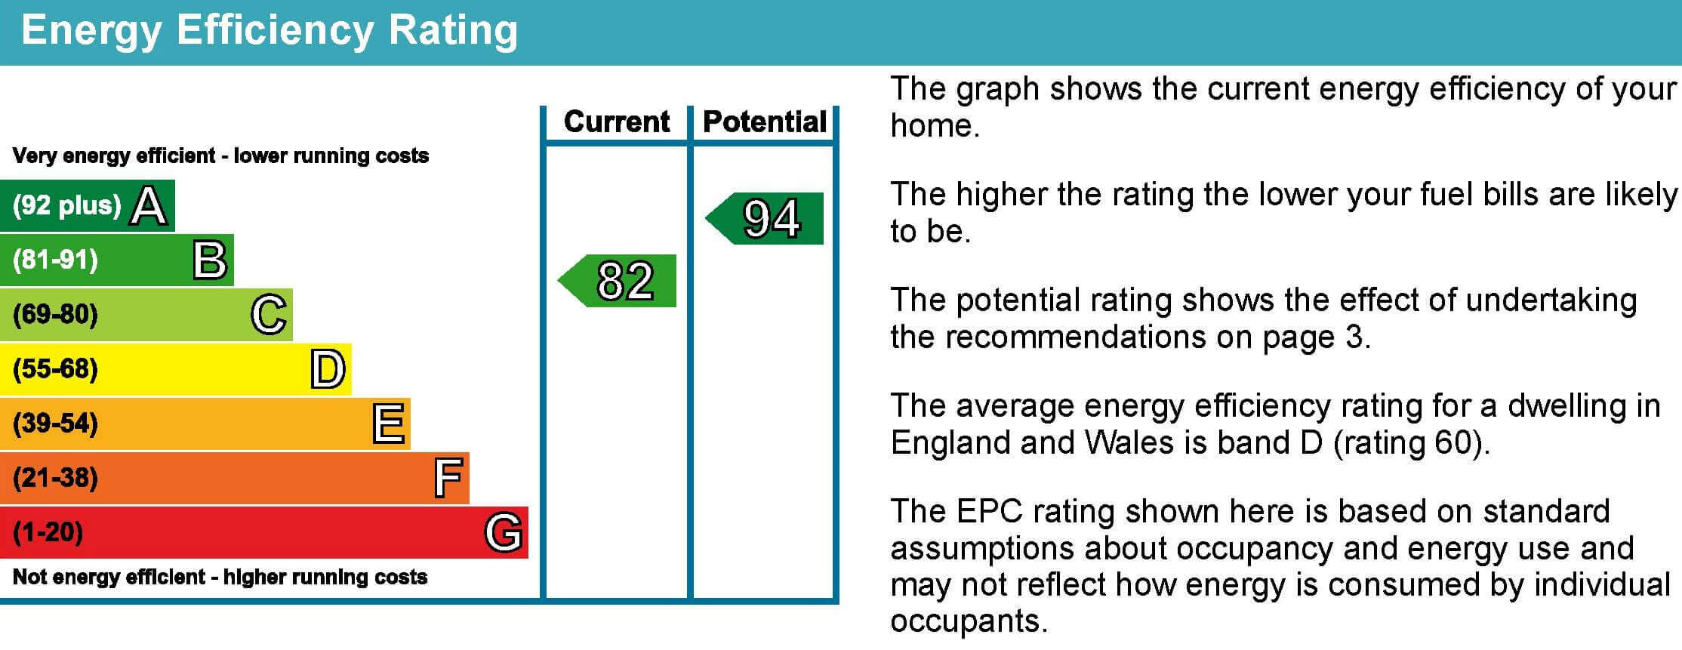

<https://www.evergreenenergy.co.uk/sustainable-home/what-is-an-epc-rating/>

1. **Literature Review (Fuerst et al., 2016):**
2. With an interesting focus on **presale (dwellings bought from developers) and resale (dwellings sold by owners) prices**, Deng and Wu (2014) compared a sample of 13,224 dwellings in 62 Green Mark developments with 55,983 dwellings in 1375 non- Green Mark developments in Singapore between 2000 and 2010. Premiums for resales were found to be substantially higher.
3. Kahn and Kok (2014) conducted a hedonic pricing analysis of all single-family home sales in California between 2007 and 2012. Using a sample of matched **dwellings based on the likelihood of having a green label and the local area weather condition,** they found a 2% premium for green labels.
4. In Europe, based on a sample of 31,993 residential sale prices in the Netherlands in 2008–9 for **dwellings with (voluntary) EPC ratings**, Brounen and Kok (2011) identified premiums of 10%, 5.5% and 2.5% for A, B and C respectively, compared to D-rated dwell- ings. For dwellings rated E, F and G, there were respective dis- counts of 0.5%, 2.5% and 5%. The data set contained a broad range of control variables including dwelling size, insulation quality, central heating and level of maintenance.
5. Finally, in a study closely related to this paper, drawing upon a sample of 325,950 English housing transactions with **mandatory energy certificates and with a control for age of dwelling**, Fuerst et al. (2015) find significant positive price premiums for dwellings with EPC ratings of A/B (5%) or C (1.8%) compared to dwellings rated D. Dwellings in band E (0.18%) and F (0.26%) were also estimated to have had statistically significant lower rates of price growth compared to D-rated dwellings.
6. Approximately 20% of homes in Wales are ‘off-gas’, without connection to mains-gas infrastructure for heating (Roberts, 2020). Most of the off-gas households in Wales are in rural areas. **Rural households in Wales may be more vulnerable** to decarbonisation due to infrastructural, material, and socio-economic inequalities. For example, those that are experiencing fuel poverty may achieve comfort by burning wooden logs easily accessible in their vicinity versus paying for energy from the grid. However, if a decarbonisation process removes fireplaces, this limits the resiliency of these households to respond to fluctuations in fuel prices. This leads to **potentially geographically uneven patterns of energy deprivation**.
7. Research that studied the **spatial patterns of income and vehicle fuel efficiency** and found low-income areas have less powerful, but more efficient vehicles (Mattioli *et al.*, 2019). Therefore, low-income areas have better average levels of fuel efficiency as compared to high-income areas. It finds that low-income areas with high-fuel efficiency are clustered in northern city regions, whereas high-income low fuel efficiency are found in the South-East and peri-urban areas in the North. It recommends a method to **measure disposable income instead** to better determine sensitivity to price fluctuations.
8. **Literature Review: Incentive Policies and Costs to Retrofit homes**
   1. Reuters Energy efficiency gap in buildings is undermining UK’s bid to reach net-zero (Early, 2020):
      1. Retrofitting a house from EPC band F to E or D could cost £3,500, whereas a whole house retrofit would cost £70,000.
      2. The UK is emulating an “Energiesprong” program from the Netherlands that retrofits a home in a few days through energy efficient façade on the house, insulated shell around the property, solar panels to generate all the energy a house uses, house batteries and a heat pump that connects back to the grid. It is estimated that these types of retrofits will raise property values by 25% and cut energy bills by 60% per year. If the UK government commits to 5,000 retrofits, it may be possible to reduce the cost of this retrofit from £75,000 to £35,000.
   2. In Wales specifically:
      1. Policies: Wales recently announced the Optimised Retrofit Programme to decarbonise Welsh homes. It has a budget of £19.5M to update at least 1,000 homes (Government, 2020).
      2. Costs: Improving a home’s energy efficiency from E/F/G to D can reduce annual fuel bills by £600 (Government, 2019).
9. **Methods**

* **Hedonic pricing method:** used to **estimate economic values for ecosystem or environmental services that directly affect market prices.**  It is most commonly applied to variations in housing prices that reflect the value of local environmental attributes.

It can be used to estimate economic benefits or costs associated with:

* environmental quality, including air pollution, water pollution, or noise
* environmental amenities, such as aesthetic views or proximity to recreational sites

<https://www.ecosystemvaluation.org/hedonic_pricing.htm>

* **From (Fuerst et al., 2016):**

Hedonic model estimates can be **sensitive to choice of model specification and availability of information** on variables that determine prices. This is particularly so if it is suspected that the price impact of an attribute (energy performance, for example) is likely to be small in comparison to other attributes such as location and age of dwelling. Data availability is, therefore, a major challenge to researchers in this area. The feasibility and **quality of empirical research into the price effects of energy efficiency certification is dependent upon the availability of dwelling-level data on three main areas: market prices (rents and sales), environmental performance of real estate assets, and building attributes**. Data constraints may mean that certain attributes are omitted from the hedonic model and this can lead to bias.

Two attributes that are essential controls for any residential hedonic price modelling are **size** (represented by number of bedrooms in this data set) and **age**:

* If age of dwelling is omitted and age and energy performance are considered to be correlated, negative price effects associated with aging would be reflected in the energy efficiency variable.
* **Price per square metre** is easier to interpret than the more commonly used total price as it eliminates the size effect from the dependent variable. This size effect may generate undesirable effects as it tends to inflate the predictive power of a hedonic model

About **time periods:**

The fact that housing **transactions** took place in **different time periods** and different areas is controlled for by including quarterly time fixed effects and postcode area fixed effects in the model.

1. **The Gap:**

- A particular concern in this study is that an **unobserved variable** such as **condition, quality or recent improvements** may be related to energy efficiency and consequently their (unobserved) effect on house price may be misattributed as being due to energy efficiency.

- Incoming legislation in the UK which forbids the leasing of dwellings below a minimum energy efficiency rating from 2017 onwards may alter the price patterns for low-energy efficiency dwellings, which warrants a **follow-up study that could also model the relationship between prices, rents and energy bills** more explicitly than this paper was able to do with information on sales transaction prices only.

1. **References**

# Paper: Energy performance ratings and house prices in Wales: An empirical study.

# <https://www.sciencedirect.com/science/article/pii/S0301421516300258#f0010>

This paper investigates whether EPCs influence transaction prices and price growth rates. Variables:

# Paper: Does energy efficiency matter to home-buyers? An investigation of EPC ratings and transaction prices in England

# <https://www.sciencedirect.com/science/article/pii/S0140988314003296>

Content:

1. Descriptive statistics*
2. Spatial distribution of EPC ratings for the sample dwellings in Wales.

**Variables:**

* Housing prices (Dependant variable)
* EPC rates
* Physical characteristics.
* Type of property
* Year of construction
* Renovations
* Dwellings for purchaser occupation / dwellings for investment reasons – ‘buy-to-let’ (Fuerst et al., 2016). *This distinction is important because in 2013 buy-to- let landlords owned 19% of all dwellings in the UK compared to 11% a decade earlier. This growing category of investors may value energy efficiency differently as, under typical lease arrangements, tenants usually pay energy bills. (Fuerst et al., 2016). Also, see <https://www.ft.com/content/58402ce0-334c-11e8-ac48-10c6fdc22f03> and <https://www.ft.com/content/1d76b77a-dec6-11e8-8f50-cbae5495d92b>

<https://assets.publishing.service.gov.uk/government/uploads/system/uploads/attachment_data/file/207527/Insullation_house_price_increase_rev7_copy.pdf>

Early, C. (2020). *Energy efficiency gap in buildings ‘is undermining UK’s bid to reach net-zero’ | Reuters Events | Sustainable Business*. Available at: https://www.reutersevents.com/sustainability/energy-efficiency-gap-buildings-undermining-uks-bid-reach-net-zero (Accessed: 25 March 2021).

Fuerst, F., McAllister, P., Nanda, A. and Wyatt, P. (2016). ‘Energy performance ratings and house prices in Wales: An empirical study’. *Energy Policy*, 92, pp. 20–33. doi: 10.1016/j.enpol.2016.01.024.

Government, W. (2019). ‘Energy Efficiency in Wales’, p. 58.

Government, W. (2020). *Social housing sector to set Wales on the path to decarbonise thousands of homes and boost green economic recovery*. *GOV.WALES*. Available at: https://gov.wales/social-housing-sector-set-wales-path-decarbonise-thousands-homes-and-boost-green-economic-recovery (Accessed: 25 March 2021).

Mattioli, G., Philips, I., Anable, J. and Chatterton, T. (2019). ‘Vulnerability to motor fuel price increases: Socio-spatial patterns in England’. *Journal of Transport Geography*, 78, pp. 98–114. doi: 10.1016/j.jtrangeo.2019.05.009.

Roberts, E. (2020). ‘Warming with wood: Exploring the everyday heating practices of rural off-gas households in Wales’. *Energy Policy*, 142, p. 111451. doi: 10.1016/j.enpol.2020.111451.