PROJECT 14

1.You have to create a repository of your classmate’s name and mobile number’s. And whenever you want to search the mobile/contact number of some of your classmate, you can easily search it out from the repository you maintained. Searching single contact is one of the functionalities, some other functionalities your app must cover are:

1. Your app must be capable of displaying all the contacts with your classmate names present in the repository.

2. Your app must be capable of extracting contact numbers of your multiple classmates when required.

CODE OF PROJECT

while True:

    q= input(' To Add contact press(a)  To Search a contact press(s)  To Quit press(q)')

    if q=='a':

        with open('contact.txt', 'a')as f:

            name=input('name: ')

            phone=input('phone: ')

            f.writelines((name,' : ',phone,'\n'))

    elif q=='s':

        with open('contact.txt' ,'r') as f:

            search=input('Search: ')

            for i in f:

                if search in i:

                         print(i)

    else:

        break

OUTPUT 1. ADD CONTACTS

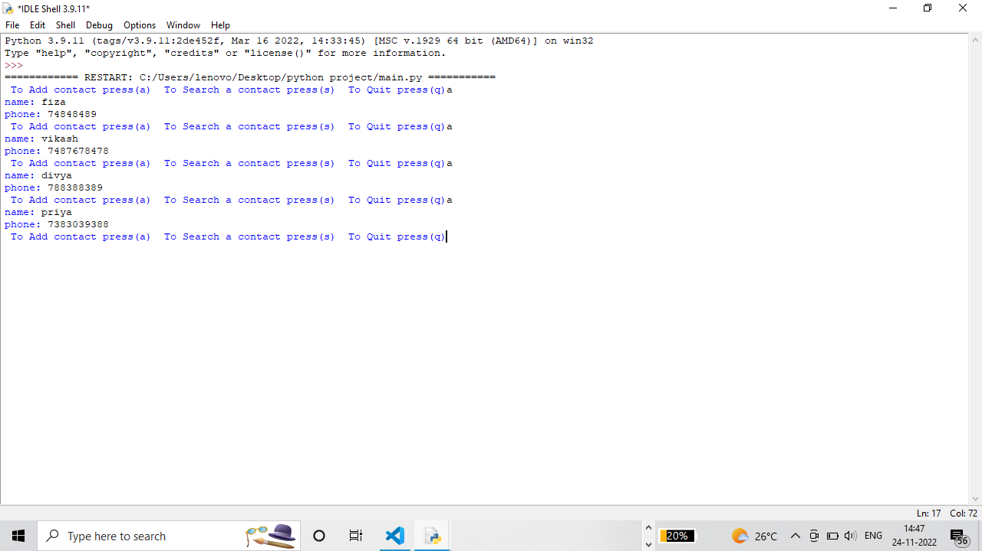

OUTPUT 2. SEARCH CONTACTS

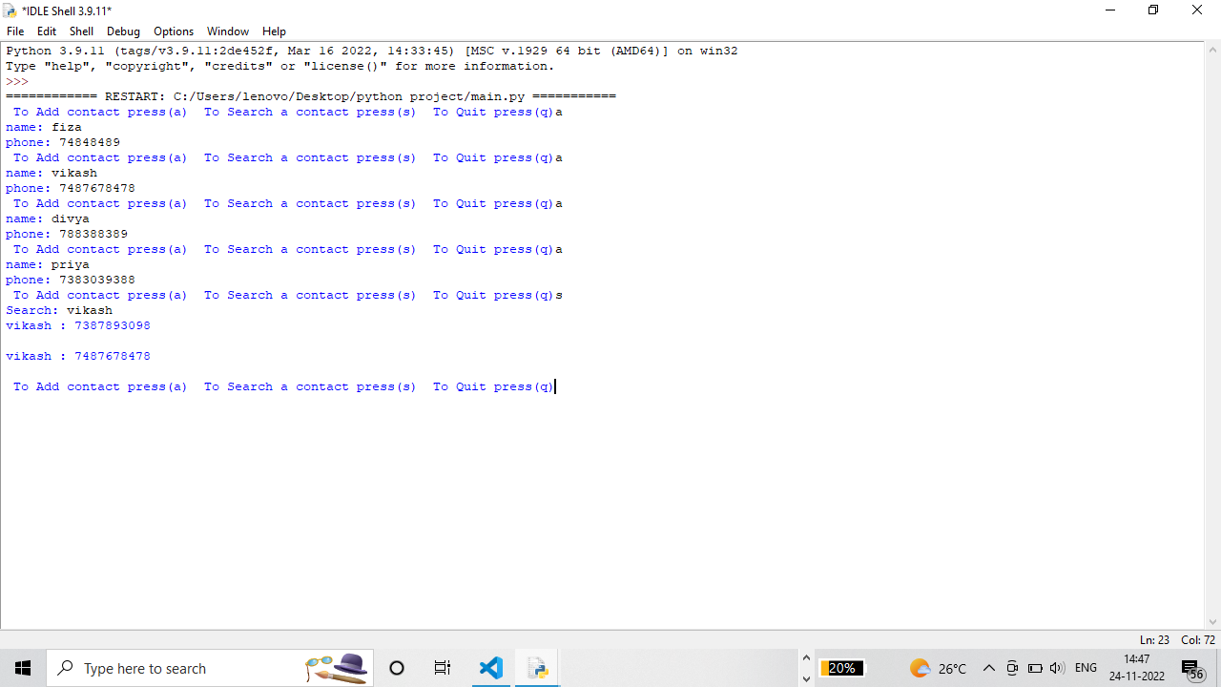

OUTPUT WHEN USER GIVES WRONG INPUT

