--------------- --------------Application Explanation-----------------------
My app contains 3 menus:
- Home
- Profile
- Registered Users
If I clicks on any of these options, url will be changed and a new component is getting rendered on the screen.
inside router-outlet.
So when I click on Home – URL becomes this what is it doing – it matches the route and loads the Home component which we define in app.routes,ts file

So our layout will be like
Top bar – fixed – clicking on links – updates the URL and renders the component (and remember all components will sit inside router-outlet that’s a must have for route to work)

Code wise explanation
We have a file called app.routes.ts. We need to define all the routes used in the application in this file.
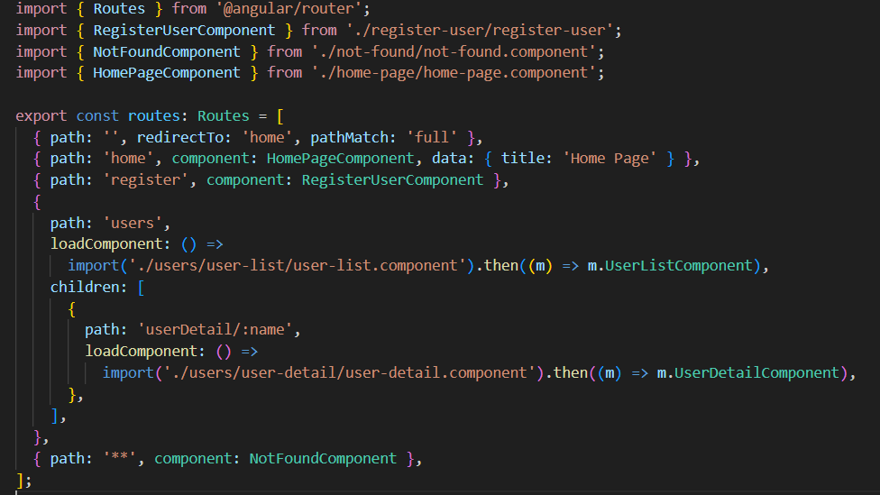
- When I run my app it redirects to home.
  - Why so because if you see this line no 7 in Code, I redirect empty path to Home
  - { path: '', redirect To: 'Home', path Match: 'full' },

- Path Match – full -Means it matches the entire URL exactly. SO, this view will be rendered when url is completely empty
- Like if we have locahost:4200/xyz – No match
- If localhost:4200 – match
- If we don’t use full, maybe it will not match full url.

path Match: 'full' – check full word: ‘’, so angular check ya its empty redirect to empty.

Path match: ’prefix’ – only check beginning.

Why for empty not for others: path match?

- Because it has empty path which means nothing, so it tells to load when URL is completely empty.
- Others have some Prefix or route
- If we don’t use this then angular thinks empty string to any other path like /home or /user etc. hence loads wrong page
Now if I comment line no 7 now what will happen if I load the app with empty url, it will not redirected to Home. – You see it shows page not found which comes from
{ path: '**', component: NotFoundComponent },
If we don’t have path to component it will show above component.
If I do like this –
{ path: '', redirectTo: 'home', pathMatch: 'full' },
{ path: '', component: HomePageComponent, data: { title: 'Home Page' } },
Both paths are empty so again it will show NotFoundComponent.
** - matches any URL that didn’t match any of the routes given in the app.Mostly used for Not found.
Its like a default case in switch

Now if you see this code –
{
path: 'users',
loadComponent: () =>
import('./users/user-list/user-list.component').then((m) => m.UserListComponent),
children: [
{
path: 'userDetail/:name',
loadComponent: () =>
import('./users/user-detail/user-detail.component').then((m) => m.UserDetailComponent),
},
],
},
- It is called nested routes also user details are treated as child route.
- Also you can see this route follows lazy loading so means only load when clicked.

