Routing
- Angular Routing is the mechanism that allows you to navigate between different views.
- Since angular works on Single Page Application (SPA) mechanism it will render the views without reloading the entire page because Angular uses JavaScript and DOM manipulation to render changes.
- That means It loads the application once in the browser.
- When you navigate to a URL in your web browser, the browser normally makes a network request to a web server and displays the returned HTML page the index.html.
- After that, a client-side router takes over, controlling which content displays based on the URL. When a navigates to a different URL, the router updates the page's content in place without triggering a full-page reload.
- Routing uses the Angular Router module (angular/router).
- Why do we need routing in SPA – To change views instead of reloading the entire page.
Why it shows home with 4200 because I redirect empty path to Home
{ path: '', redirectTo: 'Home', pathMatch: 'full' },
pathMatch – it tells angular to match the url before activating route.
As default has empty path but in case of others it already has path name so it will not confuse the angular
Default route uses pathmatch it has empty path which means nothing so it actually tells to load when url is completely empty.
If we dnt use this then angular thinks empty string to amny other path like /home or /user etc hence loads wrong page

Not found component ka example - <li class="nav-item">
<a routerLink="" >
<svg xmlns="http://www.w3.org/2000/svg" fill="none" viewBox="0 0 24 24" stroke="currentColor">
<path stroke-linecap="round" stroke-linejoin="round" stroke-width="2" d="M16 7a4 4 0 11-8 0 4 4 0 018 0zM12 14a7 7 0 00-7 7h14a7 7 0 00-7-7z" />
</svg>
<span>Test</span>
</a>
</li>

{ path: '', redirectTo: 'Home', pathMatch: 'full' }, if I remove this then 4200 returns { path: '**', component: NotFoundComponent }

Matches only if the entire URL matches the route's path.

Architecture:
AppComponent contains the Router Outlet.
Router-outlet is place where our component gets rendered. and it renders the component whenever our path matches. If we remove this then our components will not be loaded.

then we have Routes in app routes file which is like below
- /dashboard → DashboardComponent
- /user/:id → UserDetailComponent
- /settings → SettingsComponent

Structure
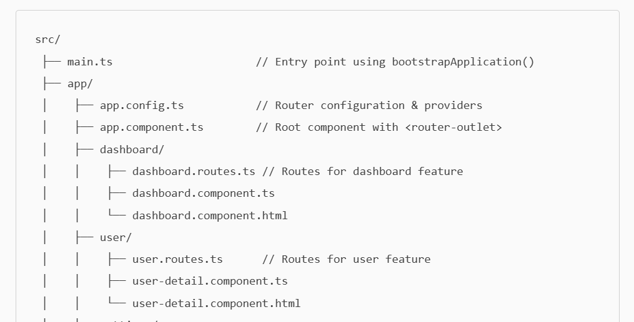

Dependencies:
- Install or ensure the router package is present
Angular’s router functionality comes from the angular/router package. By default, when you create an Angular project using the CLI, routing support is included. In package.json file you can check
- Import Router in your App
From angular 19, we need to add below configuration in app.config.ts file, however I observe its already there when I installed the project.
import { provideRouter } from '@angular/router';
providers: [ provideRouter(routes) ]
- Define your routes - In app.routes.ts file
import { Routes } from '@angular/router';
const routes: Routes = [
{ path: '', component: HomeComponent },
{ path: 'about', component: AboutComponent }]
- Add <router-outlet> and routerLink directives in templates
  - In root component add <router-outlet></router-outlet>.
  - If not used app starts giving err because Angular doesn’t recognize router-outlet because the Router directives are not available in your component.
  - In Angular 19 (with standalone components), we need to explicitly import the router directives (RouterOutlet, RouterLink) in the imports array of your component.
Router-outlet is place where our component gets rendered. and it renders the component whenever our path matches. If we remove this then our components will not load.
RouterLink
Instead of using regular anchor elements <a> with an href attribute, you add a RouterLink directive with the appropriate path in order to leverage Angular routing.
<nav>
<a routerLink="/user-profile">User profile</a>
<a routerLink="/settings">Settings</a>
like in header.html we used this
- Set base href for HTML5 routing
Ensure <base href="/"> is in index.html if using HTML5 pushState style.
Routing in Angular is comprised of three primary parts:
Routes - define which component is displayed when we hit any URL.
In Angular, a route is an object that defines which component should render for a specific URL path or pattern, as well as additional configuration options about what happens when a user navigates to that URL.
import { AdminPage } from './app-admin/app-admin.component';
const adminPage = {
path: 'admin',
component: AdminPage
}
Outlets are placeholders in your templates that dynamically load, and render components based on the active route. - <router-outlet>
Links provide a way for users to navigate between different routes in your application without triggering a full page reload.

Key Difference:
- Outlet = Where the component is displayed. -- <router-outlet>
- Link = How you navigate to that component. - routerLink directive on <a> or <button>

Route Component Strategies:
Eagerly loaded - Components that are loaded immediately.
When you define a route with the component property, the referenced component is eagerly loaded as part of the same JavaScript
bundle as the route configuration.
Example -
export const routes: Routes = [
{
path: "",
component: HomePage
},
{
path: "login",
component: LoginPage
}
]
Lazily loaded: Components loaded only when needed.
We can use the load Component property to lazily load the JavaScript for a route only at the point at which that route would become active.
In Angular, a route is an object that defines which component should render for a specific URL path or pattern, as well as additional
configuration options about what happens when a user navigates to that URL.
Example --
import { Routes } from "@angular/router";
export const routes: Routes = [ {
path: 'login',
loadComponent: () => import('./components/auth/login-page').then(m => m.LoginPage)
},
{
path: '',
loadComponent: () => import('./components/home/home-page').then(m => m.HomePage)
}
]

It will only work if component is standalone = true-- need this in component else not show the page

when to use eager or lazy loaded components
Eager loads when we start the app.so all the routes available as soon as Ur app runs but with lazy loading those components loaded only when we navigate to that them so lazy loading basically reduces the loading time.
Eager we can use for like header footers and for complexity we can use lazy loading so that app performance will not hamper.

IN routing we have the concept of Redirects as well
You can define a route that redirects to another route instead of rendering a component
Example---
import { BlogComponent } from './home/blog.component';
const routes: Routes = [
{
path: 'articles',
redirectTo: '/blog',
},
{
path: 'blog',
component: BlogComponent
},
];
Page titles:
We can also add the Pagetitle in routes array.
const routes: Routes = [ { path: '', component: HomeComponent, title: 'Home Page' ];

Passing data via routing: We can navigate to components with data as well like in my example I am sharing username from user list to user detail page which I did using URL params
- Route Parameters (URL params): e.g., /users/42.
- Define route -
const routes: Routes = [
{ path: 'user/:id', component: UserComponent }
];
- Navigate - this.router.navigate(['/user', 42]);
- Read in Component -
import { ActivatedRoute } from '@angular/router';
constructor(private route: ActivatedRoute) {
ngOnInit() {
const id = this.route.snapshot.paramMap.get('id');
console.log(id);
}
- Query Parameters – : Like we see some urls which
Used for optional values: /products?sort=asc&category=shoes.

Navigate
this.router.navigate(['/products'], {
queryParams: { sort: 'asc', category: 'shoes' }
});

Read in Component
this.route.queryParamMap.subscribe(params => {
const sort = params.get('sort');
});

3. Router Navigation State (In-Memory State)
Sometimes we need to pass the data but don’t want in the url so at that time we can use this routing.
--------- But In this when we refresh the page, data will be lost.
Navigate -
this.router.navigate(['/checkout'], {
state: { cart: this.cartItems }
});
Read :
const state = history.state;
console.log(state.cart);

users is an array of objects. Angular router can’t serialize it to a URL path.
If you tried:
this.router.navigate(['/users', users])
It would convert the array to a string like:
/users/[object Object],[object Object],[object Object]
That’s invalid for routing and not usable in your detail component.

Nested Routes
- Nested routes, also known as child routes, which sits inside another route.
- Parent have multiple child routes or single child route.
Example –
/app
app.component.ts
app.routes.ts
/admin
admin.component.ts
dashboard.component.ts
users.component.ts
so the routes would be like
export const routes: Routes = [
{
path: 'admin',
component: AdminComponent,
children: [
{ path: 'dashboard', component: DashboardComponent },
{ path: 'users', component: UsersComponent },
{ path: '', redirectTo: 'dashboard', pathMatch: 'full' }
]
}
];

why do we need –
- For shared layouts.
Imagine an Admin section that always shows:
- a sidebar
- a top menu
- a dashboard/users/settings area inside the layout
Instead of repeating the layout on every page, we use a parent route:
/admin
/dashboard
/users
/settings
One parent layout → multiple internal views.

- For lazy loading
When we need common UI elements for example - and can be sharable.
Example - Dashboard with sidemenu,top and footer. so it remains as is if we are moving to diff pages only content changes.
simple example is Facebook.
- Better Component Reuse

---------------Application Explaination------------
My app contains 3 menus:
Home
Profile
Registered Users
When user clicks on any of these links, angular changes the url and load a new component inside router-outlet.
So when I click on Home – url becomes this what is it doing – it nmatches the route and loads the Home component which we define in app.routes,ts file

So our layout will be like
Top bar – fixed – clicking on links – updates the url and renders the component

Code wise explanation
When app opens with an empty url it redirects to home.

Users ate parent component – so when we click on this it will laze load the user list component and show list of users.
Child component – Click on any suer – show details of user

