---------------------------Application Explanation-----------------------
My app contains 3 menus:
- Home
- Profile
- Registered Users
If I clicks on any of these options, URL will be changed, and a new component is getting rendered on the screen.
inside router-outlet.
So when I click on Home – URL becomes this what is it doing – it matches the route and loads the Home component which we define in app.routes,ts file

So our layout will be like
Top bar – fixed – clicking on links – updates the URL and renders the component (and remember all components will sit inside router-outlet that’s a must have for route to work)

Guards

In Angular, guards are special services that help control navigation within your application. They allow you to decide whether a route can be activated, deactivated, loaded, or if navigation should continue based on certain conditions. Guards are part of Agular’s Router module and are commonly used for tasks like authentication, authorization, and preventing data loss.
--- A guard is a service in Angular that controls navigation. It decides whether a user can enter or leave a route.

Types of Angular Guards
- CanActivate
  - Decides if a route can be activated.
  - Example: Check if the user is logged in before accessing a dashboard.
- CanActivateChild
  - Similar to CanActivate, but applies to child routes.
  - Example: Restrict access to child routes under an admin section.
- CanDeactivate
  - Decides if the user can leave the current route.
  - Example: Warn the user about unsaved changes before navigating away.
- Resolve
  - Fetches data before the route is activated.
  - Example: Load user details before showing the profile page.
- CanLoad
  - Controls whether a lazy-loaded module can be loaded.
  - Example: Prevent loading of an admin module if the user lacks permissions.

Simple way to remember:
- CanActivate = “Can I enter?”
- CanDeactivate = “Can I leave?”

How TimeGuard works in your code
- On /guard route:
  - When the user navigates to /guard, Angular checks canActivate on GuardTestComponent.
  - TimeGuard.canActivate() runs:
    - Before 6 PM, the component loads return true.
    - If 6 PM or later, returns false → the component does not load, and the user stays on the previous page (or you could redirect).
- On /users/userDetail/:name route:
  - TimeGuard runs only when you navigate to a specific user detail, e.g., /users/userDetail/John.
  - The child route is lazy-loaded with loadComponent, so Angular checks the guard before activating that child component.
  - Same logic applies: before 6 PM → allow, after 6 PM → block
2️⃣ What happens if you try to access the route after 6 PM
- Without redirect logic, the user will stay on the current page and see the alert from TimeGuard.
- The child component (UserDetailComponent) won’t be loaded at all.
Simple way to remember:
- CanActivate = “Can I enter?”
- CanDeactivate = “Can I leave?”

Code explanation without guards
We have a file called app.routes.ts. We need to define all the routes used in the application in this file.
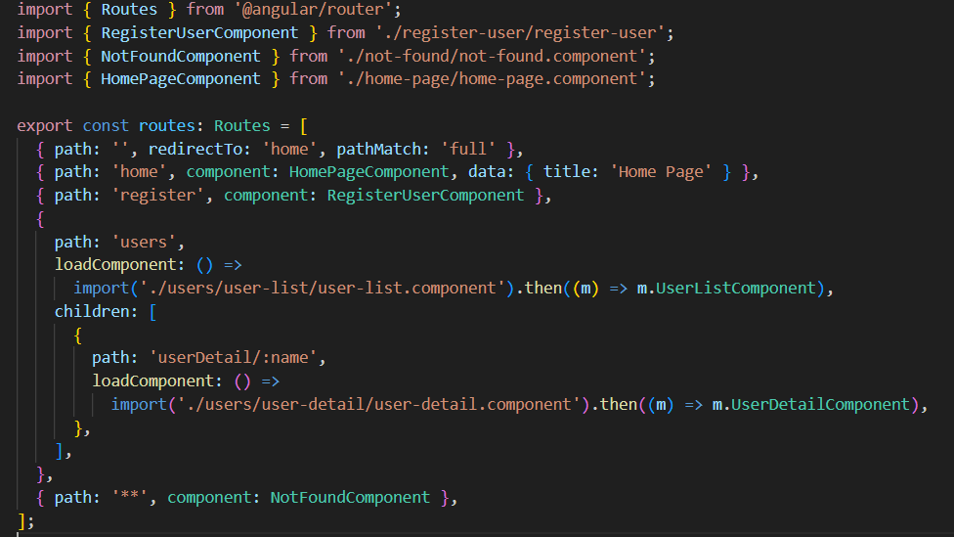
- When I run my app it redirects to home.
  - Why so because if you see this line no 7 in Code, I redirect empty path to Home
  - { path: '', redirect To: 'Home', path Match: 'full' },

- Path Match – full -Means it matches the entire URL exactly. SO, this view will be rendered when url is completely empty
- Like if we have locahost:4200/xyz – No match
- If localhost:4200 – match
- If we don’t use full, maybe it will not match full url.

path Match: 'full' – check full word: ‘’, so angular check ya its empty redirect to empty.

Path match: ’prefix’ – only check beginning.

Why for empty not for others: path match?

- Because it has empty path which means nothing, so it tells to load when URL is completely empty.
- Others have some Prefix or route
- If we don’t use this then angular thinks empty string to any other path like /home or /user etc. hence loads wrong page
Now if I comment line no 7 now what will happen if I load the app with empty url, it will not redirected to Home. – You see it shows page not found which comes from
{ path: '**', component: NotFoundComponent },
If we don’t have path to component it will show above component.
If I do like this –
{ path: '', redirectTo: 'home', pathMatch: 'full' },
{ path: '', component: HomePageComponent, data: { title: 'Home Page' } },
Both paths are empty so again it will show NotFoundComponent.
** - matches any URL that didn’t match any of the routes given in the app.Mostly used for Not found.
Its like a default case in switch

Now if you see this code –
{
path: 'users',
loadComponent: () =>
import('./users/user-list/user-list.component').then((m) => m.UserListComponent),
children: [
{
path: 'userDetail/:name',
loadComponent: () =>
import('./users/user-detail/user-detail.component').then((m) => m.UserDetailComponent),
},
],
},
- It is called nested routes also user details are treated as child route.
- Also you can see this route follows lazy loading so means only load when clicked.
And in URL you are getting this as in route I used name field
And Now moving from one component to another inside app.
navigateToProfile(user: User) {
this.router.navigate(['/users/userDetail', user.name], {state: { user }, }); }

In this I am navigating to userDetail' with user object. And in UserDetail I get these values using history.
this.route.paramMap.subscribe(() => {
const data = history.state;
this.user = data.user;
});
We have other options as well, we will try once we can create any application, I just tried this one for this.

With Guards explanation
How TimeGuard works in your code
- On /guard route:
  - When the user navigates to /guard, Angular checks canActivate on GuardTestComponent.
  - TimeGuard.canActivate() runs:
    - Before 6 PM, the component loads return true.
    - If 6 PM or later, returns false → the component does not load, and the user stays on the previous page (or you could redirect).
- On /users/userDetail/:name route:
  - TimeGuard runs only when you navigate to a specific user detail, e.g., /users/userDetail/John.
  - The child route is lazy-loaded with loadComponent, so Angular checks the guard before activating that child component.
  - Same logic applies: before 6 PM → allow, after 6 PM → block
2️⃣ What happens if you try to access the route after 6 PM
- Without redirect logic, the user will stay on the current page and see the alert from TimeGuard.
- The child component (UserDetailComponent) won’t be loaded at all.
Simple way to remember:
- CanActivate = “Can I enter?”
- CanDeactivate = “Can I leave?”

Guards code explanation
TimeGuard is a route guard service in Angular.
It implements two interfaces:
- CanActivate → decides if a route can be entered.
- CanDeactivate → decides if a route can be exited.
<CanComponentLeave> is a custom interface which ensures the component has a canLeave() method. This is used to check if it’s safe to leave the page (for example, if there are unsaved changes).

Canactivate:
• Purpose: Block access to a route after 6 PM.
• How it works:
- Get the current hour using new Date().getHours().
- If the hour is 18 or later (6 PM) → show an alert and return false, which blocks navigation.
- If before 6 PM → return true → navigation allowed.
• Runs: When a user tries to enter the route.

CanDeactivate:
• Purpose: Prevent leaving a route if the user has unsaved changes.
• Step by step:
- Shows an alert 'hi' (for debugging or demo purposes).
- Checks if the component implements canLeave() and if it returns false.
- If canLeave() is false → a confirmation dialog appears asking if the user wants to leave.
  - Click OK → returns true → navigation allowed.
  - Click Cancel → returns false → navigation blocked.
- If canLeave() is true → return true → navigation allowed.
• Runs: When a user tries to leave the route (clicks a link, browser back, etc.).

