**Web Design Project**

**Main Page**

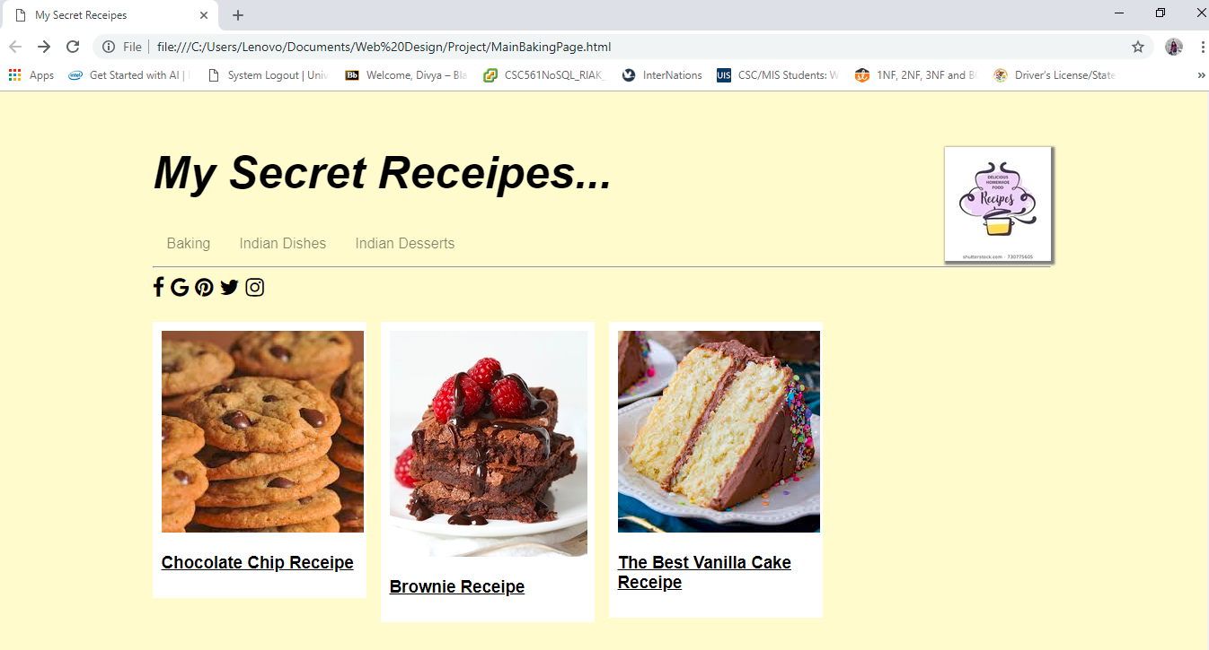

**Second Page -Indian Dishes**

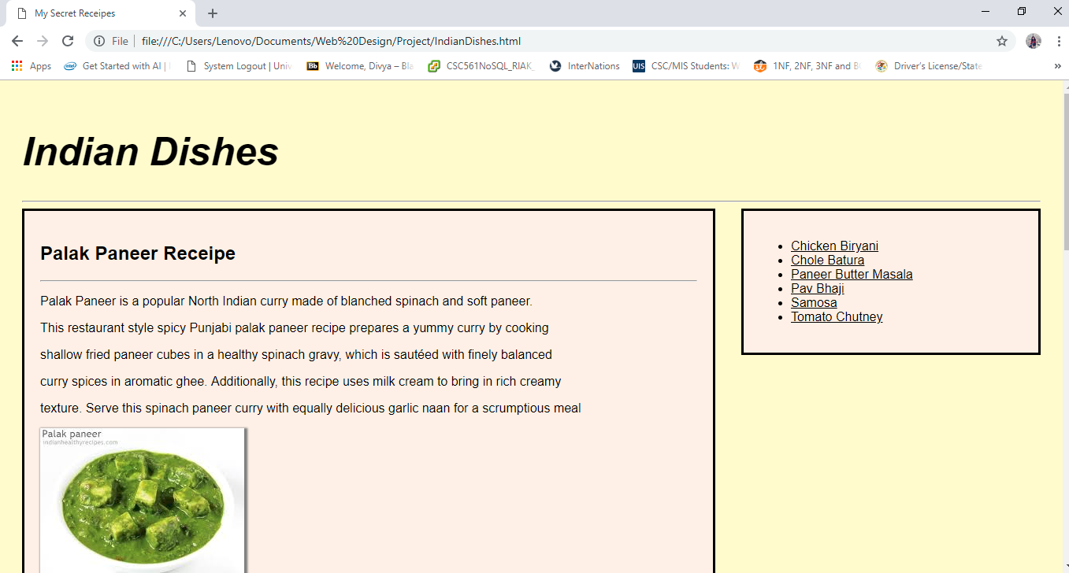

**Third Page-Indian Desserts**

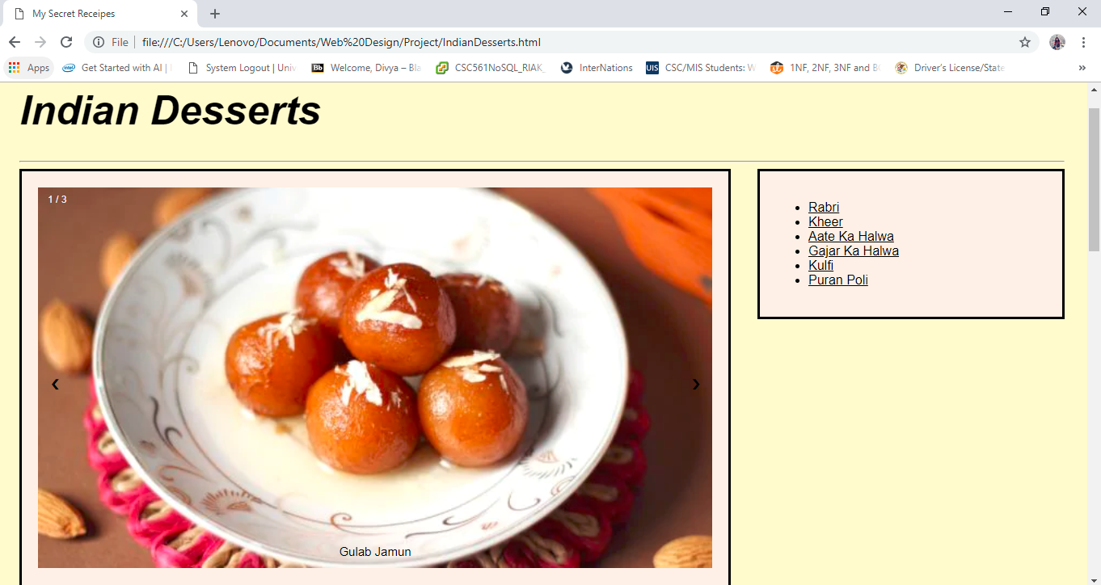

**Functionality** :Works best with Google Chrome Browser

**References**: www.w3schools.com