# 

# To diminish the lead content flak on human which is incite by vehicles

# Shri Vishnu Engineering College for Women

# Proposed Design

**Proposed Solution:**

lead has no essential role in the human body. No safe level of lead exposure has so far been established. Even blood lead concentration as low as 5 micro grams/deciliter in decreased intelligence in children,behavioral difficulties and learning problems;therefore prevention from exposure is important.

**Block Diagram:**

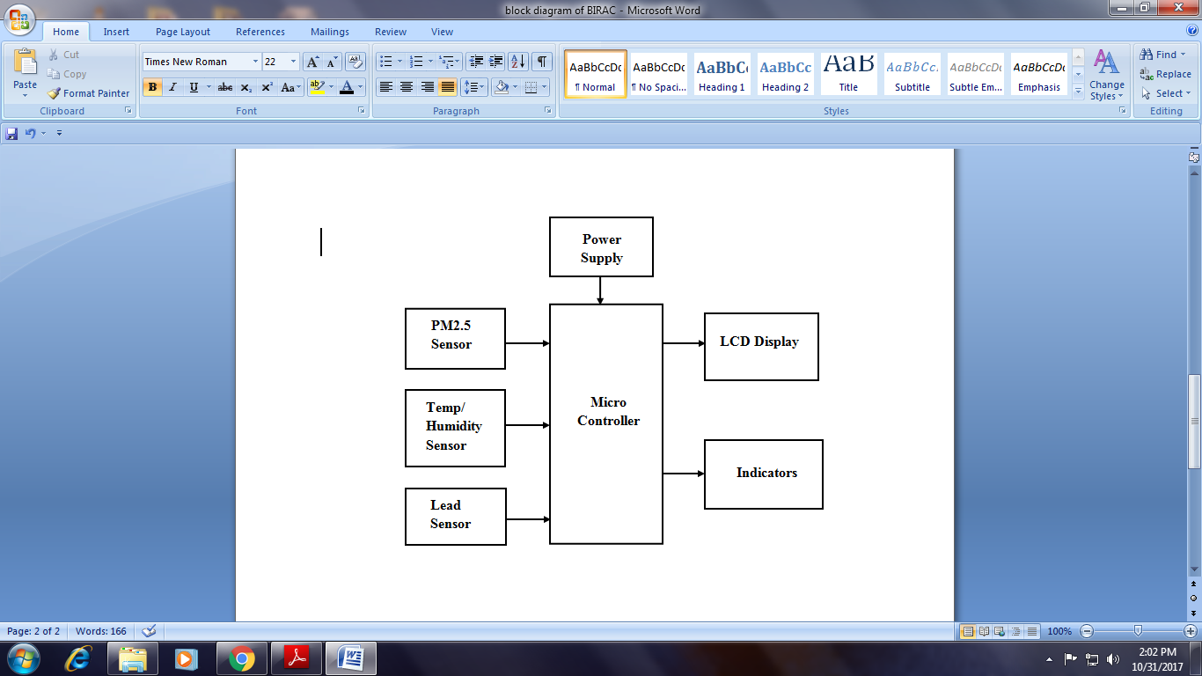

**DESCRIPTION:**

Lead poisoning is one of the most common and best-recognized childhood diseases of toxic environmental origin. Children around the world today are at risk of exposure to lead from multiple sources. Lead poisoning accounts for about 0.6% of the global burden of disease (WHO, 2009). Patterns and sources of exposure to lead, prevalence rates of lead poisoning and the severity of outcomes vary greatly from country to country and from place to place within countries. Countries also vary greatly in their degree of recognition of the problem and in the strength and effectiveness of their lead poisoning prevention programs. Some countries have robust programs for monitoring levels of lead in blood and the environment, as well as strong programs for primary and secondary prevention of childhood lead poisoning. These countries have imposed bans on certain uses of lead, have set environmental standards and have deployed screening programs. Some countries have lead hot spots, such as battery recycling plants, smelters, refineries, mines, hazardous waste sites and sites where waste is burned in the open. Some countries recognize that they have a childhood lead-poisoning problem in relation to certain exposure sources, but have not yet implemented assessment and exposure prevention programs. And in countries where the potential problem of lead poisoning has not yet been recognized, there are no screening or surveillance programs and, as a result, public health authorities have little or no knowledge of the existence of a childhood lead-poisoning problem. Because of this heterogeneous situation, the true picture of global and regional lead poisoning in children is not yet fully defined. The contribution of lead poisoning to the global burden of disease and its effect on the global economy and human development are probably still underestimated. Numerous international conferences and declarations have recognized the importance of childhood lead poisoning and the need to intervene to prevent it (see Annex for examples). The 1989 Convention of the Rights of the Child and the 1992 Agenda 21 adopted by the United Nations Conference on Environment and Development both addressed the need to protect children from toxic chemicals.

**Innovativeness of the Proposed Solution:** By using lead detector we can detect thelead content containing in vehicles separated from the dust particles. If it exceeds threshold level it will detect or else it won’t detect.

**Impact of the proposed solution**:During the past century, much has been learned aboutthe adverse effects of lead on children. At high levels of acute exposure, lead attacks the brain and central nervous system to cause coma, convulsions and even death. Children who survive acute lead poisoning are typically left with grossly obvious mental retardation and behavioral disruption. At lower levels of exposure that cause no obvious symptoms. Tubular and glomerulus kidney effects in Swedish women with low environmental cadmium exposure.