2303A51581
Batch-10
WEEK-10.3
Problem Statement 1: AI-Assisted Bug Detection
#PROMPT
I wrote a Python function to calculate factorial, but it gives the wrong result for factorial (5). Identify the logical bug in the loop and explain why it happens. Provide a corrected version of the code and mention any edge cases like 0 or negative numbers.
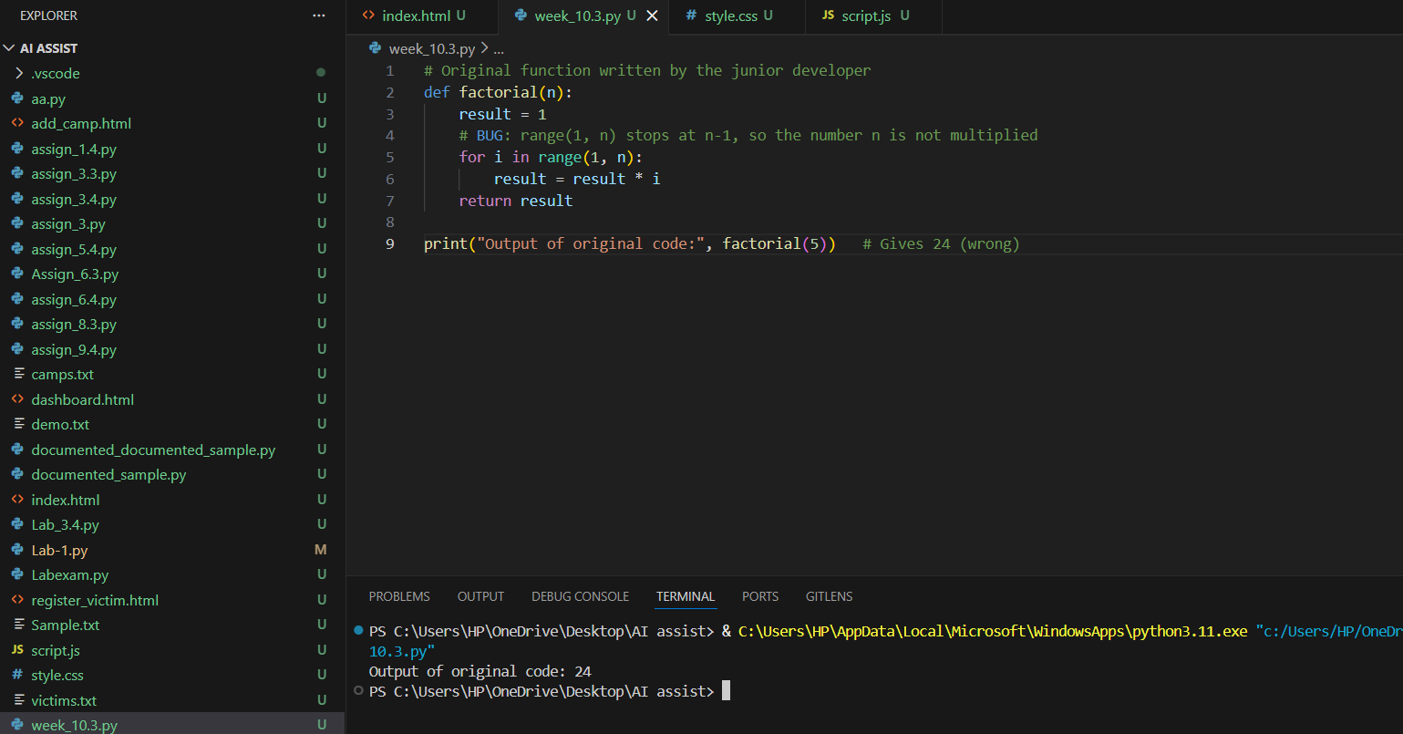
#CODE AND OUTPUT

AI Bug Detection and Fix
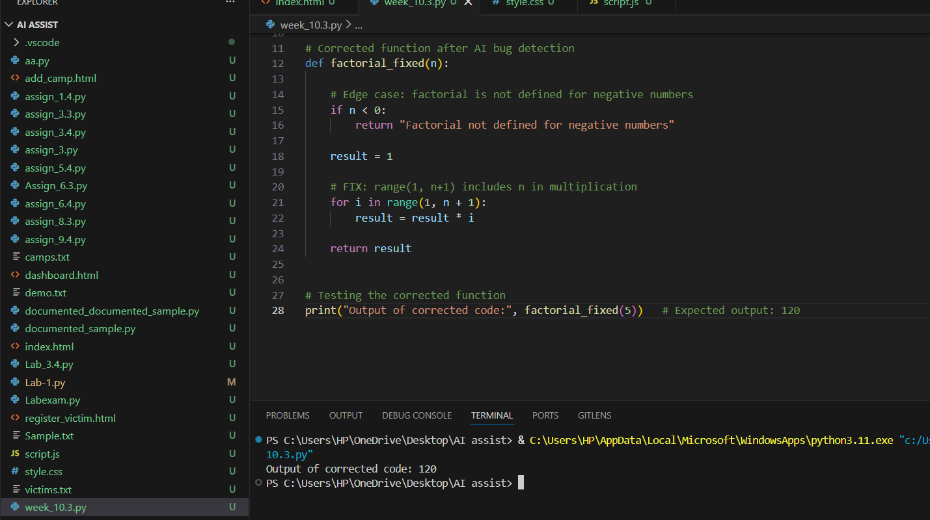
The loop uses range (1, n), which stops at n-1. So the number n is not multiplied. This is called an off-by-one error.
#ANALYSIS
The bug is an off-by-one error because range (1, n) stops at n-1, so the number n is not included in the multiplication. The corrected loop should be range (1, n+1). The improved version should also handle edge cases such as 0! = 1 and reject negative numbers.
Problem Statement 2: Task 2 — Improving Readability & Documentation
#PROMPT
Improve the readability of this Python function that performs arithmetic operations. Rename the function and parameters with meaningful names, add a proper docstring, and include error handling for division by zero. Also validate user input for the operation.
#CODE AND OUTPUT
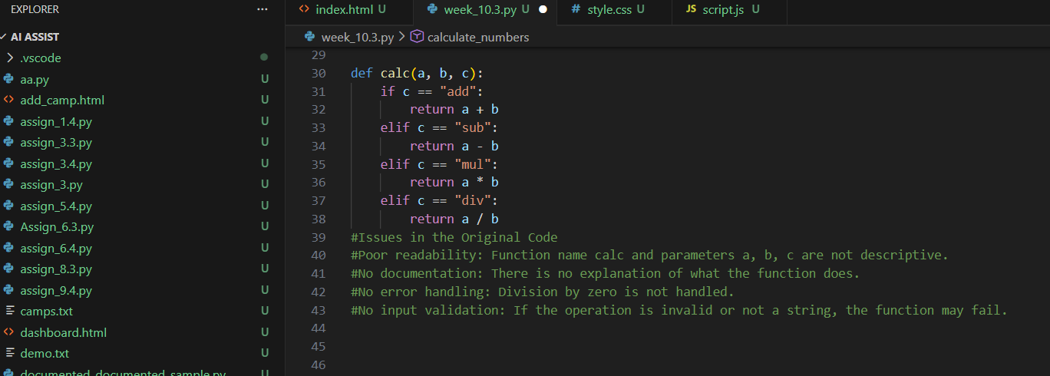
Original Code

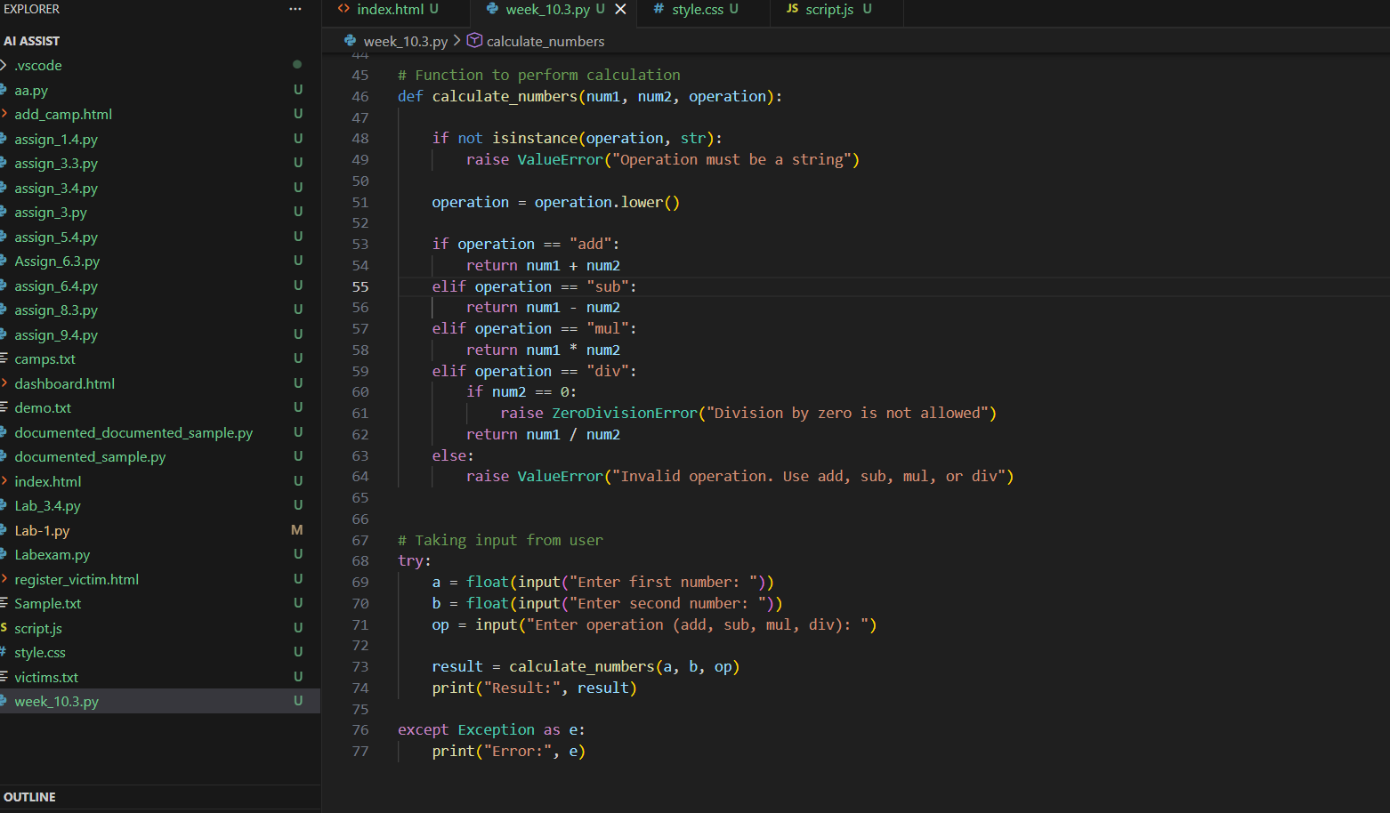
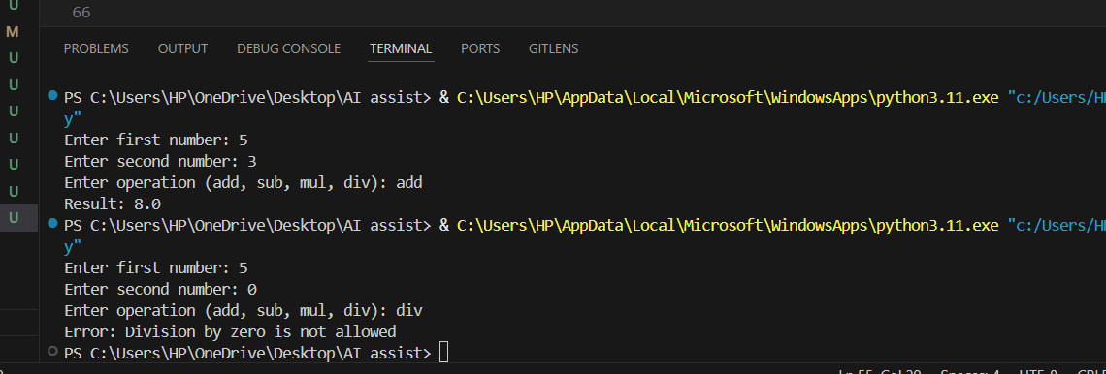
AI-Improved Code
#ANALYSIS
The original function has poor readability because of unclear names (calc, a, b, c) and no documentation. The improved version uses descriptive names, includes a detailed docstring, and adds input validation and exception handling. This makes the function more readable, maintainable, and robust for invalid inputs like division by zero.
Problem Statement 3: Enforcing Coding Standards
#PROMPT
Check the following Python function for PEP8 compliance. Identify all violations related to naming, indentation, and formatting, and refactor the code to follow PEP8 standards while keeping the same functionality.
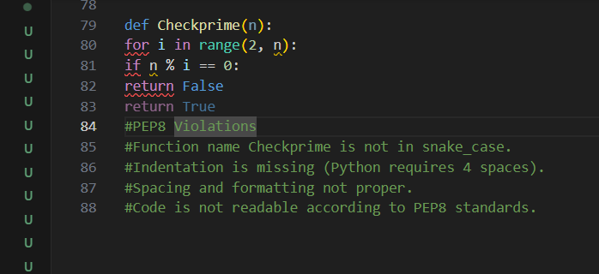
#CODE AND OUTPUT

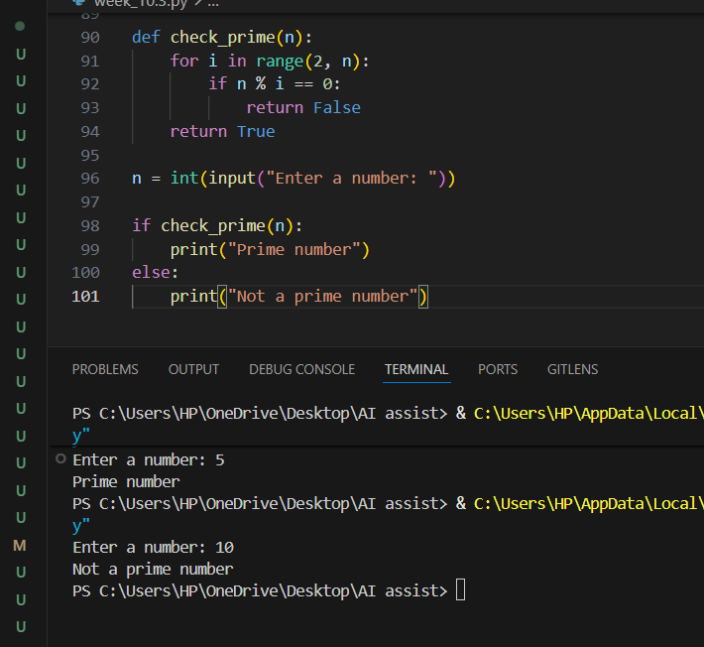
#ANALYSIS
The AI detected issues such as incorrect function naming, missing indentation, and improper formatting. It refactored the code using PEP8 standards while keeping the logic unchanged. The updated function was tested with sample inputs to confirm the output remains correct.
#Problem Statement 4: AI as a Code Reviewer in Real Projects
#PROMPT
Review the following Python function and suggest improvements for readability, naming, input validation, and reusability. Add type hints and handle edge cases such as non-list input and non-numeric elements. Refactor the function while keeping the original functionality.”
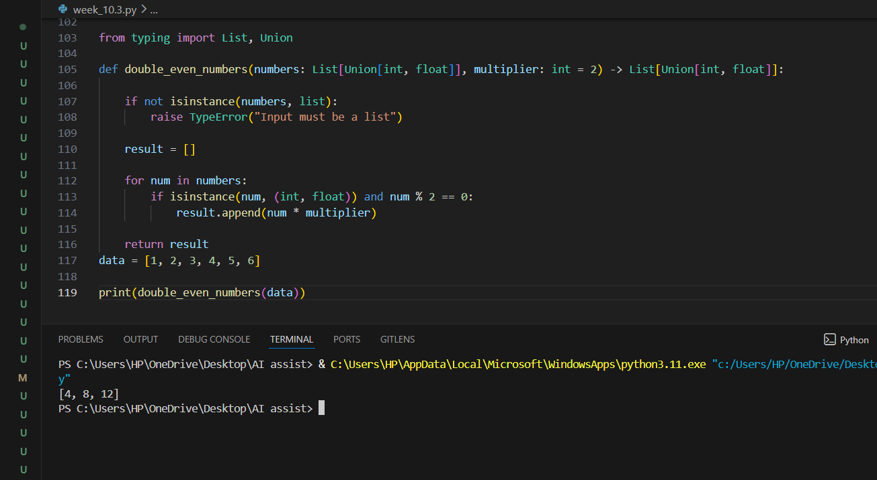
#CODE AND OUTPUT
#ANALYSIS
The AI identified issues such as unclear function name, lack of input validation, and fixed multiplier which reduces reusability. It suggested adding type hints, proper naming, and checks for valid input types. The function was refactored to improve readability, flexibility, and robustness while preserving the original logic.
Problem Statement 5: — AI-Assisted Performance Optimization
#PROMPT
Analyze the following Python function for time complexity and performance when processing a large dataset. Suggest improvements using Python built-in functions or optimized techniques and provide a faster version of the code.”

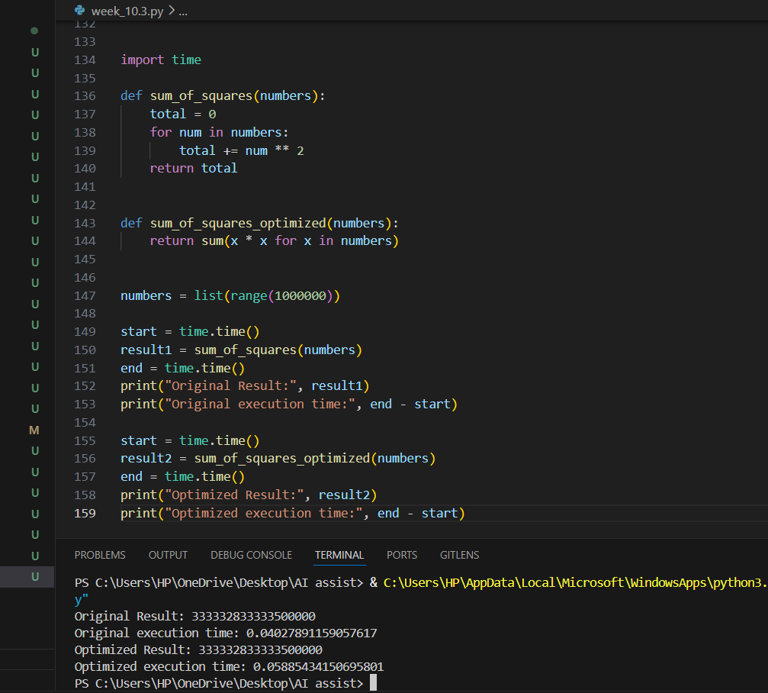
#CODE AND OUTPUT
#ANALYSIS
The AI identified that the function has O(n) time complexity because it iterates through all elements in the list. It suggested using Python’s built-in sum () with a generator expression, which is more efficient and concise. The optimized version reduces loop overhead while maintaining the same functionality.

