2303A51581
BATCH-10
LAB ASSIGNMENT-5.4
#TASK-1
#PROMPT
Generate a Python script that collects basic user information like name, age, and email from input. Add inline comments explaining how the data can be anonymized or protected for (ex:-hashing, encryption, avoiding plaintext storage). Also include best practices for handling sensitive data securely.
#CODE
import hashlib

#user for basic information
name = input("Enter your name: ")
age = input("Enter your age: ")
email = input("Enter your email: ")

# Never store emails in plain text.
# Hash the email so the real value is not saved.
hashed_email = hashlib.sha256(email.encode()).hexdigest()

#Only store the minimum data you really need.
user_data = {
"name": name, # Consider anonymizing or removing if not required
"age": age, # You could store age range instead (e.g., 18–25)
"email_hash": hashed_email # Store only the hashed version
}

#Avoid saving sensitive data without protection.
# In real apps, use encryption and secure databases.
print("\nSecure User Data:")
print(user_data)

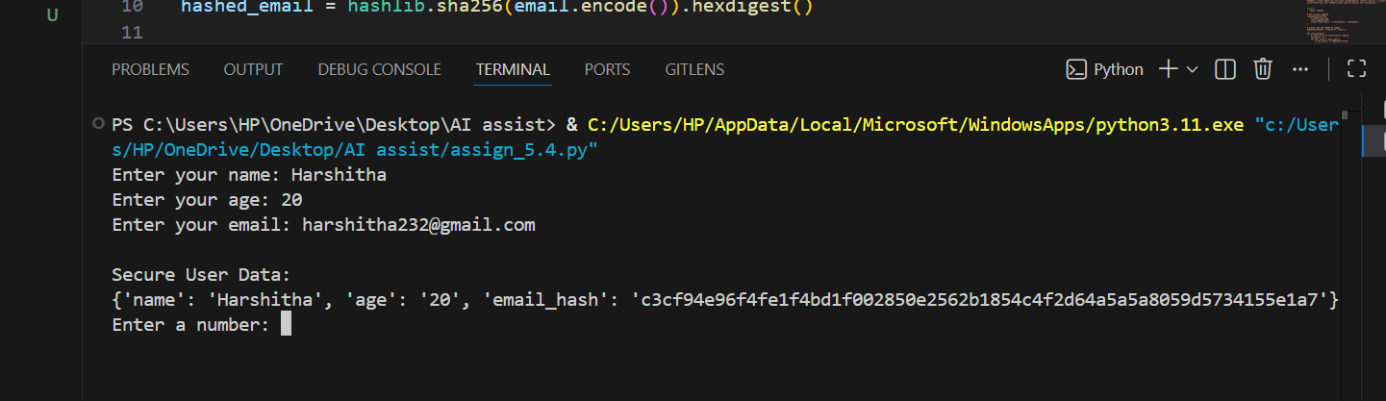
#OUTPUT
#ANALYSIS
We collected user info like name, age, and email. Sensitive info like emails is hashed so it’s safe. Comments explain how to protect data and not store it in plain text.
#TASK-2
#PROMPT
Generate a Python function that performs basic sentiment analysis on text. Then add inline comments explaining how to identify and handle potential biases in the data, such as removing offensive terms and balancing the dataset.

#CODE
def analyze_sentiment(text):
text = text.lower()

positive_words = ["good", "great", "happy", "love", "excellent", "nice"]
negative_words = ["bad", "sad", "hate", "terrible", "awful", "poor"]

score = 0

#Count positive and negative words
for word in positive_words:
if word in text:
score += 1

for word in negative_words:
if word in text:
score -= 1

# Decide sentiment based on score
if score > 0:
return "Positive"
elif score < 0:
return "Negative"
else:
return "Neutral"
text_input = input("Enter a sentence: ")
result = analyze_sentiment(text_input)
print("Sentiment:", result)'''
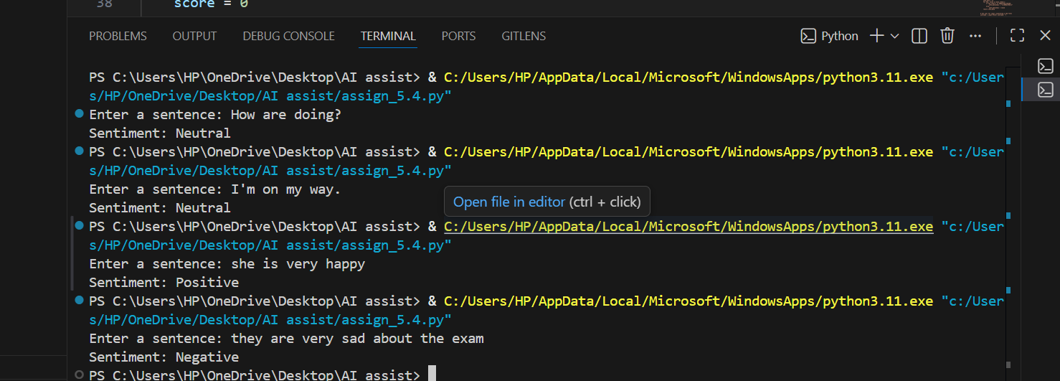
#OUTPUT
#ANALYSIS
The program checks if a sentence is positive, negative, or neutral. It also suggests ways to avoid bias, like removing offensive words and balancing the dataset.
#TASK-3
#PROMPT
Generate a Python program that recommends products based on user history. Add inline comments that follow ethical guidelines such as transparency, fairness, avoid favoritism, and giving users feedback or control over recommendations.
#CODE
# Ask the user about their past behavior (this is their history)
print("To recommend products, we use your past activity.")

viewed = input("What categories have you viewed before? (comma separated): ")
purchased = input("What categories have you purchased from? (comma separated): ")

# Normalize and combine user history
viewed_list = [v.strip().lower() for v in viewed.split(",")]
purchased_list = [p.strip().lower() for p in purchased.split(",")]

user_history = set(viewed_list + purchased_list)

# Product database kept diverse to avoid favoritism
products = [
{"name": "Laptop", "category": "electronics"},
{"name": "Headphones", "category": "electronics"},
{"name": "Novel", "category": "books"},
{"name": "Notebook", "category": "books"},
{"name": "T-shirt", "category": "fashion"},
{"name": "Jacket", "category": "fashion"},
{"name": "Running Shoes", "category": "sports"},
{"name": "Football", "category": "sports"},
]

# Recommendation logic with transparency & fairness
def recommend_products(history, product_list):
# Be transparent about how recommendations work
print("\n🔍 Recommendations are based on the categories in your history.")

recommendations = []

# Match by category only (no brand or seller favoritism)
for product in product_list:
if product["category"] in history:
recommendations.append(product)

# Fairness check — avoid empty or biased results
if not recommendations:
print("ℹ No direct matches. Showing a balanced set instead.")
recommendations = product_list[:3]

return recommendations

# Generate and show recommendations
final_recs = recommend_products(user_history, products)

print("\n🛒 Recommended Products:")
for item in final_recs:
print(f"- {item['name']} ({item['category']})")

#Ask for feedback (user control + ethical AI)
feedback = input("\nDid you find these recommendations useful? (yes/no): ").lower()
print("Thank you! Your feedback helps improve fairness and transparency.")
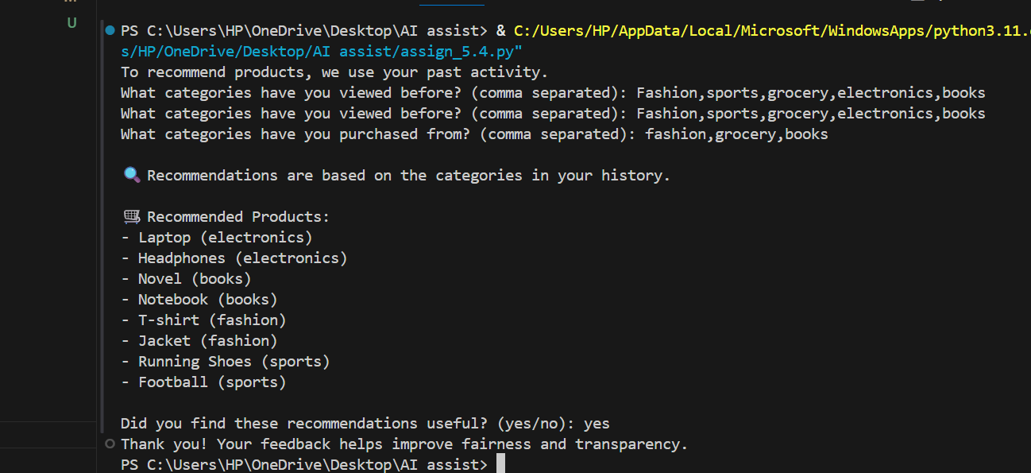
#OUTPUT
#ANALYSIS
It asks the user about their history and suggests products based on that. Comments explain fairness, transparency, and letting users give feedback so recommendations are ethical.
#TASK-4
#PROMPT
Generate logging functionality for a Python web application. Add inline comments to ensure logs do not record sensitive information such as passwords, emails, or personal identifiers. Follow ethical logging practices.
#CODE
import logging
# Set up basic logging
logging.basicConfig(
filename="app.log",
level=logging.INFO,
format="%(asctime)s - %(levelname)s - %(message)s"
)
# Fields that must NEVER be logged
SENSITIVE_FIELDS = ["password", "email"]
def sanitize(data):
# Mask sensitive values before logging
safe_data = {}
for key, value in data.items():
if key.lower() in SENSITIVE_FIELDS:
safe_data[key] = "***REDACTED***"
else:
safe_data[key] = value
return safe_data
# Ask user for input (simulating a web form)
username = input("Enter username: ")
email = input("Enter email: ")
password = input("Enter password: ")
user_data = {
"username": username,
"email": email,
"password": password
}
# Always sanitize before logging
safe_user_data = sanitize(user_data)
#Log only safe, non-sensitive information
logging.info("User submitted data: %s", safe_user_data)
print("Your data was processed safely. No sensitive info was logged.")
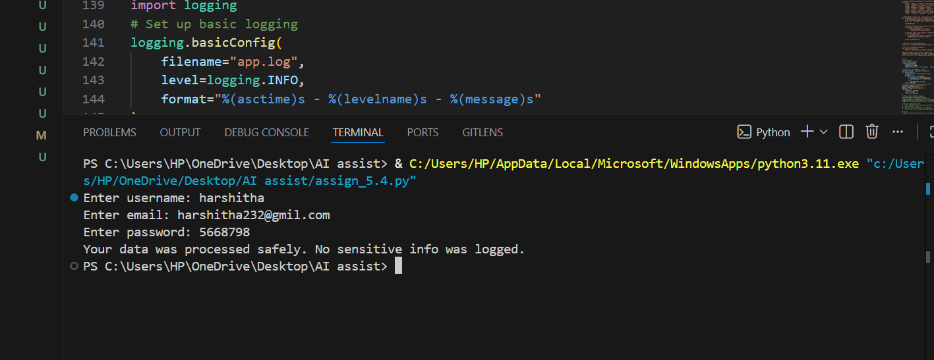
#OUTPUT
#ANALYSIS
The code logs user input but hides sensitive info like passwords and emails. Comments tell how to log safely, only keep necessary info, and protect the log file.

#TASK-5
#PROMPT
Generate a simple Python machine learning model. Add inline documentation or a README-style section explaining how to use the model responsibly, including explainability, accuracy limitations, and fairness considerations.
#CODE
def simple_model(value):
# Model logic is very simple and explainable
if value >= 5:
return "High"
else:
return "Low"

#Ask user for input
num = float(input("Enter a number: "))
result = simple_model(num)

print("Model Prediction:", result)

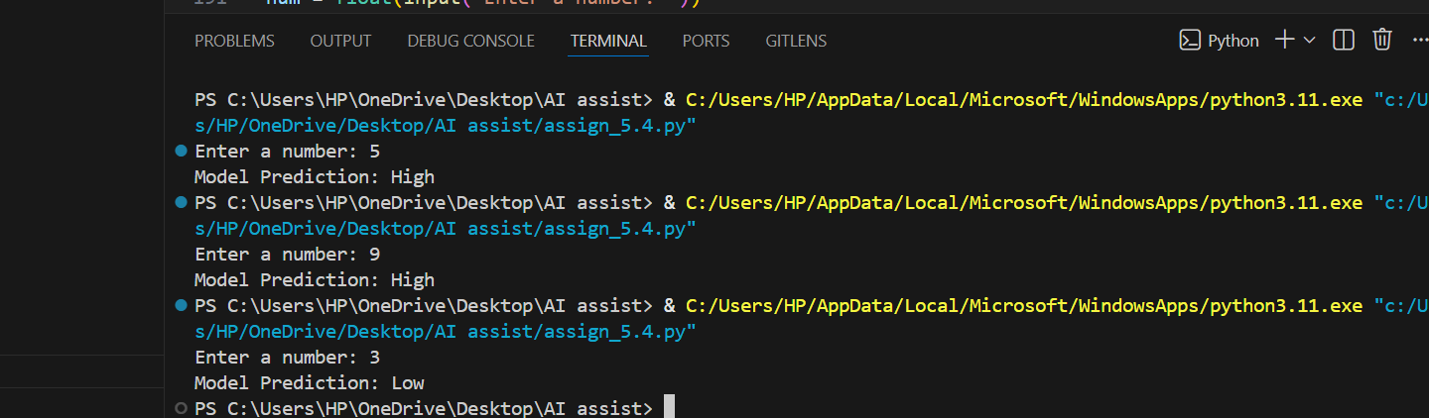
#OUTPUT
#ANALYSIS
A simple ML model predicts outcomes (like pass/fail). Documentation explains limits, how it works, fairness, and ethical use so people understand it and don’t misuse it.

