2303A51581
Batch-10
Lab Assignment-8.3
Task 1: Email Validation using TDD
#PROMPT
Create a Python program to validate email addresses using Test-Driven Development. Generate AI- test cases for valid and invalid emails and implement a function that passes all tests.
#CODE
def is_valid_email(email):
# Must contain exactly one '@'
if email.count("@") != 1:
return False

local, domain = email.split("@")
if "." not in domain:
return False
if not email[0].isalnum() or not email[-1].isalnum():
return False

return True
valid_emails = [
"user@example.com",
"student123@gmail.com",
"name.surname@yahoo.in"
]
invalid_emails = [

"@example.com",
"userexample.com",
"user@@example.com",
".user@gmail.com",
"user@gmail.com."
]
for email in valid_emails:
assert is_valid_email(email) == True

for email in invalid_emails:
assert is_valid_email(email) == False
user_email = input("Enter email address: ")

if is_valid_email(user_email):
print("Valid email format")
else:
print("Invalid email format")
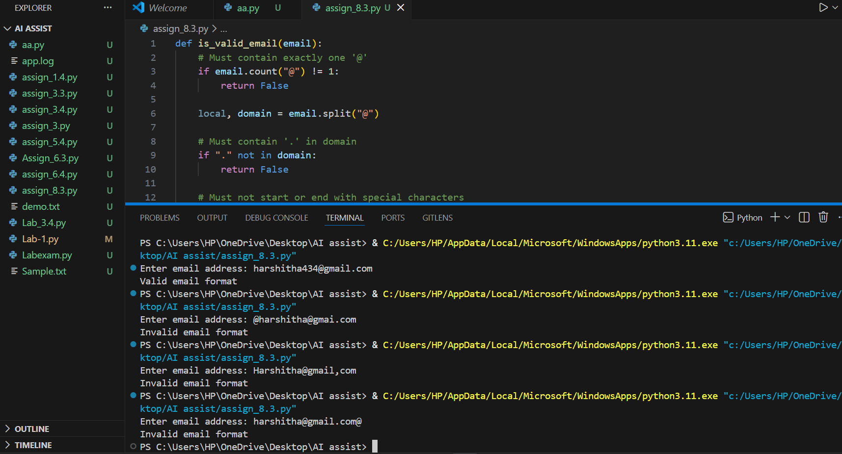
#OUTPUT
#ANALYSIS
The program follows TDD by validating logic against AI-generated test cases first. It enforces all given constraints like single @, valid dot placement, and no special characters at ends. Only valid email formats return True.
Task 2: Grade Assignment using Loops
#PROMPT
Write a Python program to assign grades to students based on their marks. Use test cases first (including boundary and invalid values) and then check the program using loops.
#CODE
def assign_grade(score):
# Handle invalid data types
if not isinstance(score, (int, float)):
return "Invalid"
if score < 0 or score > 100:
return "Invalid"

if score >= 90:
return "A"
elif score >= 80:
return "B"
elif score >= 70:
return "C"
elif score >= 60:
return "D"
else:
return "F"
test_cases = [
(60, "D"), (70, "C"), (80, "B"), (90, "A"),
(95, "A"), (85, "B"), (75, "C"), (65, "D"), (40, "F"),
(-5, "Invalid"), (105, "Invalid"), ("eighty", "Invalid")
]

for score, expected in test_cases:
assert assign_grade(score) == expected

try:
user_score = int(input("Enter your exam score: "))
grade = assign_grade(user_score)

if grade == "Invalid":
print("Invalid score entered")
else:
print("Grade:", grade)

except ValueError:
print("Invalid score entered")
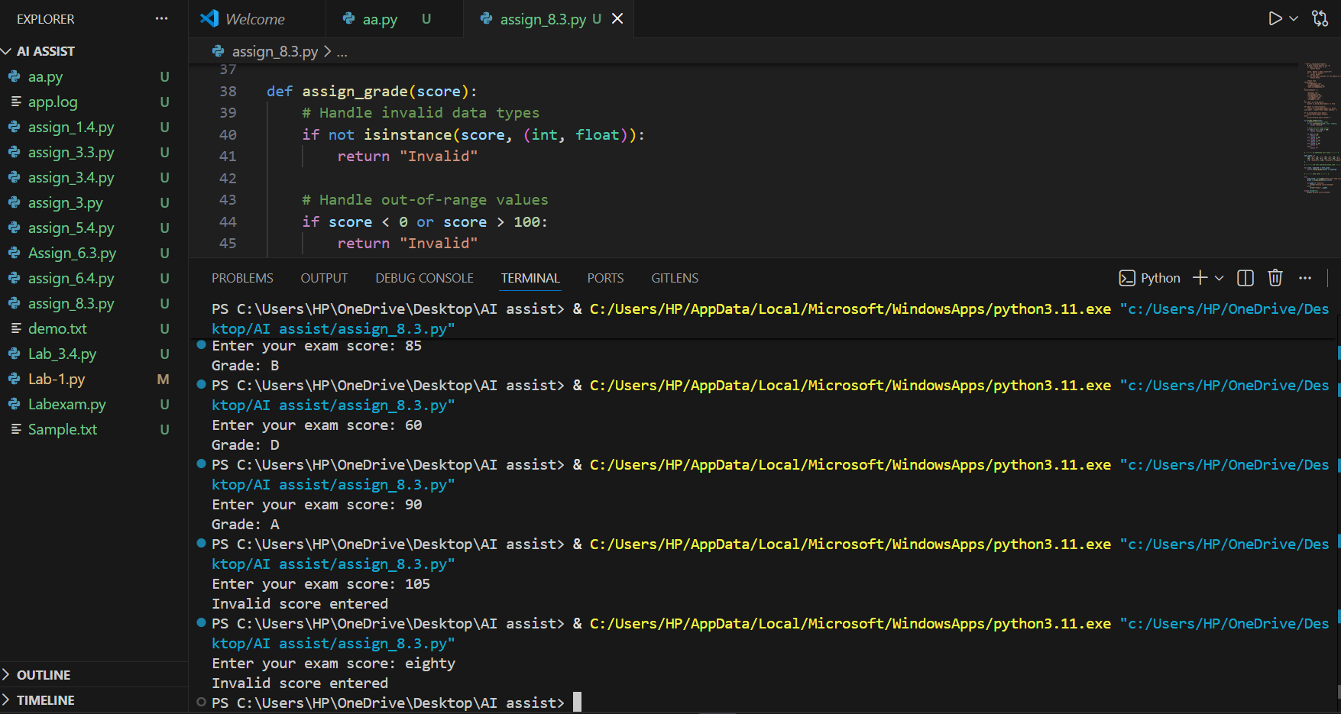
#OUTPUT
#ANALYSIS
In this program, test cases are checked before taking user input.
All boundary values like 60, 70, 80, and 90 are handled correctly.
Invalid inputs are also checked so the program does not give wrong grades.
Task 3: Sentence Palindrome Checker
#PROMPT
Write a Python function to check whether a given sentence is a palindrome. Ignore case, spaces, and punctuation while checking.
The function should return True or False.
#CODE
def is_sentence_palindrome(sentence):
cleaned = ""

for ch in sentence:
if ch.isalnum():
cleaned += ch.lower()

return cleaned == cleaned[::-1]

test_cases = [
("A man a plan a canal Panama", True),
("Madam", True),
("No lemon, no melon", True),
("Hello World", False),
("Python Programming", False)
]
for sentence, expected in test_cases:
assert is_sentence_palindrome(sentence) == expected
user_sentence = input("Enter a sentence: ")
print(is_sentence_palindrome(user_sentence))
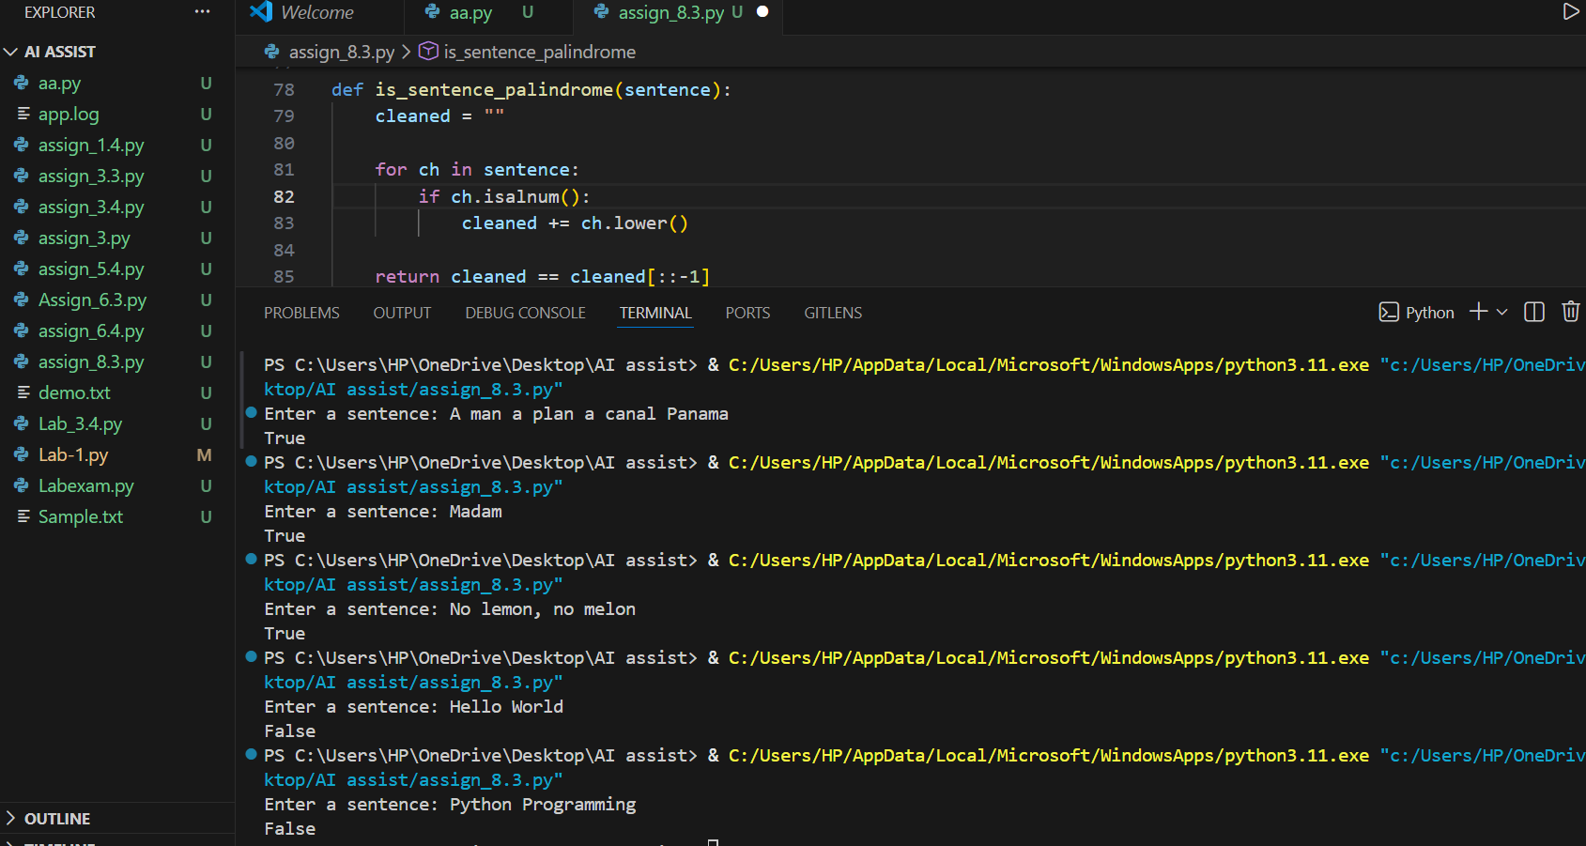
#OUTPUT
#ANALYSIS
The sentence is cleaned by removing spaces and punctuation and converting it to lowercase. Then the cleaned sentence is compared with its reverse. If both are the same, the function returns True, otherwise False.
Task 4: ShoppingCart Class
#PROMPT
Write a Python program to design a simple ShoppingCart class for an e-commerce system. The class should allow adding items, removing items, and calculating the total cost. Use user input to interact with the shopping cart.
#CODE
class ShoppingCart:
def __init__(self):
self.items = {}

def add_item(self, name, price):
self.items[name] = price

def remove_item(self, name):
if name in self.items:
del self.items[name]

def total_cost(self):
return sum(self.items.values())

cart = ShoppingCart()

while True:
print("\n1. Add Item")
print("2. Remove Item")
print("3. View Total Cost")
print("4. Exit")

choice = input("Enter your choice: ")

if choice == "1":
name = input("Enter item name: ")
price = float(input("Enter item price: "))
cart.add_item(name, price)
print("Item added")

elif choice == "2":
name = input("Enter item name to remove: ")
cart.remove_item(name)
print("Item removed (if it existed)")

elif choice == "3":
print("Total cost:", cart.total_cost())

elif choice == "4":
break

else:
print("Invalid choice")
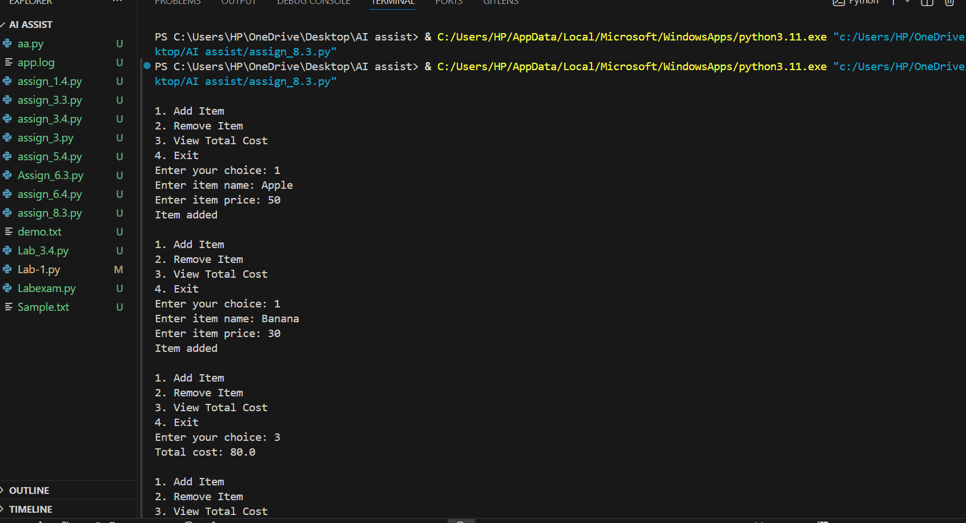
#OUTPUT

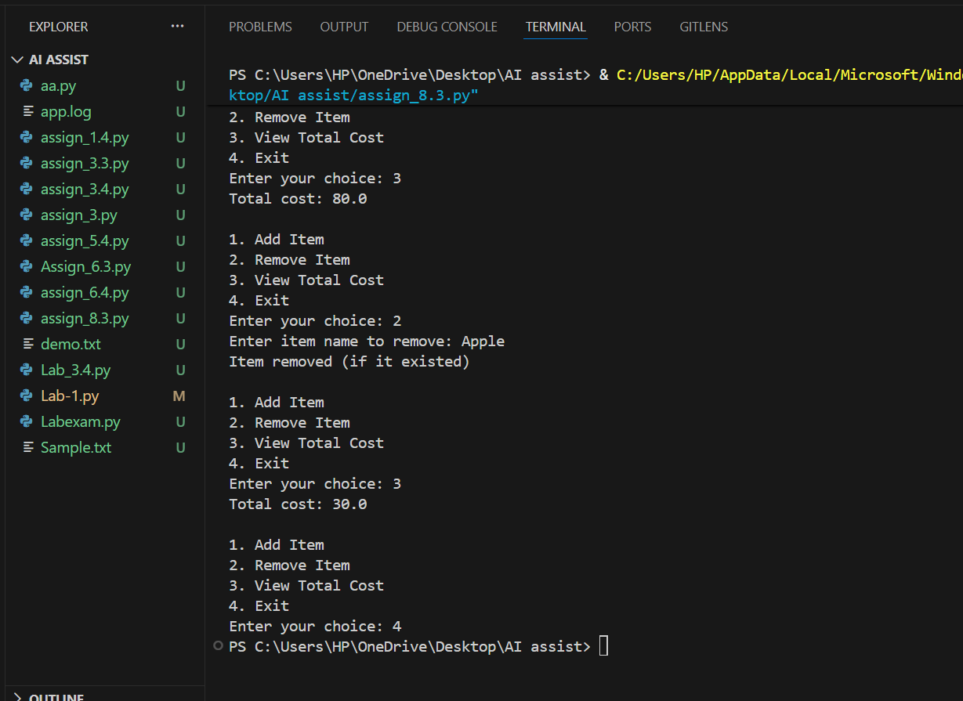
#ANALYSIS
The program uses a ShoppingCart class to store items and their prices.
Users can add or remove items, and the total cost is calculated using a loop. The program also handles empty cart situations without errors.
Task 5: Date Format Conversion
#PROMPT
Write a Python function to convert a date from YYYY-MM-DD format to DD-MM-YYYY. Generate test cases first and then implement the function so all tests pass.
#CODE
def convert_date_format(date_str):
# Step 1: Split the input date string using '-'
year, month, day = date_str.split("-")

# Step 2: Rearrange the date into DD-MM-YYYY format
converted_date = day + "-" + month + "-" + year

# Step 3: Return the converted date
return converted_date

# Ask the user to enter the date
date_input = input("Enter the date in YYYY-MM-DD format: ")

# Call the function and store the result
result = convert_date_format(date_input)

# Display the converted date
print("Converted date (DD-MM-YYYY):", result)

#OUTPUT

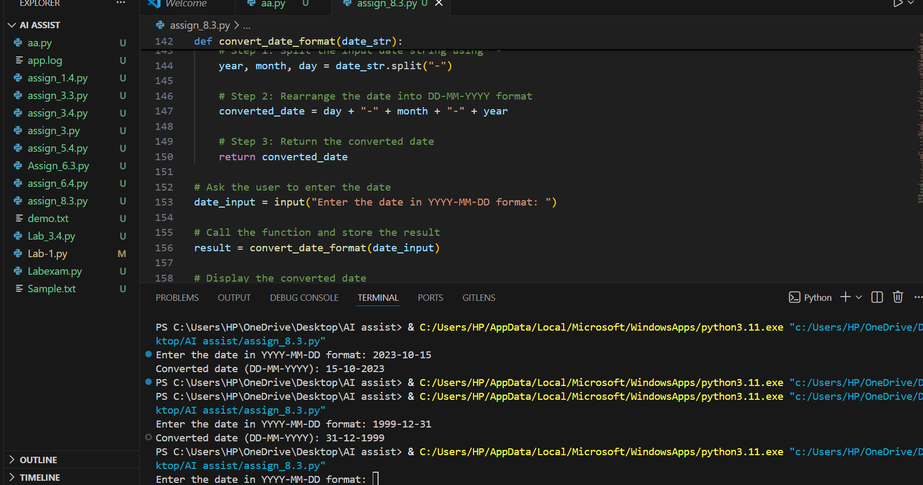
#ANALYSIS
The input date is split using the - symbol.
The parts are rearranged to form the new required format.
All test cases pass, showing the function works correctly.

