2303A51581
Batch-10
Lab Assignment-9.4
Auto-Generating Function Documentation in a Shared
Codebase
#PROMPT
Create and Add Google-style docstrings to the given Python functions.
Include simple explanation, parameters with types, return values, and one example for each function. Make it clear and easy to understand.
#CODE
def add_numbers(a, b):
"""
Adds two numbers and returns the result.

Args:
a (float): The first number.
b (float): The second number.

Returns:
float: The sum of the two numbers.

Example:
>>> add_numbers(4, 6)
10.0
"""
return a + b

def divide_numbers(a, b):
"""
Divides one number by another.

Args:
a (float): The numerator.
b (float): The denominator.

Returns:
float: The result of the division.

Raises:
ValueError: If the denominator is zero.

Example:
>>> divide_numbers(10, 2)
5.0
"""
if b == 0:
raise ValueError("Cannot divide by zero")
return a / b

def is_even(number):
"""
Checks whether a given number is even.

Args:
number (int): The number to check.

Returns:
bool: True if the number is even, otherwise False.

Example:
>>> is_even(8)
True
"""
return number % 2 == 0

def reverse_string(text):
"""
Reverses the given string.

Args:
text (str): The string to reverse.

Returns:
str: The reversed string.

Example:
>>> reverse_string("AI")
'IA'
"""
return text[::-1]

if __name__ == "__main__":
print("===== Utility Functions Program =====")

try:
# Input for arithmetic operations
num1 = float(input("Enter first number: "))
num2 = float(input("Enter second number: "))

addition_result = add_numbers(num1, num2)
print("Addition Result:", addition_result)

division_result = divide_numbers(num1, num2)
print("Division Result:", division_result)

# Input for even check
number = int(input("Enter a number to check even or odd: "))
print("Is Even:", is_even(number))

# Input for string reversal
text = input("Enter a string to reverse: ")
print("Reversed String:", reverse_string(text))
except ValueError as error:
print("Error:", error)

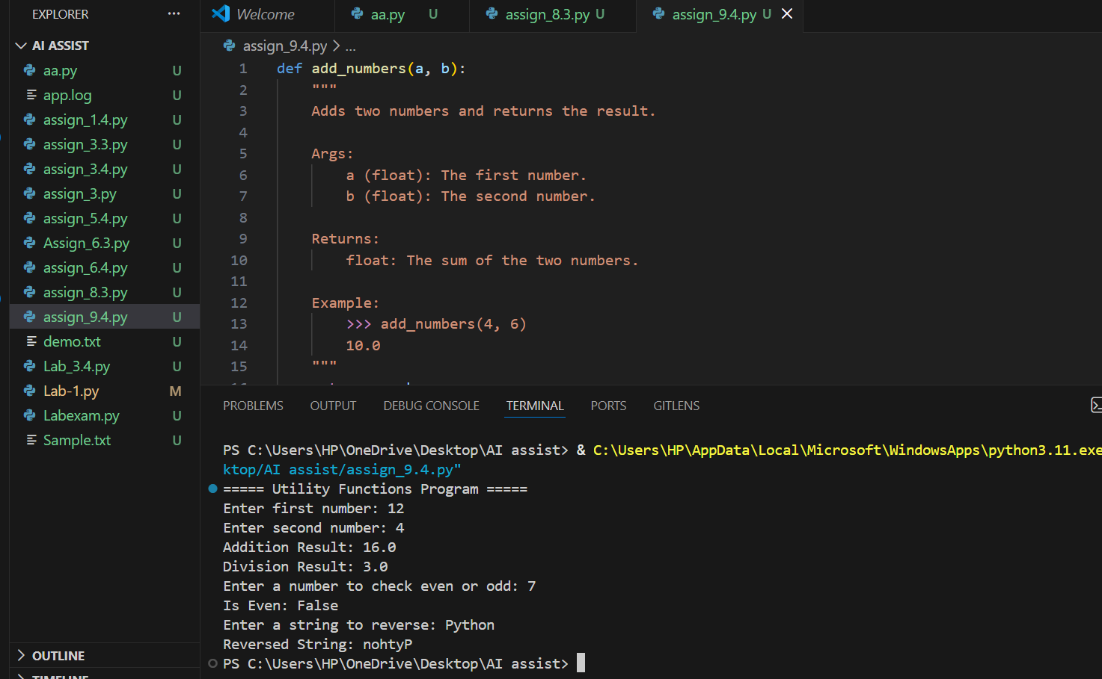
#OUTPUT
#ANALYSIS
The AI added proper docstrings to all functions in a clear format.
It explained what each function does and how to use it with examples.
This makes the code easier for new students or developers to understand.
Task 2: Enhancing Readability Through AI-Generated Inline Comments
#PROMPT
Insert concise inline comments into the given Python script to clarify complex or non-obvious logic such as algorithm steps, loop reasoning, optimizations, and conditional decisions. The comments should explain why the logic is used rather than what basic Python syntax does, and they should improve readability without cluttering the code.
#CODE
def fibonacci(n):
if n <= 0:
return []
if n == 1:
return [0]
sequence = [0, 1]
for _ in range(2, n):
sequence.append(sequence[-1] + sequence[-2])
return sequence
def bubble_sort(arr):
n = len(arr)
for i in range(n):
swapped = False

for j in range(0, n - i - 1):
if arr[j] > arr[j + 1]:
arr[j], arr[j + 1] = arr[j + 1], arr[j]
swapped = True

if not swapped:
break

return arr
def binary_search(arr, target):
left, right = 0, len(arr) - 1

while left <= right:
mid = (left + right) // 2

if arr[mid] == target:
return mid

elif arr[mid] < target:
left = mid + 1

else:
right = mid - 1

return -1
if __name__ == "__main__":
print("===== Algorithm Program =====")

n = int(input("Enter number of Fibonacci terms: "))
print("Fibonacci Sequence:", fibonacci(n))
numbers_input = input("Enter numbers separated by space: ")
numbers = list(map(int, numbers_input.split()))
sorted_list = bubble_sort(numbers)
print("Sorted List:", sorted_list)

target = int(input("Enter number to search: "))
result = binary_search(sorted_list, target)

if result != -1:
print("Element found at index:", result)
else:
print("Element not found"
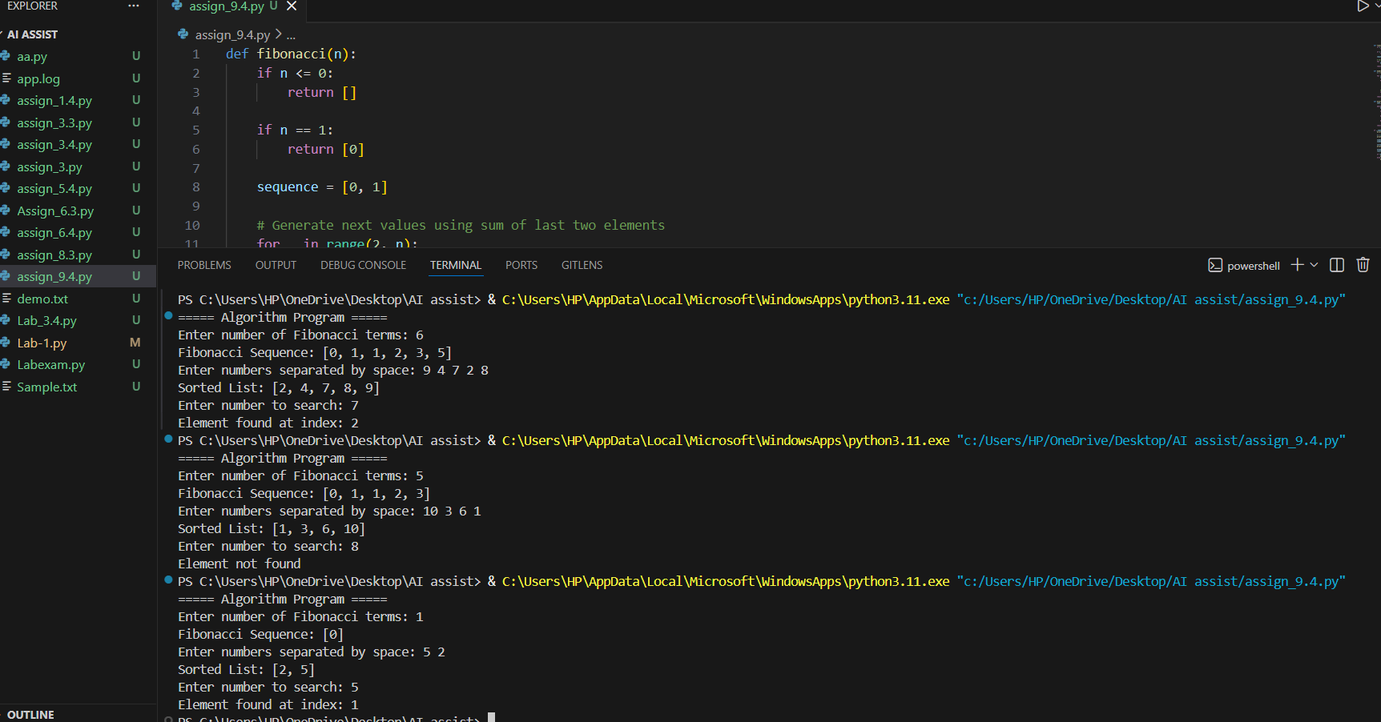
#OUTPUT
#ANALYSIS
The AI added clear and concise inline comments only where the logic was complex. It explained why certain steps like early stopping in sorting and midpoint calculation in binary search are used. This improved readability without making the code look cluttered.
Task 3: Generating Module-Level Documentation for a Python Package
#PROMPT
Write a professional multi-line module-level docstring for the given Python module. The docstring should clearly describe the purpose of the module, required dependencies, key classes and functions, and include a short example of how the module can be used. Ensure the tone is suitable for an internal repository or real-world project.
#CODE
class Student:
def __init__(self, student_id, name, marks):
self.student_id = student_id
self.name = name
self.marks = marks

def calculate_average(self):
if not self.marks:
return 0
return round(sum(self.marks) / len(self.marks), 2)

def add_student(student_list, student):
student_list.append(student)

def find_student_by_id(student_list, student_id):
for student in student_list:
if student.student_id == student_id:
return student
return None
if __name__ == "__main__":
print("===== Student Management Demo =====")

students = []
sid = int(input("Enter Student ID: "))
name = input("Enter Student Name: ")
marks_input = input("Enter marks separated by space: ")
marks = list(map(int, marks_input.split()))

student = Student(sid, name, marks)
add_student(students, student)

search_id = int(input("Enter Student ID to search: "))
result = find_student_by_id(students, search_id)

if result:
print("Student Found:", result.name)
print("Average Marks:", result.calculate_average())
else:
print("Student not found")
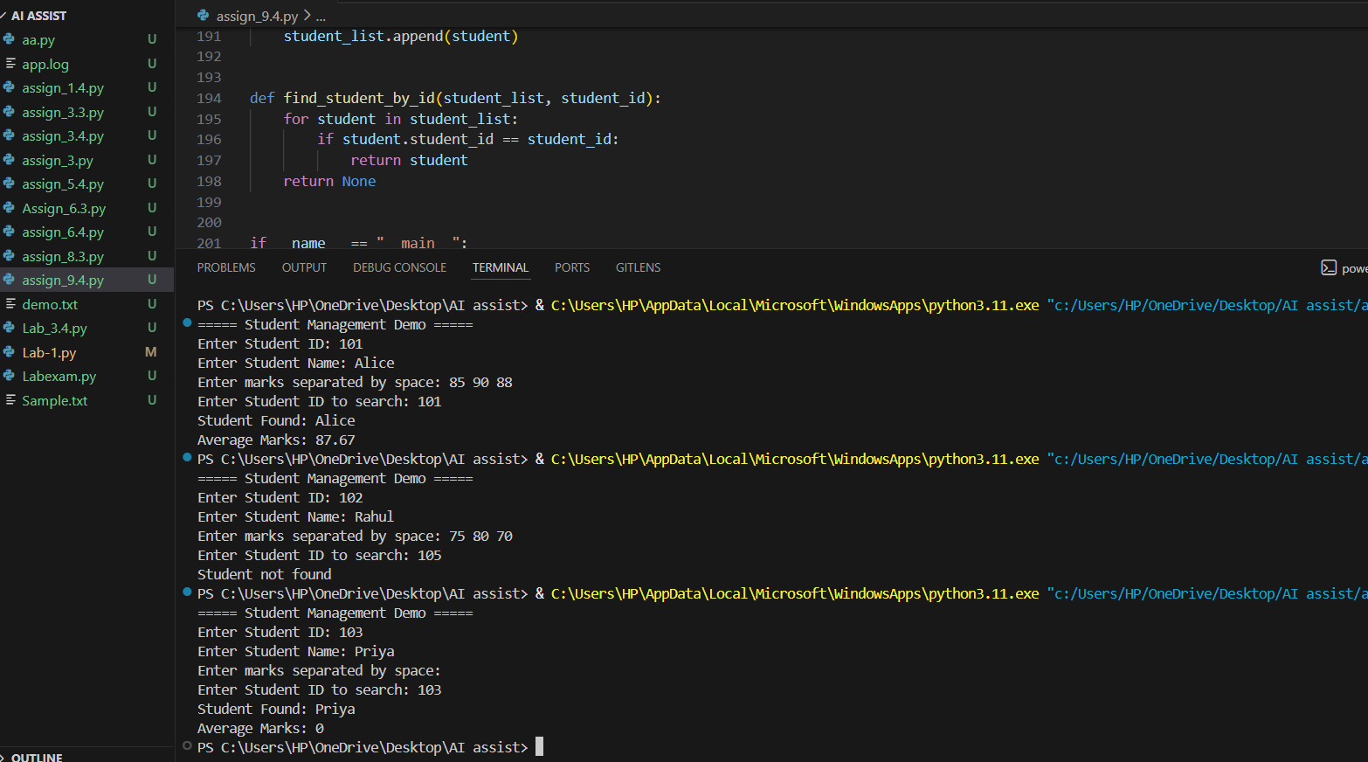
#OUTPUT

#ANALYSIS
The AI generated a clear and well-structured module-level docstring at the top of the file. It explained the purpose, dependencies, and key components in a professional way. This makes the module easy to understand for anyone who opens the file.
Task 4: Converting Developer Comments into Structured Docstrings
#PROMPT
Convert the existing inline developer comments inside the functions into structured Google-style docstrings. Preserve the original meaning of the comments, include description, parameters, return values, and an example where appropriate. Remove redundant inline comments after converting them into docstrings to keep the function bodies clean.
#CODE
def calculate_discount(price, discount_percentage):
"""
Calculate the final price after applying a discount.

Args:
price (float): The original price of the product.
discount_percentage (float): The percentage of discount to apply.

Returns:
float: The final discounted price.
Returns 0 if the price is negative.

Example:
>>> calculate_discount(200, 10)
180.0
"""
if price < 0:
return 0

discount = (price * discount_percentage) / 100
final_price = price - discount
return final_price

def find_max(numbers):
"""
Find the maximum value in a list of numbers.

Args:
numbers (list of int or float): List of numbers to evaluate.

Returns:
int or float: The largest number in the list.
Returns None if the list is empty.

Example:
>>> find_max([5, 9, 3])
9
"""
if not numbers:
return None

maximum = numbers[0]
for num in numbers:
if num > maximum:
maximum = num

return maximum
if __name__ == "__main__":
print("===== Discount Calculator & Maximum Finder =====")

# User input for discount calculation
price = float(input("Enter original price: "))
discount_percentage = float(input("Enter discount percentage: "))

final_price = calculate_discount(price, discount_percentage)
print("Final Price after Discount:", final_price)

# User input for maximum finder
numbers_input = input("Enter numbers separated by space: ")
numbers = list(map(float, numbers_input.split()))

max_value = find_max(numbers)

if max_value is not None:
print("Maximum Value:", max_value)
else:
print("No numbers provided.")
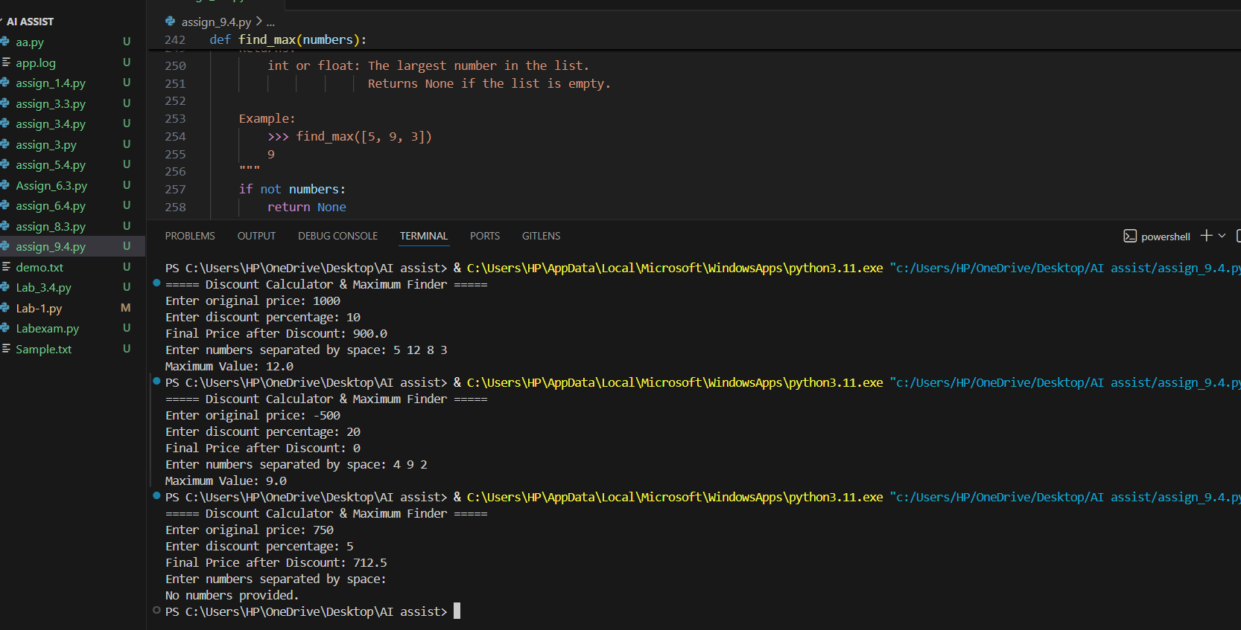
#OUTPUT
#ANALYSIS
The AI successfully transformed the long inline comments into proper structured docstrings. It preserved the original explanation while making the code cleaner and more professional. The function bodies became less cluttered, improving readability and consistency across the code.

Task 5: Building a Mini Automatic Documentation Generator
#PROMPT
Design a Python utility that reads a given .py file, detects all functions and classes, and automatically inserts placeholder Google-style docstrings for each. The tool should generate documentation scaffolding and save the updated content into a new file without modifying the original
#CODE
import re
import os

def generate_docstring(name, indent, obj_type="function"):
"""
Generates a Google-style placeholder docstring.
"""
if obj_type == "class":
doc = f'{indent}"""Summary of {name} class.\n\n'
doc += f'{indent}Description:\n'
doc += f'{indent} TODO: Add class description.\n'
doc += f'{indent}"""\n'
else:
doc = f'{indent}"""Summary of {name} function.\n\n'
doc += f'{indent}Args:\n'
doc += f'{indent} TODO: Add parameter descriptions.\n\n'
doc += f'{indent}Returns:\n'
doc += f'{indent} TODO: Add return description.\n'
doc += f'{indent}"""\n'

return doc
def process_file(filename):
"""
Reads the file and inserts placeholder docstrings
after functions and class definitions.
"""

if not os.path.exists(filename):
print("File does not exist.")
return

with open(filename, "r") as file:
lines = file.readlines()

new_lines = []
i = 0

while i < len(lines):
line = lines[i]
new_lines.append(line)

# Detect function
func_match = re.match(r'^(\s*)def\s+(\w+)\s*\(', line)

# Detect class
class_match = re.match(r'^(\s*)class\s+(\w+)\s*[\(:]?', line)
if func_match:
indent = func_match.group(1) + " "
func_name = func_match.group(2)

# Check if next line already has docstring
if i + 1 < len(lines) and '"""' not in lines[i + 1]:
doc = generate_docstring(func_name, indent, "function")
new_lines.append(doc)

elif class_match:
indent = class_match.group(1) + " "
class_name = class_match.group(2)

# Check if next line already has docstring
if i + 1 < len(lines) and '"""' not in lines[i + 1]:
doc = generate_docstring(class_name, indent, "class")
new_lines.append(doc)

i += 1

output_file = "documented_" + filename

with open(output_file, "w") as file:
file.writelines(new_lines)

print(f"\nDocumentation generated successfully!")
print(f"Updated file saved as: {output_file}")
if __name__ == "__main__":
print("Mini Automatic Documentation Generator")
print("---------------------------------------")

user_file = input("Enter the Python file name (with .py extension): ")
process_file(user_file)

#OUTPUT

#ANALYSIS
The solution involves reading the file, identifying def and class patterns using techniques like regular expressions, and inserting properly indented placeholder docstrings. The main goal is automation of basic documentation structure, improving code readability and reducing manual effort for developers.

