2303A51581
B_10
Lab 3: Application for TGNPDCL – Electricity Bill Generation Using Python &
AI Tools
Lab Objectives
• To design a real-world electricity billing application using Python
• To use AI-assisted coding tools for logic generation and optimization
• To understand conditional logic and arithmetic operations
• To generate structured billing output similar to utility bills
Lab Outcomes (LOs)
After completing this lab, students will be able to:
Week2 -
Wednesday
• Read and validate user input in Python
• Apply conditional logic for tariff-based billing
• Use AI tools to assist in program development
• Calculate and display electricity bill components
• Build a complete real-time application
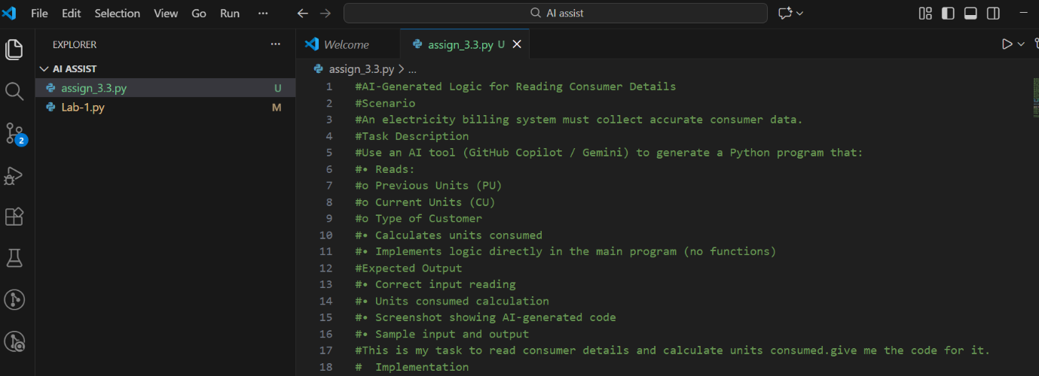
TASK-1: Prompt
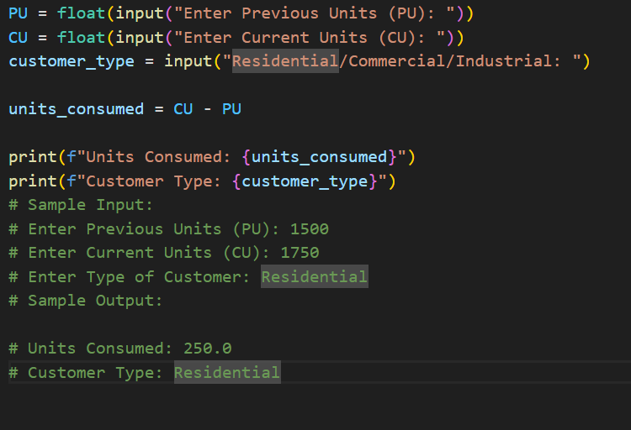
#Code

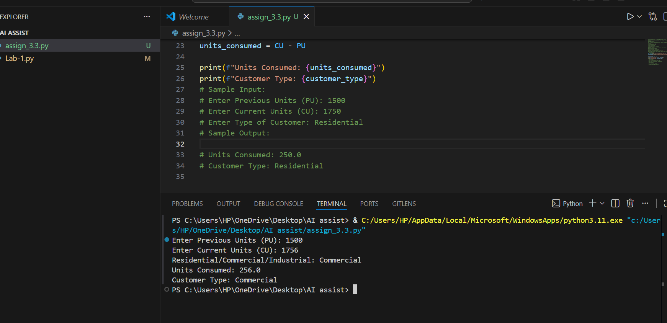
#Output

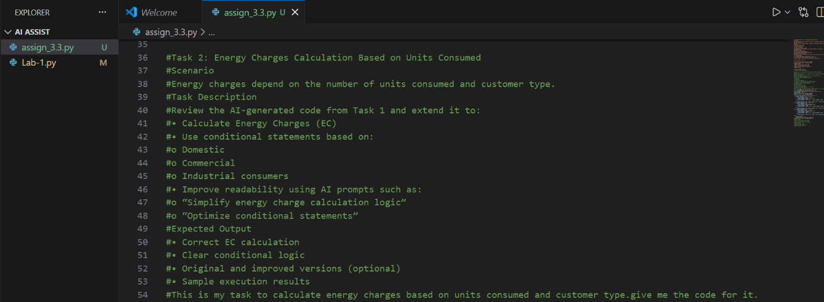
TASK-2: #Prompt
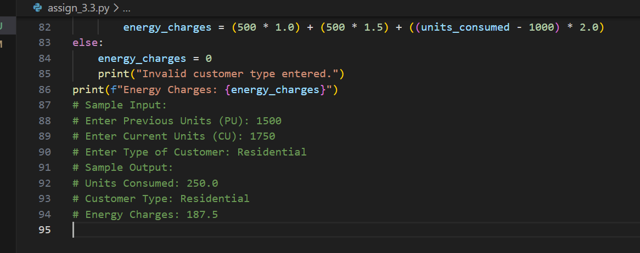
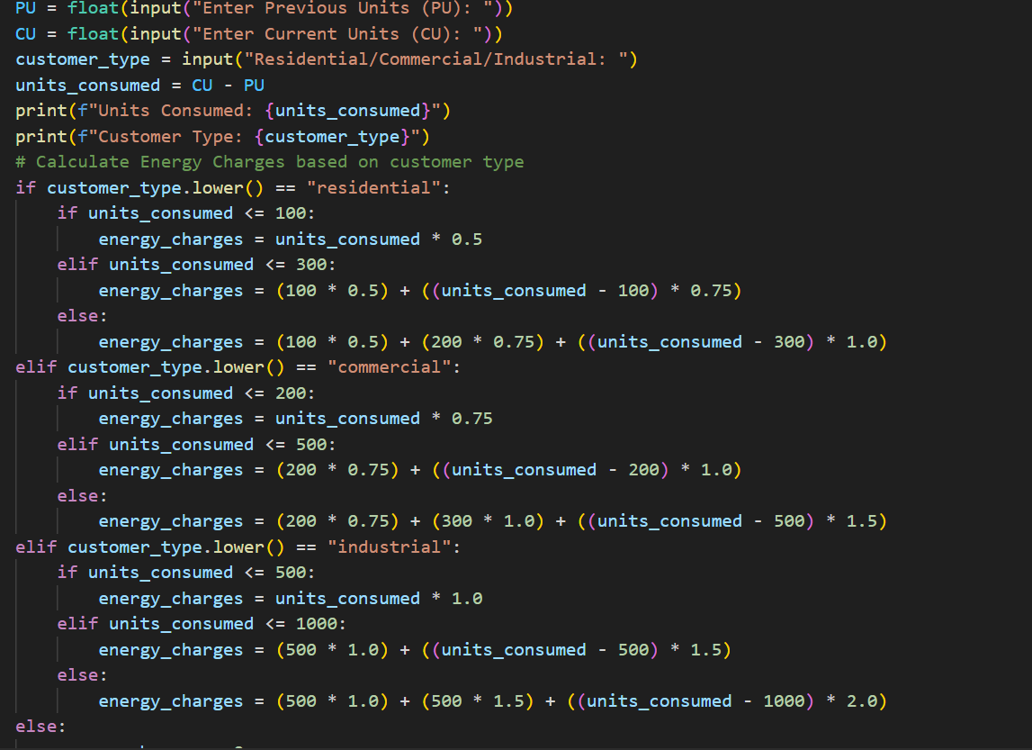
#code
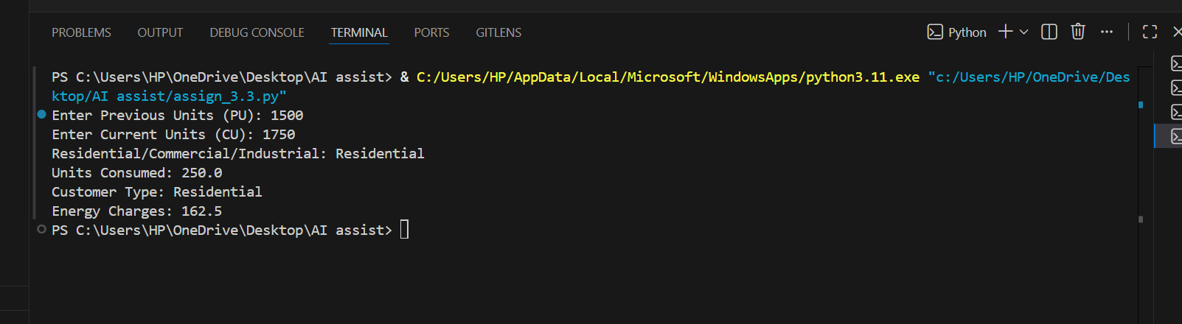
#Output
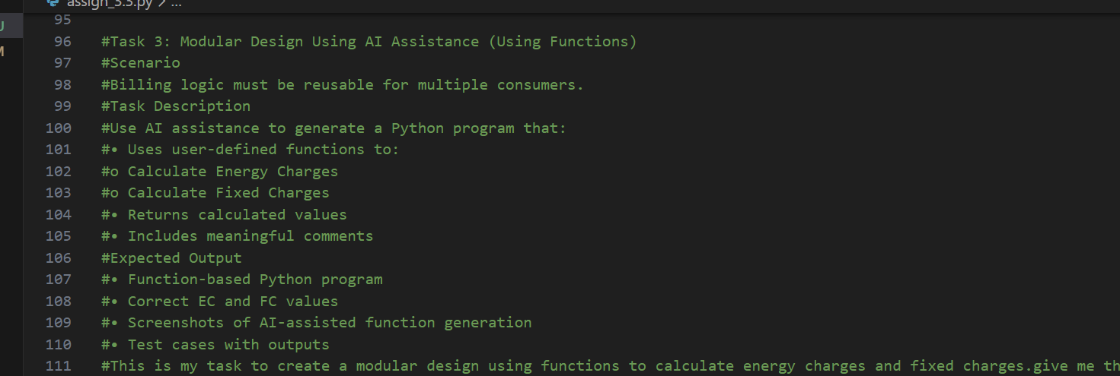
TASK-3: #Prompt
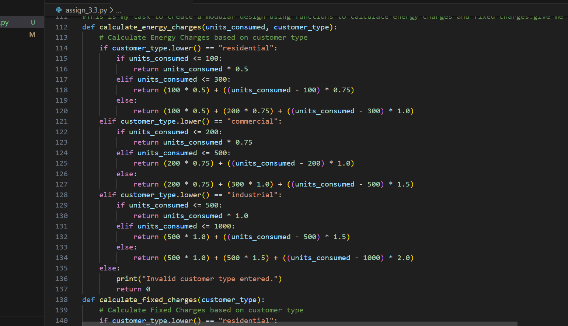
#code
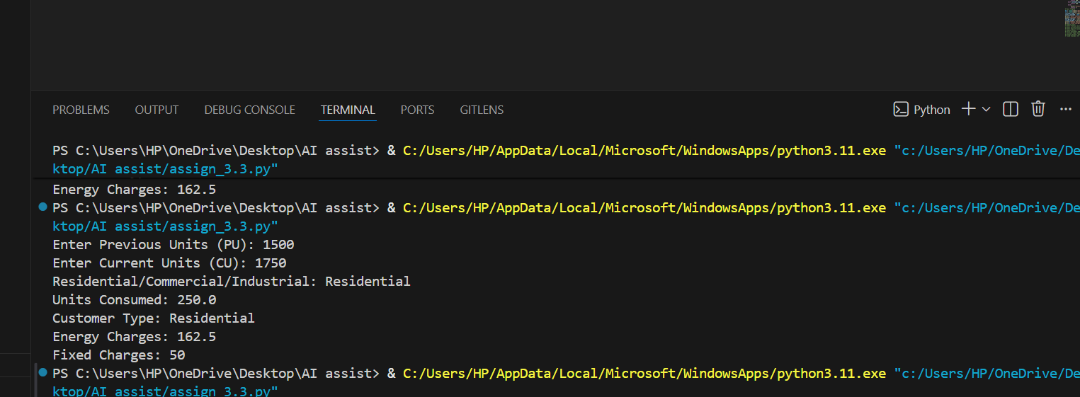
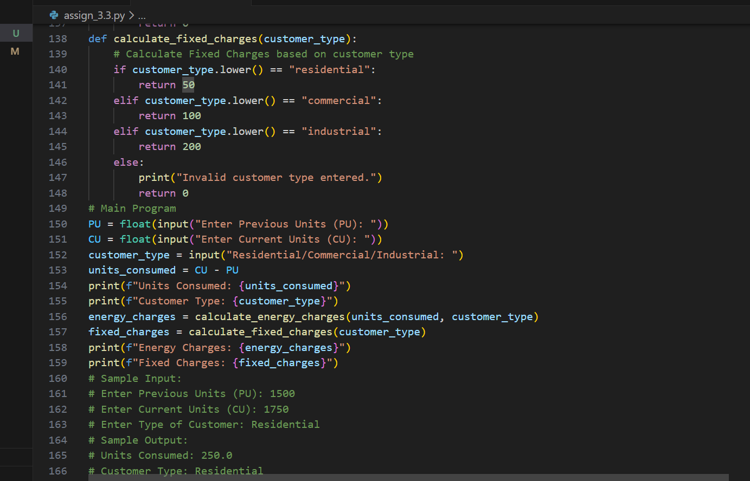
#Output

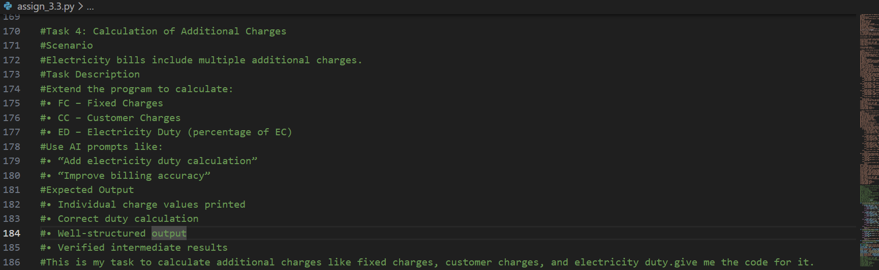
TASK-4: #Prompt

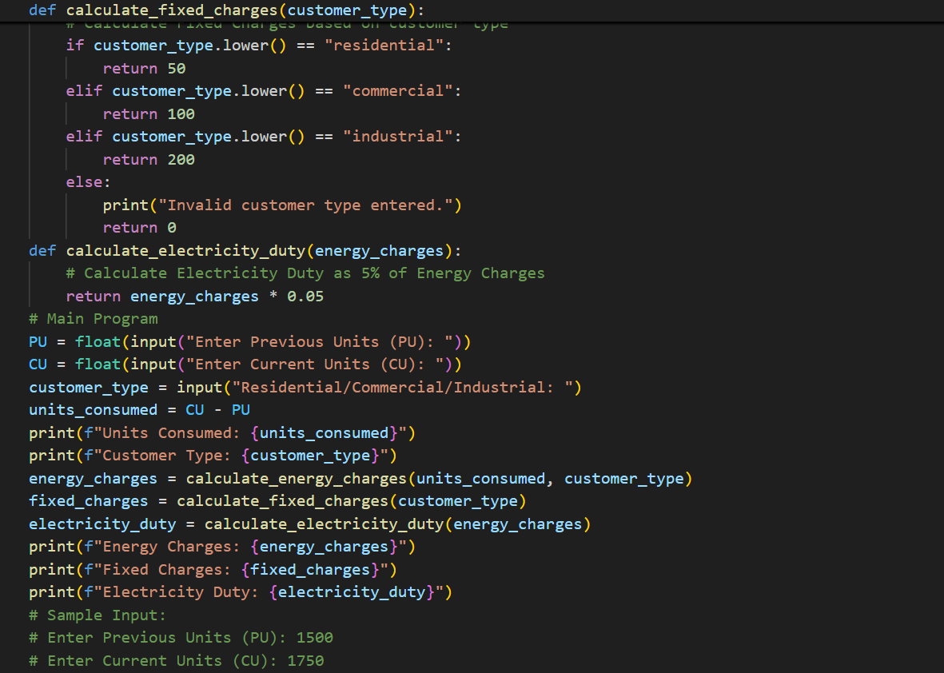
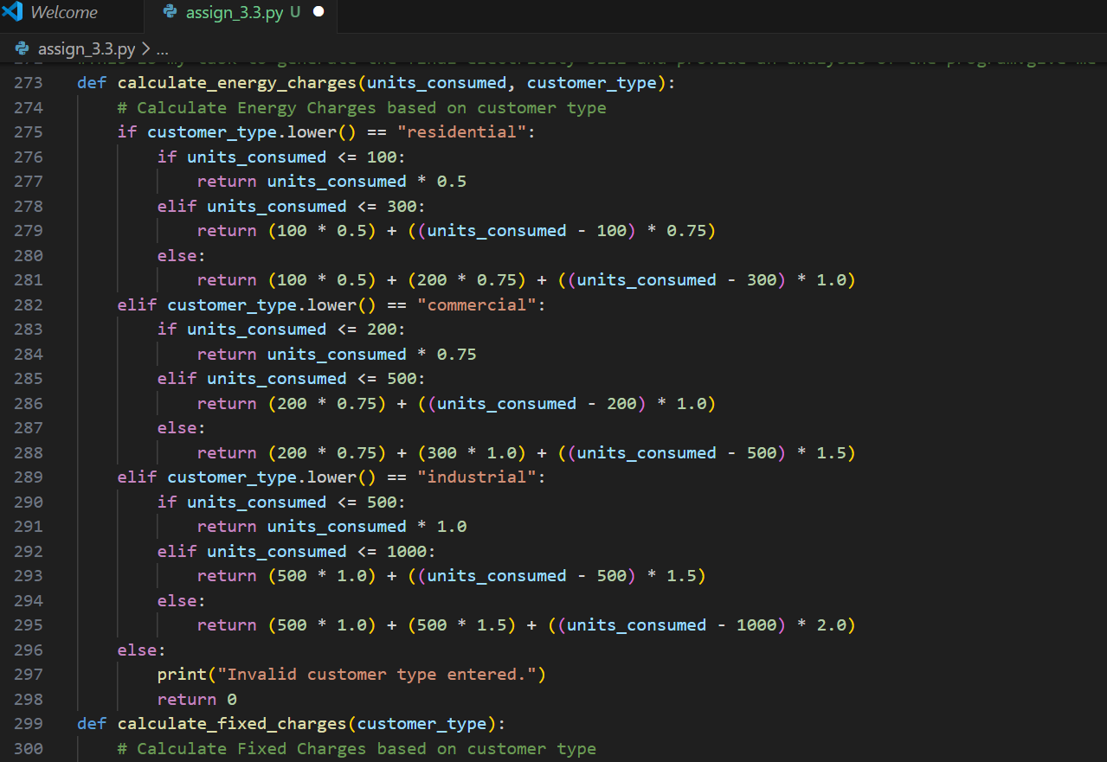
#Code

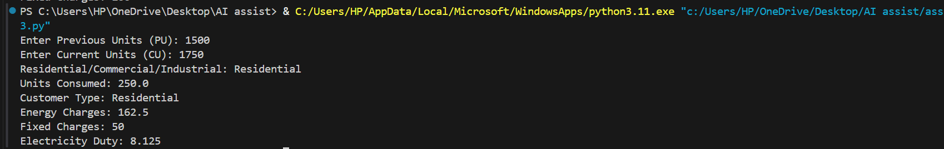
#Output
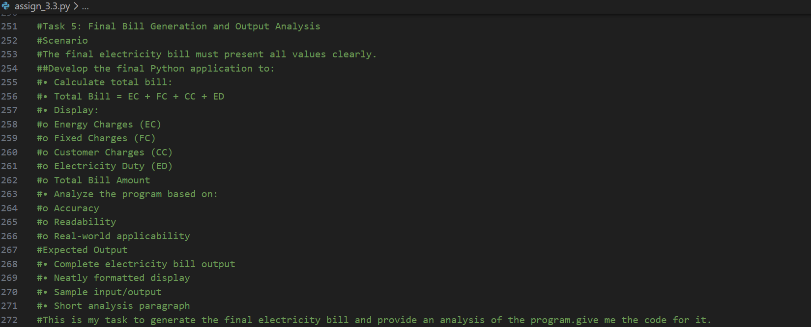
TASK-5: #Prompt
#Code
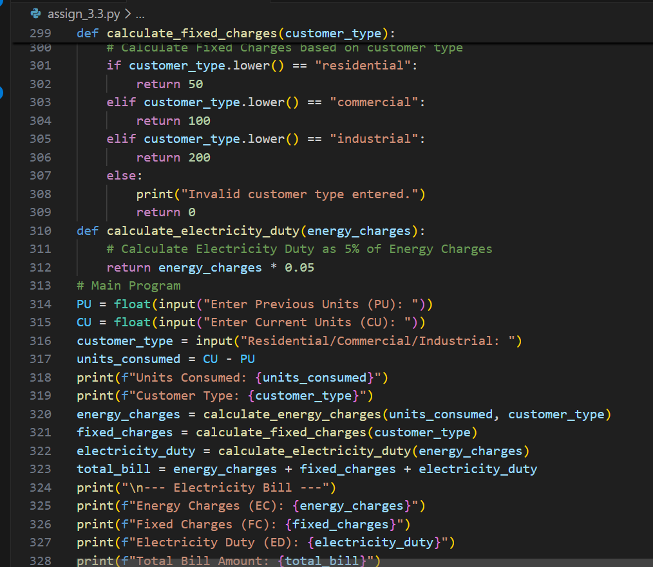

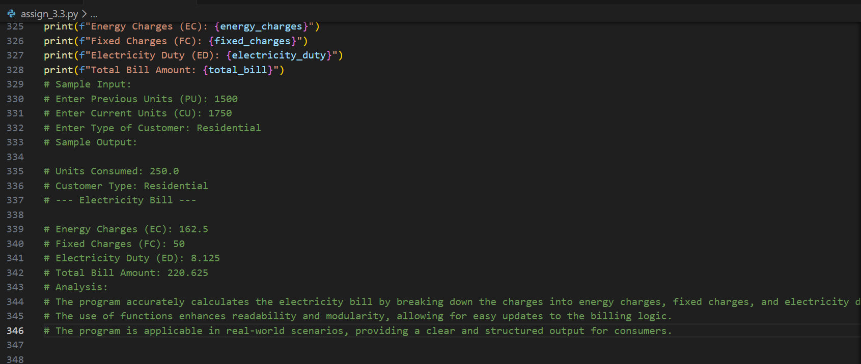
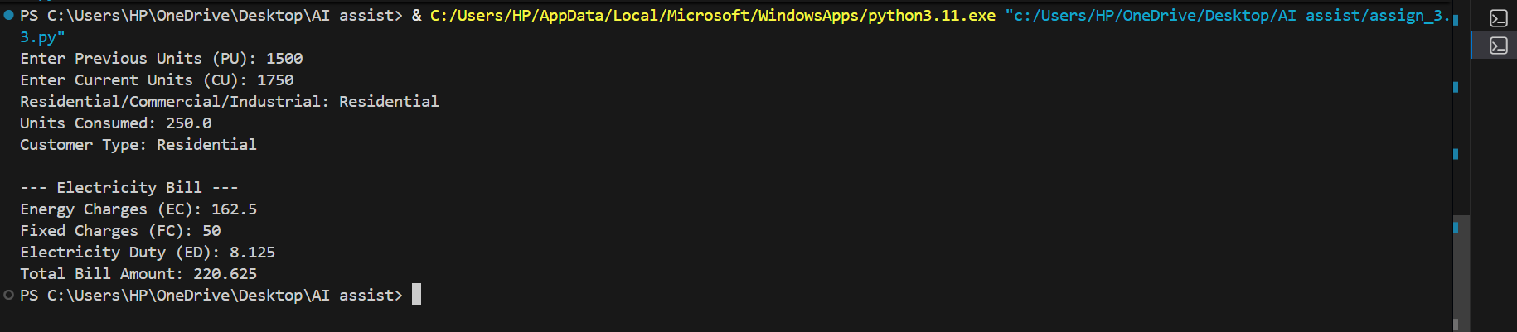
#Output

Explanation:
1.The code is designed to help calculate an electricity bill based on the amount of electricity a consumer uses.
2.It first reads the previous and current electricity readings to find out how much electricity was used.
3.Then, it calculates different charges like energy charges, fixed charges, and a small tax called electricity duty based on the type of customer (residential, commercial, or industrial).
4.Finally, it adds all these charges together to give the total bill amount and displays everything clearly for the user. The program is easy to read and understand because it uses functions to organize the calculations.
5.The program calculates an electricity bill based on usage. It reads previous and current meter readings to find consumption.
6.Different charges are calculated based on customer type. Finally, it sums up all charges to show the total bill.
7.The use of functions makes the code organized and easy to follow.

