# ERD

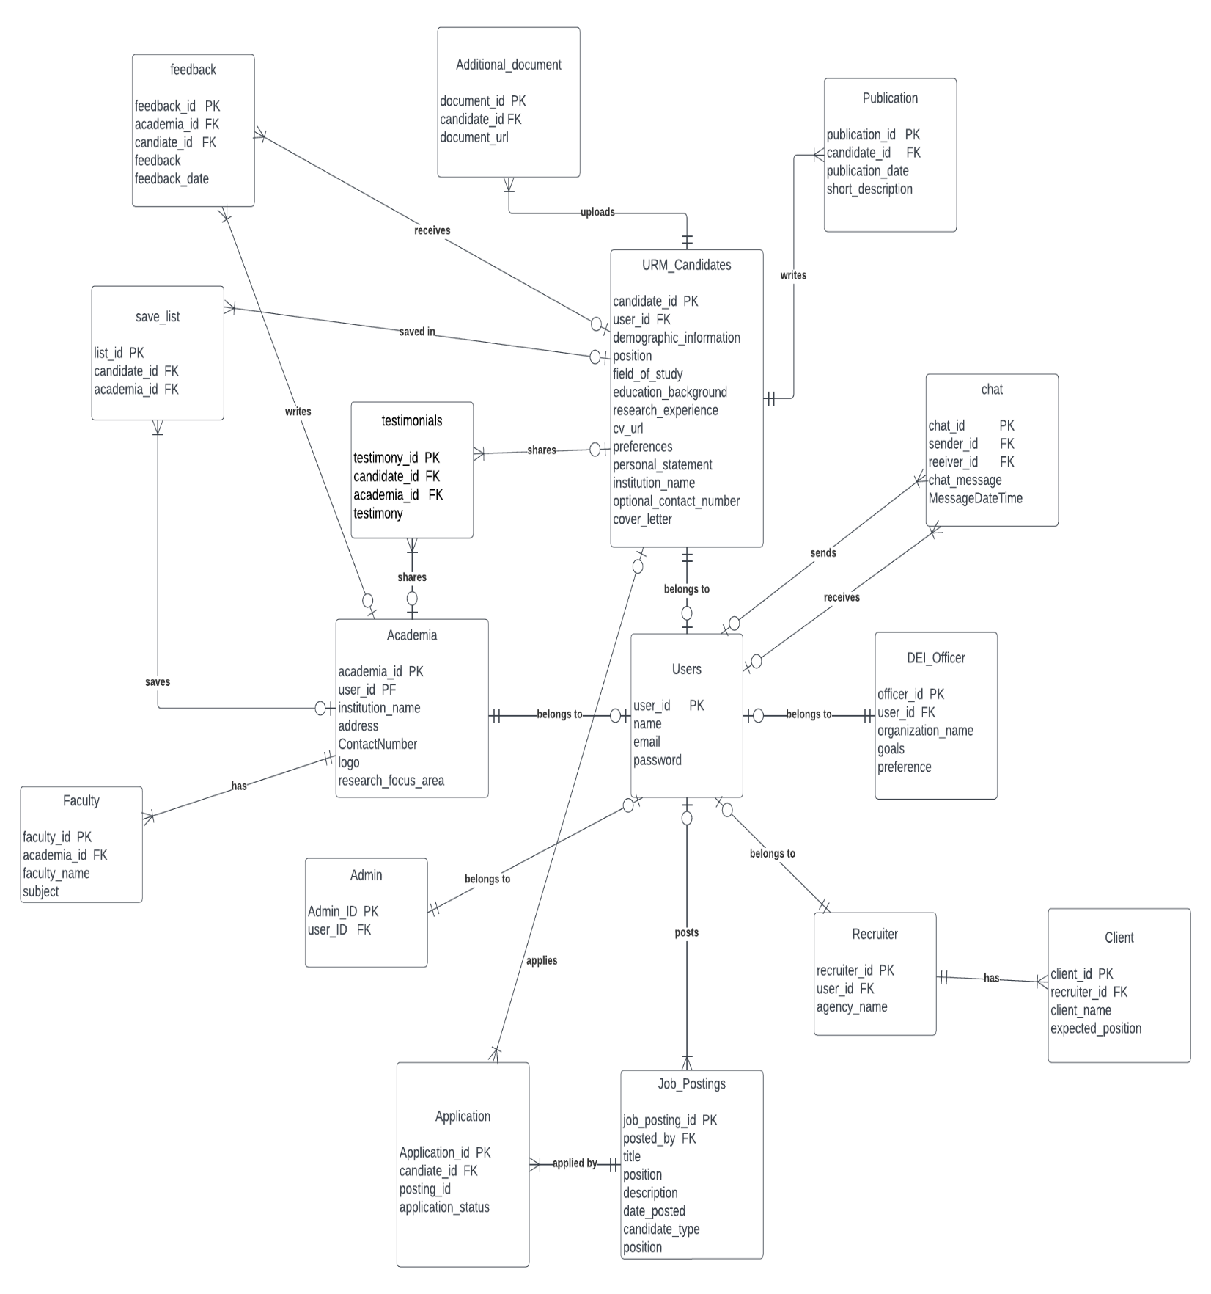

**Figure: ERD diagram**