Task 3: Develop a C program using fork() that creates a parent and child process. Display the Process ID (PID), Parent Process ID (PPID), and process states at different stages of execution.
Flow Chart
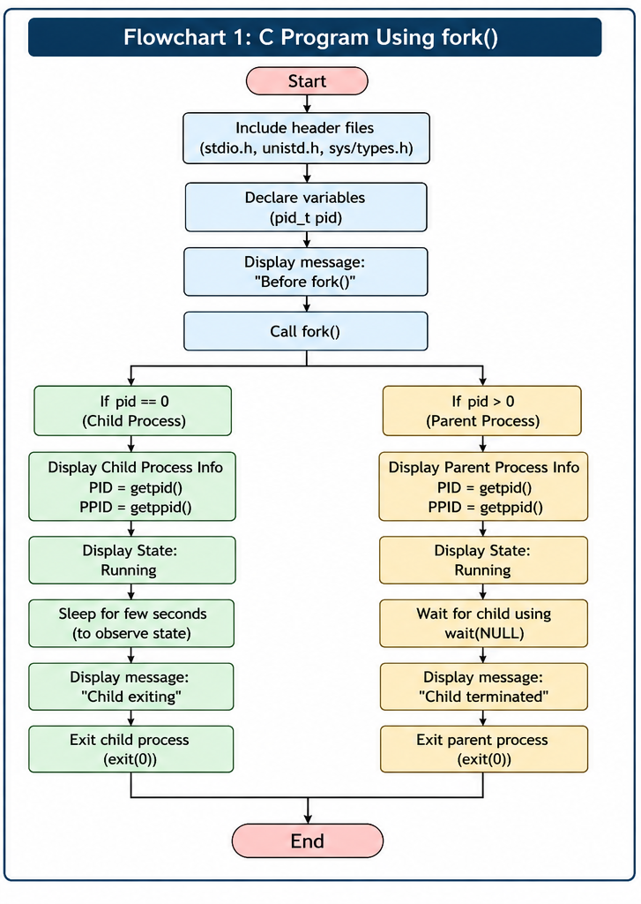

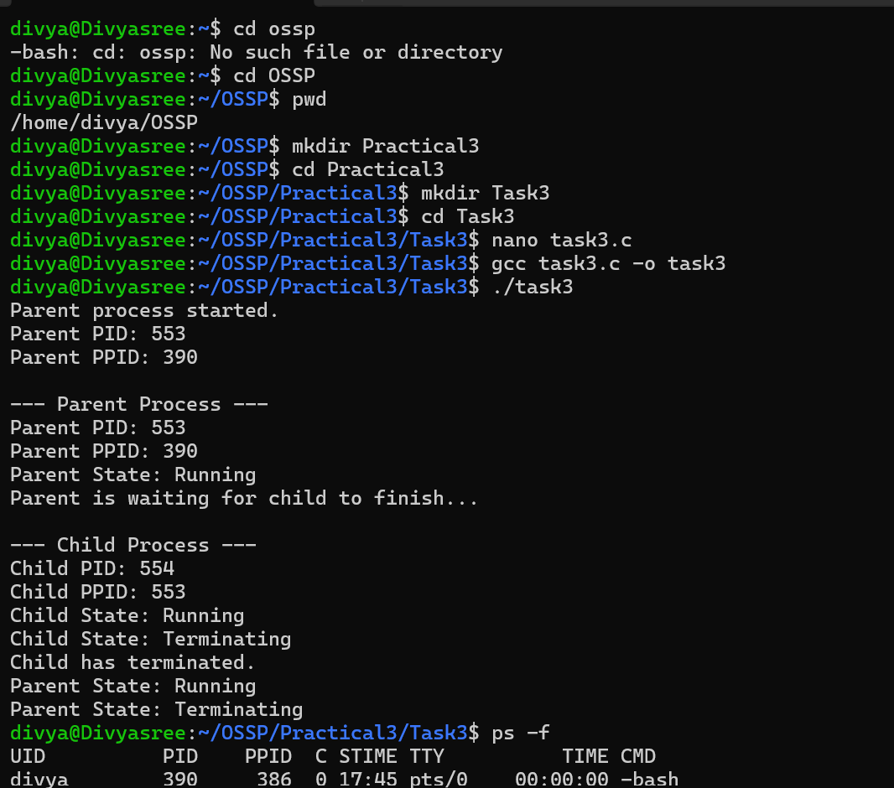
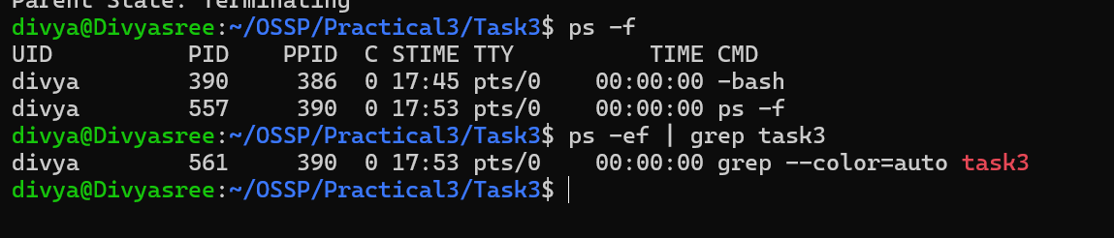
Source code :
